SQL Assignment 8

Question 1: Assume each salesperson has 12% commission.Write a query on the orders table that will produce the order number,the salesperson number, and the amount of the salesperson’s commission for that order?
Answer:

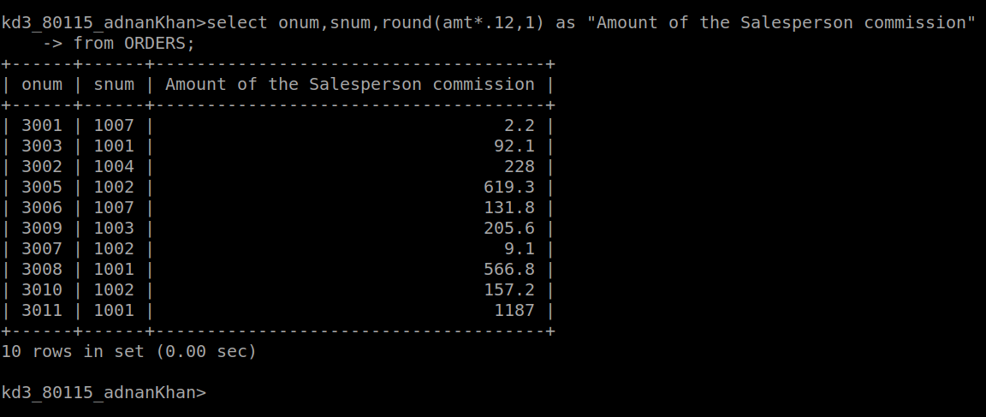
Question 2: Write a query on the customers table that will find the highest rating in each city. Put the output in this form:
For the city(city),The highest rating is:(rating).
Answer:
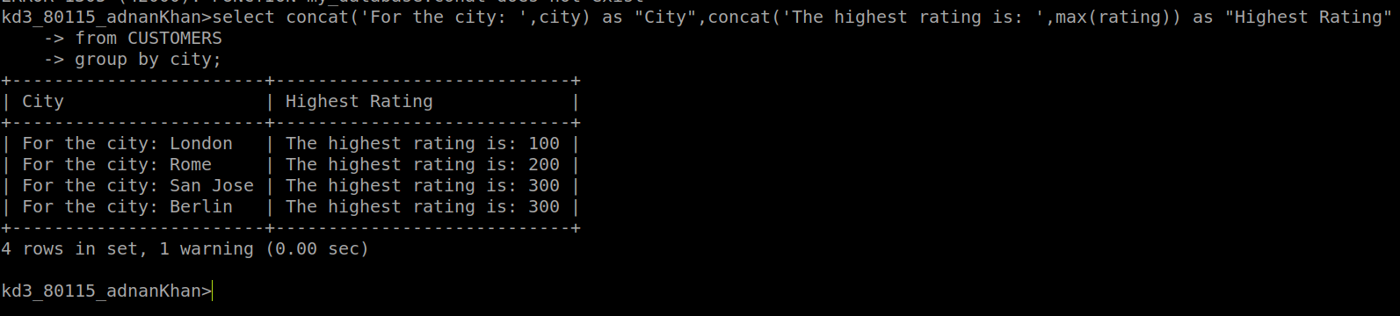

Question 3: Write a query that lists customers in descending order of rating.Output the rating field first, followed by the customer’s name and number?
Answer:
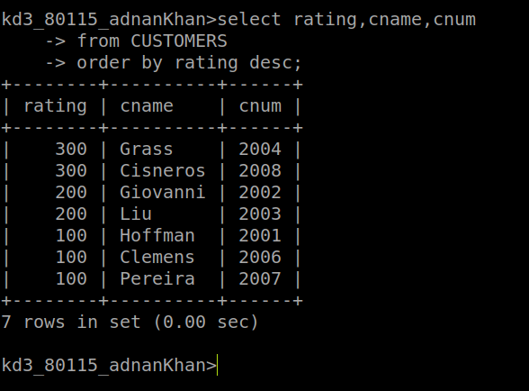
Question 4: Write a query that totals the orders for each day and places the results in descending order?
Answer:
