SQL Assignment 12

Question 1:Write a query that selects all customers whose ratings are equal to or greater than any of Serres?
Answer:
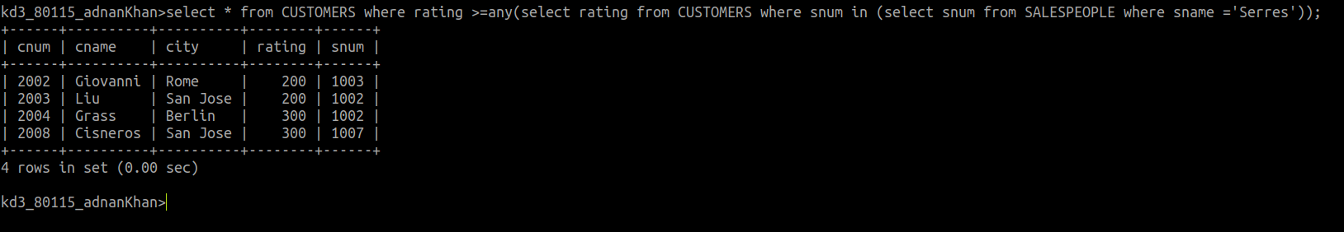
Question 2: Write a query using ANY or ALL that will find all salespeople who have no customers located in their city?
Answer:
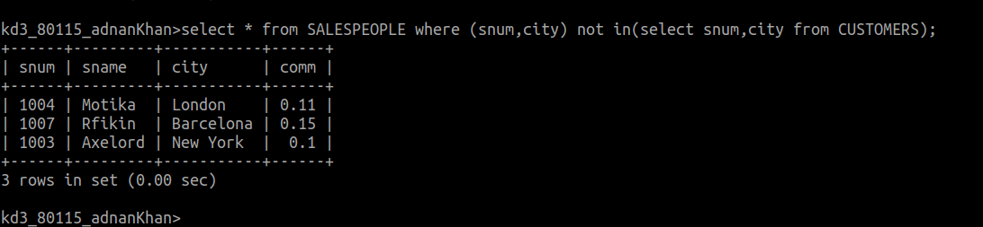
Question 3:Write a query that selects all orders for amounts greater than any for the
customers in London?
Answer:
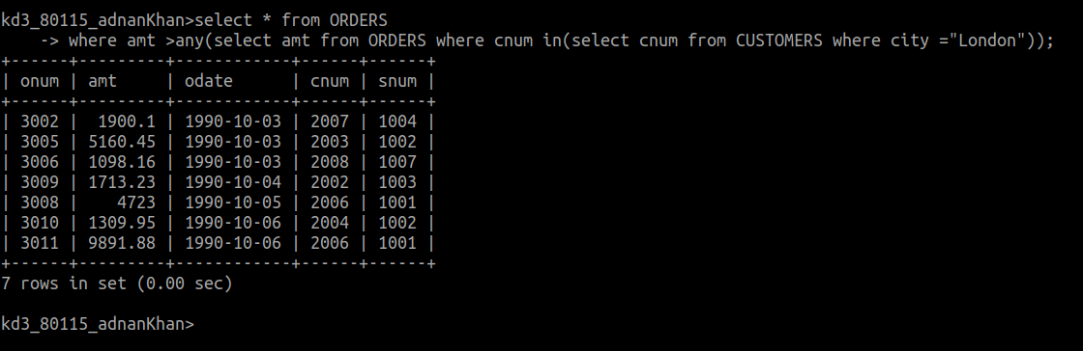
Question 4: Write the above query using MIN or MAX?
Answer:
