MongoDB Assignement

6: View list of available databases?
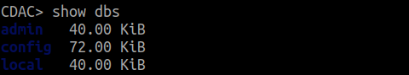

7: Create a new database named CDAC and connect to it?
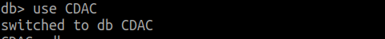

8: View list of available collections in CDAC Database?

9: Create a new collection by the name of LIBRARY?

10: Insert the following document in the LIBRARY collection:
title:”Mongo programming”,
author:”Sameer”,likes:”100”?

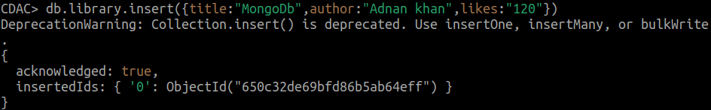

11: View the recently inserte document and note the id field?
-->ObjectId:(“650c333d69bfd86b5ab64f00”)

12: Insert another document in the library collection as follows:
title:”MySQL Programming”,
authors:[‘Jack’,’Jill’],likes:”100”?
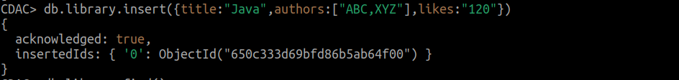

13: View the inserted documents?
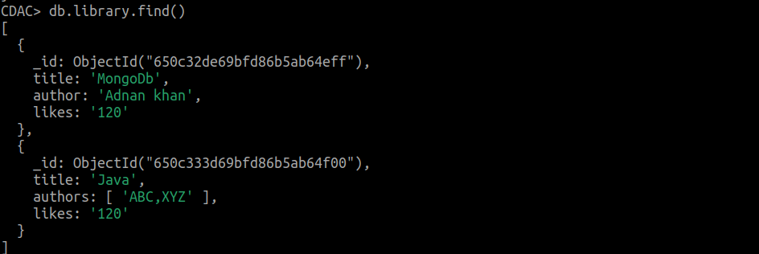

14: View only the first inserted document?
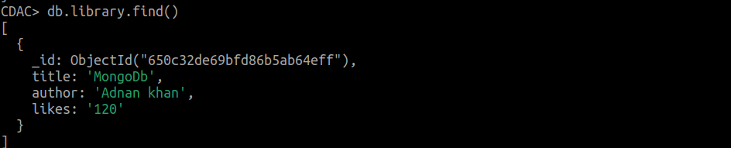

15: View the documents using the pretty() method?

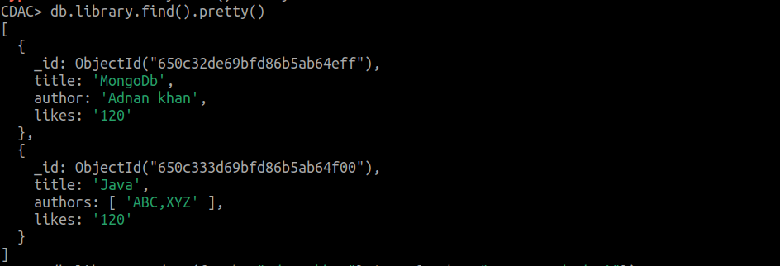

16: Update the document where author name Sameer and change it to Sameer Dehadrai?

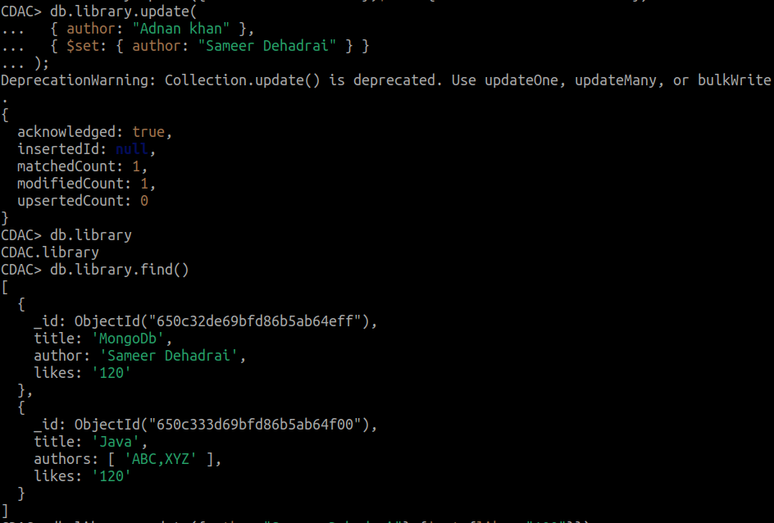

17: Delete all documents that have 100 likes?
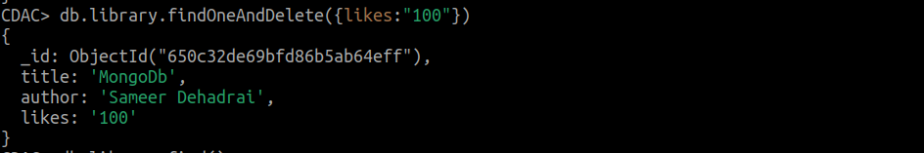

18: Drop the LIBRARY collection?
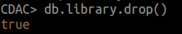

19: Drop the CDAC database?
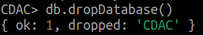

20: Exit from MongoDB shell?
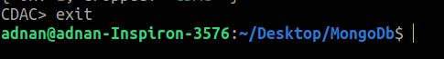

21: Stop MongoDB server?

