SQL Assignment 10

Question 1: Write a query that produces all pairs of salespeople who are living in the same city. Exclude combinations of Salespeople with themselves as well as duplicate rows with the order reversed?
Answer:
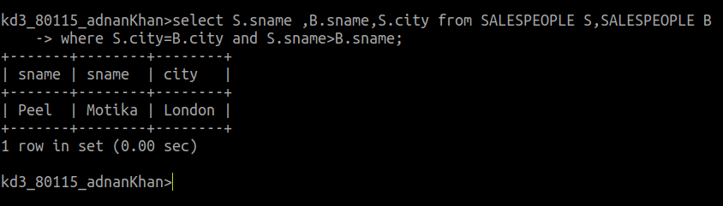
Question 2: Write a query that produces the names and cities of all customers with same rating as Hoffman?
Answer:
