Assignment 3
1.ls
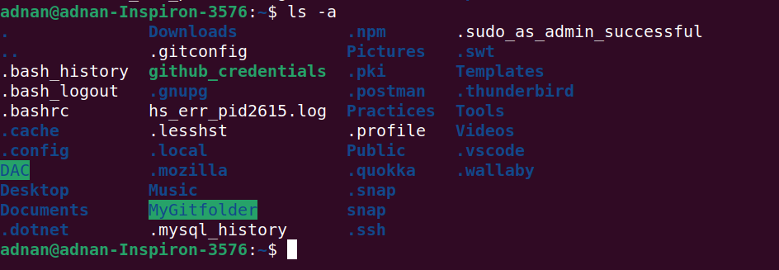
2.rename
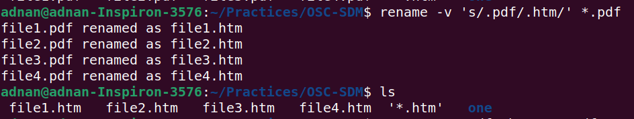

3.ln -s
4.ln
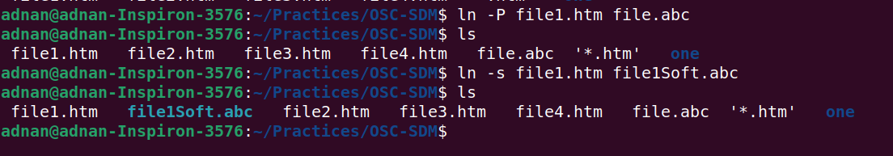

5.stat
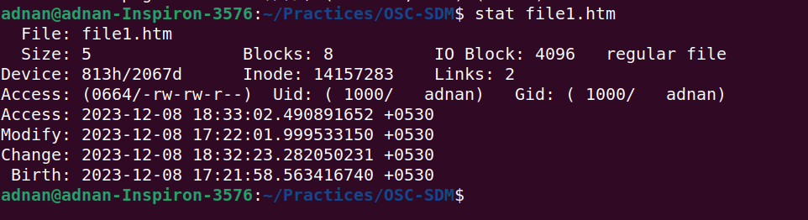

6.touch
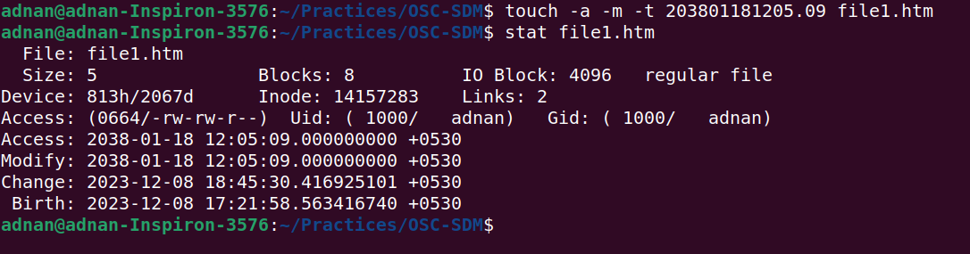

7.touch

8.tail
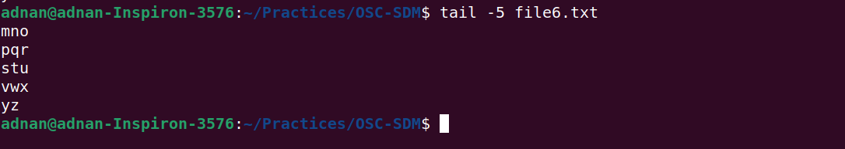

12.whoami

13.tty

14.who am i
15.users

16.who

17.grep, egrep, fgrep
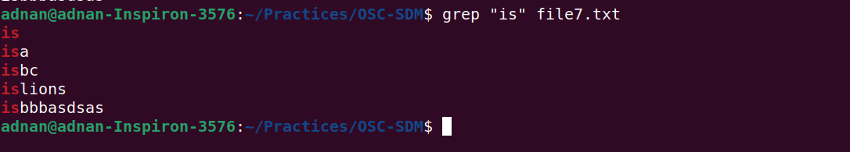

18.chmod

19.chmod

20.wc



21.who | wc

22.head, tail
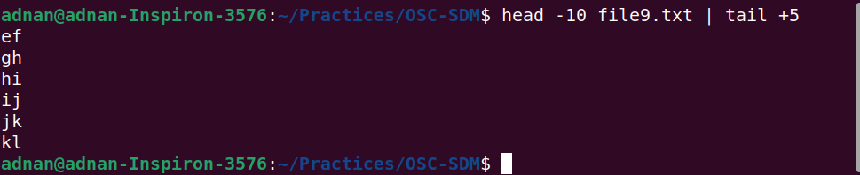

23.sort , uniq
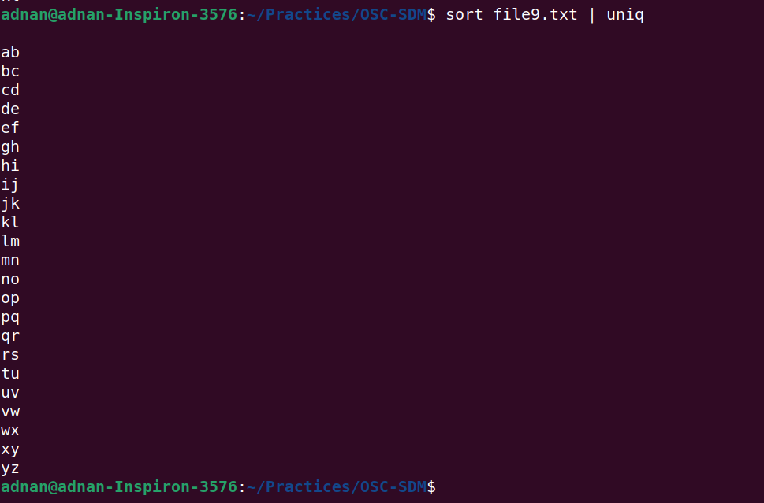

24.who, grep

25.ls
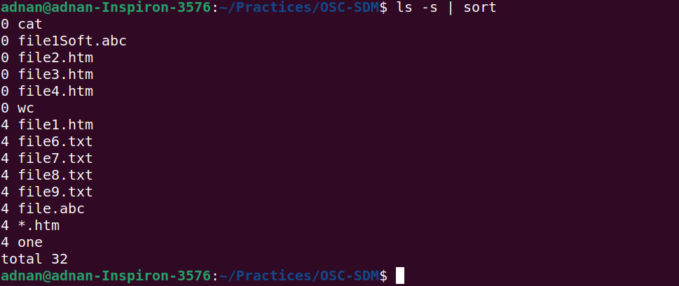

26.ls, grep

27.ls, grep
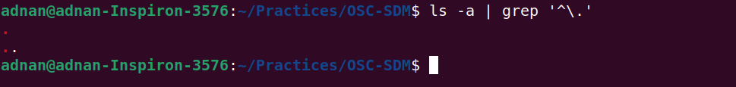

28.tr
