Assignment 1
1.man->
2.uname->
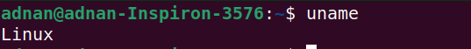
3.pwd->
4.hostname->
5.date->
6.cal->
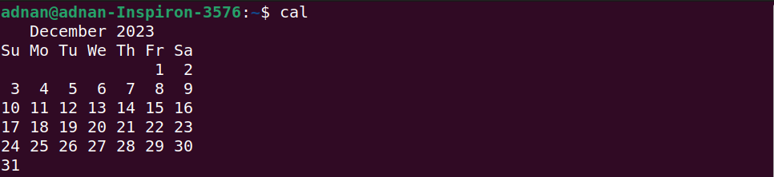
7.ls dir
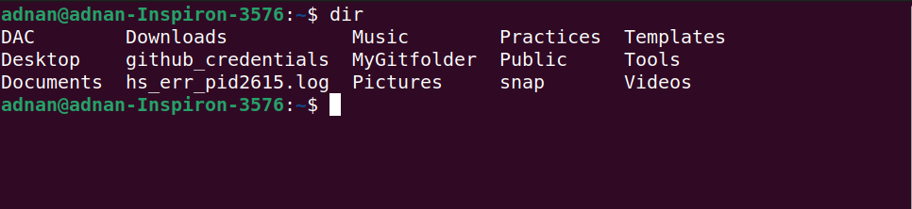
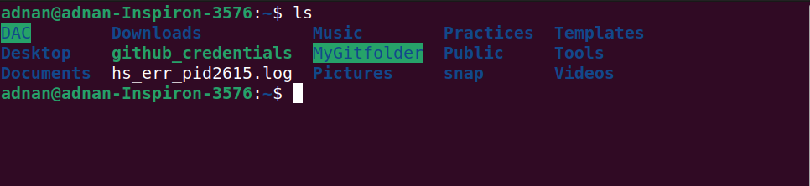
8.cat
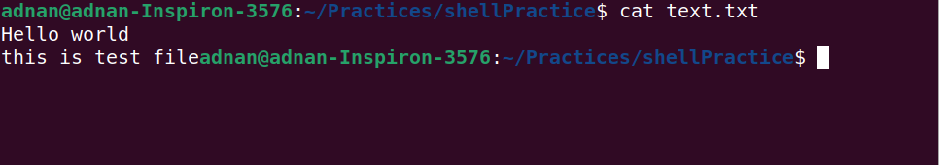
9.cat >>
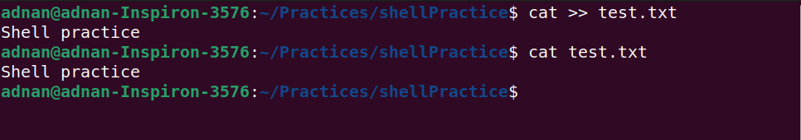
10.cp
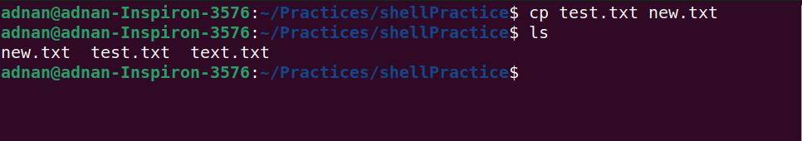
11.mv
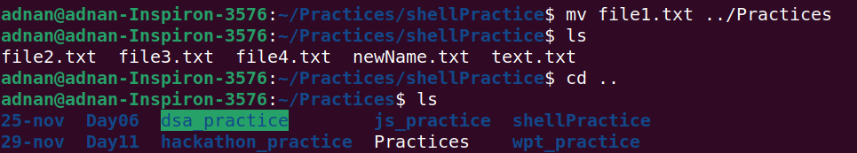
12.mv

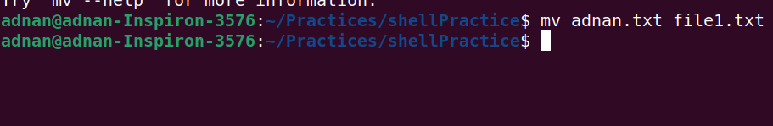
13.tac, rev
14.wc
15.mkdir

16.cd

17.rm

18.rm
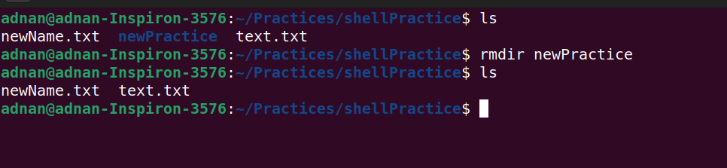

19.touch

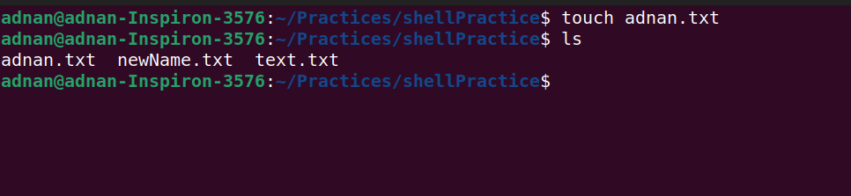
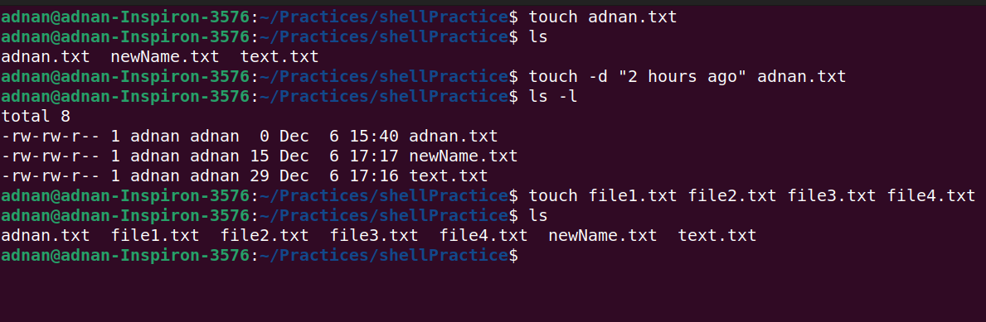
20.sort
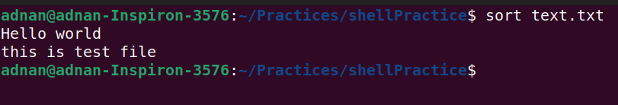
21.uni q
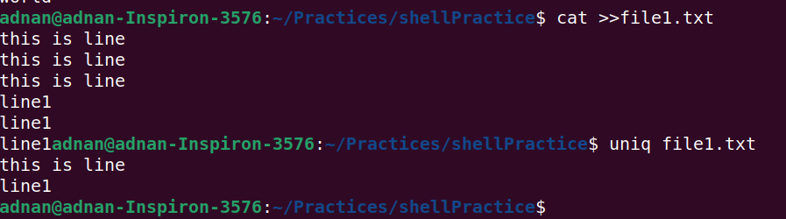

22.head
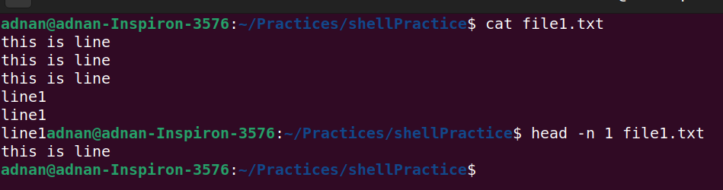
23.tail
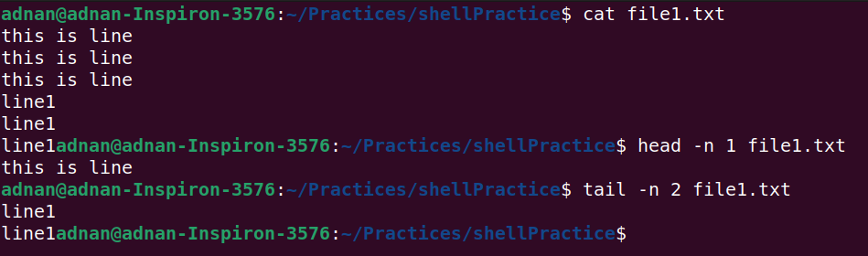
24.factor
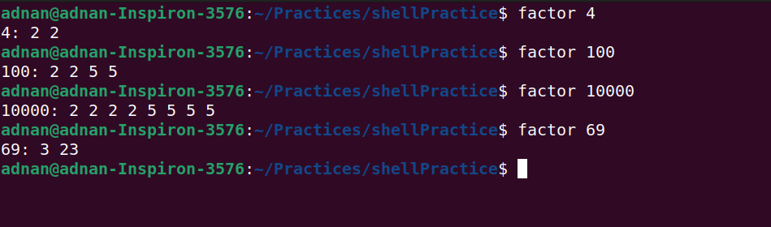
25.alias
26.unalias

27.echo 28.ps


29.kill
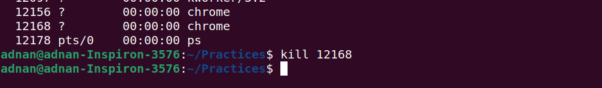

30.env

