KDE Wacom Tablet 2.0

Architecture

Last Update: 17. Feb. 2013

Inhaltsverzeichnis
KDE Tablet Daemon 3
Daemon Overview 3
Class: TabletDaemon 3
Subsystem: X11EventNotifier 3
Subystem: TabletFinder 4
Subsystem: TabletHandler 4
Subsystem: DBusTabletService 4
Profile Management 5

KDE Tablet Daemon

Daemon Overview
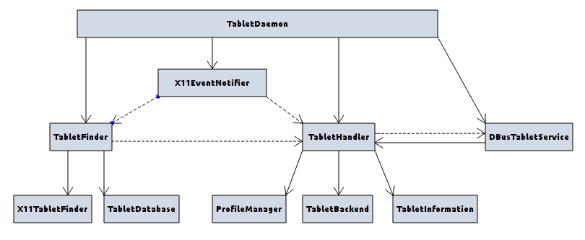
The tablet daemon is a KDE background daemon which handles all tablet operations. It monitors the system for tablets being added or removed, sets different profiles on the tablet and handles all events like i.e. screen rotation. External applications are given access to the tablet via a D-Bus interface.
On startup the daemon initializes all subsystems, connects them via Qt signals & slots and initializes a search for currently connected tablets. If a tablet is found the last used tablet configuration is automatically set on the tablet. Besides from initializing the tablet, the daemon also registers all global keyboard shortcuts and registers an X11 event handler which monitors tablets being connected or removed.

Class: TabletDaemon
TabletDaemon is the main class of the KDE tablet daemon. It extends KDE's KDEDModule class so it can be run as a KDE service through kded. On startup it initializes the tablet handler, the tablet finder, the X11 event notifier and the D-Bus service interface. It also registers all global shortcuts with the KDE shortcut manager. All subsystem are connected via the Qt signal & slots mechanism to ensure the components can be developed independently.
After initializing the subsystems, a search for currently connected tablets is started using the tablet finder. If a tablet is found, the finder emits a signal to notify the tablet handler which does all necessary steps to configure the tablet, i.e. setting the last used configuration profile. External applications can then use the D-Bus service interface to query the tablet handler for device information or to modify device properties.
While running, the daemon also monitors the system for external X11 events using the X11 event notifier. This subsystem notifies (using Qt signals) the TabletFinder of devices being connected or removed and the tablet handler of the screen being rotated.

Subsystem: X11EventNotifier
The X11EventNotifier uses X11's XInput system and KDE's X11 event filter to monitor the system for X11 events. It specifically listens for events which signal a device being connected or removed or the screen being rotated. If a device gets connected or removed, the notifier does some basic checks to determine if it is a tablet device and emits a Qt signal which can be connected to other subsystems. If the screen gets rotated, the new rotation is determined and again a Qt signal gets emitted.

Subystem: TabletFinder
The TabletFinder keeps a list of all tablets currently being connected to the system and gathers as much information as possible about each tablet. While it is able to scan for currently connected devices, it depends on external signals to determine when a device is being connected or removed.
On system startup a scan for currently connected devices is usually initiated by an external component, i.e. the tablet daemon. The scan is executed by using the tablet finder implementation for the underlying window system. At the time of writing only the X11TabletFinder has been implemented yet. For each tablet found, the finder then tries to gather as much information about the device using the TabletDatabase. This database contains necessary configuration options like i.e. the hardware button mappings. All tablets found are added to a list which is managed by the TabletFinder and for each tablet a Qt signal is emmited to inform other components about the device.
As the tablet finder does not actively monitor for devices being added or removed, it depends on external Qt signals to be informed of such an event. If a signal is received, the finder analyzes the device and again tries to gather as much information as possible. If it is a tablet device, the finder will upate its list of connected tablet devices and then emit the appropriate Qt signal for a tablet being connected or removed.

Subsystem: TabletHandler
The TabletHandler initializes the currently connected tablet and handles all events concerning the tablet device. It also gives the D-Bus service access to the tablet properties. At the time of writing the tablet handler is only able to handle one tablet, this is usually the first tablet found by the TabletFinder. The information about the current tablet is stored in the TabletInformation structure. As the tablet handler does not monitor for tablets being connected or removed it depends on external signals from the TabletFinder.
When the handler receives a signal of a device being connected it uses the ProfileManager to load the last configuration used on that device. To get access to the physical device, the tablet handler depends on the TabletBackend which offers methods to read/write properties or set a device profile configuration. Whenever the tablet handler has taken or relinguished control of a device, it will emit a signal which will be passed to the D-Bus service to notify external applications.
Besides handling connect/disconnect events, the tablet handler also offers other slots to handle i.e. screen rotation events which require the tablet properties to be updated.

Subsystem: DBusTabletService
The DBusTabletService gives external applications access to the currently connected tablet devices. All queries are passed to the tablet handler which manages property modifications or configuration profile changes. The D-Bus service also receives signals from the tablet handler about devices being connected or removed and passes them to external applications listening on the D-Bus interface.

Profile Management
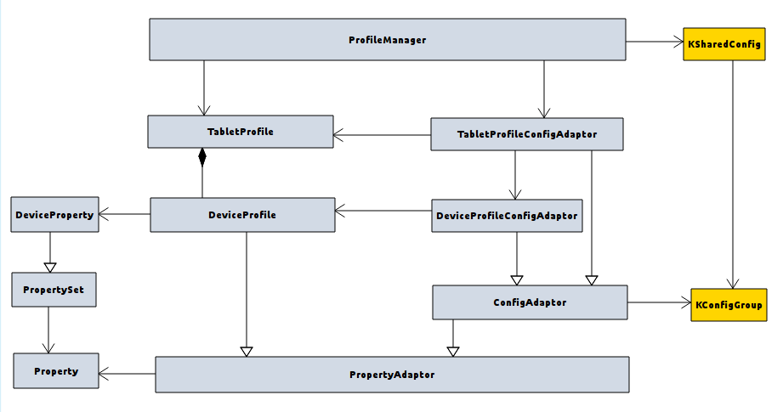
The profile manager is responsible for reading and writing configuration profiles of a tablet device. All profiles are stored in KDE configuration files. When reading a profile the configuration keys are mapped to device properties which give unified access to configuration properties across the whole wacom tablet application. Each tablet profile consists of multiple device profiles for each hardware component of the tablet device (i.e. stylus, eraser, pad, touch).

Class: ProfileManager

Class: DeviceProperty, PropertySet, Property, PropertyAdaptor

Class: TabletProfile, DeviceProfile

Class: Tablet- / DeviceProfileConfigAdaptor, ConfigAdaptor

Properties
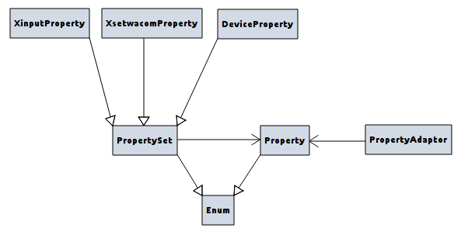
All properties are managed by the Property class which is an enumeration consisting of all properties the system supports. However as each subsystem supports different kind of properties or only a subset of properties, the global properties are further partitioned into property sets. A PropertySet is an enumeration of properties a subsystem supports. Each property set has its own identifier keys and its own order the properties have to be applied in. Still each property of a property set is mapped to a property from the main Property class. Therefore properties of a PropertySet can easily be mapped to global properties and vice versa.
At the time of writing, three property sets exist. The XinputProperty set which lists all properties supported by the X11 xinput system, the XsetwacomProperty set which list the properties supported by xsetwacom and the DeviceProperty set which contains all properties of the configuration file.
As properties of a PropertySet should only be used by their own subsystem, those subystems have to be accessed via property adaptors. The PropertyAdaptor class has to be implemented by each component which wants to give external subsystems access to its own properties. Via the PropertyAdaptor the external subsystems can then access all the properties by their global property name from the Property enumeration. The PropertyAdaptor maps these global properties to its own property set and then accesses its subsystem using its local properties.

Adaptors
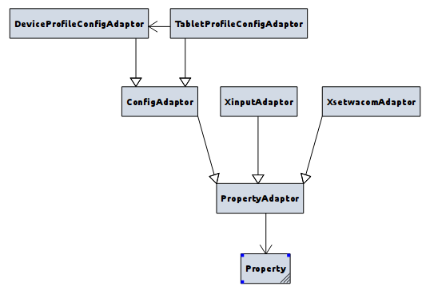

PropertyAdaptors are used to map properties between different subsystems. As the properties of a subsystem should not be used by external subsystems, property adaptors allow different subsystems to exchange information via global properties.

