SET-2

AADITYA KEDIYAL

20020570001

BSc(H) Computer Science

Submitted to **Dr Nikhil Rajput**

QUESTION 1: Simulate and implement stop and wait protocol for noisy channel

OUTPUT:

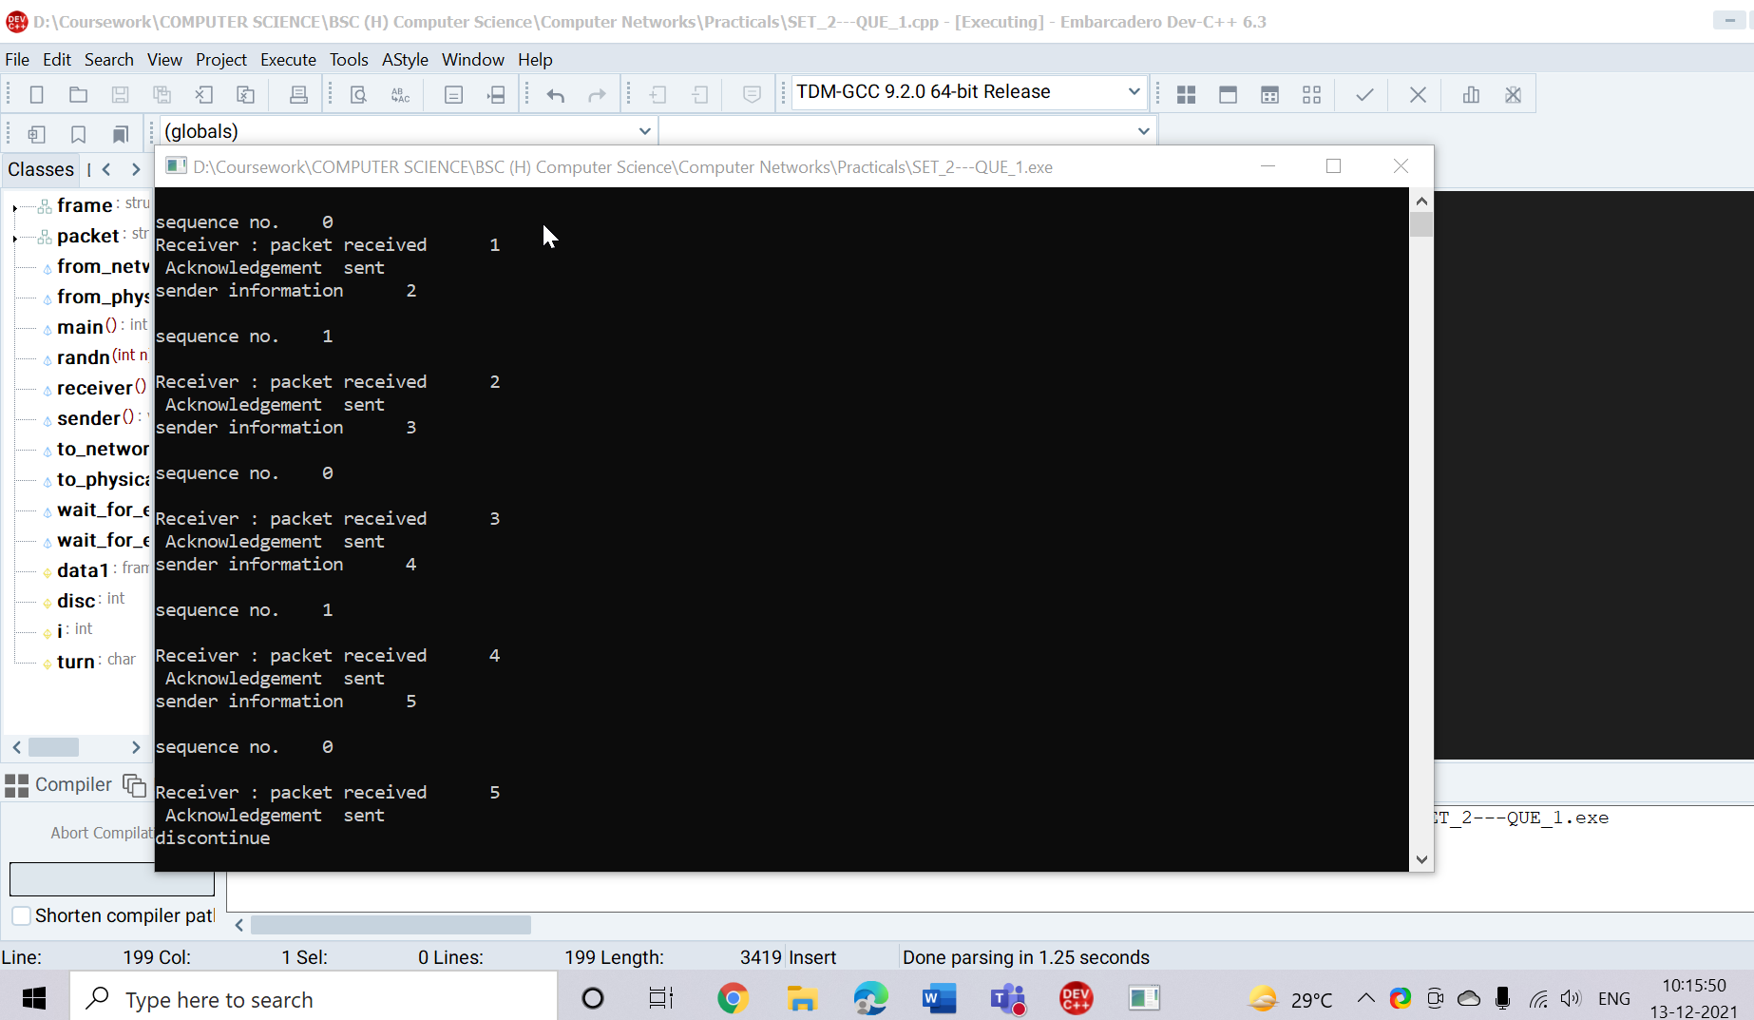

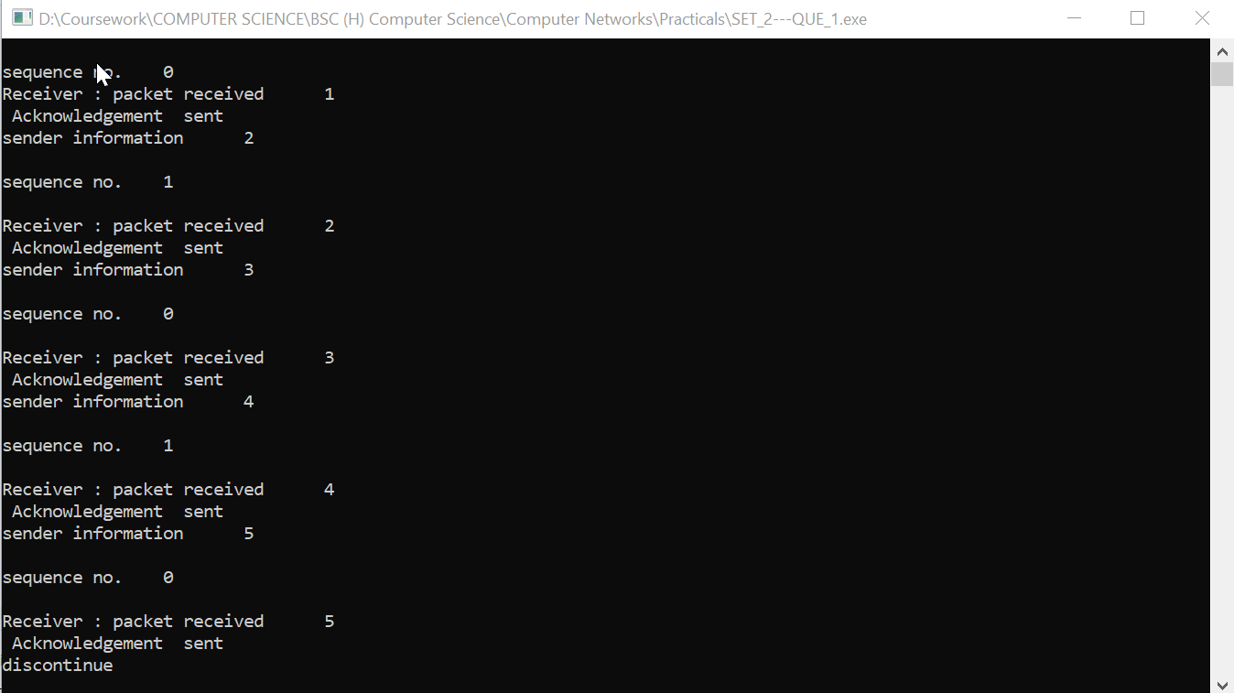

QUESTION 2: Simulate and implement selective repeat sliding window protocol

OUTPUT:

