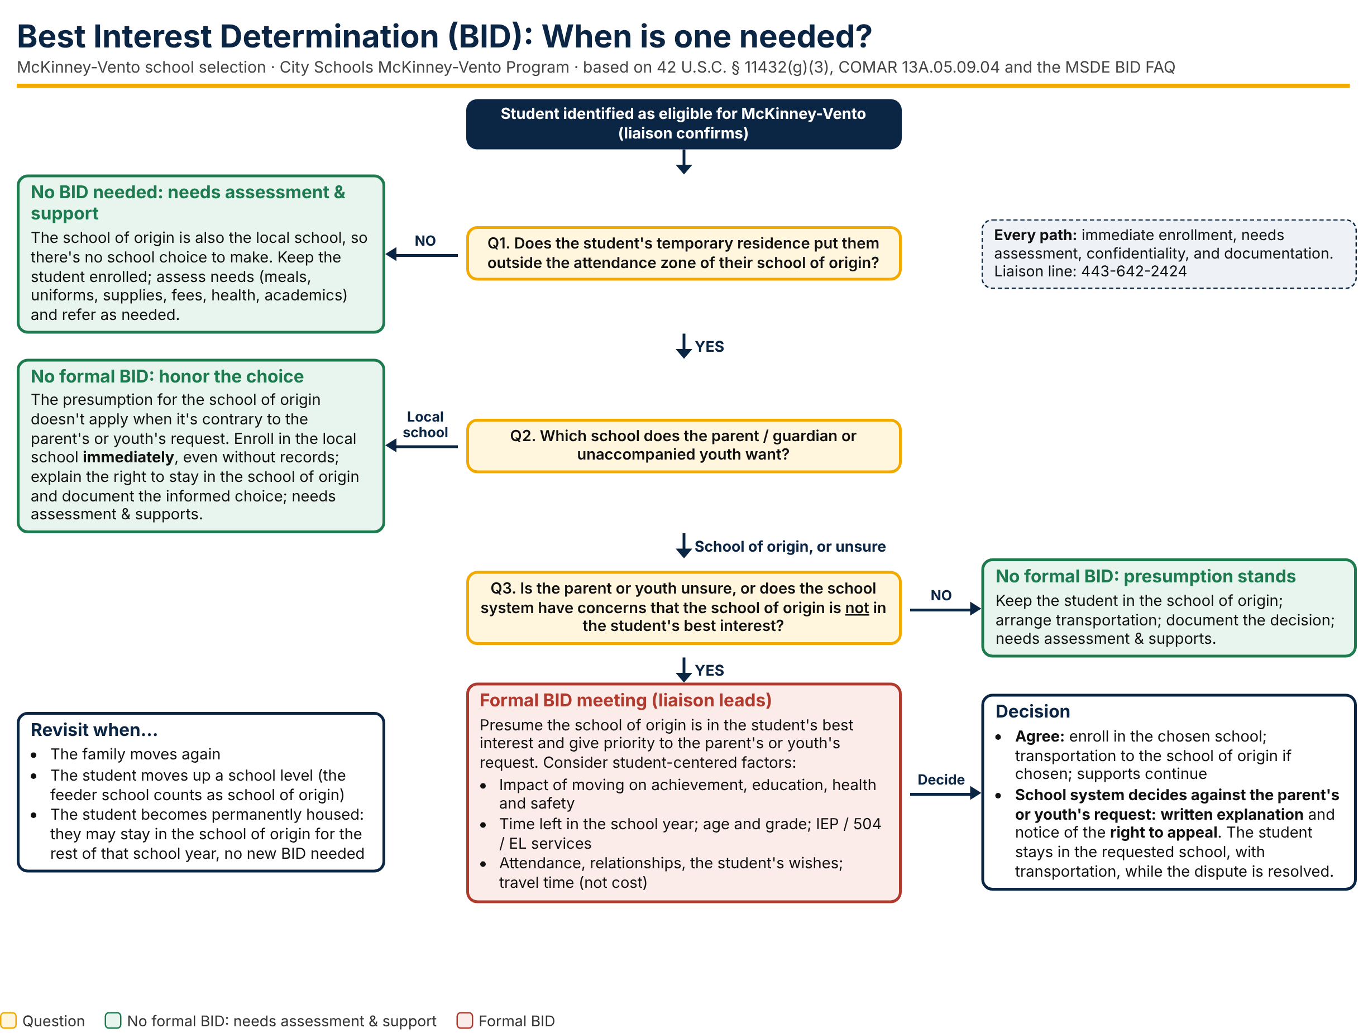

BID Decision Guide (editable text version of the flowchart)
Use this table alongside the flowchart. Every path includes immediate enrollment, a needs assessment, confidentiality, and documentation.
Step | Question | What to do
Q1 | Does the student's temporary residence put them outside the attendance zone of their school of origin? | No: No BID needed. Keep the student enrolled; complete a needs assessment (meals, uniforms, supplies, fees, health, academics) and refer as needed.  Yes: go to Q2.
Q2 | Which school does the parent / guardian or unaccompanied youth want? | Local school: No formal BID. Enroll immediately, even without records. Explain the right to stay in the school of origin and document the informed choice.  School of origin, or unsure: go to Q3.
Q3 | Is the parent or youth unsure, or does the school system have concerns that the school of origin is not in the student's best interest? | No: No formal BID; the presumption stands. Keep the student in the school of origin, arrange transportation, document the decision.  Yes: hold a formal BID meeting using the worksheet.
Decision | Did the meeting reach agreement? | Agree: enroll in the chosen school; transportation to the school of origin if chosen.  School system decides against the parent's or youth's request: give a written explanation and notice of the right to appeal. The student stays in the requested school, with transportation, while the dispute is resolved.
Revisit | When should the decision be reviewed? | When the family moves again; when the student moves up a school level (the feeder school counts as school of origin). A student who becomes permanently housed may stay in the school of origin for the rest of that school year without a new BID.

Best Interest Determination (BID) Meeting Worksheet
Confidential student record when completed. Housing information is shared only with staff who need it to serve the student.

1. Student and meeting information
Student name | Student ID / Grade / DOB
School of origin | Local attendance-area school
Date identified as McKinney-Vento eligible | Meeting date
McKinney-Vento liaison | Parent / guardian or unaccompanied youth
Other participants (name / role)

2. Current living situation (check one)
☐ Doubled up (sharing housing due to loss of housing or economic hardship) ☐ Shelter ☐ Motel / hotel
☐ Car, park, or other place not meant for housing ☐ Unaccompanied youth ☐ Other: ____________________

3. Parent / guardian or unaccompanied youth preference
☐ School of origin ☐ Local attendance-area school ☐ Unsure
Reason(s) given: ______________________________________________________________________________
Student's own views (if age-appropriate): ________________________________________________________

4. Student-centered factors
Presume the school of origin is in the student's best interest and give priority to the parent's or youth's request. Note how each factor applies to each school.
Factor | School of origin | Local school | Notes
Academic progress and grades
Time left in the school year / grading period
IEP, 504 plan, English learner services
Attendance at each school
Health and safety (including the route)
Relationships: teachers, peers, siblings
Extracurriculars, athletics, programs
Travel time and its effect (not cost)
Expected length of the housing situation
The student's own wishes (age-appropriate)

5. Decision
☐ School of origin, for the duration of homelessness (or the rest of the school year if permanently housed)
☐ Local attendance-area school
☐ Decision agrees with the parent's / youth's request ☐ Decision is contrary to the request (complete section 7)

6. Transportation and support plan
Transportation to the school of origin (mode, pick-up / drop-off, start date)

Needs assessment and supports (meals, uniforms, supplies, fees, health, academics, referrals)

Records / services to transfer (IEP, 504, EL, immunizations, credits)

7. Written explanation and right to appeal (if the decision is contrary to the request)
Reasons for the decision, in plain language: ____________________________________________________________
______________________________________________________________________________________________
☐ Written explanation given to parent / youth on (date): __________ ☐ Notice of the right to appeal given
The student remains enrolled in the school requested by the parent or youth, with transportation, while the dispute is resolved. The liaison helps the parent or youth file the appeal and follows City Schools' and MSDE's dispute resolution process.

8. Signatures
Parent / guardian or unaccompanied youth | Date
McKinney-Vento liaison | Date
School administrator (optional) | Date
Parent / youth comments: ☐ I agree ☐ I disagree and want to appeal

McKinney-Vento Resources
Resources that support City Schools Board Policy JFE (Students Experiencing Homelessness) and the McKinney-Vento Program. Verify phone numbers and links before sharing with families.

City Schools
Resource | What it's for | Contact
City Schools McKinney-Vento Program | Eligibility, enrollment, school-of-origin transportation, uniforms, supplies, fee waivers, referrals | 443-642-2424
Board Policy JFE: Students Experiencing Homelessness | City Schools' policy on identification, enrollment, school selection and disputes | BoardDocs
School-based McKinney-Vento liaison | First contact for staff referrals and BID meetings at each school | Name / ext.: ________

Maryland
Resource | What it's for | Contact
MSDE McKinney-Vento program | State coordinator, guidance, dispute resolution information | MSDE website
MSDE Best Interest Determinations FAQ | Maryland guidance on when and how to hold a BID | PDF
MSDE McKinney-Vento Fact Sheet | Plain-language summary of student rights for families and staff | PDF
COMAR 13A.05.09: Programs for Homeless Children | Maryland regulation on placement and school selection | Maryland DSD
Maryland 211 | Shelter, food, utility and housing help statewide | Dial 2-1-1

Baltimore City community partners
Resource | What it's for | Contact
Mayor's Office of Homeless Services | City shelter system, outreach and housing programs | Website
Health Care for the Homeless | Medical, dental, behavioral health and pediatric care for people experiencing homelessness | Website

National
Resource | What it's for | Contact
National Center for Homeless Education (NCHE) | School selection and best interest briefs, liaison toolkit | Helpline listed on site
SchoolHouse Connection | School selection interview checklists, Q&A from the field, FAFSA help for unaccompanied youth | Website
Federal Student Aid: unaccompanied homeless youth | Applying for financial aid as an independent student with a liaison's determination | studentaid.gov

References
- 42 U.S.C. § 11432(g)(3): school selection, presumption, student-centered factors, written explanation, enrollment during disputes, school of origin definition: https://uscode.house.gov/view.xhtml?req=granuleid:USC-prelim-title42-section11432&num=0&edition=prelim
- 42 U.S.C. § 11432(g)(1)(J)(iii): transportation to the school of origin: https://uscode.house.gov/view.xhtml?req=granuleid:USC-prelim-title42-section11432&num=0&edition=prelim
- COMAR 13A.05.09.04: Maryland placement of homeless students: https://dsd.maryland.gov/regulations/Pages/13A.05.09.04.aspx
- MSDE, McKinney-Vento Best Interest Determinations FAQ: https://marylandpublicschools.org/about/Documents/DSFSS/Homeless/Best-Interest-Determination-FAQ-A.pdf
- MSDE, McKinney-Vento Fact Sheet: https://marylandpublicschools.org/about/Documents/DSFSS/Homeless/McKinney-Vento-Factsheet-A.pdf
- City Schools Board Policy JFE, Students Experiencing Homelessness: https://go.boarddocs.com/mabe/bcpss/Board.nsf/goto?open=&id=96DRWG6F891E
- NCHE, School Selection & Best Interest: https://nche.ed.gov/school-selection/
- NCHE, Understanding and Implementing School Selection and Best Interest Under the McKinney-Vento Act: https://nche.ed.gov/school-selection-and-best-interest-determination-brief/
- SchoolHouse Connection, Interview Checklists for Supporting School Selection: https://schoolhouseconnection.org/interview-checklists-for-supporting-school-selection/
- NC Homeless Education Program, Considerations for Determining Best Interest: https://hepnc.uncg.edu/wp-content/uploads/2025/08/Considerations-for-Determining-Best-Interest.pdf

