**SE 102.3 – Web Based Application Development**

**Tutorial**

ID - 28371

1. Write down the HTML codes required to create the following form

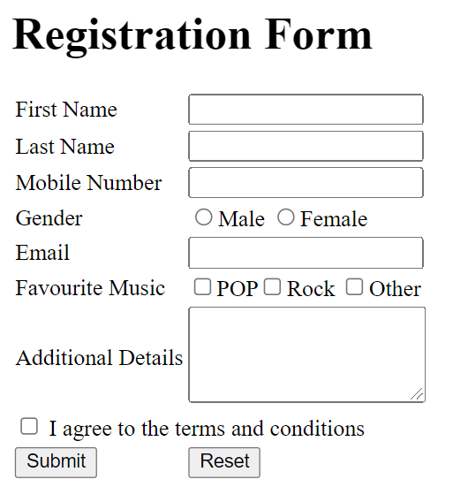

<!DOCTYPE html>

<html lang="en">

<head>

    <meta charset="UTF-8">

    <meta name="viewport" content="width=device-width, initial-scale=1.0">

    <title>Html List</title>

</head>

<body>

  <table border="1" align="center">

    <tr>

        <td>

  <h1>Registration Form</h1>

  <table>

  <tr>

    <td>First Name </td><td><input type = "text" name = "First Name" id = ""></td>

  </tr>

  <tr>

    <td>Last Name </td><td><input type = "text" name = "Last Name" id = ""></td>

  </tr>

  <tr>

    <td>Mobile Number </td><td><input type = "text" name = "Mobile Number" id = ""></td>

  </tr>

  <tr>

    <td>Gender</td><td><input type = "radio" name = "Age">Male <input type = "radio" name = "Age">Female</td>

  </tr>

  <tr>

    <td>Email </td><td><input type = "text" name = "Email" id = ""></td>

  </tr>

  <tr>

    <td>Favourite Music</td><td><input type = "checkbox" name = "Age">POP<input type = "checkbox" name = "Age">Rock<input type = "checkbox" name = "Age">Other</td>

  </tr>

  <tr>

    <td>Additional Details </td><td><textarea></textarea></td>

  </tr>

  <table>

  <tr>

   <td><input type ="checkbox">I agree to the terms and conditions.</td>

  </tr>

  </table>

  <table>

  <tr>

    <td><input type="submit" name ="Submit">&nbsp;&nbsp;&nbsp;&nbsp;&nbsp;&nbsp;&nbsp;&nbsp;&nbsp;&nbsp;&nbsp;&nbsp;&nbsp;&nbsp;</td><td><input type="reset" name ="Reset"></td>

  </tr>

  </table>

</table>

        </td>

    </tr>

</table>

</body>

</html>

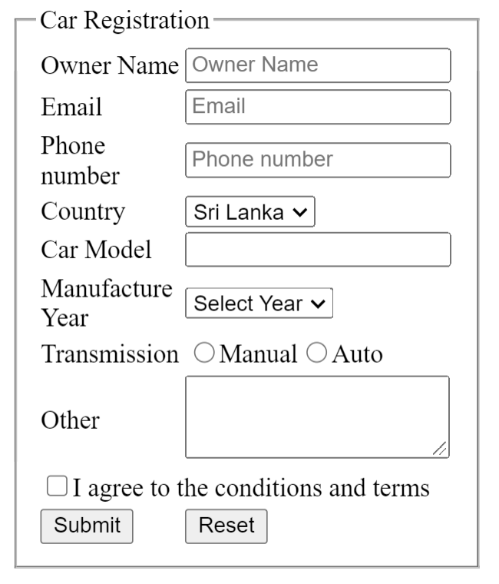

<!DOCTYPE html>

<html lang="en">

<head>

    <meta charset="UTF-8">

    <meta name="viewport" content="width=device-width, initial-scale=1.0">

    <title>Html List</title>

</head>

<body>

  <table border="1" align = "center">

    <tr>

    <td>

    <h1>Car Registration</h1>

    <table>

    <tr>

        <td>Owner Name</td><td><input type ="text" placeholder="Owner Name"></td>

    </tr>

    <tr>

        <td>Email</td><td><input type ="text" placeholder="Email"></td>

    </tr>

    <tr>

        <td>Phone number</td><td><input type ="text" placeholder="Phone number"></td>

    </tr>

    <tr>

        <td>Country</td><td><select><option selected>Sri Lanka</option><option>India</option><option>Other</option></select></td>

    </tr>

    <tr>

        <td>Car Model</td><td><input type ="text" name ="Car Model"></td>

    </tr>

    <tr>

        <td>Manufacture Year</td><td><select><option>Select Year</option><option>2023</option><option>2024</option></select></td>

    </tr>

    <tr>

        <td>Transmission</td><td><input type = "radio" name = "Age">Manual<input type = "radio" name = "Age">Auto</td>

    </tr>

    <tr>

        <td>Other</td><td><textarea></textarea></td>

    </tr>

    <table>

     <tr>

        <td><input type= "checkbox" name = "checkbox">I agree to the conditions and terms.</td>

     </tr>

    </table>

     <table>

        <tr>

            <td><input type="submit" name = "Submit">&nbsp;&nbsp;&nbsp;&nbsp;&nbsp;&nbsp;&nbsp;&nbsp;&nbsp;&nbsp;&nbsp;</td><td><input type="reset" name = "Reset"></td>

        </tr>

     </table>

    </table>

    </td>

    </tr>

  </table>

</body>

</html>