**SE 102.3 – Web Based Application Development**

**Tutorial**

**ID - 28371**

1. Write down the HTML codes required to generate the following outputs.

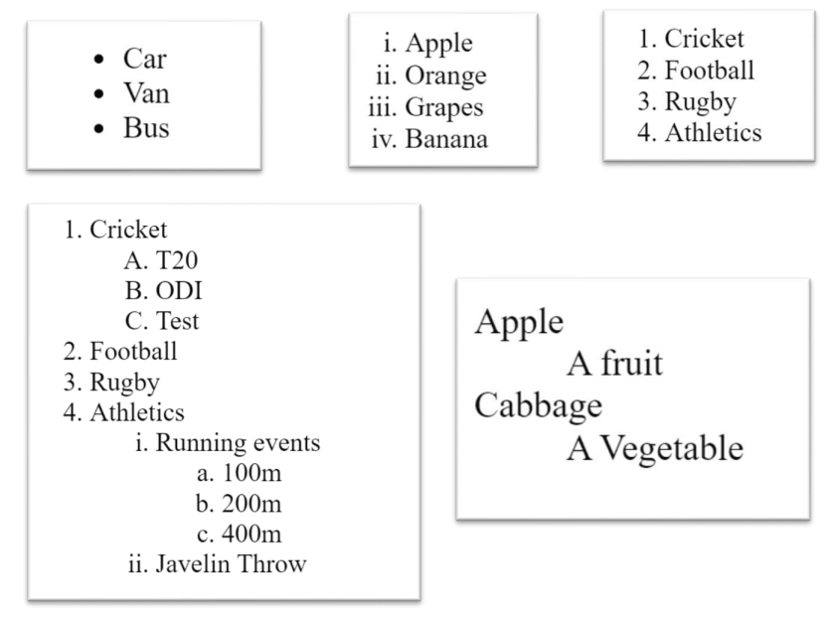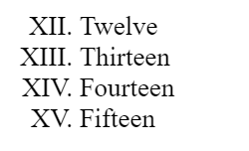

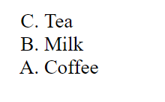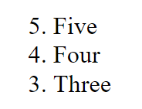

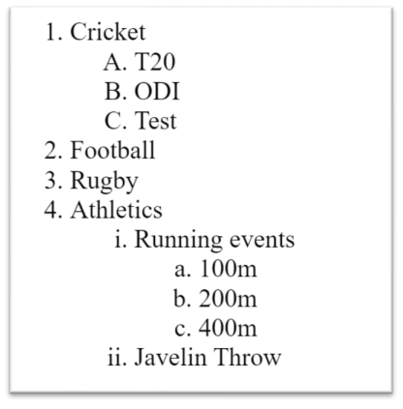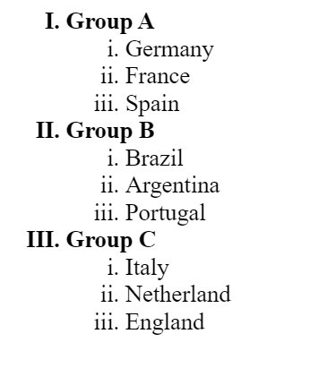

<!DOCTYPE html>

<html lang="en">

<head>

    <meta charset="UTF-8">

    <meta name="viewport" content="width=device-width, initial-scale=1.0">

    <title>Html List</title>

</head>

<body>

<ul>

<li>Car</li>

<li>Van</li>

<li>Bus</li>

</ul>

<ol type = "i">

<li>Apple</li>

<li>Orange</li>

<li>Graps</li>

<li>Banana</li>

</ol>

<ol>

<li>Cricket</li>

<li>Football</li>

<li>Rugby</li>

<li>Athletics</li>

</ol>

<ol type ="i" start="12">

<li>Twelve</li>

<li>Thirteen</li>

<li>Fourteen</li>

<li>Fifteen</li>

</ol>

<ol type ="A" reversed>

<li>Tea</li>

<li>Milk</li>

<li>Coffee</li>

</ol>

<ol type ="1" start="5" reversed>

  <li>Five</li>

  <li>Four</li>

  <li>Three</li>

</ol>

<ol type ="I">

<li>Group A</li>

   <ol type ="i">

     <li>Germany</li>

     <li>France</li>

     <li>Spain</li>

   </ol>

<li>Group B</li>

<ol type ="i">

    <li>Brazil</li>

    <li>Argentina</li>

    <li>Portugal</li>

  </ol>

  <li>Group C</li>

  <ol type ="i">

    <li>Italy</li>

    <li>Netherland</li>

    <li>England</li>

  </ol>

</ol>

<ol type ="1">

<li>Cricket</li>

   <ol type ="A">

    <li>T20</li>

    <li>ODI</li>

    <li>Test</li>

   </ol>

<li>Football</li>

<li>Rugby</li>

<li>Athletics</li>

   <ol type ="i">

      <li>Running events</li>

          <ol type ="a">

              <li>100m</li>

              <li>200m</li>

              <li>400m</li>

          </ol>

      <li>Javelin Throw</li>

   </ol>

</ol>

</body>

</html>