ID - 28371

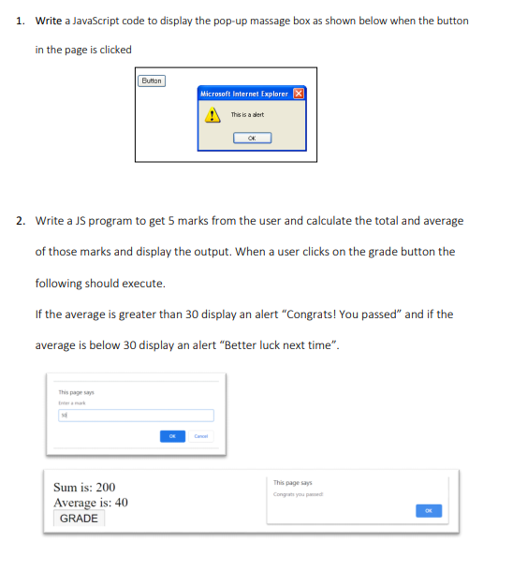

<!DOCTYPE html>

<html lang="en">

<head>

    <meta charset="UTF-8">

    <meta name="viewport" content="width=device-width, initial-scale=1.0">

    <title>Find Average</title>

</head>

<body>

<button id = "Grade">Grade</button>

<script>

     var sum = 0;

      var marks;

     for(var i = 1; i <=5 ; i++){

         marks = prompt("Enter a number ", );

        sum = sum + marks;

     }

     var avg = sum / 5;

     document.write("Sum is " + sum);

     document.write("<br>");

     document.write("Average is " + avg);

     document.getElementById("Grade").onclick = function(){

      if(avg > 30)

        alert("Congrats! you passed");

      else

        alert("Better luck next time");

}

</script>

</body>

</html>

Q1) <!DOCTYPE html>

<html lang="en">

<head>

    <meta charset="UTF-8">

    <meta name="viewport" content="width=device-width, initial-scale=1.0">

    <title>POP up message box</title>

</head>

<body>

  <button id = "popbutton">Button</button>

<script>

document.getElementById("popbutton").onclick = function(){

     alert("This is a alert");

}

</script>

</body>

</html>

3)

<!DOCTYPE html>

<html>

<head>

    <title>Change Background Color</title>

    <style>

        .color-button {

            padding: 10px 20px;

            margin: 5px;

            cursor: pointer;

        }

    </style>

</head>

<body>

    <h1>Change Background Color</h1>

    <button class="color-button" name="redButton" onmouseover="changeToRed();"

        onmouseout="restoreBackgroundColor();">Red</button>

    <button class="color-button" name="greenButton" onmouseover="changeToGreen();"

        onmouseout="restoreBackgroundColor();">Green</button>

    <button class="color-button" name="blueButton" onmouseover="changeToBlue();"

        onmouseout="restoreBackgroundColor();">Blue</button>

    <script>

        function changeToRed() {

            document.body.style.backgroundColor = "red";

        }

        function changeToGreen() {

            document.body.style.backgroundColor = "green";

        }

        function changeToBlue() {

            document.body.style.backgroundColor = "blue";

        }

        function restoreBackgroundColor() {

            document.body.style.backgroundColor = "";

        }

    </script>

</body>

</html>

4) <!DOCTYPE html>

<html lang="en">

<head>

    <meta charset="UTF-8">

    <meta name="viewport" content="width=device-width, initial-scale=1.0">

    <title>Circle Area</title>

</head>

<body>

  <script>

  var r = prompt("Enter area of the circle"," ");

  var area = (22/7)\*r\*r;

  document.write("Circle area is " + area);

  </script>

</body>

</html>

5)

<!DOCTYPE html>

<html lang="en">

<head>

    <meta charset="UTF-8">

    <meta name="viewport" content="width=device-width, initial-scale=1.0">

    <title>Display Date</title>

</head>

<body>

    <script>

   function displayDate(){

   const inputnumber = prompt("Enter a number 1-7", " ");

   const number = parseInt(inputnumber);

   const dateofweek = ["Monday","Tuesday","Wednesday","Thursday","Friday","Saturday","Sunday"];

       if(number > 0 && number < 8){

       var day = dateofweek[number - 1];

       alert("The date is " + day);

   }else{

    alert("Invalid input. Please enter a number from 1 to 7.");

   }

}

displayDate();

</script>

</body>

</html>

6)

<!DOCTYPE html>

<html>

<head>

  <title>Confirm Redirect</title>

</head>

<body>

  <h1>Confirm Redirect</h1>

  <button id="googleButton" onclick="cRedirect();">Google</button>

  <script>

    function cRedirect() {

      var confirmation = confirm("Are you sure you want to visit Google?");

      if (confirmation) {

        window.location.href = "https://www.google.com";

      } else {

        alert("You decided to stay");

      }

    };

  </script>

</body>

</html>

7)

<!DOCTYPE html>

<html lang="en">

<head>

    <meta charset="UTF-8">

    <meta name="viewport" content="width=device-width, initial-scale=1.0">

    <title>Mathematical operators</title>

</head>

<body>

<script>

function operation(){

const no1 = prompt("Enter first number ", " ");

  const num1 = parseFloat(no1);

  const no2 = prompt("Enter second number ", " ");

  const num2 = parseFloat(no2);

   var Addition = num1 + num2;

   var Subtraction = num1 - num2;

   var Division = num1 / num2;

   var Multiplication = num1 \* num2;

   document.write("Addition is " + Addition);

   document.write("<br>");

   document.write("Subtraction is " + Subtraction);

   document.write("<br>");

   if(num2 == 0){

    document.write("num2 can not be 0 ");

    document.write("<br>");

   }else{

   document.write("Divition is " + Division);

   document.write("<br>");

    }

   document.write("Multiplication is " + Multiplication);

}

operation();

</script>

</body>

</html>

8)

function extractYearOfBirth(nicNumber) {

// Assuming the year of birth is in the first 4 characters of the NIC

var yearOfBirth = nicNumber.substr(0, 4);

return yearOfBirth;

}

// Example NIC number (replace this with the actual NIC number)

var studentNicNumber = "1995-1234567-1";

// Call the function to extract the year of birth

var yearOfBirth = extractYearOfBirth(studentNicNumber);

console.log("Year of Birth:", yearOfBirth);