**SE 102.3 – Web Based Application Development**

**Tutorial**

**ID - 28371**

1. Write HTML codes to create the following tables

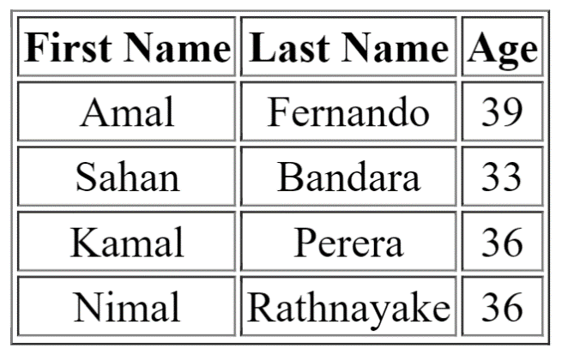

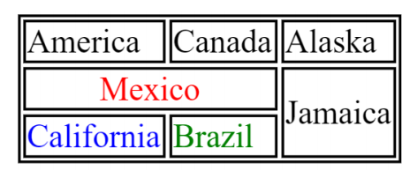

<!DOCTYPE html>

<html lang="en">

<head>

    <meta charset="UTF-8">

    <meta name="viewport" content="width=device-width, initial-scale=1.0">

    <title>Html List</title>

</head>

<body>

 <table border="1" align="center">

  <thead>

    <th>First Name</th>

    <th>Last Name</th>

    <th>Age</th>

  </thead>

   <tr>

    <td>Amal</td><td>Fernando</td><td>39</td>

   </tr>

   <tr>

    <td>Sahan</td><td>Bandara</td><td>33</td>

   </tr>

   <tr>

    <td>Kamal</td><td>Perera</td><td>36</td>

   </tr>

   <tr>

    <td>Nimal</td><td>Rathnayake</td><td>36</td>

   </tr>

 </table>

<table border="1">

<tr>

    <td width = "200" height = "100">America</td><td width = "200">Canada</td><td width = "200">Alaska</td>

</tr>

<tr>

    <td width = "400" height = "100">Mexico</td><td height = "200">Jamaica</td>

</tr>

<tr>

    <td width = "200" height = "100">California</td><td width = "200">Brazil</td>

</tr>

</table>

</body>

</html>