Retinal Disease Classification Using Convolutional Neural Networks

Abstract
This report presents a deep learning approach for automatic classification of retinal fundus images into eight eye disease categories. We implemented a Convolutional Neural Network based on the ConvNeXt-Base architecture with transfer learning from ImageNet. To address the significant class imbalance in the dataset (9,868 images across 8 classes), we applied multiple optimization techniques including data augmentation, class weighting, label smoothing, and test-time augmentation. Our model achieved a Macro F1-Score of 0.7355 and overall accuracy of 73% on the validation set, demonstrating effective performance across both majority and minority classes.

1. Problem Formulation

1.1 Problem Statement
Given a retinal fundus image, the task is to classify it into one of eight categories:
Code | Disease | Description
N | Normal | Healthy retina
D | Diabetic Retinopathy | Damage to blood vessels from diabetes
G | Glaucoma | Optic nerve damage from elevated pressure
C | Cataract | Clouding of the eye's lens
A | AMD | Age-related Macular Degeneration
H | Hypertensive Retinopathy | Retinal damage from high blood pressure
M | Myopia | Pathological changes from severe nearsightedness
O | Other | Other diseases/abnormalities

2. Data Analysis

2.1 Dataset Overview
- Total Images: 9,868 retinal fundus images (JPG/PNG format)
- Image Size: Variable, resized to 256×256 for training
- Train/Validation Split: 80% (7,894) / 20% (1,974)

2.2 Class Distribution
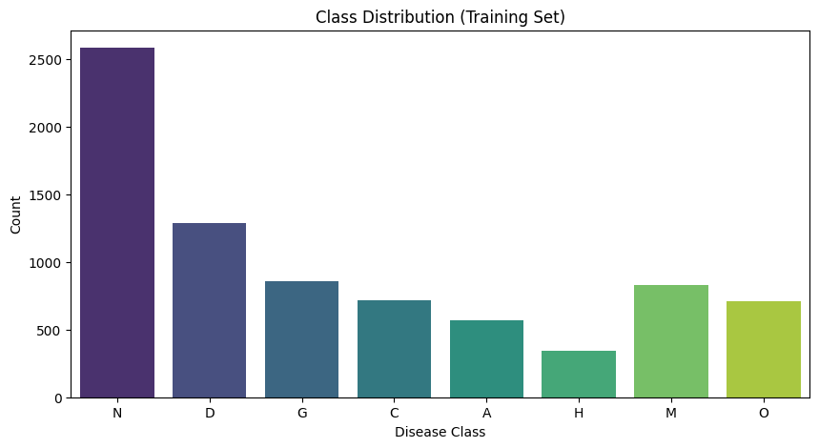

2.3 Imbalance Analysis
The class imbalance ratio (largest to smallest class) is approximately 7.5:1 (Normal vs. Hypertensive). This severe imbalance necessitates special handling to prevent the model from being biased toward majority classes.

3. Methodology

3.1 Model Architecture
We selected ConvNeXt-Base as our backbone architecture due to its:
- State-of-the-art performance on image classification tasks
- Efficient design combining CNN strengths with modern training techniques
- Strong transfer learning capabilities from ImageNet pretraining

Model Architecture Diagram
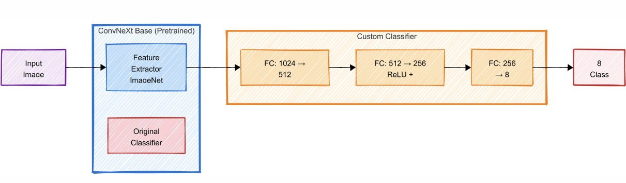
Architecture Details:
- Backbone: ConvNeXt-Base pretrained on ImageNet (~88M parameters)
- Custom Classifier Head: 3 fully connected layers (~400K parameters)
- Regularization: Dropout 0.4 and 0.3

3.2 Optimization Techniques

Technique 1: Data Augmentation
To increase training data diversity and improve generalization:
Augmentation | Parameters
Random Horizontal Flip | p=0.5
Random Vertical Flip | p=0.5
Random Rotation | ±20 degrees
Color Jitter | brightness=0.2, contrast=0.2
Random Affine | shear=10°, scale=(0.8, 1.2)
Rationale: Retinal images can appear in various orientations and lighting conditions. Augmentation simulates these variations without collecting new data.

Technique 2: Class Imbalance Handling
We employed multiple strategies:
- Weighted Cross-Entropy Loss: Assigns higher loss weights to minority classes
  - Weight formula: balanced mode from sklearn
  - Effect: Model penalized more for misclassifying rare diseases
- Label Smoothing (0.1): Prevents overconfident predictions
  - Soft labels: [0.0125, ..., 0.8875, ..., 0.0125] instead of [0, ..., 1, ..., 0]
  - Effect: Improves calibration and generalization

3.3 Training Configuration
Parameter | Value
Optimizer | AdamW
Learning Rate | 3×10⁻⁴
Weight Decay | 1×10⁻³
Batch Size | 32
Epochs | 25 (early stopped at 13)
LR Scheduler | ReduceLROnPlateau (factor=0.2, patience=2)
Early Stopping | Patience=5 based on F1-Score
Mixed Precision | FP16 with GradScaler

4. Experiments and Results

4.1 Training Progress
The model was trained for 13 epochs before early stopping triggered:
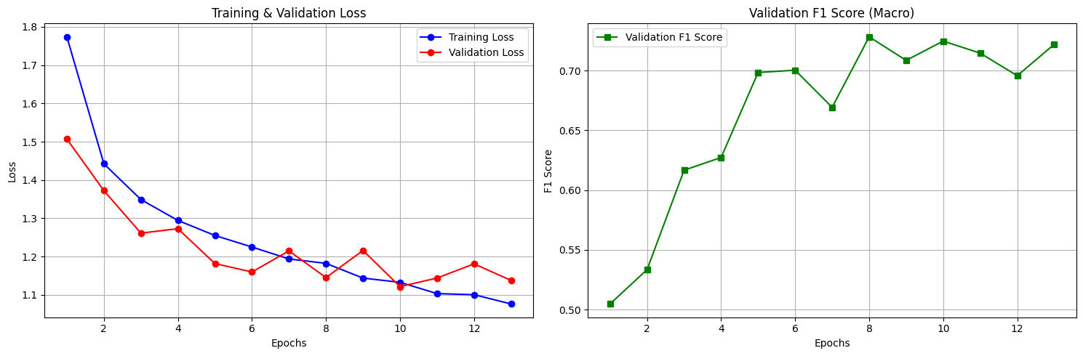
Observations:
- Rapid initial improvement in first 5 epochs
- Best model achieved at epoch 8
- Validation loss plateaued while training loss continued decreasing (slight overfitting)
- Early stopping prevented further overfitting

4.2 Test-Time Augmentation (TTA)
We applied TTA to improve predictions:
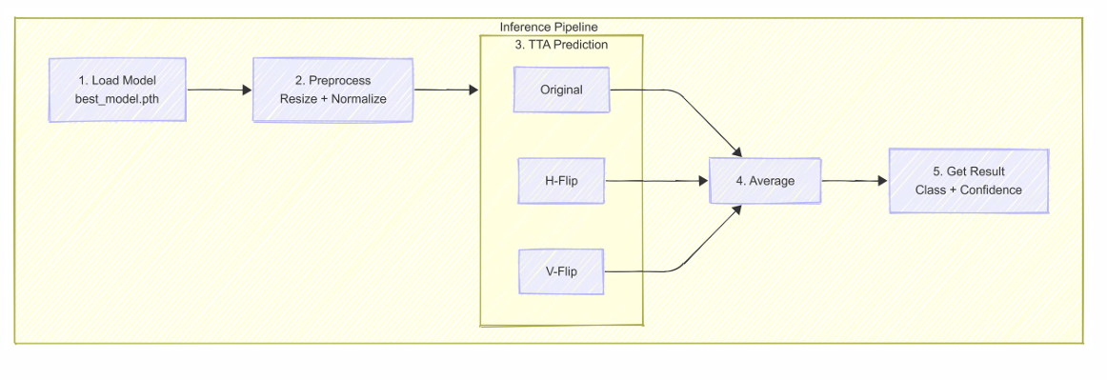

TTA Improvement: F1-Score increased from 0.7282 to 0.7355 (+0.73%)

4.3 Final Performance Metrics
Metric | Value
Accuracy | 73%
Macro F1-Score | 0.7355
Macro Precision | 0.74
Macro Recall | 0.73

Confusion Matrix Analysis

5.1 Per-Class Performance
Class | Precision | Recall | F1-Score | Support
N (Normal) | 0.73 | 0.75 | 0.74 | 646
D (Diabetic) | 0.63 | 0.62 | 0.62 | 322
G (Glaucoma) | 0.87 | 0.76 | 0.81 | 214
C (Cataract) | 0.76 | 0.91 | 0.83 | 179
A (AMD) | 0.70 | 0.70 | 0.70 | 142
H (Hypertensive) | 0.88 | 0.73 | 0.80 | 86
M (Myopia) | 0.93 | 0.91 | 0.92 | 207
O (Other) | 0.47 | 0.47 | 0.47 | 178
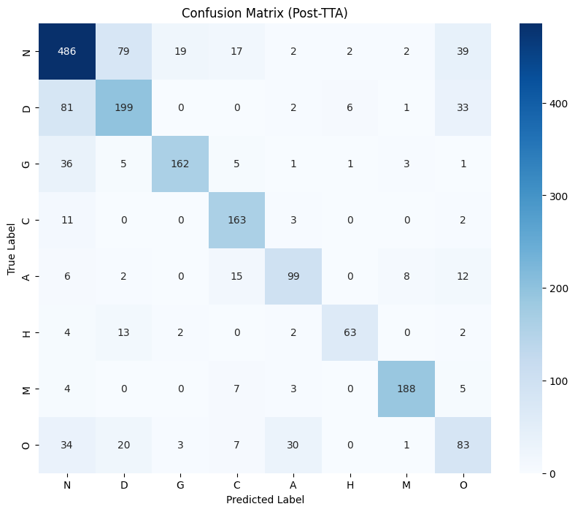

5.2 Analysis
Best Performing Classes:
- Myopia (M): F1=0.92 - Distinctive features (elongated eyeball effects) are easily recognizable
- Cataract (C): F1=0.83 - Lens clouding creates clear visual patterns
- Glaucoma (G): F1=0.81 - Optic disc changes are distinctive
Challenging Classes:
- Other (O): F1=0.47 - Heterogeneous category with diverse conditions
- Diabetic Retinopathy (D): F1=0.62 - Overlapping features with other vascular diseases
Key Confusion Patterns:
- Normal (N) ↔ Other (O): Some "Other" cases may appear nearly normal
- Diabetic (D) ↔ Hypertensive (H): Both affect blood vessels similarly
- Other (O) ↔ Multiple classes: Catch-all category creates ambiguity

6. Discussion

6.1 Effectiveness of Optimization Techniques
Technique | Impact
Data Augmentation | Prevented overfitting; improved generalization
Class Weights | Boosted minority class recall (H: 73% despite only 86 samples)
Label Smoothing | Improved confidence calibration
TTA | +0.73% F1 improvement at inference time
Early Stopping | Prevented overfitting after epoch 8

6.2 Limitations
- "Other" Category: The heterogeneous nature limits model performance
- Dataset Size: Some classes have <200 samples
- Single Dataset: Results may not generalize to different imaging equipment

6.3 Future Improvements
- Ensemble Methods: Combine multiple architectures
- Focal Loss: Better handling of hard examples
- External Data: Augment with additional retinal datasets
- Attention Mechanisms: Highlight disease-specific regions
- Grad-CAM Visualization: Interpretability for clinical use

7. Conclusion
We successfully developed a CNN-based system for multi-class retinal disease classification achieving:
- 73% overall accuracy on 8-class classification
- 0.7355 Macro F1-Score demonstrating balanced performance
- Effective handling of 7.5:1 class imbalance through weighted loss and augmentation
The ConvNeXt-Base architecture with transfer learning proved effective for medical image classification. Our optimization techniques—particularly class weighting and data augmentation-were crucial for achieving reasonable performance on minority classes.
This work demonstrates the potential of deep learning for automated retinal disease screening, which could assist ophthalmologists in large-scale screening programs and improve early detection of vision-threatening conditions.

