Mobile App Wireframing — Revised Submission
Expense & Budget Tracker
Thiranex UI/UX Design Internship | Sushaanth | Resubmitted 04 Oct 2026

Revision Summary
This resubmission strengthens the original wireframing task with (1) annotated wireframes explaining the reasoning behind each key UI decision, (2) a clearer link between research findings and design choices, and (3) a simple user-flow diagram to accompany the written flows. Original research, personas and user-flow write-ups are carried over unchanged.
Note: specific mentor comments weren't available when preparing this revision — if there's a particular point they flagged, point it out and I'll adjust this section directly.

Annotated Wireframes
Each screen below is annotated with numbered callouts tying the layout back to the research findings in the original submission (fast entry, visible budget status, and a scannable spending breakdown).

Home Dashboard
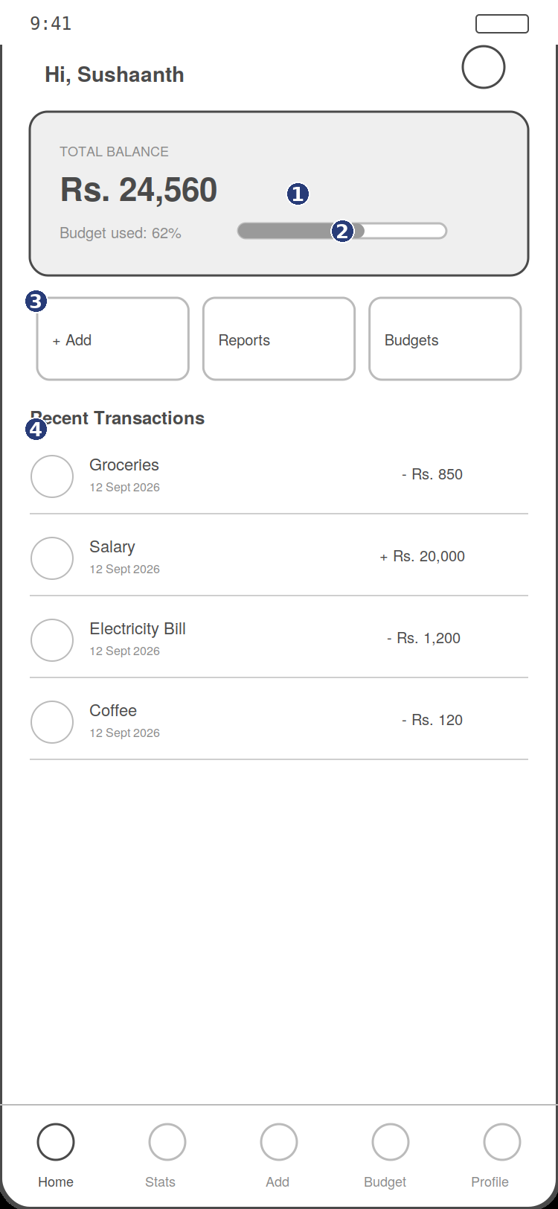
Dashboard with annotations
1 | Balance is the largest, highest-contrast element on screen — addresses the research finding that users want an instant answer to “how much do I have left,” not a detailed ledger.
2 | Budget-used bar sits directly under the balance so overspending is visible before it becomes a surprise, rather than only at a month-end report.
3 | “+ Add” is placed as the first, left-most quick action — the highest-frequency task gets the shortest reach and first visual priority.
4 | Recent transactions are shown inline on the dashboard (not buried in a separate tab) so users get a quick sanity check without navigating away.

Add Expense
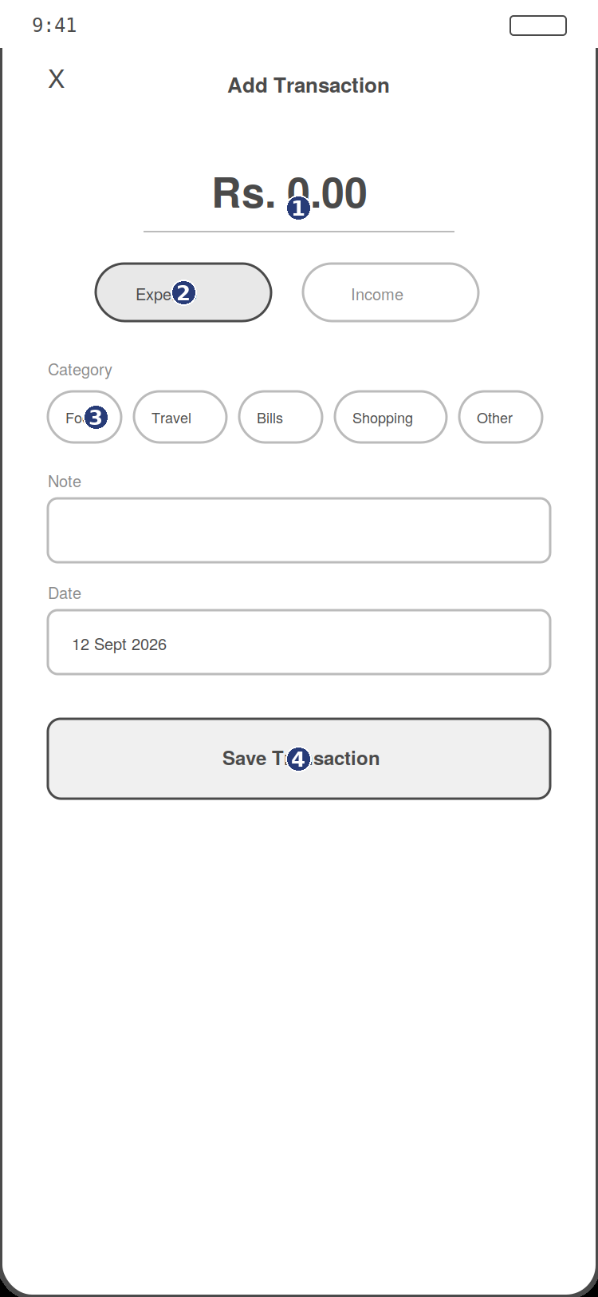
Add Expense screen with annotations
1 | Amount entry is the first and largest input — this is the one field every log action needs, so it gets keyboard focus immediately on screen open.
2 | Expense/Income toggle defaults to “Expense” since that's roughly 90% of entries for this user base, reducing taps for the common case.
3 | Categories are shown as single-tap chips instead of a dropdown, directly addressing the research finding that manual entry needs to take under 10 seconds.
4 | Save is a full-width button fixed near the thumb zone for one-handed use.

Reports
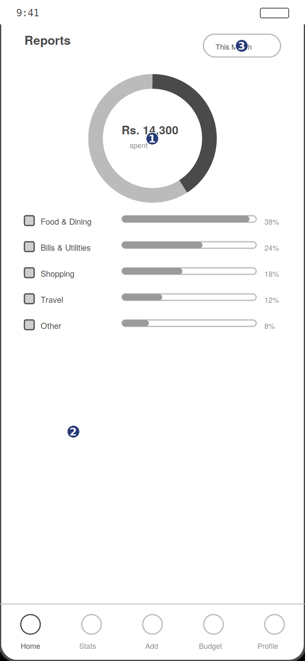
Reports screen with annotations
1 | Donut chart leads the screen because research showed users think in “where did my money go” proportions, not absolute historical data.
2 | Category list below the chart gives the supporting detail without competing with the chart for attention.
3 | Month filter is top-right, out of the primary scan path, since changing the time range is a secondary action.

User Flow Diagram
Welcome → Sign Up → Dashboard (empty state) → Tap + Add → Enter amount & category → Save → Dashboard updates → Tap Reports → Category breakdown
This single path covers onboarding, the core logging action, and the reporting loop — the three flows described in the original submission — in one continuous sequence, matching how a first-time user would realistically move through the app.

