Website UI Redesign
Maison Bakery — Local Bakery Website
Thiranex UI/UX Design Internship | Sushaanth | 04 October 2026

1. Site Chosen
Redesign target: a small local bakery's website (representative example — a simple business site with a homepage, menu, and ordering flow, typical of the kind of small-business sites this exercise is meant to simulate). The existing site is assumed typical of this category: a dense text-heavy homepage, no clear call-to-action, tiny unoptimized food photos, and a navigation bar that doesn't adapt on mobile.

2. Heuristic Evaluation
Evaluated against Nielsen's 10 usability heuristics; listing the issues most relevant to a small e-commerce/local-business site.
Heuristic | Issue Found | Severity
Visibility of system status | No clear “Order Now” or cart indicator in the header | High
Aesthetic & minimalist design | Homepage crowds text and images with no visual hierarchy | High
Flexibility & efficiency | No responsive layout — mobile users pinch-zoom a desktop layout | High
Recognition over recall | Menu items listed as plain text with prices, no imagery to recognize products | Medium
Consistency & standards | Buttons styled differently across pages (some text links, some boxed) | Medium

3. Mood Board & Style Guide
Direction: warm, artisanal and appetite-driven — terracotta and dark brown against a soft cream background, generous food photography, and a serif display font paired with a clean sans-serif for body text.
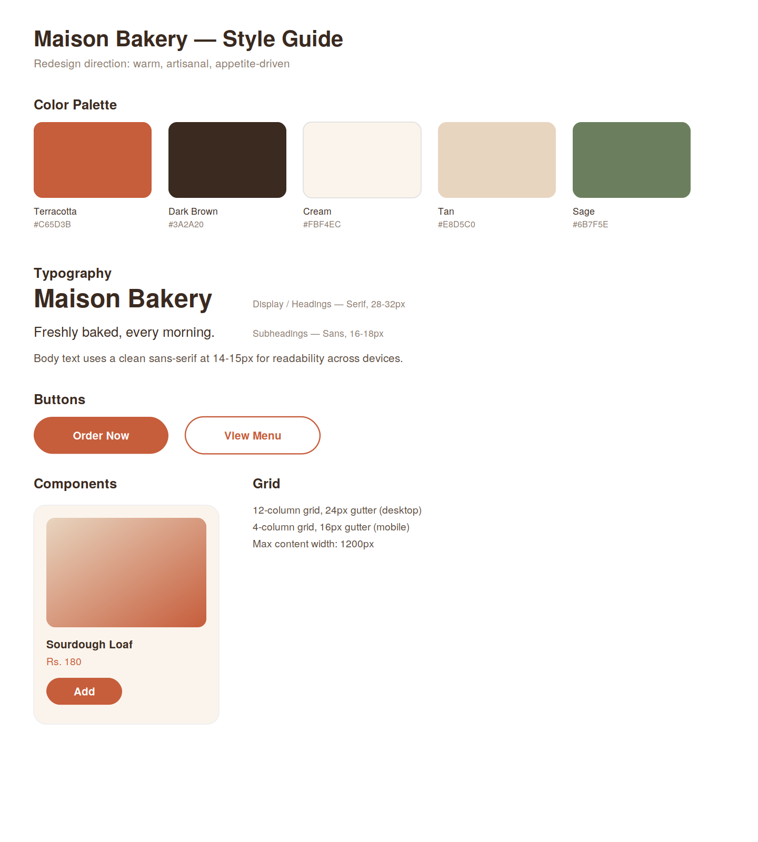
Color palette, typography, buttons and component styles

4. High-Fidelity Mockups

Homepage — Desktop (1280px)
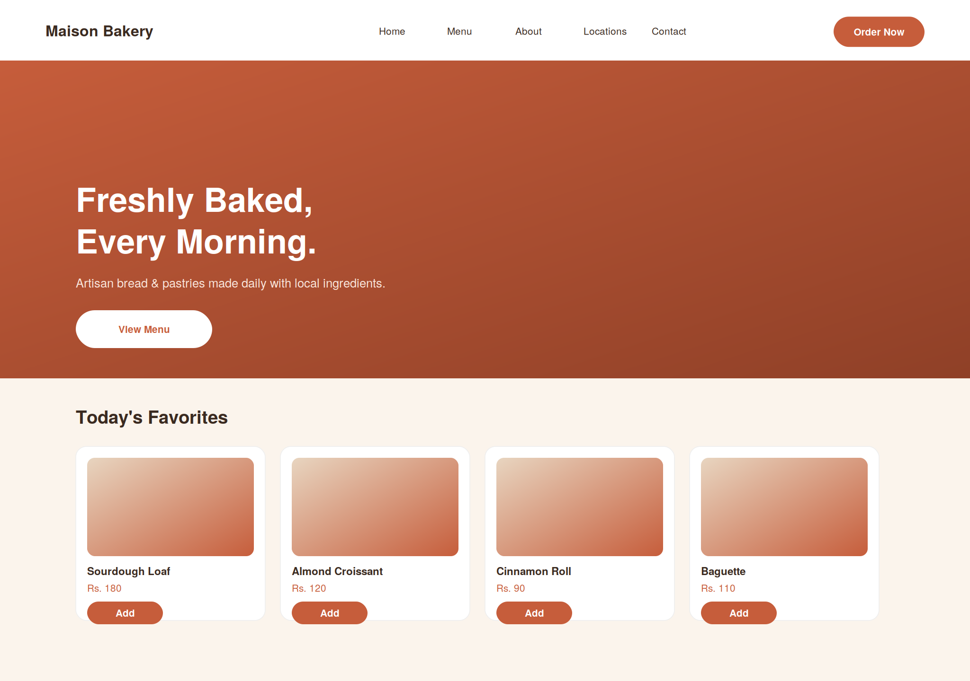
Desktop homepage: clear nav with persistent CTA, full-width hero with one message and one action, product cards with imagery and inline Add buttons

Homepage — Mobile (375px)
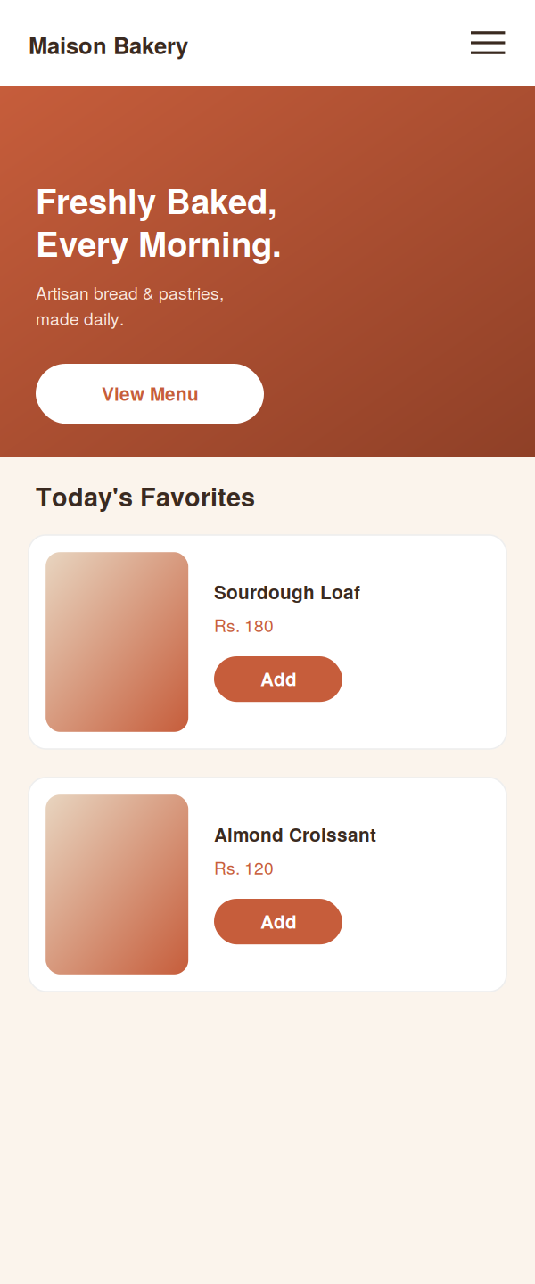
Responsive mobile layout: nav collapses to a hamburger menu, hero and product cards reflow to a single column, CTA stays full-width and thumb-reachable

5. Responsive Design Notes
- Navigation collapses from a 5-item horizontal bar to a hamburger menu under 768px, keeping the logo and a persistent CTA visible.
- Product grid reflows from 4 columns (desktop) → 2 columns (tablet) → 1 column (mobile), using the same card component at every size.
- Hero text and button scale down and left-align on mobile rather than centering, keeping line lengths readable on small screens.
- Touch targets (Add buttons, nav items) are kept at a minimum 44x44px on mobile per standard accessibility guidance.

6. Summary of Improvements
- Added a persistent, high-contrast “Order Now” CTA in the header — addresses the visibility-of-system-status issue.
- Introduced clear visual hierarchy: hero → featured products → supporting content, instead of a flat text wall.
- Unified button styling (one filled style, one outline style) used consistently across all pages.
- Added real product imagery placeholders to every menu item for faster recognition while scanning.
- Built a fully responsive layout instead of a fixed desktop-only one.

