RFT Analysis
Scope Definition

29/04/2026

Konstantin Danos

Table of Contents
1. Introduction 3
2. Summary 4
3. Common Modules-subprojects 6
4. Application specific elements: 8
5. Classes definition 9
5.1. Fluid Class 9

Introduction
The primary purpose of the “RFT Analysis” tool is to serve as a teaching tool. I am a professional Oil and Gas engineer with some 20 years experience. I learned Python over the last 12 months and have decided to convert some of my calculation spreadsheets into standalone desktop applications.
Since I don’t have any training in software design and built, I am lacking best practises and simple solutions. I require a base to guide me when building new applications. Personally, I have extensive coding knowledge in vba (have built multiple programmes over 20 years) and feel comfortable to code fully in Python.
The tool will be built using:
- Python as the coding language
- PyQt as the GUI builder
- Extensive explanation on the code to explain every line of code

Summary
The intention is to build a desktop app to replace a spreadsheet based set of calculations.
- Create a stand-alone application to replace spreadsheet calculations.
- The code should be explicit and thoroughly documented to allow me to understand, dissect and replicate it. A crude picture of how the GUI is envisaged is included.
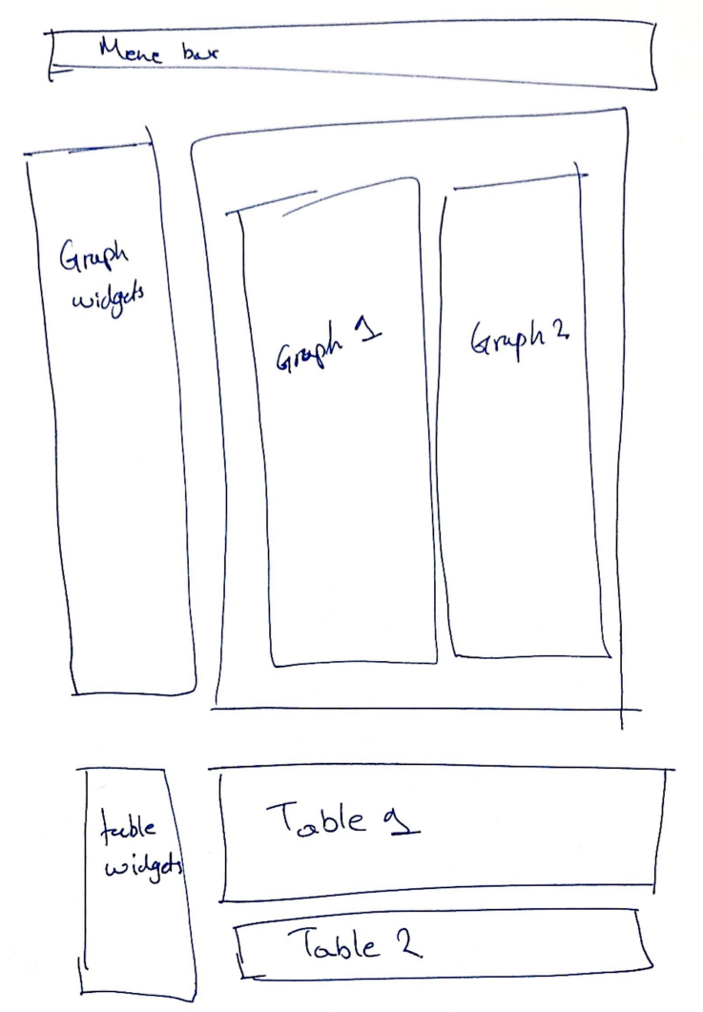
Figure 1: Analysis window
- The application should be written in python and use a GUI building library, preferably PyQT.
- Some hidden calculations will be included, to ensure that appropriate interaction with the tables and graphs is understood, e.g.
  - Add a constant value to a column variable
  - Extract the gradient of two points on a graph
- The table needs to have the following minimum functionality:
  - Show and change units
  - Add and remove columns and rows
  - Paste new data at any location, and extend the table dimensions to fit
  - Filter the data
- The graphs need to have the following minimum functionality.
  - Display and extract the value of selected data
  - Drop down menu with multiple options, e.g:
    - Add a line (create a new class instance)
    - Edit existing line (alter attribute of existing class instance)
    - Select points to regress
  - Typical formatting options on scales, titles, fonts, colours etc
  - Add or remove variables
  - Plot the table filtered data
  - Allocate data to groups based on classes or attributes
- The GUI needs to have the following minimum functionality
  - Import alpha numeric data
  - Assign the data to variables (eg pressure, distance, temperature)
  - Assign units to the data, from pre-defined units options
  - Save and reload the current analysis
  - Open additional windows
The work is envisaged to be broken into two parts:
- A short period to deliver a minimum viable product. One stand alone application that will reflect one of my spreadsheets and achieve the analysis done in the spreadsheet.
- A longer support period, where I duplicate your work to reflect other analysis and different projects.
When all these modules are in place, I can use them as the blueprint to build other applications myself to reflect different types of calculations or spreadsheets.

Common Modules-subprojects
- Front end-GUI
- Data loader
  - Clipboard/csv data import
  - Assign quantities (pressure, length, etc)
  - Assign units
  - Append additional data
  - Create project data/df
  - The specific steps of importing the data via the data loader module are:
    - Identify the headings row
    - Skip empty rows before loading the data
    - Identify the first row of data

- Table viewer (window)
  - Select visible data
  - Filter data
  - Select/change units
  - Add columns, rows, data
- Graph viewer (window)
  - Link to table viewer
  - Select axis-df columns
  - Select data (filters)/split series
  - Select points and perform linear regression
  - Calculate gradient-fluid attribute
  - Add lines (fluids)
  - Define line attributes (class: fluid)
    - Underlying fluid (user selection)
    - Calculate intersection with underlying fluid (function)
    - Select fluid type (user selection: oil, gas, water, undefined, drill mud)
  - Manipulate lines (drag, rotate)
  - Select visible lines
- Application level
  - Project save
  - Project load
  - Select/edit units
  - All new or altered instances of the classes (such as new lines on the graph or changes to the data table) need to be able to be saved and loaded again in the program.
  - Different versions of the saved analysis need to be able to be loaded at different times in the program simultaneously, i.e. create an analysis class, which will contain:
    - The filtered table
    - The selected graphs
    - The created fluid classes.

- Back-end
  - Pre-defined units
    - Pressure: psia, bara, atm
    - Length: m, ft
    - Density: s.g., kg/m3, psi/ft

Application specific elements:
- Select reference fluid.
- Parse base data-question:
  - What is the depth column?
  - What is the pressure column?
- Define unique depth class (class: station)
  - Number of measurements at that depth (station) as attribute
  - Select the valid measurement
  - Assign fluid sample if present as attribute
- Graph option-view samples
- When selecting which columns will be visible in the table:
  - TVDSL will always be by default selected, and be the first column
  - Formation pressure will always also be selected and be the first column
  - A NEW COLUMN will be created, titled “Excess Pressure”
    - This column will be empty, unless the project has a “Reference fluid” defined
    - If there is a reference fluid defined, then this column:
      - Will use the depth in column 1
      - The gradient and intercept of the reference fluid
    - Using the depth, gradient and intercept above:
      - Calculate the pressure of the reference fluid at that depth;
      - Subtract the calculated pressure from the reported pressure in column 2; if no pressure is available, set the value to “empty”
  - This calculation will auto-update whenever the reference fluid is changed

Classes definition
The classes to be used in the RFT plotter will include the following:

Analysis Class
This is effectively the window on which we are working, as per Figure 1. It will contain:
- The tables and selected data from the project data
- The graphs linked to the tables
- The fluid classes generated in the analysis

Fluid Class
This is generated every time a new straight line is added to the graph. It’s a include:
- Name
- Phase
  - Water
  - Oil
  - Gas
  - Undefined
- Gradient
- Underlying fluid
  - None
  - Any fluid from the selection of all created fluids
- Intersection with the underlying fluid
  - Depth
  - Pressure

