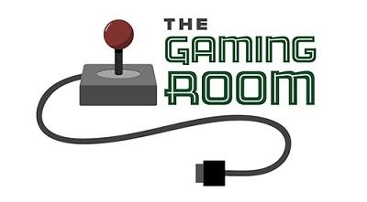

Draw it or Lose it

CS 230 Project Software Design Template
Version 1.0

Table of Contents

CS 230 Project Software Design Template 1
Table of Contents 2
Document Revision History 2
Executive Summary 3
Requirements 3
Design Constraints 3
System Architecture View 3
Domain Model 3
Evaluation 4
Recommendations 5

Document Revision History

Version | Date | Author | Comments
1.0 | 03/19/2023 | Keaton Davies | Covering the Summary,

Instructions
Fill in all bracketed information on page one (the cover page), in the Document Revision History table, and below each header. Under each header, remove the bracketed prompt and write your own paragraph response covering the indicated information.

FiExecutive Summary

The Client the Gaming Room is wanting to create an multi-Operating System (OS) spanning version of their currently only Android application (App). This document will outline the necessary business models and operating considerations needed to address constraints.

Requirements

User is requiring that this web application be able to be accessed across all possible platforms to cast the broadest reach possible. This would require the team to work on multiple languages and use different hardware to reach the broadest audience.

Design Constraints

The team selected to work on the app development will need to be skilled in the design of Java, so they can follow best practices. The app will need optimization so it can run on the broadest pool of users possible. The development team will this to best suit the company at app maintenance and usability. The team should comprise of web developers, at least one network engineer, and one or more user facing roles to help with troubleshooting and general questions.

This can be rectifyed quite easily by expanding current employment options and pulling in fresh talent skilled in web dev and app creation. The game itself has the design constraints of only one game existing at a time as well as unique team names and players.

This will also require a developer to use a Mac system as they will need to develop the Mac version of the game and test it locally.

System Architecture View

Please note: There is nothing required here for these projects, but this section serves as a reminder that describing the system and subsystem architecture present in the application, including physical components or tiers, may be required for other projects. A logical topology of the communication and storage aspects is also necessary to understand the overall architecture and should be provided.

Domain Model

The ProgramDriver class has the main() method in it which uses Associtation with SingletonTester to test if there is already an instance of GameService. Entity class is the Parent class to the Team, Player, and Game classes. All of them inherit Entity’s required attributes. This sets up so that Player can’t have a team but a team can have a player. A game can have a team but not a gameservice. This also sets up the Singleton for Gameservice so only one instance of a game can be running at once, and each team can only have one of each individual player at a time.

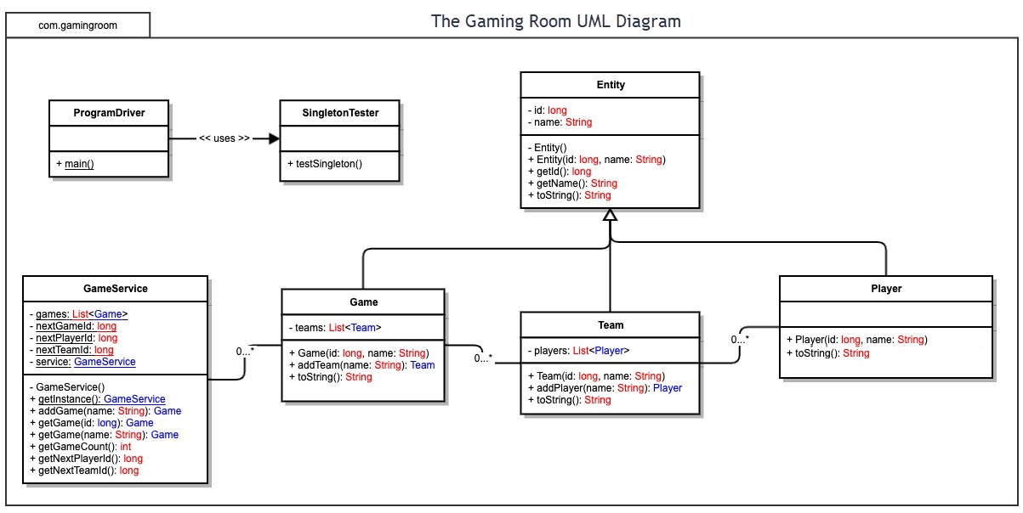

Evaluation

Using your experience to evaluate the characteristics, advantages, and weaknesses of each operating platform (Linux, Mac, and Windows) as well as mobile devices, consider the requirements outlined below and articulate your findings for each. As you complete the table, keep in mind your client’s requirements and look at the situation holistically, as it all has to work together.

In each cell, remove the bracketed prompt and write your own paragraph response covering the indicated information.

Development Requirements | Mac | Linux | Windows | Mobile Devices
Server Side | Although possible to use as the server side of the application this would cause an increase in cost. | Linux would be the best choice as it is free and very popular for web-based hosting. | A middle ground between Mac and Linux. Not free, but cheaper than Apple. More secure. | In my own opinion. This is a bad idea. Mobile devices can in theory work as a web host, but the necessary computing power would be lacking.
Client Side | Great for users, simple to use and nice hardware, however they require that the app be developed and written in propriatry software for it to function. | Potentially the hards of the three client sides to develop for, as most gaming done on Linux is done via emulation. Would potentially require building the Linux app in Python. | Probably the easiest to develop for as most Web Devs will be experienced working in Windows from school or self-learning. | A potentially difficult to work with client-side as the developers will need to keep UI and screen size constriants in mind as they work on the project.
Development Tools | An integrated Imac with the necessary software to code on it. | Python comes pre-installed on most distributions of Linux. Visual Code Studio (VCS) or another IDE could be used without any issues free of charge. | Windows can also utilize the free software VCS. With Windows there is a wide flexibility in language options. | For Mobile devices the fastest and easiest method would be having a developer use the iMac and code the apple version, and an Android web dev with Android Studio. Both Could use Unity.

Recommendations

Analyze the characteristics of and techniques specific to various systems architectures and make a recommendation to The Gaming Room. Specifically, address the following:

- Operating Platform: I would absolutely recommend a Linux Host server running either Ubuntu or Debian as these are free and one of the most ubiquitous distributions for hosting, and using Amazon Web Service cloud to host a virtual server running Windows for hosting the virutal sessions.

- Operating Systems Architectures: If the client does decide to use AWS this would allow the separation of in-house hardware and the actual Host. This frees up resources that clients can then draw on without it being an issue. If the client did decide to use an on premise server then Debian or Ubuntu would be a good idea as it would allow for the server to be set up with minimal cost as the distribution of the operating system would be free, but would require someone with the linux experience to format it and make sure it was properly stood up.

- Storage Management: SDD Raided together so you have the necessary storage for the Client’s pictures and information stored for the various game instance would be ideal if using an on premise server, otherwise storage could be purchased from Amazon equal to about 2 cents per GB needed for the virtual storage per month.

- Memory Management: I would recommend a monitoring system so that way under peak or above average load the necessary AWS memory can be adjusted for the best client experience. This does increase cost as you will essentially be paying the outsourced work to keep an eye on this for you but I think this would be the best option to mitigate potential issues with performance. With a Debian or Ubuntu server you would probably want to give at least 8GB of RAM dedicated to the rendering of the images.

- Distributed Systems and Networks: As this app would be ultimately hosted on AWS as the main point for access fo the users I would have it set up so in the event of issues the game instance could be moved from node to node so that way the users experience little to no downtime and their service is uninterruptable. With on premise this would be more difficult as you would have to have a separate back up for you to move to with the chance for downtime.

- Security: This would be included in the AWS monitoring. They would be in charge of keeping track of information flowing in and out of the Cloud service. This would prevent private information leak and with the virtualization layer the cloud provides this prevents most easy access to the on-premises hardware.

