1.Git
Git version verification
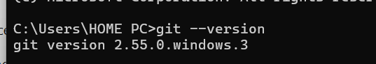

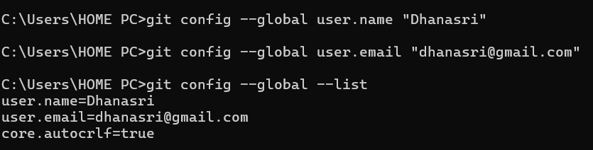
Git path setup
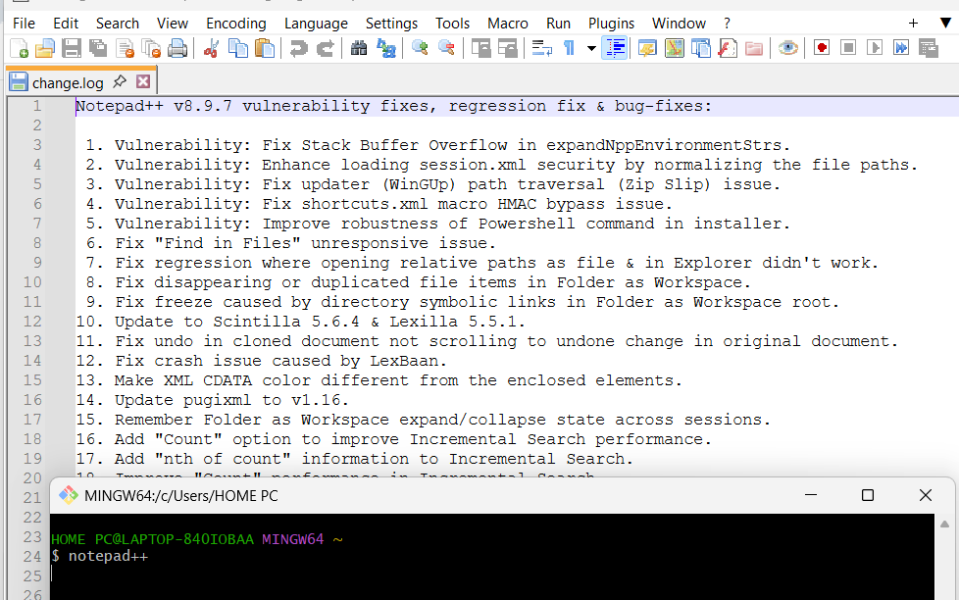
Creating alias
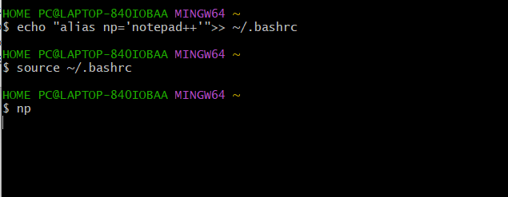
Checking:
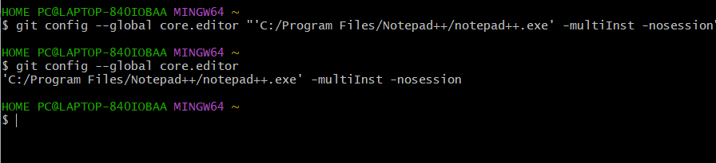
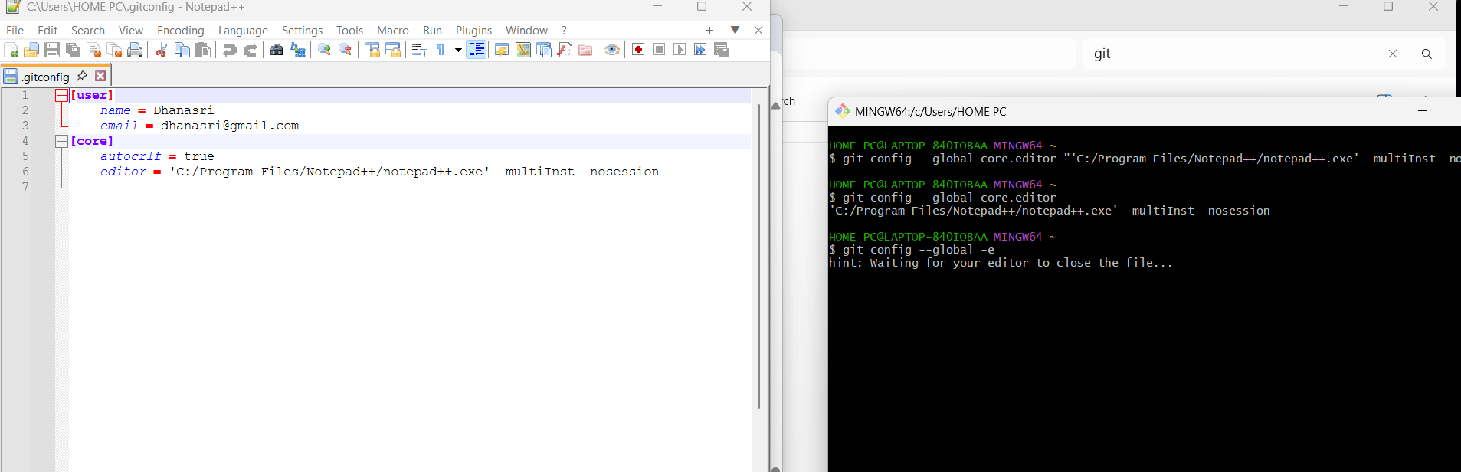
Verify the Default Editor
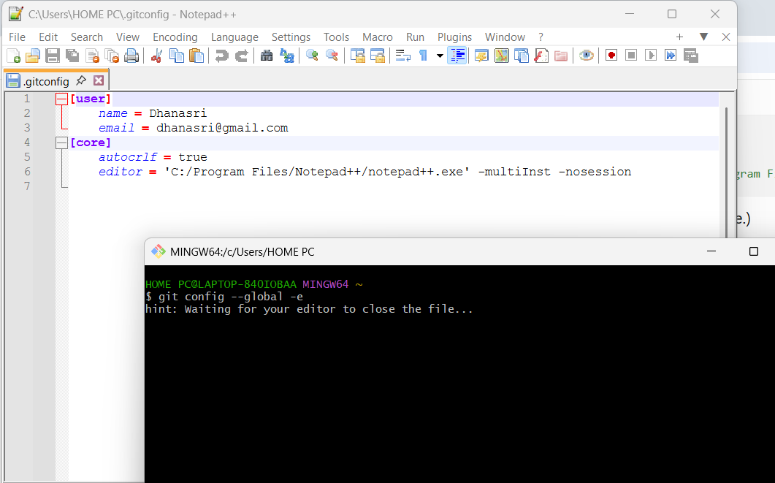
create a new project “GitDemo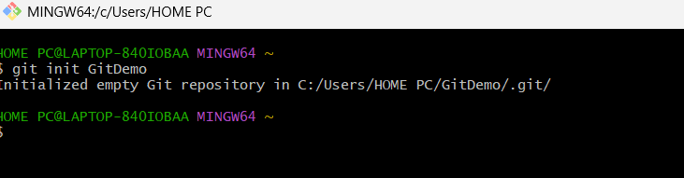
Git bash initializes the “GitDemo” repository
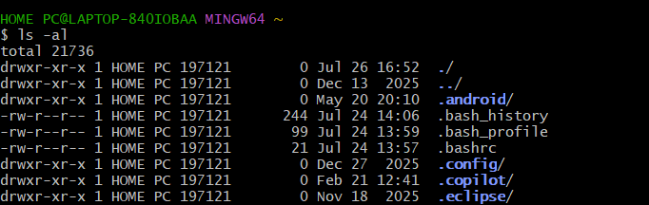
To create a file “welcome.txt”
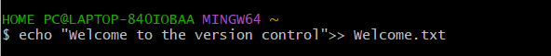
To verify if the file “welcome.txt” is created
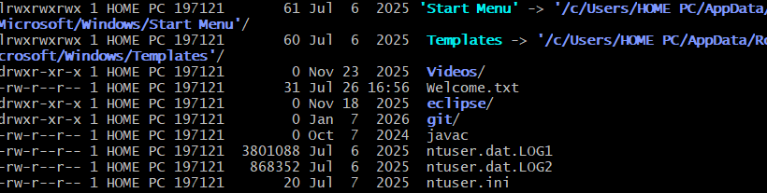
To verify the content
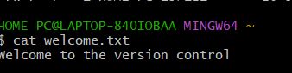

Git status
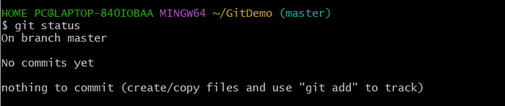
Adding this file to git
After adding the status is
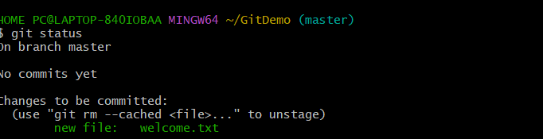
To add multiline comment
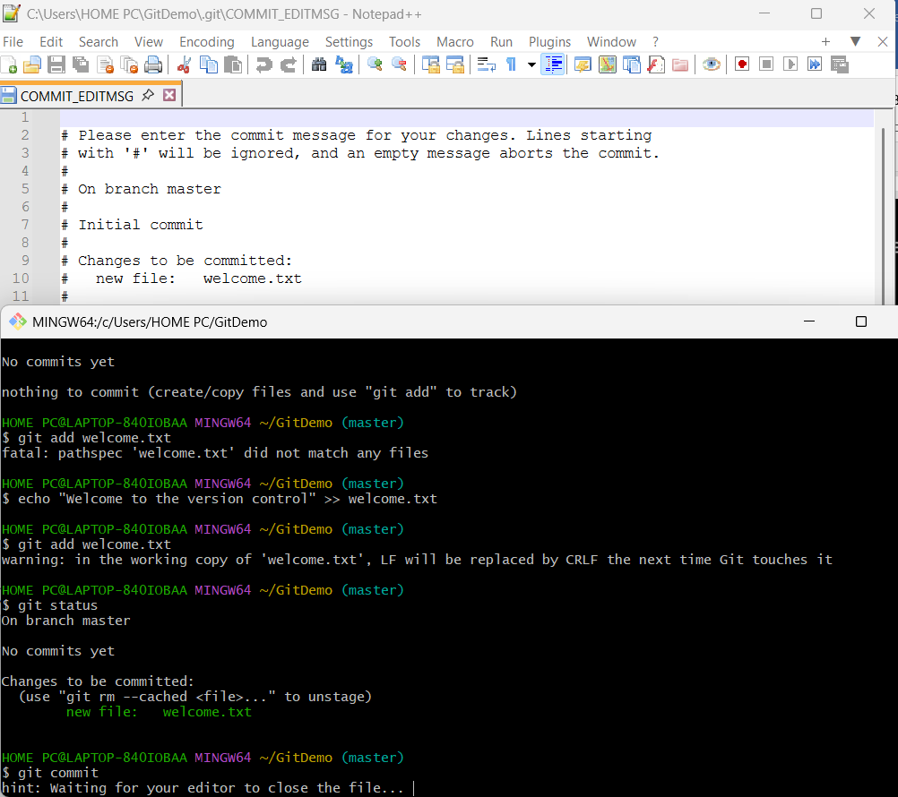

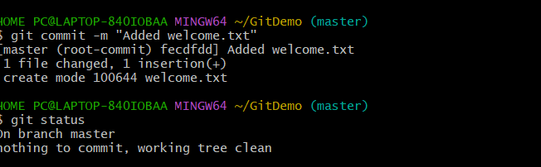

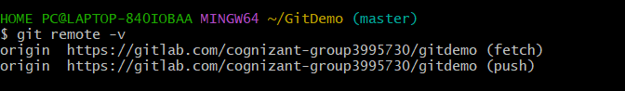
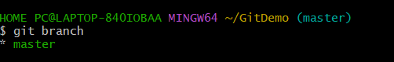
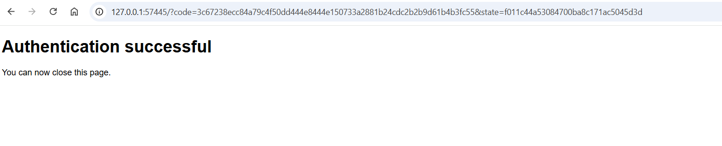
Push local to remote repository
