House Price Analysis and Prediction
Practical Data Science Coursework

- Introduction
This report analyses the given dataset that contains information regarding properties with aims to find the major factors that affect house prices, and creating a model for price prediction. The dataset contains the following variables: square footage, number of bedrooms and bathrooms, year built, garage size and lot size, neighbourhood quality, and house price.
The main purpose of this coursework is to find the variables with the greatest impact on house prices and create a regression model for price prediction. In order to accomplish this, descriptive statistics, graphical data evaluation, correlation analysis, and regression modelling were carried out using R software.

- Data Preparation and Cleaning
The first stage of the analysis was to observe if the data were clean and consistent. The dataset was checked for missing values and duplicate entries, but none have been detected.
During the screening, 32 houses were noted as having zero bedrooms. Further observation revealed that 28 of these properties had a size greater than 884 sq. ft., which is unrealistic for zero-bedroom houses. Hence, these 28 entries (less than 3% of the data) were removed. The remaining four zero-bedroom properties were left in the final dataset, as they apply as realistic studio apartments.
One data point in the Neighbourhood Quality category had a value of 11, which lies outside of the set range of 1 to 10, and has been adjusted to 10 to match the data definition. Following data cleaning, the final dataset included 968 observations, which were used in all further analyses.
- Descriptive Analysis
For the purpose of descriptive analysis, summary values were calculated, and graphical analysis was used to evaluate the distribution and the spread of the variables in the dataset. House prices varied significantly across the properties, with a median price of approximately £600,000, ranging from around £97,000 to £1.37 million. The results were confirmed by the histogram (Figure 2) and boxplot (Figure 1), showing a slight positive skew. This is typical in property price data, where a small number of houses fall at the highest price end.
The scatterplot of House Price against Square Footage (Figure 3) shows a strong positive linear relationship, indicating that larger houses tend to have higher prices.
The rest of the variables show a weaker impact on house prices. Year Built and Lot Size ( Figures 4 and 5) have a wide spread of values, but no clear pattern with house prices. The boxplots of Number of Bedrooms, Bathrooms, and Garage Size (Figures 6-8) show different median prices with a large overlap of values.
This suggests that although other variables affecting house prices, Square Footage appears to be the most important factor related to property prices.

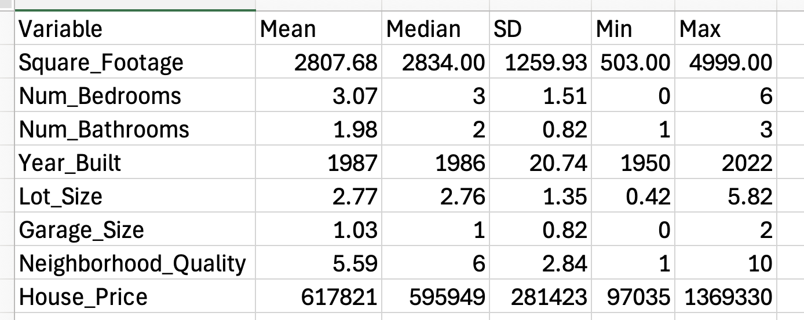
Table 1: Descriptive statistics of housing variables

Table 1 shows house prices ranging from £97,000 to over £1.36 million. The high standard deviation shows a wide spread in property prices in the dataset.
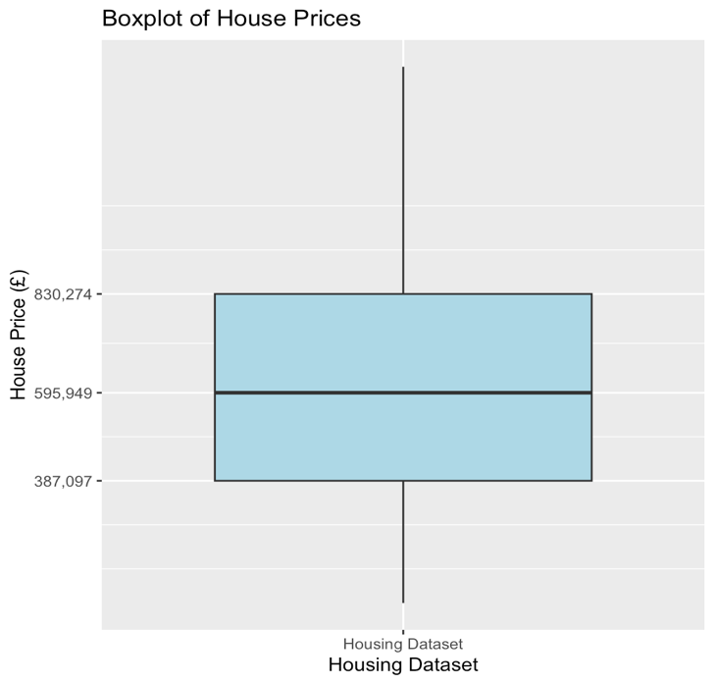
Figure 1: Boxplot of House Prices

The boxplot shows the median and interquartile range(Q3-Q1) of house prices.

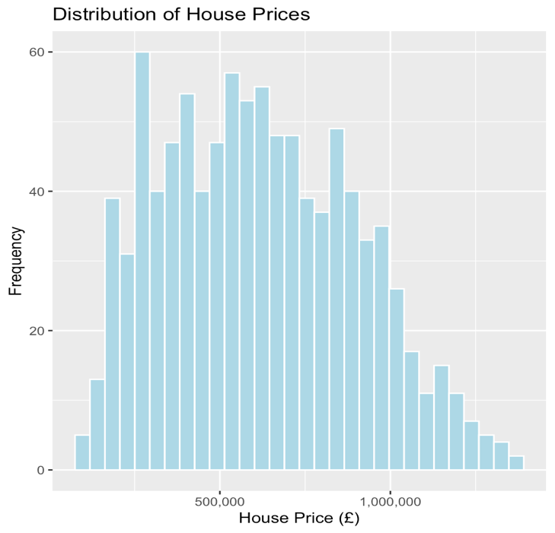
Figure 2: Histogram – Distribution of House Prices

The histogram shows a slightly positive skew in house prices.

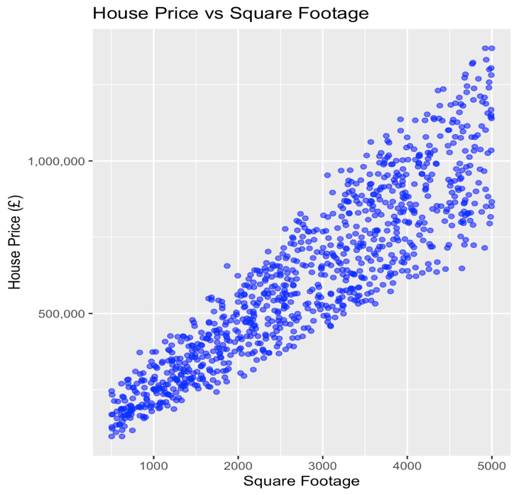
Figure 3: Scatterplot of House Prices vs Square Footage

Square footage shows a strong positive relationship with house prices (larger houses tend to have higher prices)

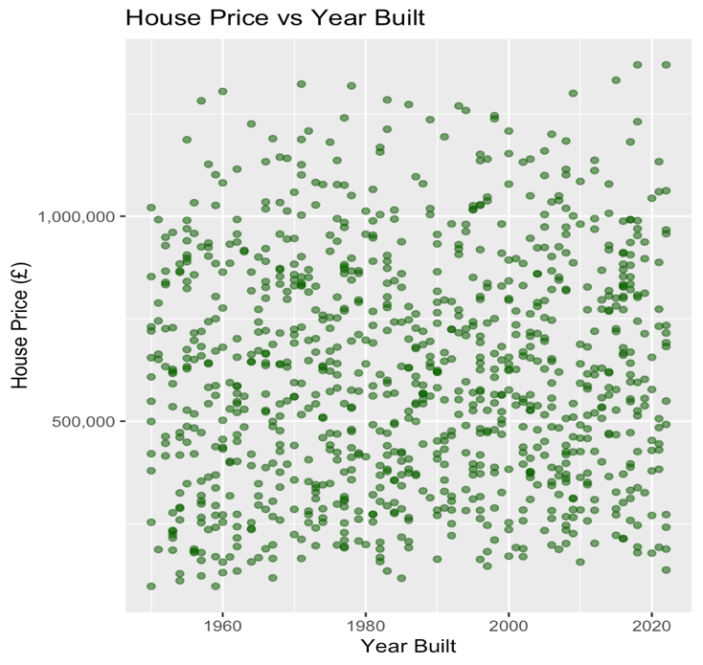
Figure 4: House Prices vs Year Built

Year built shows no clear relationship with house prices.
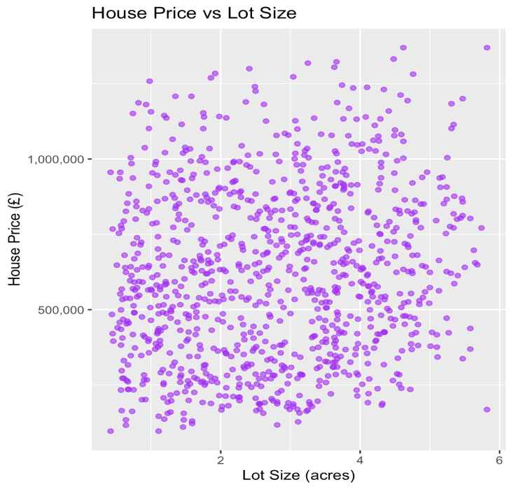
Figure 5: Scatterplot - House Prices vs Lot Size

Lot size has a limited influence on house prices.

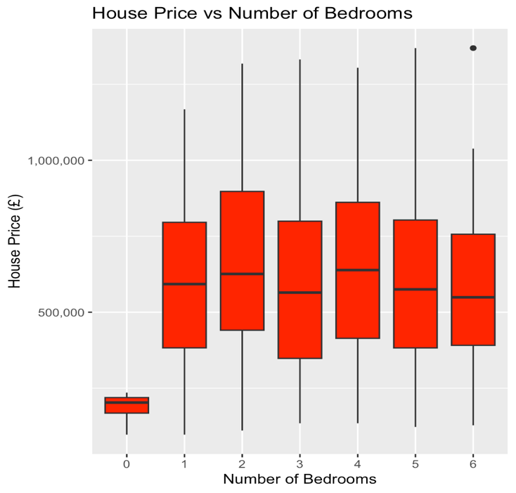
Figure 6: Boxplot - House Prices by Number of Bedrooms

Bedroom categories show different median house prices.
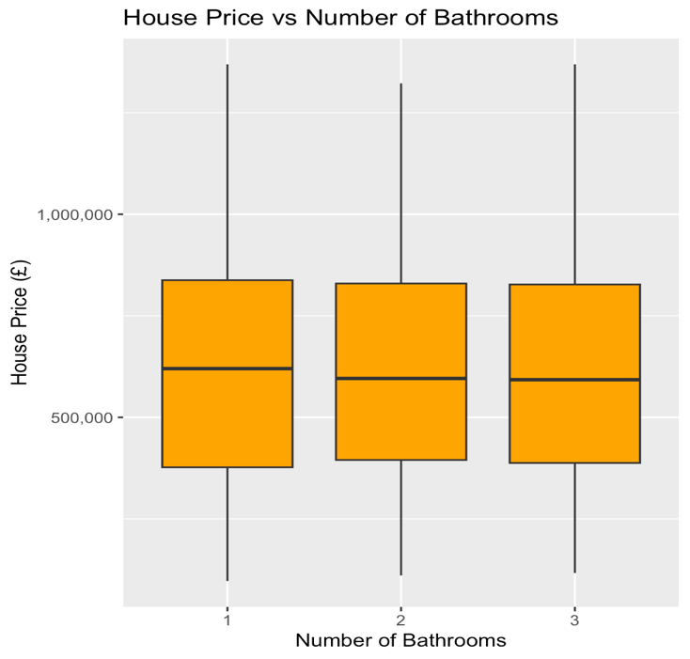
Figure 7: Boxplot - House Prices by Number of Bathrooms

House prices vary by the number of bathrooms, with significant overlap

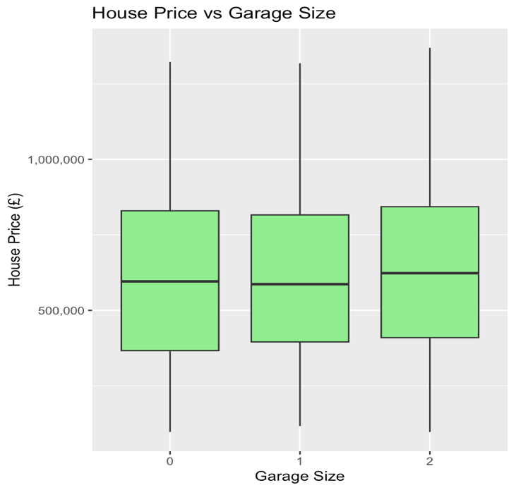
Figure 8: House Prices by Garage Size

The boxplot reveals that Garage Size has a limited impact on property prices
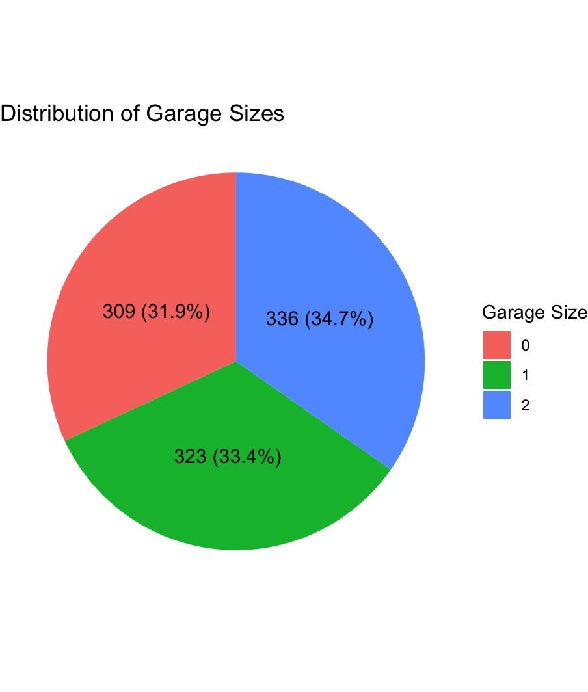
Figure 9: Pie chart – Distributions of Garage Sizes

The pie chart shows that most of houses have one or two garages

- Correlation Analysis
Pearson correlation analysis was done to understand the relationship between House Price and the other variables. The results revealed a strong positive correlation between Square Footage and House Price (r = 0.905), implying that larger houses tend to have higher prices.
Conversely, Lot Size shows a weak correlation (r ≈ 0.145), suggesting its minimal impact on house prices. The remaining variables - Garage Size, Number of Bedrooms, Number of Bathrooms and Neighbourhood Quality- appear to have very weak relationships (r < 0.1).
The correlation between Square Footage and House Price was also found to be statistically significant (p < 0.001), meaning that the possibility of this strong correlation by chance is extremely low. Generally, the correlation analysis indicates that Square Footage is the key factor influencing house prices, which is also supported by the descriptive analysis
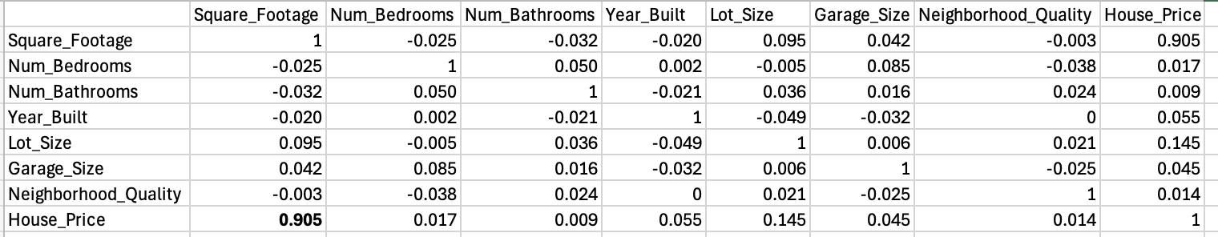
Table 2: Correlation Matrix

Table 2 shows a strong positive correlation between House Price and Square Footage (r = 0.905) and a weak correlation with Lot Size(r ≈ 0.145).

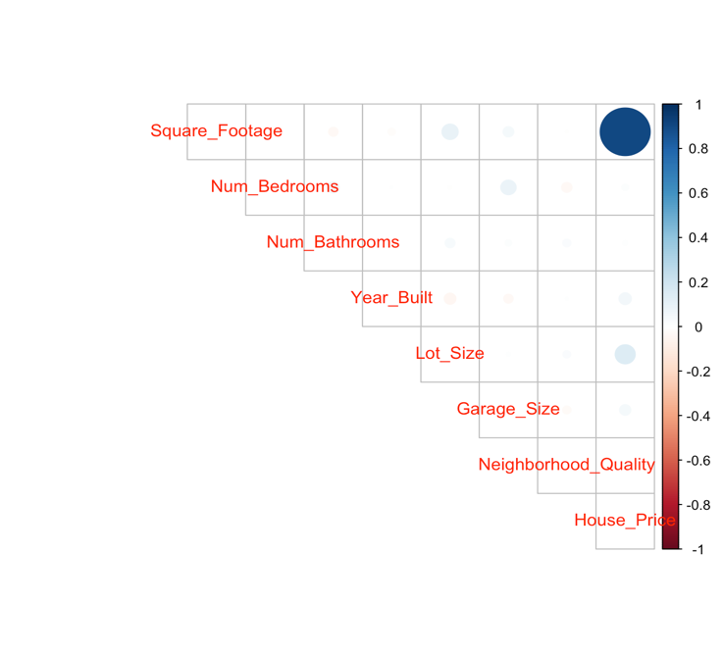
Figure 10: Correlation Heatmap
The heatmap shows correlations between all the variables. Darker colours indicate stronger relationships.

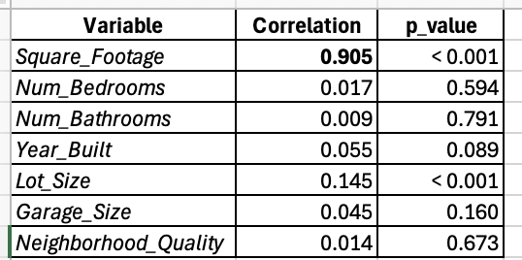
Table 3: Correlation between variables and house prices

Table 3 reveals the Pearson correlation between House Price and each predictor variable. Square Footage has a strong positive relationship ( r = 0.905, p < 0.001), while the remaining variables show very weak correlations.

- Regression Analysis

Regression analysis was used to identify the property features that impact house prices and to develop a predictive model. The full multiple regression model with all independent variables was first used to examine the cumulative impact of all variables on house prices.

  - Simple Linear Regression
A simple linear regression model was applied to check whether Square Footage can predict house prices. The results indicate that Square Footage is a statistically significant predictor (p < 0.001). The coefficient indicates that each additional 1 sq. ft increases the house price by approximately £202. The model explains 81.9% of the variance in house prices, with an R² value of 0.819.

  - Multiple Regression (Reduced Model)
A multiple regression model (full model) containing all the variables was tested and found to be statistically significant (p < 0.001), explaining 83% of the variation in house prices (adjusted R² = 0.830). The F-test was highly significant (p < 0.001), indicating that all predictors together explain much of the variation in house prices. Garage Size and Neighbourhood Quality were not statistically significant and therefore removed, producing a reduced model with the same adjusted R² value. This indicates that the reduced model was more efficient and appropriate in predicting house prices. Adding another year to building increases the price of a house by £1038.26, and each additional acre to the Lot Size adds £12797.98. The effect of the number of bedrooms and bathrooms is low, as indicated by the coefficient values, because of their connection with the square footage. The most influential variable remains the Square Footage, increasing the price of a house by £201.64 per square foot.
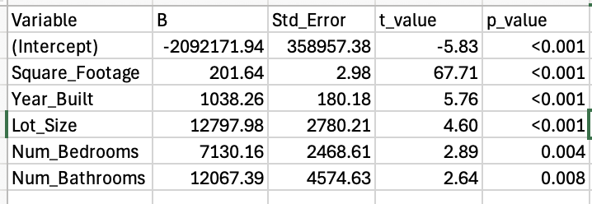
Table 4: Regression coefficient of the final regression model
Table 4 shows the coefficients of the final regression model

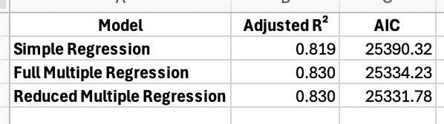
Table 5: Comparison of regression models
Table 5 compares the regression models. The reduced model has the lowest AIC value and was chosen for prediction

- Model Diagnostics
Following the development of the reduced regression model, diagnostic tests were carried out to determine whether the linearity assumptions of the regression model were met.
The Residuals vs Fitted Plot revealed that the residuals were randomly distributed around zero with no clear pattern, so the linear assumption was satisfied. Although there is a slight increase in the spread of residuals as the fitted value increases.
The Q – Q plot revealed that the residuals were closely following the reference line with minimal deviations at extreme residuals. This shows that the normal distribution was met.
Multicollinearity was checked using the Variance Inflation Factor (VIF), showing that all the values were close to 1. This implies a lack of multicollinearity in the regression model.
Cook’s Distance was checked to determine if there are influential observations in the model. A few observations slightly above the threshold line were found, but the Cook Distance there were not extreme; therefore, no observations were deleted.
The diagnostic tests revealed that the regression model met all the linearity assumptions and was statistically reliable

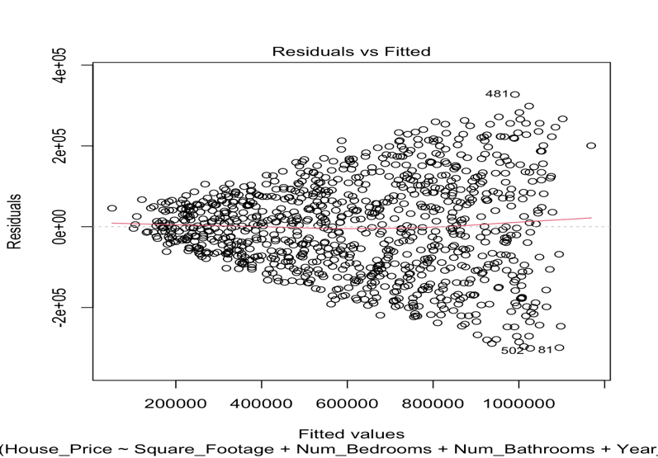
Figure 11: Residual vs Fitted Plot
No clear residual pattern, indicating linearity.

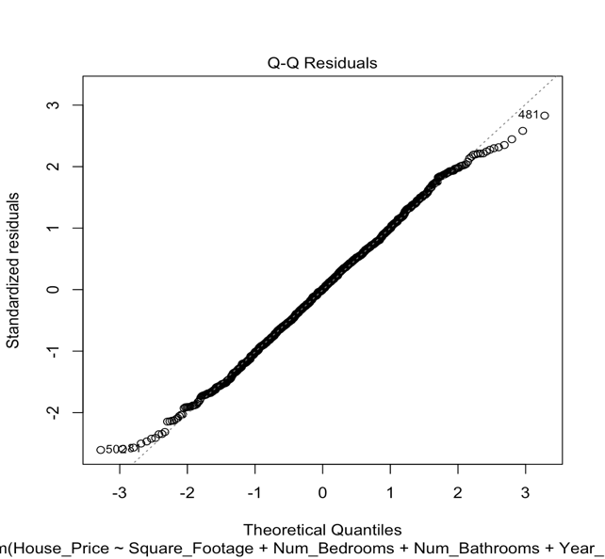
Figure 12: Q – Q plot
Residuals closely follow the Q-Q line, indicating normality

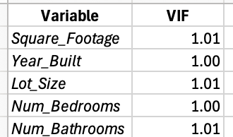
Table 6: Variance Inflation Table( VIF)
VIF values were close to 1, indicating no multicollinearity.

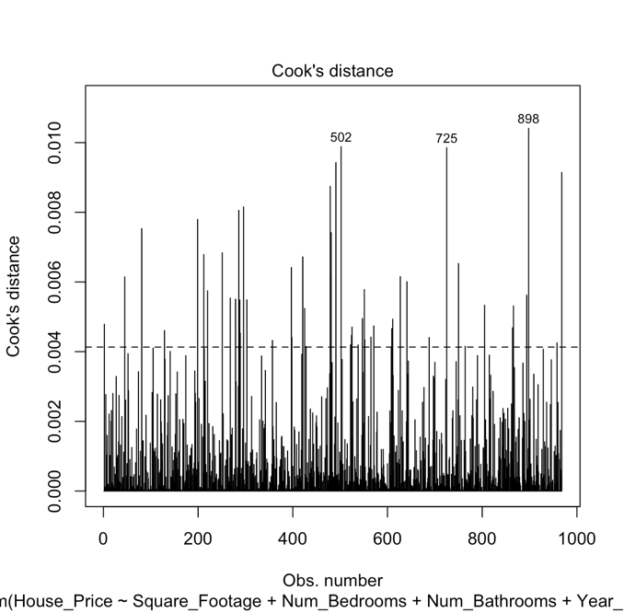
Figure 13: Cook’s Distance Plot
A few points in the dataset are slightly above the threshold. None were extreme, so no observations were removed

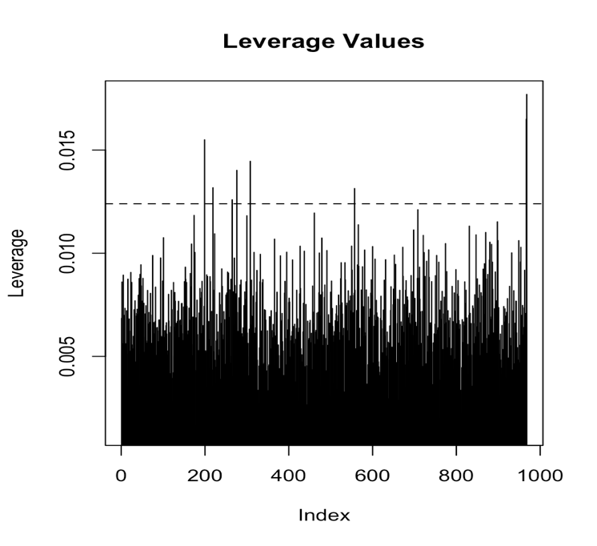

Figure 14: Leverage
Most observations fall below the leverage thresholds -no single observation has a strong impact on the model

- Prediction
The final (reduced) regression model was used to predict house prices for six properties in the dataset (Table 7). The predicted prices vary between £427,000 and around £970,000. Properties with the biggest size had higher predicted prices, which is in line with the earlier conclusion about the square footage factor and its high effect on house prices.

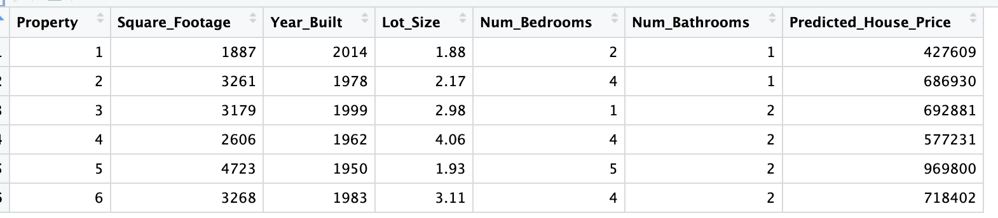

Overall, the predicted values follow the same pattern as in the training dataset. Based on property characteristics, the regression model provides reasonable estimates of house prices.

- Conclusion
The study analysed a dataset on residential properties to detect the key factors affecting house prices and to develop a predictive model. The analysis began with data preparation and monitoring to ensure that the dataset was clean and free of inconsistencies. Some unrealistic values were removed, and one value was adjusted to fall within the defined range. After data cleaning, the final dataset contained 968 rows, which were then used in all further analysis.
The descriptive analysis revealed that house prices vary across the dataset, with a median price of around £600,000. The graphical analysis showed that the variable with the most significant relationship with house price is Square Footage, while other variables such as Year Built, Lot Size, Number of Bedrooms, Number of Bathrooms, and Garage Size showed a low impact.
Correlation analysis confirmed a very strong positive relationship between Square Footage and House Price (r = 0.905). Regression analysis further supported this finding, showing that square footage itself explained 81.9% of the variation in house prices, while the multiple regression model explained approximately 83%.
Diagnostic tests provided evidence that the regression assumptions were satisfied. The final reduced model explained approximately 83% of the variation in house prices. It was therefore used to predict prices for new property scenarios, demonstrating that it can reliably estimate house prices based on property characteristics.

