You are expected to solve homework problems individually. If needed, you may seek help from your friends. However, do not copy. Show all steps with your solutions for full credit.

**Name: Key / 50**

1. Consider the combinational circuit shown in figure below:

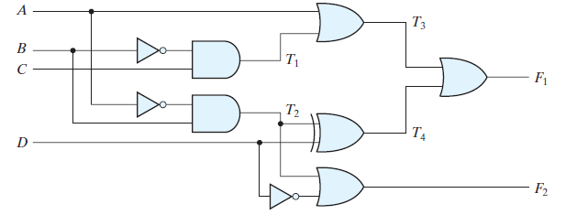

1. ( 10 points) Derive the Boolean expressions for T1 through T4. Evaluate the outputs F1 and F2 as a function of the four inputs.

T1 = B'C

T2 = A'B

T3 = A + T1 = A + B'C,

T4 = D ⊕ T2 = D ⊕ (A'B) = A'BD' + D(A + B') = A'BD' + AD + B'D

F1 = T3 + T4 = A + B'C + A'BD' + AD + B'D

With A + AD = A and A + A'BD' = A + BD':

F1 = A + B'C + BD' + B'D

F2 = T2 + D' = A'B + D'

1. (10 points) List the truth table with 16 binary combinations of the four input variables. Then list the binary values for T1 through T4 and outputs F1 and F2 in the table.

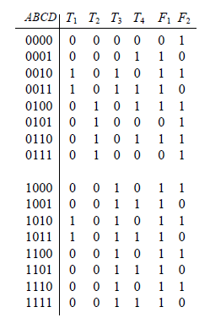

1. Plot the output Boolean functions obtained in part (b) on maps and show that the

simplified Boolean expressions are equivalent to the ones obtained in part (a).

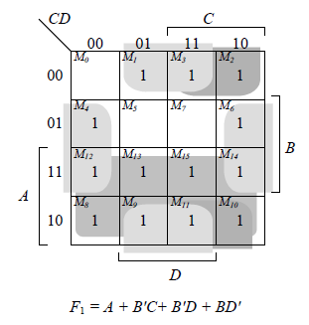

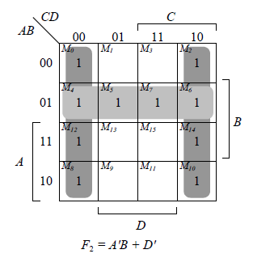

1. (20 points) Design a combinational circuit with three inputs, x , y , and z , and three outputs, A, B , and C .When the binary input is 0, 1, 2, or 3, the binary output is two greater than the input. When the binary input is 4, 5, 6, or 7, the binary output is three less than the input.

