**BANNARI AMMAN INSTITUTE OF TECHNOLOGY**

**An Autonomous Institution Affiliated to Anna University - Chennai, Accredited by NAAC with A+ Grade**

**Sathyamangalam - 638401 Erode District, Tamil Nadu, India**

**Student Name:** KEDARNAATH M

# Project ID: 20

**Project Title:** Rewards Points Dashboard

# Technical Components:

|  |  |
| --- | --- |
| **Component** | **Tech Stack** |
| Front End | * HTML * CSS * JS |
| Back End | * Python * Django (Python Web) |
| Database | * PostgreSQL * MYSQL |
| API | * Open API * SOAP APIs |

**PROBLEM STATEMENT:**

Design and implement a reward points dashboard for students, allowing them to track points earned from both technical (e.g., coding competitions) and non- technical (e.g., community service) activities. The system should enable students to create accounts, view their total and categorized points, see recent activities, and compete on a leaderboard. Students can submit proof of participation for verification by administrators, who can manage activities and points via an admin panel. Notifications will inform students of earned points and milestones, and reports will provide insights into student engagement. The dashboard should be optimized for scalability and performance, using technologies like HTML, CSS, JavaScript, Node.js, and cloud-based hosting.

# PROJECT-FLOW:

**Purpose:**

The purpose of this project is to create a system that tracks and rewards students for participating in both technical and non-technical activities, encouraging them to engage in a variety of events and helping them see their progress and achievements easily.

# Scope:

The scope of this project includes creating a student reward points dashboard that allows students to create accounts, log in, and track points earned from both technical and non-technical activities. The system will categorize activities, record and display points, show recent activities, and feature leaderboards. Students can submit proof of participation for verification by administrators, who can manage activities and points via an admin panel.

# Business Context:

In a business context, this project aims to boost student engagement and motivation by tracking and rewarding participation in various activities through a points dashboard. It encourages balanced skill development and provides valuable data for improving educational programs. Utilizing modern technologies ensures scalability, efficiency, and a user-friendly experience.

# Consideration:

* Keep user data safe, make the system easy to use, and ensure activities are properly categorized and verified.
* Ensure the system can handle many users, use reliable technology, and improve based on user feedback.

# Dependencies:

* The project's success depends on having a secure and stable hosting environment for the system to run smoothly.
* It also relies on timely access to accurate data about student activities and points earned for effective tracking and reporting.

# User personas:

* Student User Persona: A student who wants to track their participation in various activities, earn points, and compete with peers on leaderboards for recognition.
* Administrator User Persona: An administrator who manages activities, verifies student submissions, and ensures the system runs smoothly for all users.

# User Stories:

* Student User Story: As a student, I want to log in to the dashboard, participate in activities, submit proof of participation, and earn points to track my progress and compete with others.
* Administrator User Story: As an administrator, I want to manage activities, verify student submissions, generate reports on participation, and ensure the system's security and performance.

# Functional Requirements:

* **User Registration and Login:** Students should be able to create accounts and log in to the system securely.
* **Activity Tracking**: The system should track student participation in both technical and non-technical activities and assign points accordingly.
* **Points Display:** Students should see their total points, categorized by technical and non-technical activities, on their dashboard.
* **Leaderboard:** A leaderboard should display top-performing students based on points earned.
* **Admin Panel:** Administrators should have access to manage activities, verify submissions, and generate reports on student participation.
* **Notifications:** Students should receive notifications about earned points milestones and submission status.

**FLOW CHART:**

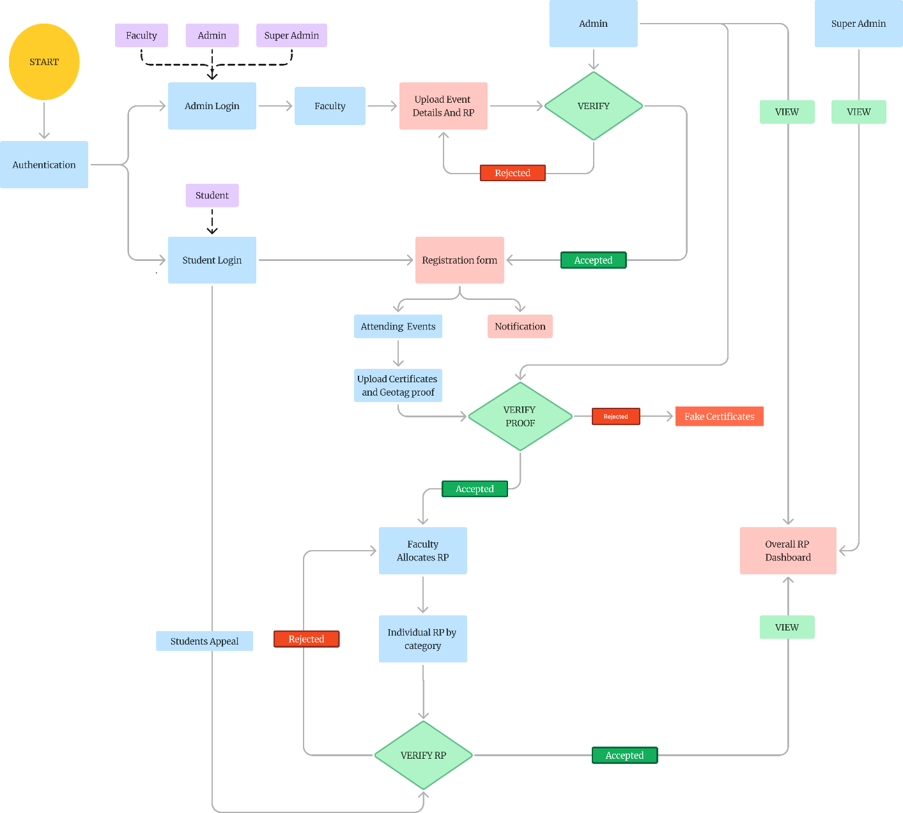

**Sample Design:**

