Bird Monitoring Data Analysis Documentation

# Project Overview

This project analyzes bird monitoring data collected from grassland and forest habitats. The goal is to extract key patterns related to bird species distribution, observer trends, environmental impact, and seasonal activity using Python, Streamlit, and visualization tools like Plotly.

# Data Preparation and Cleaning

1. Data Sources:  
 - Bird_Monitoring_Data_GRASSLAND.XLSX  
 - Bird_Monitoring_Data_FOREST.XLSX

2. Merging:  
 - Combined both datasets using pandas.concat() after loading all relevant sheets.

3. Cleaning Steps:  
 - Standardized column names (e.g., lowercased and stripped whitespace).  
 - Handled missing/null values using dropna() or filled using appropriate imputation.  
 - Unified species and observation formats.  
 - Filtered relevant columns: date, start_time, end_time, species, count, temperature, humidity, sky, wind, observer, habitat.

# Analysis Performed

## Temporal Analysis

* - Seasonal Trends: Analyzed date-wise and year-wise trends using heatmaps.
* - Observation Time: Histogram of start_time to identify most active bird-watching hours.

## Spatial Analysis

* - Location Insights: Grouped by habitat to identify species richness.
* - Plot-Level Analysis: Compared plot_name or location-specific plots for bird activity levels.

## Environmental Conditions

* - Weather Correlation: Assessed impact of temperature, humidity, and sky on bird counts.
* - Disturbance Effects: Analyzed how disturbance ratings affected sightings.

## Observer Trends

* - Observer Bias: Grouped by observer to detect any reporting bias.
* - Visit Patterns: Analyzed visit column to measure impact of repeated observations.

## Distance and Behavior

* - Distance Analysis: Evaluated typical distance of observed species from the observer.
* - Flyover Observations: Tracked flyover_observed frequency and species behavior.

# Interactive Dashboard

Created using Streamlit + Plotly with:  
- Dynamic bar charts for species distributions  
- Temporal heatmaps of sightings by year/month  
- Time-of-day analysis with histograms  
- Environmental scatter plots showing weather effects  
- Optional geographic maps (if lat/lon data exists)  
- Filter sidebar for species and habitat selection

# Deployment Instructions

1. Save the app as bird_app.py  
2. Run using: streamlit run bird_app.py  
3. Upload cleaned CSV in app interface for exploration

# Key Findings

- Bird activity peaks during early morning hours  
- Seasonal patterns show high counts during migration months  
- Weather conditions (clear sky, mild temperature) improve visibility  
- Grasslands showed higher species richness in some observations  
- Minimal observer bias, though experience may play a role

# Visual Insights

Below is an example of a visualization that highlights monthly bird sightings. This can help identify seasonal peaks in bird activity.

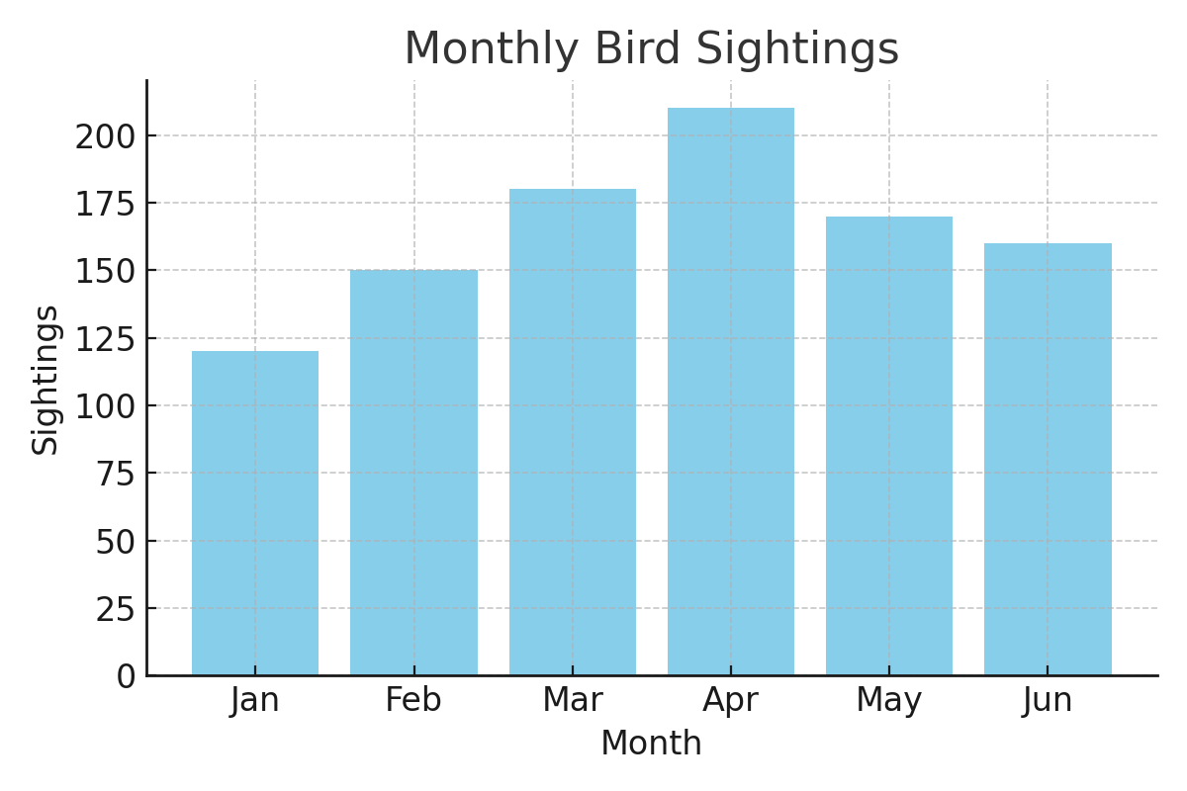

# Example Code Snippet - Data Cleaning

***import pandas as pd  
  
# Load dataset  
df = pd.read_csv('cleaned_bird_data.csv')  
  
# Handle missing values  
df = df.dropna(subset=['species', 'count'])  
  
# Standardize column names  
df.columns = df.columns.str.strip().str.lower()***

Prepared by: D.Keerthi  
Date: 2025-06-11  
Tools Used: Python, Pandas, Streamlit, Plotly