
Project Report Template

INTRODUCTION: 1.1 Overview * The project aim is to provide real-time knowledge for all the students who have basic knowledge of Salesforce and Looking for a real-time project.

1.2 Purpose

* It is help to those professionals who are in cross-technology and wanted to switch to Salesforce with the help of this project they will gain knowledge and can include into their resume as well.

- Problem Definition & Design Thinking

2.1 Empathy Map

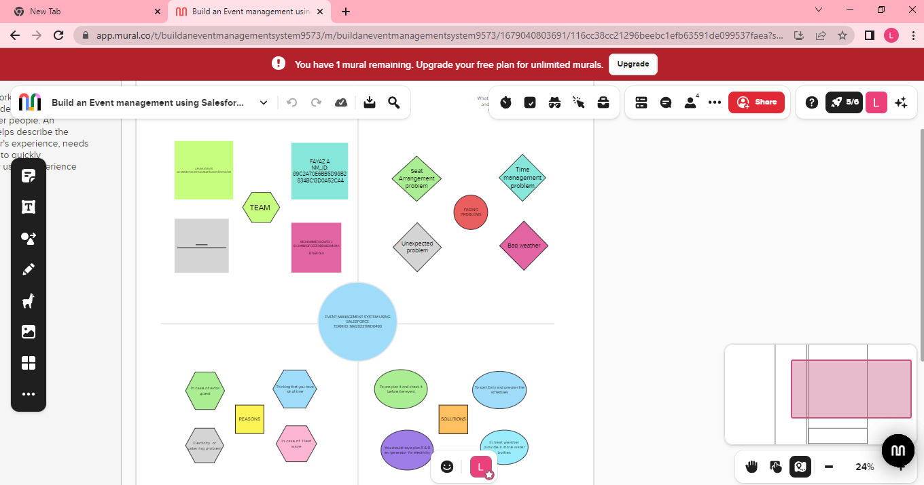 2.2 Ideation & Brainstorming Ma 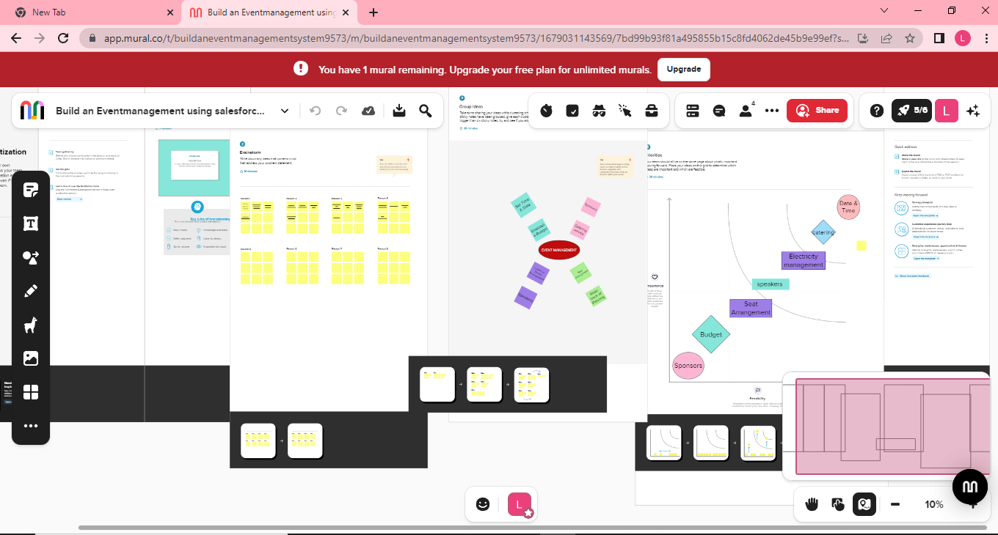

- RESULT

3.1 Data Model:

Object name | Fields in the Object
obj1:
ATTENDEES |  | Field label | Data type
 |  | Enter id | Auto number
 |  | Phone | Phone
obj2:
 |  | Field label | Data type
SPEAKER |  | Enter Bio | Text Area
 |  | Email | e-mail

3.2 Activity & Screenshot :

Milestone: 4
Activity: 2

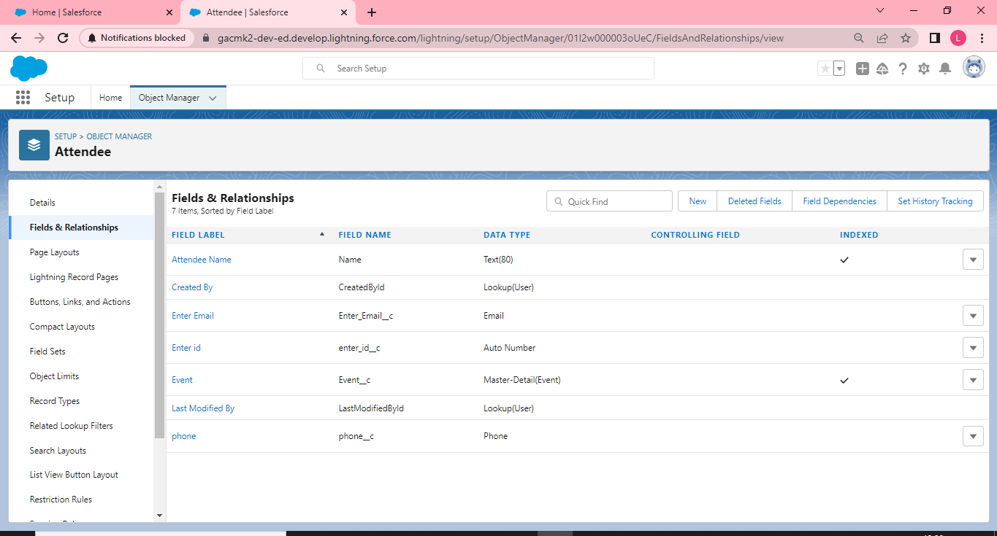

Milestone:5
Activity: 1

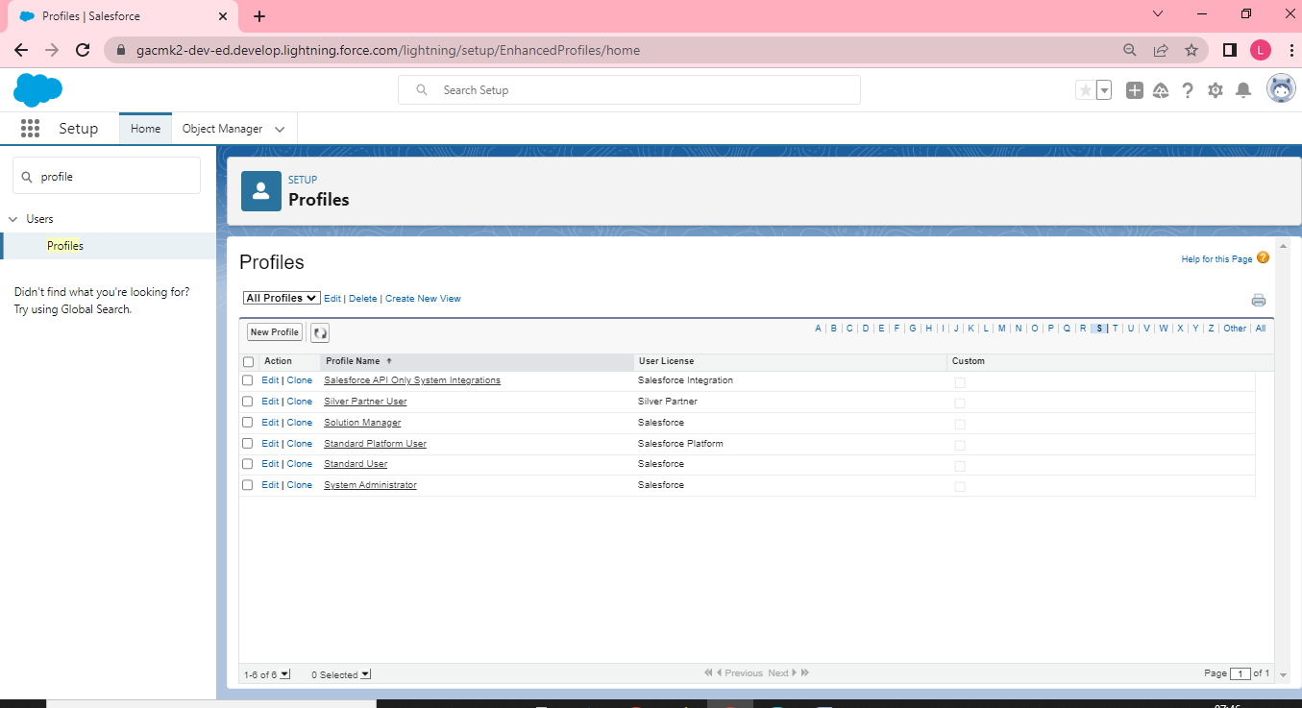

Milestone:4
Activity: 5

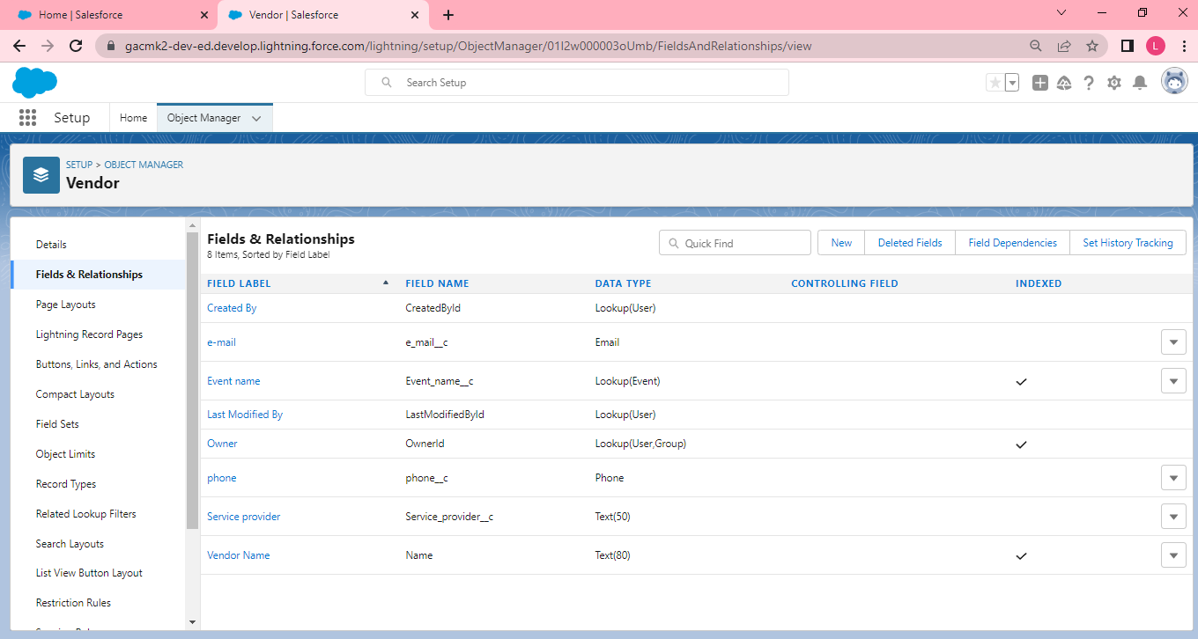

Milestone:3
Activity : 1

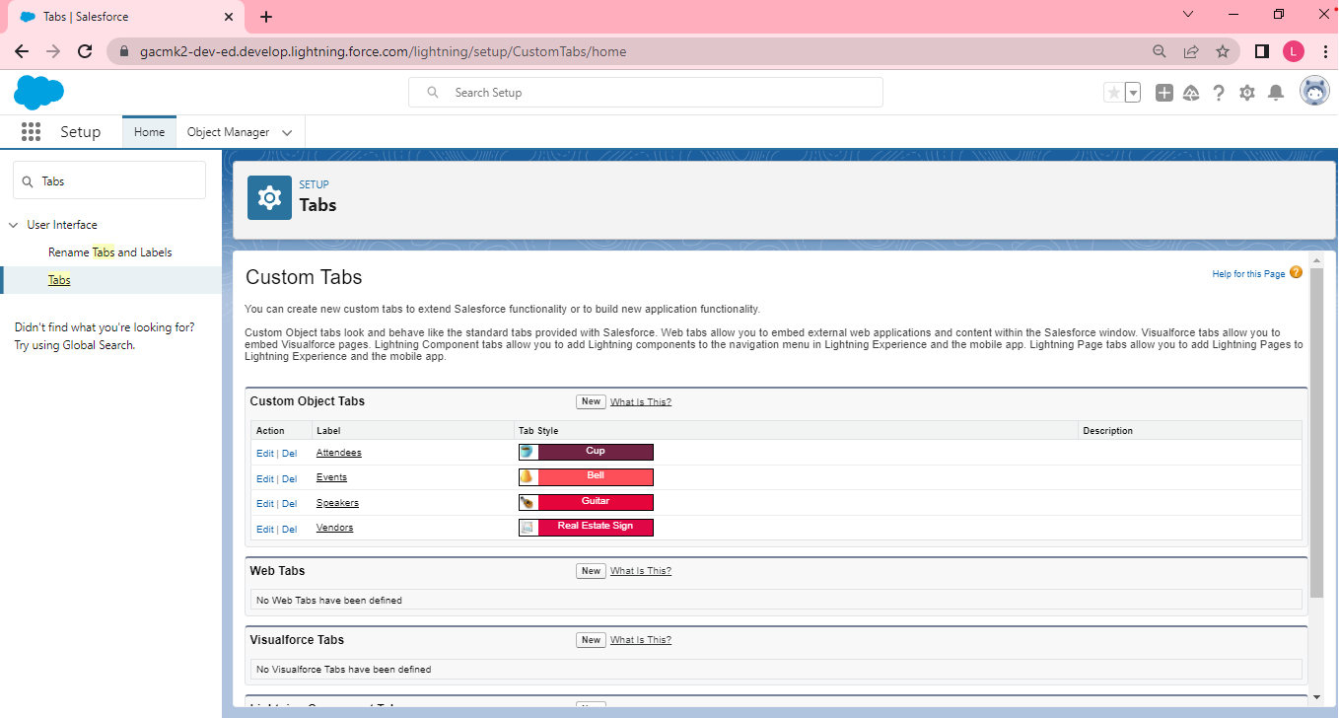 M Milestone:6
Activity : 1

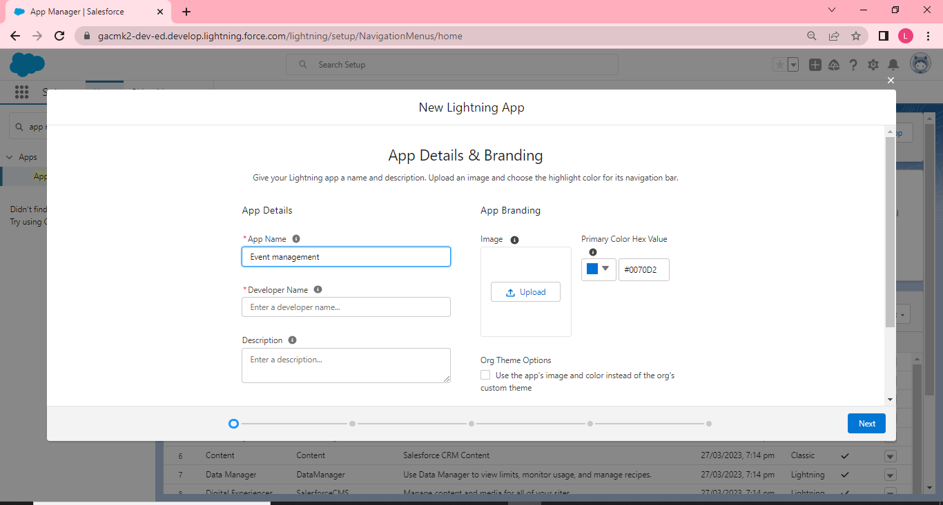

Milestone:7
Activity : 1

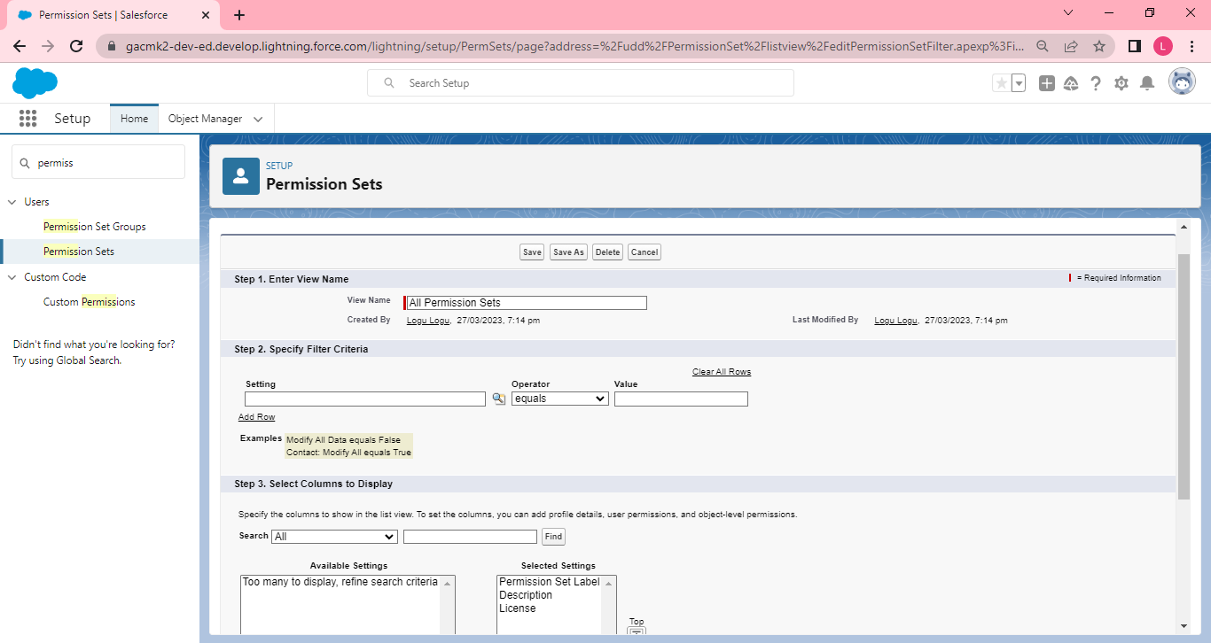
Milestone:8
Activity : 1

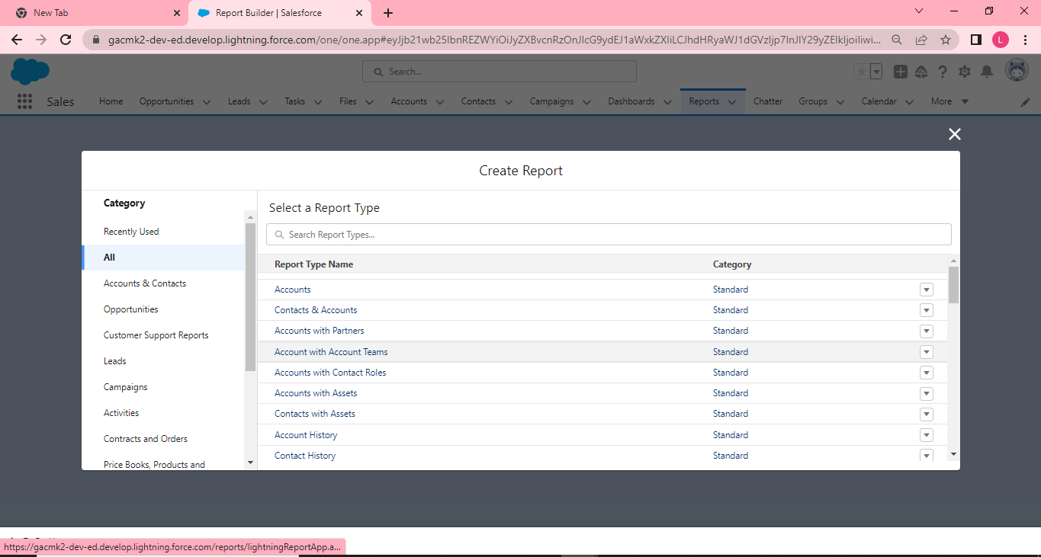

- Trailhead Profile Public URL :

Team Lead - Logushanmugam
Team Member 1 - ularu

Team Member 2 – ffayaz5
Team Member 3 – Mohammedgowes

- ADVANTAGES & DISADVANTAGE :

Advantages:

1. An Event Planner Will Help You Bring Your Vision To Life.

2.Organization And Details.

3. Budgeting For Your Wedding. ...

4. Timeliness And Flexibility. ...

5.Your Event Planner Will Be There For You. Disadvantages : 1. Difficult to handle work manually.
2. Time consuming process.
3. More human power required.

- APPLICATIONS :

1.Promote Your Event. Sounds strange, right? ...

2. Sell Event Tickets. ...

3 Targeted Digital Marketing. ...

4 Drive Pre-event Engagement. ...

5. Push Notifications. ...

6.Enables Effective Communication. ...

7.Establish An Attendee Network.
..
8. Event Apps Help With Branding.

Project Report Template

- CONCLUSION

- Event Management System is user friendly and cost
effective system/

- it is customized with activities related to event management
life style
.

- FUTURE SCOPE

1. It involves management, creation and development of events such as corporate conferences, wedding, festivities, formal parties etc…
2.. It involves a lot of research about the brand, target audience and the concept of the event before planning the actual event.

