Day3-csa2075(c programming)

1. Write a program to find the length of a string using pointers.

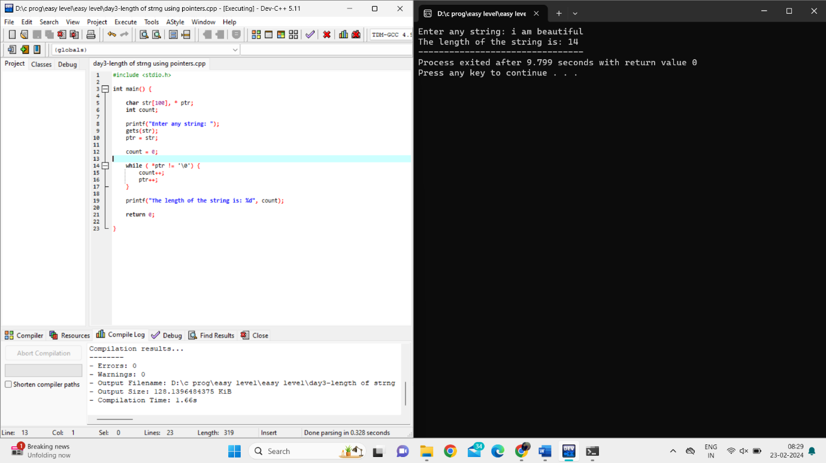

1. Write a program to reverse a string using pointers.

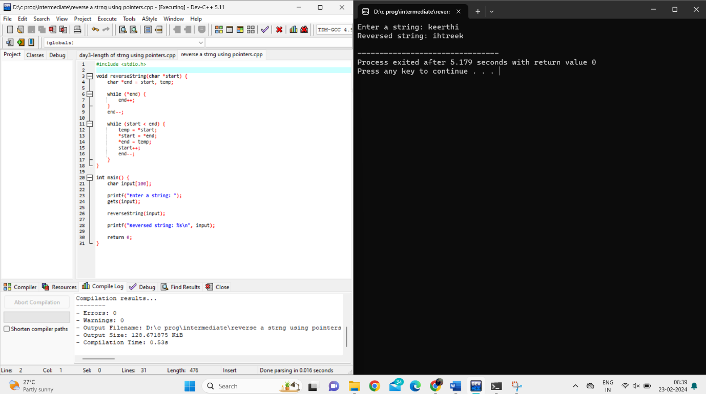

1. Write a program to count the number of occurrences of a character in a string using pointers.

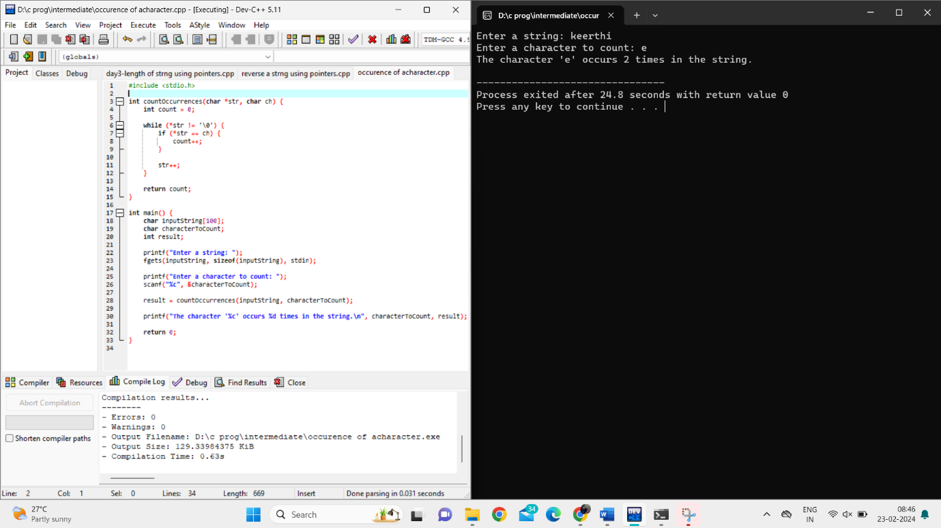

1. Write a program to find the maximum and minimum values in an array using pointers.

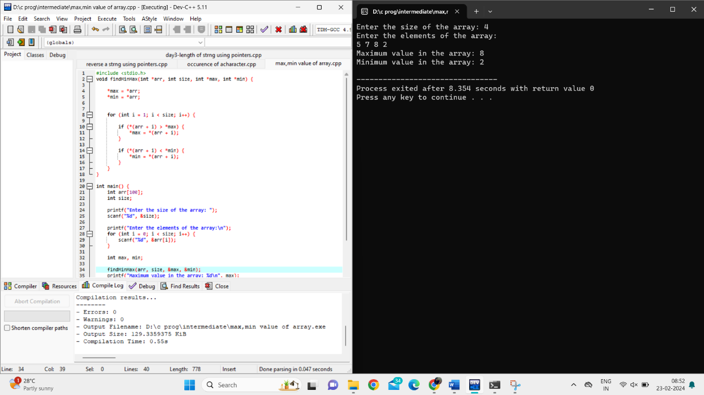

1. Write a program to sort an array of integers in ascending order using pointers.

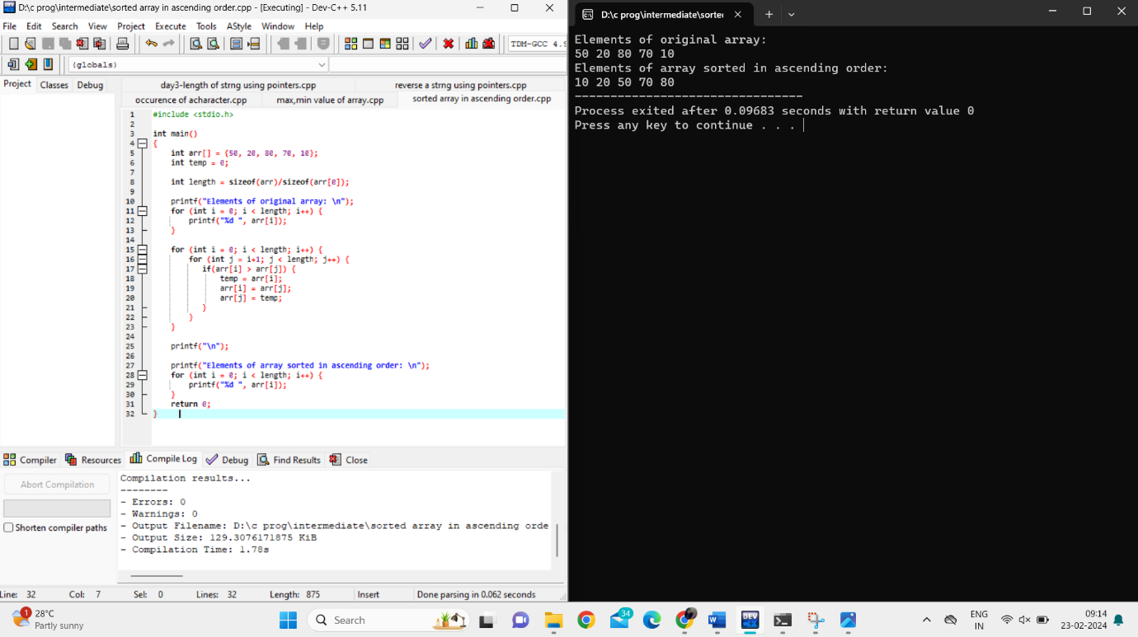

1. Write a program to find the factorial of a number using pointers.

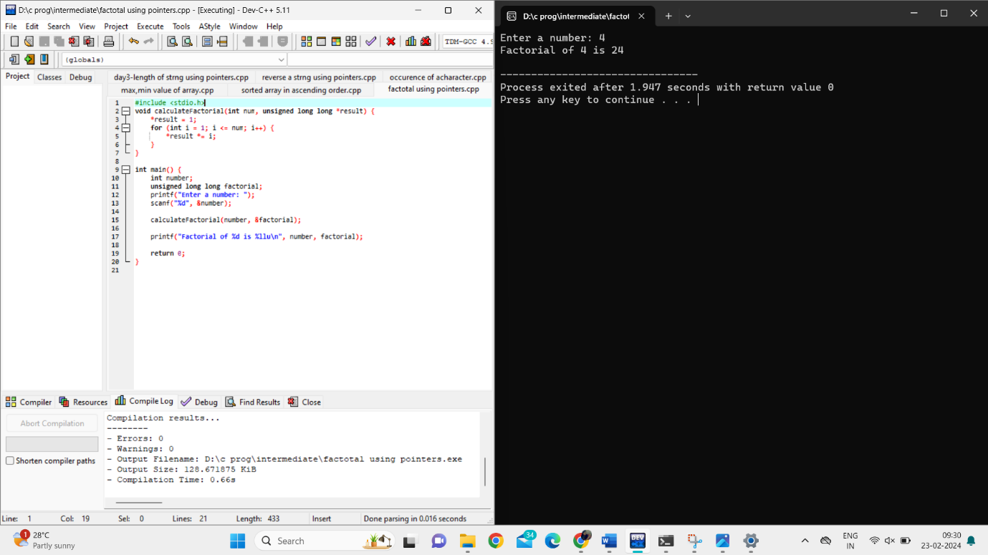

7.Write a program to check if a given number is prime using pointers.

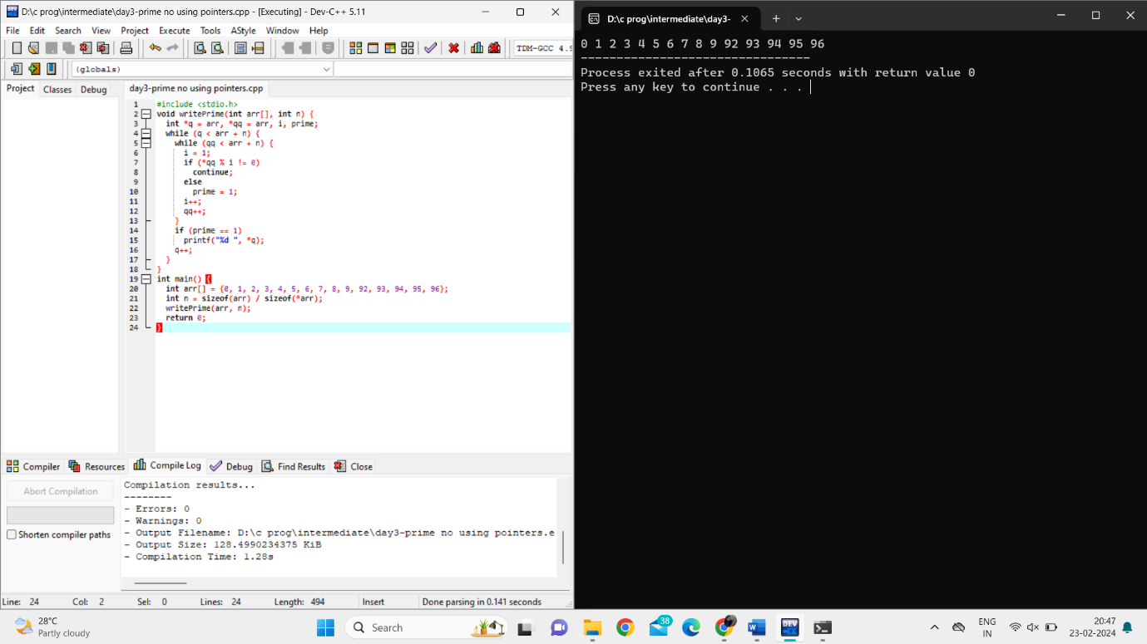

8.Write a program to concatenate two strings using pointers.

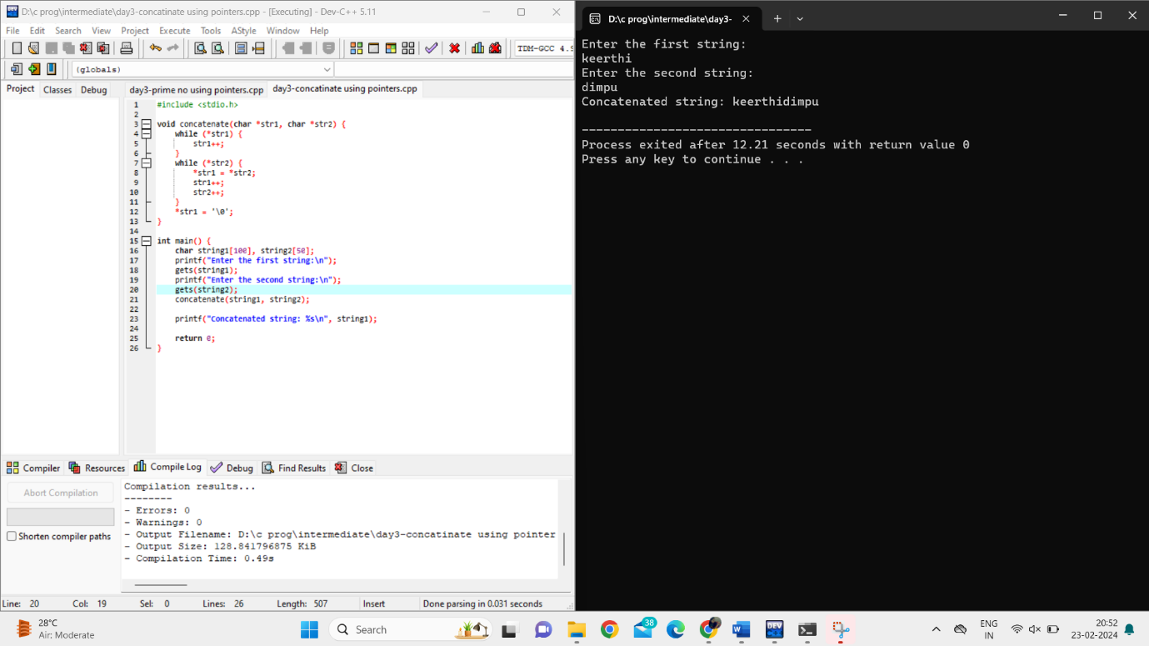

ANALYTICAL QUESTIONS:

1.Write a C program to implement a function that finds the length of the longest substring containing only distinct characters.

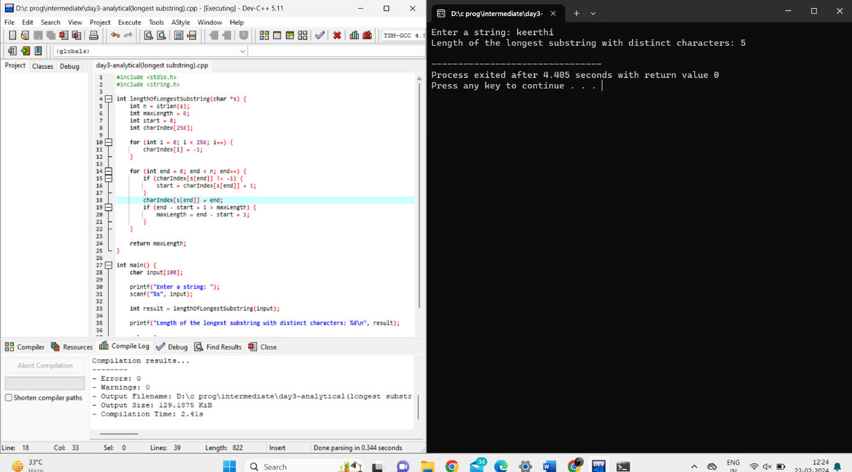

2.Write a C program to implement a function that counts the number of subarrays with sum less than a given value.

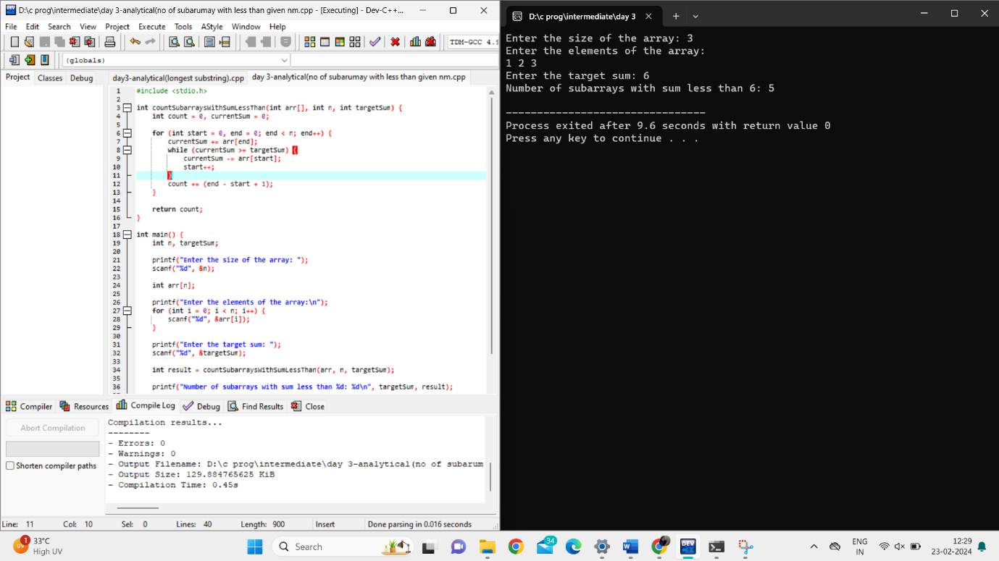

write a C program to implement a function that finds the kth largest element in an unsorted array.

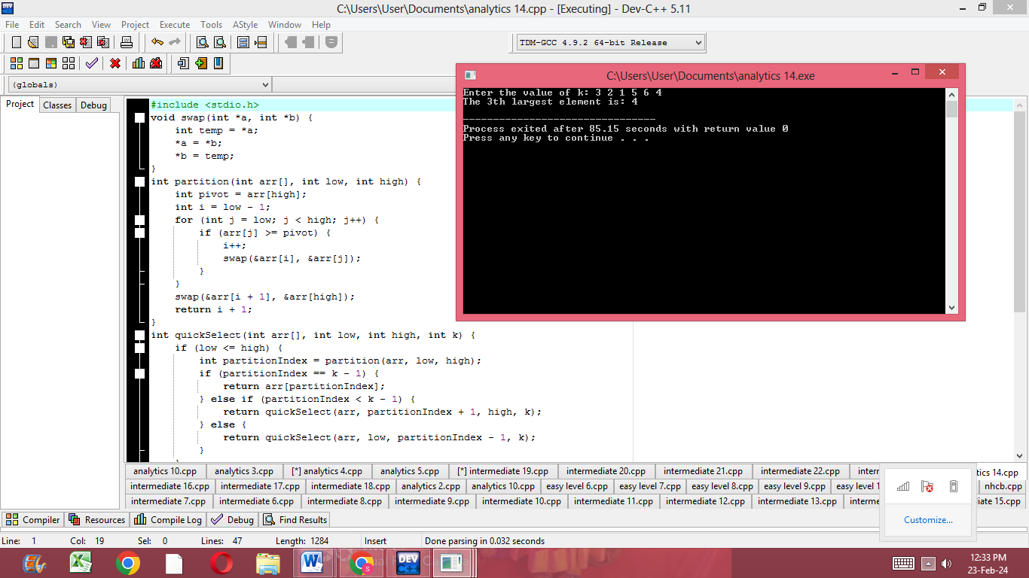

Write a C program to implement a function that finds the maximum sum subarray within a circular array (the circular array can be considered as a circular queue).

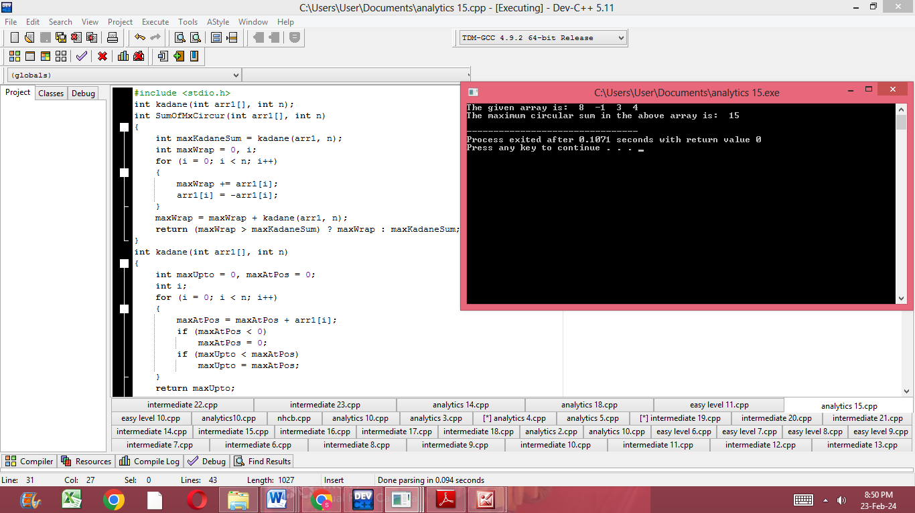

.Write a C program to implement a function that finds the longest palindromic substring in a given string.

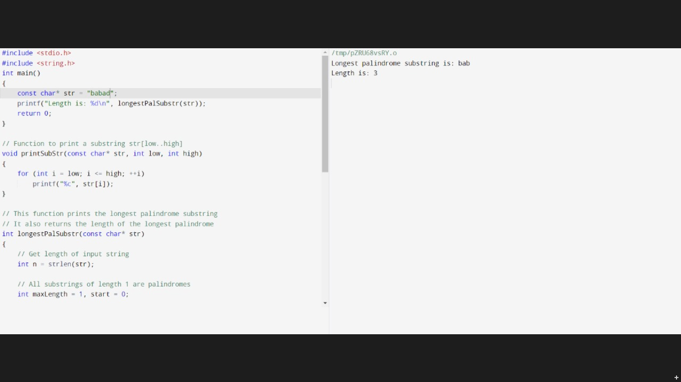

.Write a C program to implement a function that counts the number of subarrays with sum less than a given value.

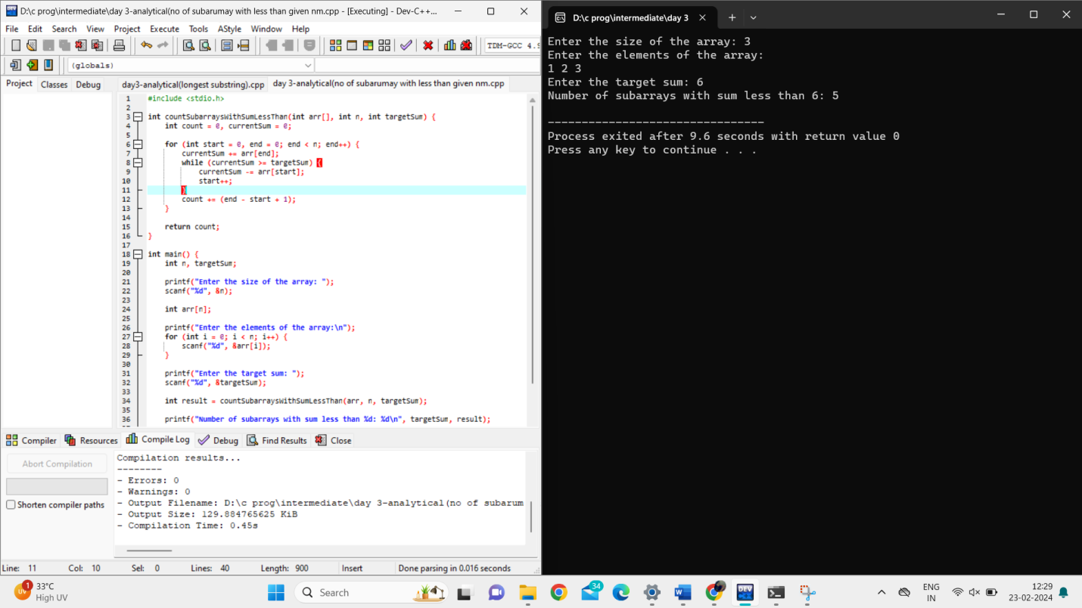

.Write a C program to implement a function that returns the count of distinct substrings of a given string.

