**Project Report For Keerthi Sweets**

Sweets such as kheer are bolid,while others such as burfi are baked ,while others such as Mysore pak are roasted ,while others such as jalebi are fried and yet others .

Everything in india is a little sweeter- the people ,the cuisine every region of the country joyfully celebrates festival as well as modest triumphs in life

Suger confection are sweet Suger based sweets are typically consumed as sweet super sweets ,chocolates ,candied fruits and nuts chewing gum and even ice cream fall into this category

* 1. **Overview**

*The india's No.1 Confectionery and sweets Manufacturer with tha products exported to over 20 countries around the world.They are dedicated to the art of producing innovation and delicious products offer tantalizing experience that sparks the imagination in people who eat their candy. Ofcource this has been sweets goals since their incepection in sweets continues to make some of The best sweets in india .sweets products can be enjoyed by kids and adults a like and their products come in an arrey of flavers shape and sizes*

**Purpose using this project .what can be achieved using this.**

*The powe of good food shared inspires all of us at sweet street to innovate and creat the finest ,indulgent foods served globally . we nurture the idea that our offerings are universally enjoyed by families and friends making us part of lifes celebration and memories*

*We at street choose to be the industry leader setting the standard by which all others are judjed .exceptional food is our way of life our passion for pure sustainable ingredients and unwavering commitment to always exceed the expectations of our customers ensures our future*

*But the sweet street is about more than great food above well we are dedicated to creating a safe ,dynamic environment so compelling our customers Suppliers and co workers want to participate in achieving mutual success.*

**Problem Definition& Design Thinking**

**Empathy Map**

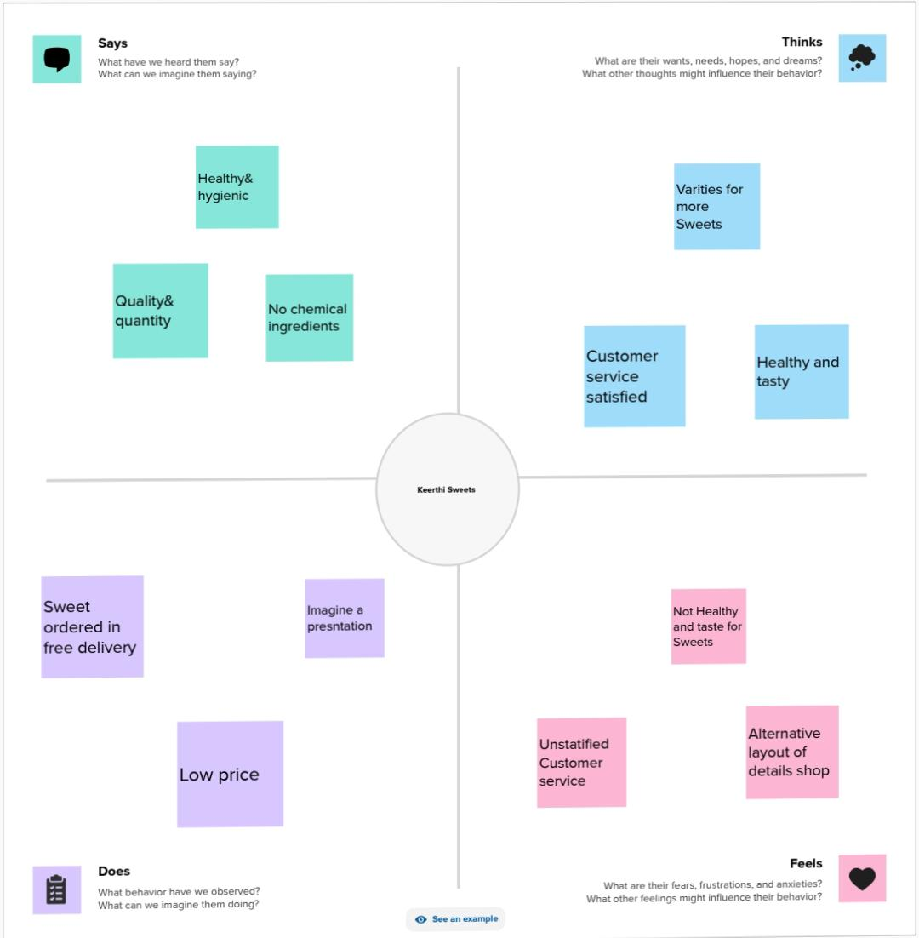

**Ideation & Brainstorming**

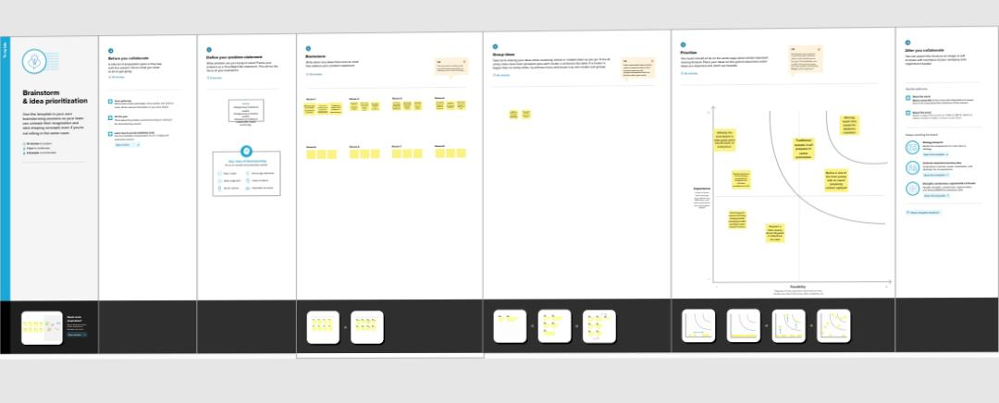

**Gst Report**

**The final finding output of the project along with Screenshot**

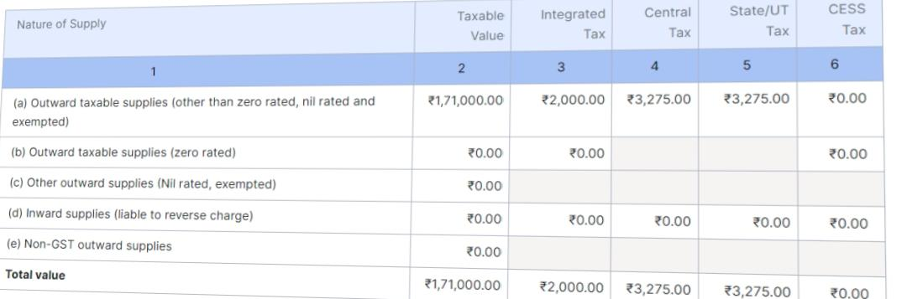

***Purchase Bil***

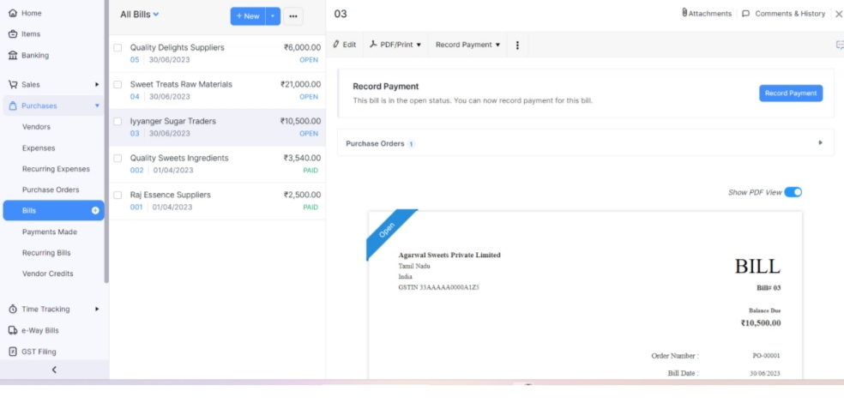

***Sales Invoice***

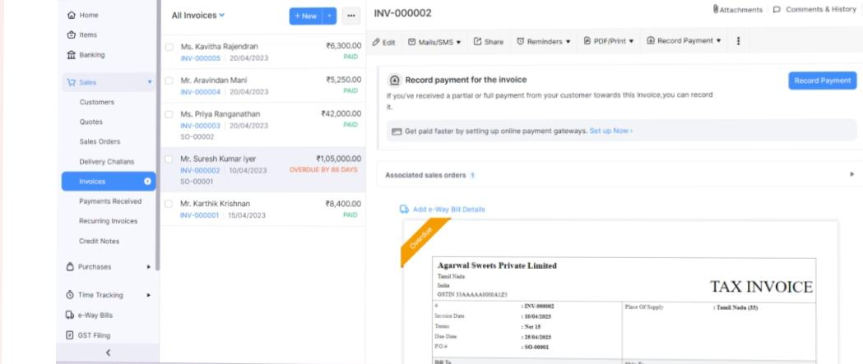

***Vendors***

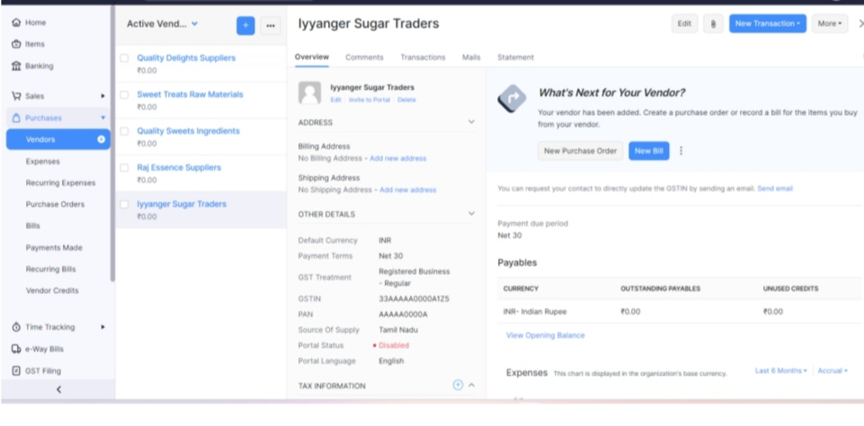

***Customers***

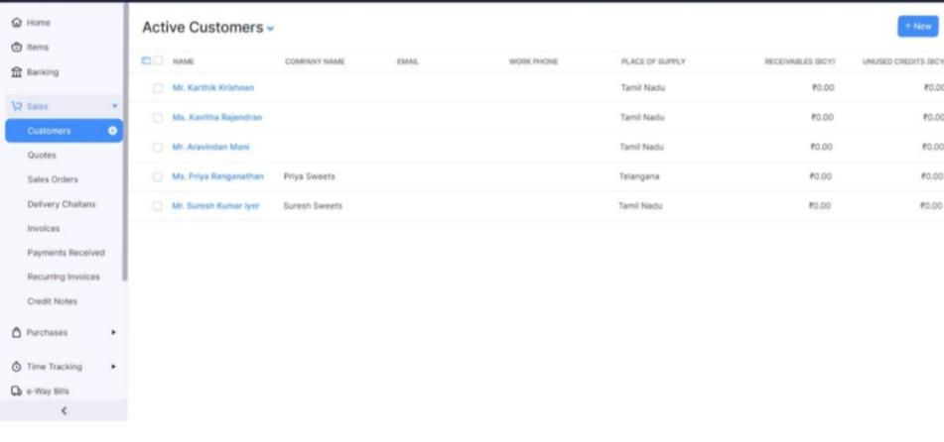

***Journal***

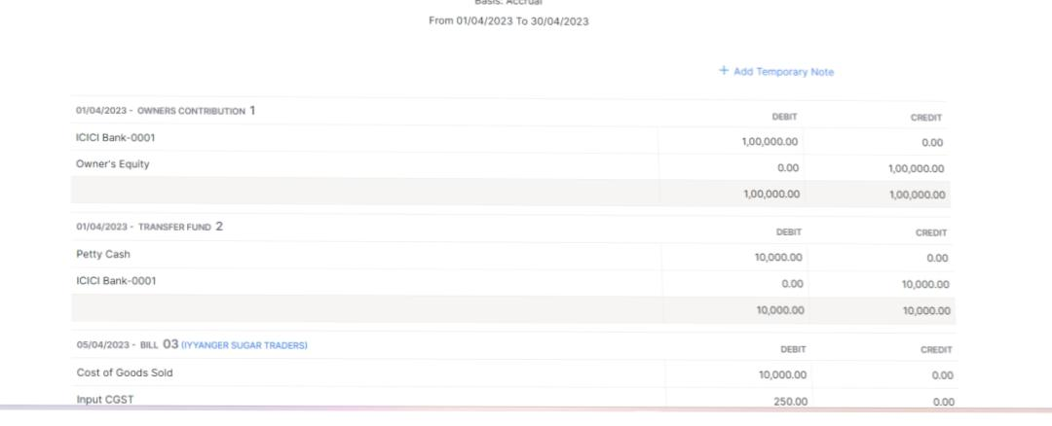

***Banking* 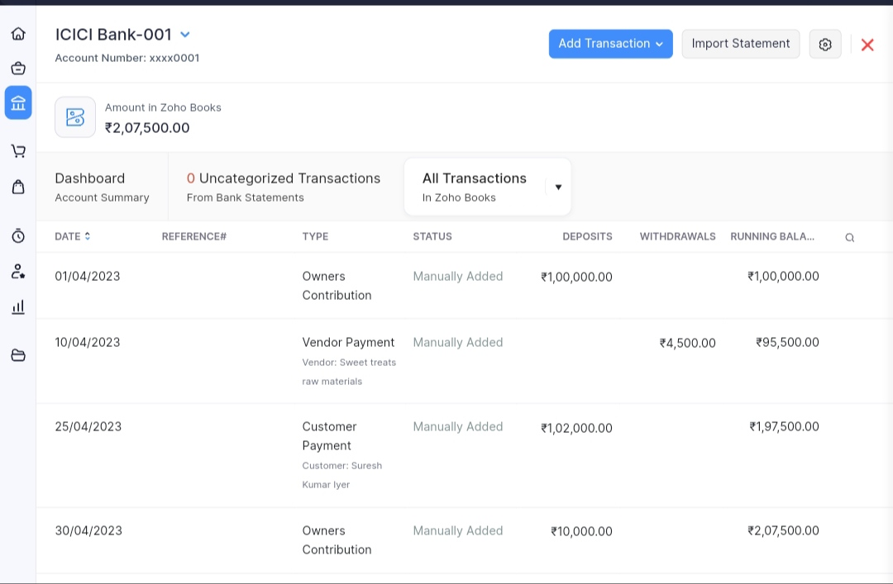**

**Advantages& Disadvantages**

* **List of Advantages and Disadvantages of the proposed**

1. ***Advantages***

***A.Advantages for Table suger:***

*Most of the food items which we consume in our day life have several benefits.Even the salt also has different advantages. But when we talk about tables Suger ,you need to understand that table Suger has only limited advantages. And if not Consumed in Moderation then that advantages may also turn into a Disadvantages*

***B.Goods Source of Energy:***

*We all are well aware or this aware of this fact and we have mentioned above also that Suger helps providing us the energy .Our Body needs glucose for various funsion performed by our body organs .*

*There are many other food items also other than the table suger that helps in providing the energy to our body. It provides a sudden boost of energy in our body.That is why when anyone fees dizzy or week it os suggested to provide them with salt and Suger water so that they can can feel better.*

***C.Helps in Boosting of Table Suger:***

***This*** *Also true that suger helps in boosting our mood.some people say that it happens because of the taste bunds whereas it has been reaeached that table suger added suger helps in causing the dopamine rush. That is why when people are sad or depressed they tend to eat the food items whish have suger in them like soft drinks ,ice cream ,sweets ,Chocolates, Cake etc……,*

***Disadvantages of Table Suger:***

*The table suger or the added suger is not very good For our health .Consuming them in the limited or Conrolled quantity is fine .*

* *It can cause weight gain*
* *May increase your Risk ho Heart Disease*
* *Linked to Acne*
* *Increase your risk of type 2 diabetes*
* *May increase you risk of canser*
* *May increase risk of depression*
* *May Accelerate the skin aging process*
* *Can increase cellur aging.*

***Profit& loss Account***

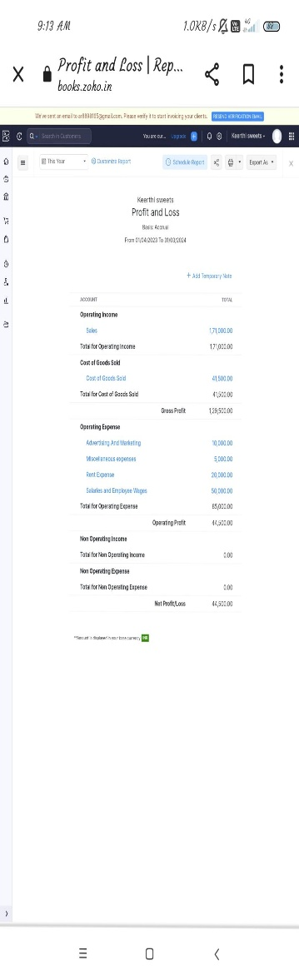

***Balancesheet***

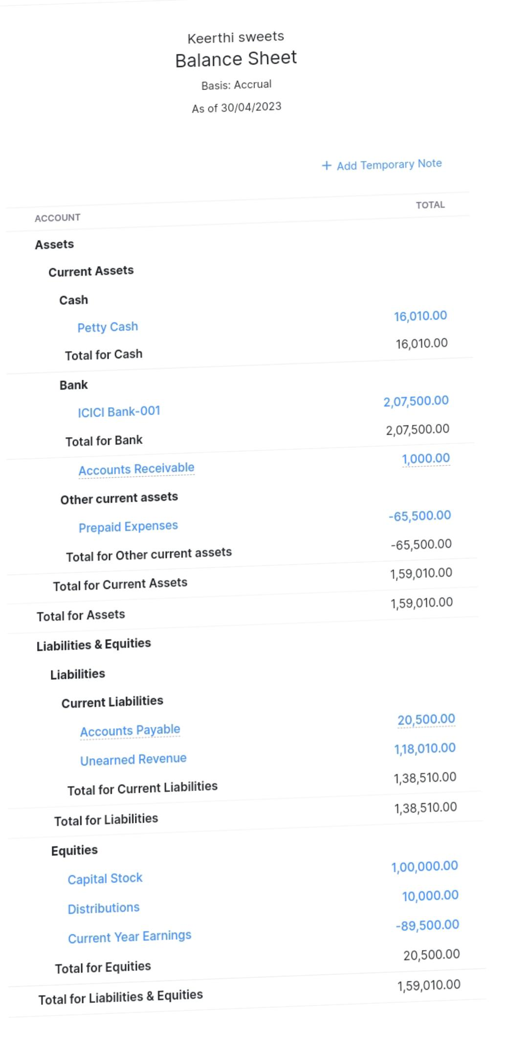

***Scops***

* ***The global sweets Confectionery market was valued USD 11570 million in 2022 and anticipated to reach usd 128510 million by 2029 witnessing a CAGR of 2.0% during The forecast period 2023-2029***