**A.KEERTHIKA**

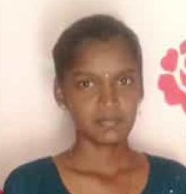

**B.SC COMPUTER SCIENCE**

D/o Mr. S.ASHOKAN,

No. 9/45, North Street,

Navaneetha krishnapuram,

Pethanadarpetti (po),

Tenkasi-627808.

Email: akeerthika29105@gmail.com

Mobile No: 7639177000/6374163007

**OBJECTIVE:**

To work in a challenging and creative environment while effectively contributing towards the goals of the organization and myself.

**PROFESSIONAL EXPERIENCE:**

* c basic

**SKILL SET:**

* Having good knowledge about windows operating systems and MS office

**EDUCATIONAL QUALIFICATION:**

* SSLC -77.8%(2019)
* HSC -86.7%(2021)
* Bachelor of Computer Science (SECOND YEAR)
* Government Arts And Science College for women .Alangulam

#### PERSONAL PROFILE

Name : **A.KEERTHIKA**

Father’s Name : Mr. S.ASHOKAN

Date of Birth : 29-01-2005

Sex : Female

Languages Known : Tamil, English

Marital Status : Unmarried

Nationality : Indian

**HOBBIES:**

* Listening Music
* Book reading

**STRENGTHS:**

* Smart and Hard Worker
* Self Confident

**DECLARATION:**

I hereby declare that the information mentioned above is true, complete and correct to

the best of my knowledge and belief.

**Place:** Tenkasi  **signature**

A.KEERTHIKA