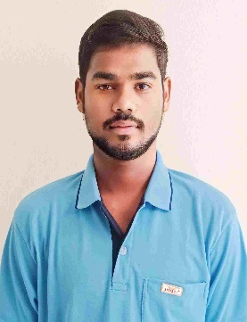**Keerthipati Vamsi Krishna**

Phone: 9121730982

E-mail: vamsichinna57@gmail.com

LinkedIn: keerthipati-vamsi-krishna-797b272aa

GitHub :KEERTHIPATIVAMSIKRISHNA (github.com)

**Career Objective:**

Enthusiastic and motivated individual, Eager to leverage academic knowledge and practical skills in HTML, CSS, JavaScript, and related technologies to contribute to innovative projects, gain good experience, and further develop expertise in the field.

**Education:**

* **Bachelor of Technology** in Electronics and Communication Engineering (2021-2025) with 70% at Dhanekula Institute of Engineering and Technology, Vijayawada.
* **Intermediate in** MSR Jr college, valaparla (2019-2021) with 806 marks.
* **SSC in** ZPH School, Komminenivaripalem(2018-2019) with 9.3 CGPA.

**Projects:**

1**.** **ApiR2 - Automate Every Possible Area(In Progress)**

- Working on the Nav bar development.

- Frontend Development (React.js, HTML,CSS).

**2.ehome E-Commerse website.**

- Designed the website using MERN stack development.

- Frontend Development (React.js, HTML,CSS).

- Backend Development (Node.js/Express.js, MongoDB).

**3. yourshop E -commerce Website.**

- Designed the website using MERN stack development.

- Frontend Development (React.js, HTML,CSS).

4. Handwritten digit classification

**Technical Skills:**

- HTML5, CSS3, JavaScript.

- Basics in Core Java.

- Basics in Hibernate

-Basics in Springboot

- Basics in C programming language.

- Familiarity with front-end frameworks such as **React.js** .

- Basic understanding of back-end technologies like Node.js and Express.js.

- Basics in Mongodb,Postman.

- MS Office(word,powerpoint,Excel)

**Certifications**:

- MERN full stack development in Henotic Technologies.

- Internet Of Things by NPTEL.

**Internships**:

- Internet of Things (2-3 months).

- VLSI in NIELIT, Calicut (2-3 months).

- Web development(2-3 months).

**Skills:**

- Strong problem-solving and analytical skills.

- Teamwork abilities.

- Quick learner with a passion for staying updated with industry trends.

**Languages**:

- Telugu

- English

**Hobbies:**

- Trekking, Traveling, Playing Games and Sports.

**Personal Information:**

- Father name : Govardhan

- Mother name : Bavojamma

- D.O.B : 02-04-2004

**Place** : Vijayawada

**Date** : Keerthipati Vamsi Krishna