SECTION A: ENTITY RELATIONSHIP DIAGRAM (ERD)
1. Purpose of the ERD
You can write this in your assignment:
The Entity Relationship Diagram (ERD) for the RaceDay system illustrates the database structure required to support event management, participant enrolment and race results. The database contains entities for users, events, categories, enrolments and results. Relationships between the entities ensure that organisers can manage events and categories, while participants can enrol in events and view their results.
2. Entities
The RaceDay system contains the following entities:
Entity | Purpose
User | Stores Organiser and Participant information
Event | Stores information about races, walks and cycling events.
Category | Stores age and distance categories associated with an event.
Enrolment | Links a Participant to an Event and their selected Category
Result | Stores a participant's finishing time and finishing position.
.
3. User Entity
USER
PK UserId
FirstName
LastName
Email
PasswordHash
Phone
Role
CreatedAt
The Role identifies whether the user is an Organiser or Participant.
4. Event Entity
EVENT
PK EventId
FK OrganiserId
Name
Description
EventDate
Location
DistanceKm
EventType
CreatedAt
EventType can be:
Run
Walk
Cycle
5. Category Entity
CATEGORY
PK CategoryId
FK EventId
Name
CategoryType
MinAge
MaxAge
DistanceKm
Examples include:
Under 20
Senior
10 km
21 km
6. Enrolment Entity
ENROLMENT
PK EnrolmentId
FK ParticipantId
FK EventId
FK CategoryId
EnrolledAt
The enrolment connects:
Participant + Event + Category
7. Result Entity
RESULT
PK ResultId
FK EnrolmentId
FinishTime
FinishingPosition
RecordedAt
Relationships
Cardinalities
User (Organiser) 1 ───────< Event

Event 1 ───────< Category

User (Participant) 1 ───────< Enrolment

Event 1 ───────< Enrolment

Category 1 ───────< Enrolment

Enrolment 1 ─────── 0..1 Result

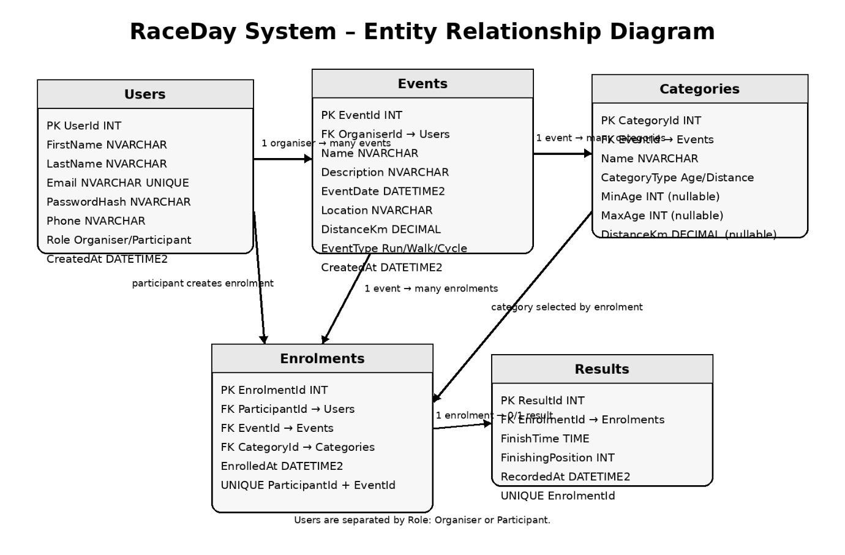
A User with the Organiser role can create and manage multiple Events. Each Event belongs to one Organiser. An Event can contain multiple Categories, while each Category belongs to one Event. A Participant can enrol in multiple Events. Each Enrolment records the Participant, Event and selected Category. An Enrolment can have a Result containing the participant's finishing time and finishing position

