WorkshopPLUS – Power Apps for Power User 1 Day

Module 1: Power Apps prerequisites

Student Lab Manual

**Conditions and Terms of Use**

Microsoft Confidential

This training package is proprietary and confidential and is intended only for uses described in the training materials. Content and software is provided to you under a Non-Disclosure Agreement and cannot be distributed. Copying or disclosing all or any portion of the content and/or software included in such packages is strictly prohibited.

The contents of this package are for informational and training purposes only and are provided "as is" without warranty of any kind, whether express or implied, including but not limited to the implied warranties of merchantability, fitness for a particular purpose, and non-infringement.

Training package content, including URLs and other Internet Web site references, is subject to change without notice. Because Microsoft must respond to changing market conditions, the content should not be interpreted to be a commitment on the part of Microsoft, and Microsoft cannot guarantee the accuracy of any information presented after the date of publication. Unless otherwise noted, the companies, organizations, products, domain names, e-mail addresses, logos, people, places, and events depicted herein are fictitious, and no association with any real company, organization, product, domain name, e-mail address, logo, person, place, or event is intended or should be inferred.

**Copyright and Trademarks**

© 2020 Microsoft Corporation. All rights reserved.

Microsoft may have patents, patent applications, trademarks, copyrights, or other intellectual property rights covering subject matter in this document. Except as expressly provided in written license agreement from Microsoft, the furnishing of this document does not give you any license to these patents, trademarks, copyrights, or other intellectual property.

Complying with all applicable copyright laws is the responsibility of the user. Without limiting the rights under copyright, no part of this document may be reproduced, stored in or introduced into a retrieval system, or transmitted in any form or by any means (electronic, mechanical, photocopying, recording, or otherwise), or for any purpose, without the express written permission of Microsoft Corporation.

For more information, see Use of Microsoft Copyrighted Content at

<http://www.microsoft.com/en-us/legal/intellectualproperty/Permissions/default.aspx>

DirectX, Hyper-V, Internet Explorer, Microsoft, Outlook, OneDrive, SQL Server, Windows, Microsoft Azure, Windows PowerShell, Windows Server, Windows Vista, and Zune are either registered trademarks or trademarks of Microsoft Corporation in the United States and/or other countries. Other Microsoft products mentioned herein may be either registered trademarks or trademarks of Microsoft Corporation in the United States and/or other countries. All other trademarks are property of their respective owners.

Contents

Lab 1: Configure trial tenant 5

Exercise 1: Sign in to Power Apps 6

1. Task 1: Confirm that you are licensed to use Power Apps 6

2. Task 2: Power Apps per user license trial 6

Exercise 2: Create a new environment and CDS for Apps database instance 8

Task 1: Create new environment 8

Task 2: Sign in to Power Apps Studio 11

Exercise 3: Create your first Power Apps app 12

Task 1: Canvas app from blank 12

Exercise 4: Create a new SharePoint site and list 14

Task 1: Create a SharePoint site 14

Task 2: Create a SharePoint list for Device Orders 16

Task 3: Create a SharePoint list for New Device Requests 18

# Lab 1: Configure trial tenant

#### Introduction

In this lab, you will sign in to the Power Apps a**dmin center** and ensure all prerequisites are in place.

#### Objectives

In this lab, you will be able to:

* Sign into the **admin center**
* Configure trial Power Apps per user plan
* Create Power Apps canvas app
* Create SharePoint site and lists

#### Prerequisites

Ensure you are using the “Incognito” or “InPrivate” browsing session of your modern browser.

Additionally, use the latest version of [Microsoft Edge](https://support.microsoft.com/en-us/help/4501095/download-the-new-microsoft-edge-based-on-chromium) (aka Edge Chromium) for the best performance.

#### Estimated time to complete this lab

30 minutes

#### Scenario

The organization wishes to build apps using the Power Apps platform to take advantage of **No Code/Low Code** application development in the cloud. As part of this effort you need to configure the trial tenant to prepare it for labs within workshop.

## Exercise 1: Sign in to Power Apps

1. Task 1: Confirm that you are licensed to use Power Apps

Visit <https://make.powerapps.com>and sign in with your business or school account. This is the same as your Office 365 or Dynamics 365 login.

2. Task 2: Power Apps per user license trial

Usage of the CDS requires a Power Apps per user license (previously called Plan 2).

1. Open the <https://powerapps.microsoft.com> (make sure to open in the Incognito browser window), then select **Start free** near the middle of the screen.

1. In the dialog box that appears, type the email address you created earlier ([username@tenantname.onmicrosoft.com](mailto:username@tenantname.onmicrosoft.com)) and then select **Submit**.
2. If a dialog box indicates that Power Apps recognizes your organizational credentials, follow the prompts to finish signing in.

**Note**: This lab documentation assumes that you will use the web version of Power Apps Studio, which will run in any of these browsers - Microsoft Edge, Internet Explorer 11, Google Chrome, or Safari.

**Note**: If you are unable to sign up for a Power Apps per user license using your organization credentials, you may provision a free Office365 demo tenant from [http://aka.ms/Office365E5Trial.](http://aka.ms/Office365E5Trial) Use the demo tenant credentials to sign up for a Power Appsper usertrial. Make.powerapps.com

Once you have signed up for the Power Apps per user license, you can verify it by following these steps:

* + Visit Office 365 admin portal - <https://admin.microsoft.com/Adminportal/Home#/homepage>
  + From the left navigation, under **Users** > **Active users**, select your user account. Make sure **Microsoft Power Apps Plan 2 trial** license is visible and checked as shown below:

## Exercise 2: Create a new environment and CDS for Apps database instance

### Task 1: Create new environment

You must have a newly created CDS for Apps environment and database instance that was **created after Apr 1, 2018**. If you don’t have a new environment or have an older environment, follow these steps to create the environment and provision the database instance.

1. Open the Power Platform Admin Center by navigating to <https://admin.powerplatform.microsoft.com/environments>in an Incognito web browser. Open the Power Platform Admin Center by navigating to <https://admin.powerplatform.microsoft.com/environments>in an Incognito web browser.

1. You may be prompted to sign up for a free Power Apps per user trial if you haven't already signed up for it. Follow the prompts to start your per user trial, which will give you access to the Admin Center.

**NOTE**: You can also access the Admin Center by signing in at <https://make.powerapps.com>and clicking the settings icon on the top right and selecting **Admin center.**

1. In the **Admin center**, go to Environments from left navigation menu. Select **+ New Environment** on the top left of the screen.

1. Provide a name for the environment**.** A common practice is to use your name followed by "Test," so that it is clear this is a test environment.
   1. Select “Type” as **Trial**
   2. Leave the default region
   3. Toggle No to **Yes** for “Create a database for this environment?” option.
   4. Click **Next**

5. Select your **Currency** and **Language,** toggle No to **Yes** for “Deploy sample apps and data,” and select **Save**.

1. You will see a screen listing all environments that will show the newly created environment.

1. **IMPORTANT**: You will need to wait for the database to finish provisioning before trying to create an application. This can be verified from the PowerApp admin center - <https://admin.powerapps.com/environments>

(orgxxxxxx) will be added to the environment name when it is ready.

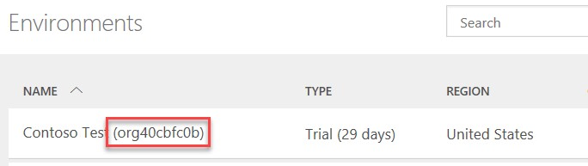

1. This may take a few minutes to complete. Wait for it to complete before proceeding with creating an app. If it has been over two minutes, try refreshing the browser. Once the database is created, you will no longer see the **Provisioning database** message and the environment state will show **Ready**. You can proceed with the lab.

### Task 2: Sign in to Power Apps Studio

1. In an Incognito browser, navigate to <https://powerapps.microsoft.com>and select **Sign in**. Alternately, you can directly navigate to <https://make.powerapps.com>[.](http://web.powerapps.com/)

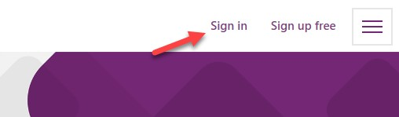

1. Sign in with your admin credentials from Module 0 if you have not already done so.
2. Before creating an app, let’s switch to the new environment that you created. Click on the **Environment** dropdown on the top right of the screen to switch to the new environment. (If your environment doesn't show up, try logging out and logging in again.)

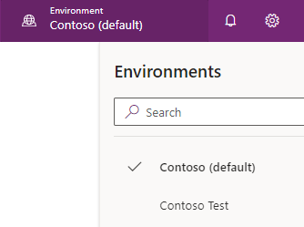

## Exercise 3: Create your first Power Apps app

### Task 1: Canvas app from blank

1. Select **Canvas app from blank**.

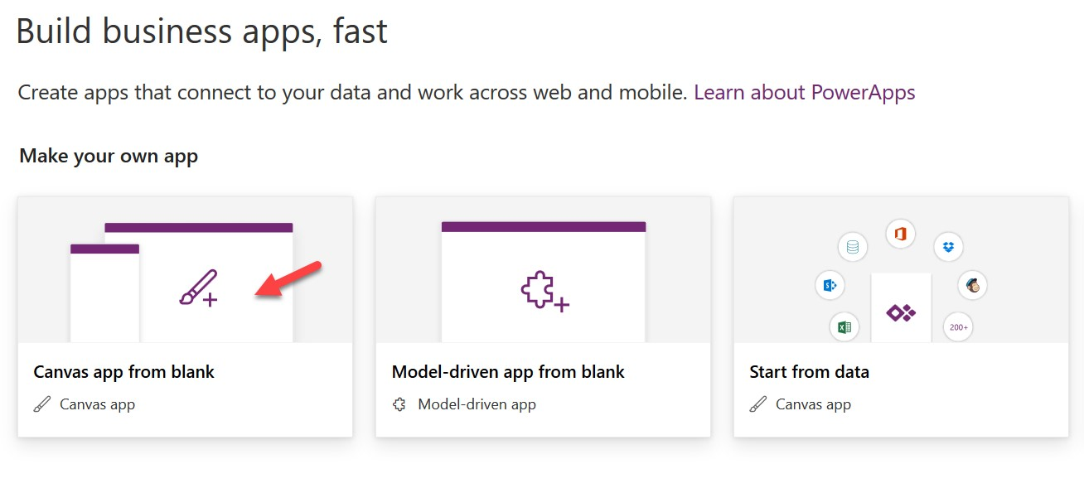

1. Input **Device Ordering App** in the **App name** field. Select **Tablet** as the **Format**. Select **Create**.

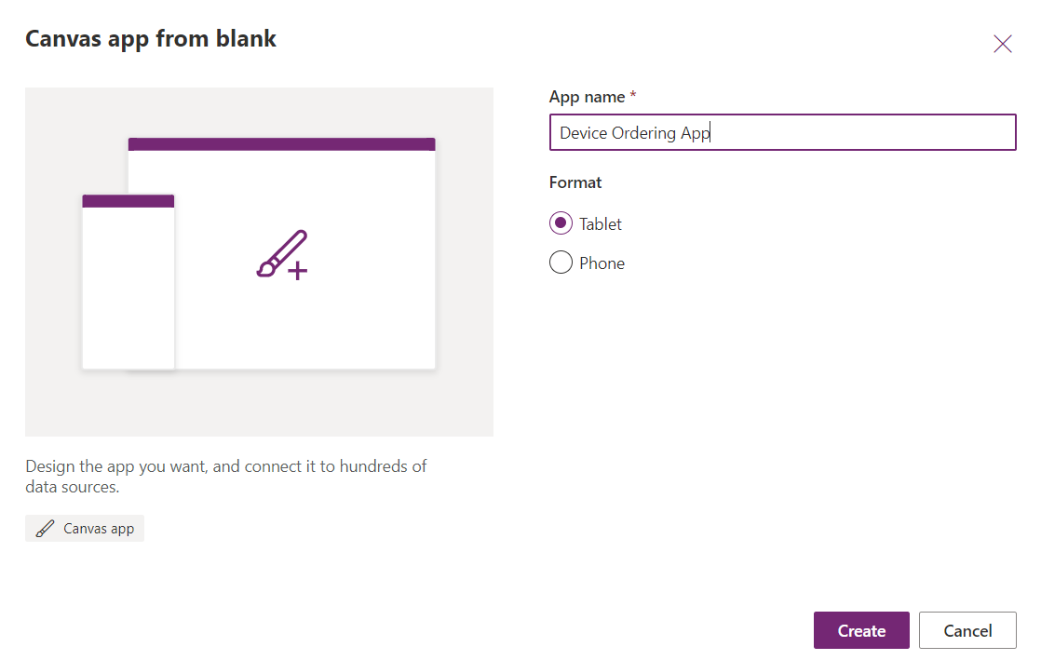

1. Select **Skip** if you receive the **Welcome to PowerApps Studio** prompt.
2. If prompted, select your region and then click **Get started**.

## Exercise 4: Create a new SharePoint site and list

### Task 1: Create a SharePoint site

1. Open the browser and go to <https://portal.office.com> and login with your Office 365 credentials you created in Module 0. Click on the **SharePoint** icon, which will take you to the SharePoint home page.

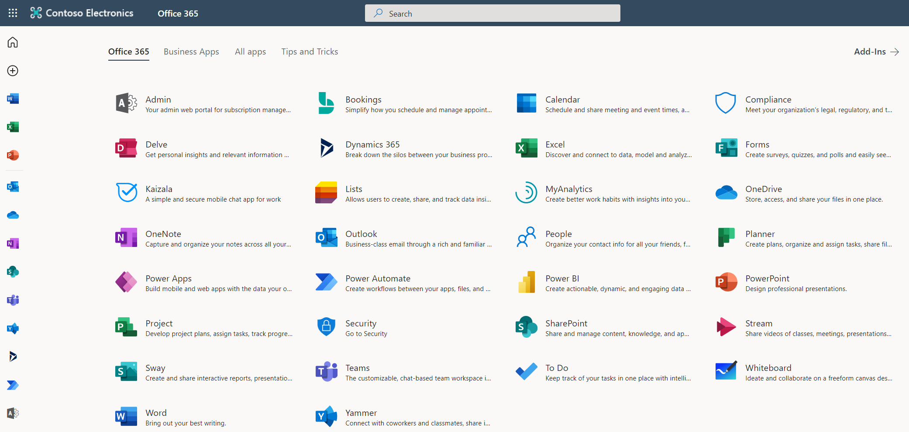

1. In the SharePoint home page, select **+ Create Site**, and create **Team Site**.

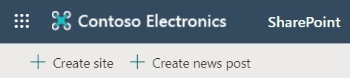

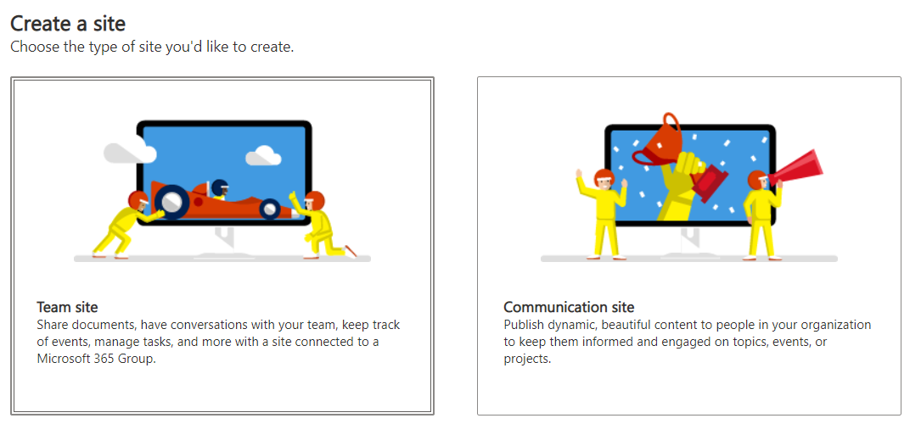

1. Input “Power Apps” as the site name and click **Next**, then click **Finish** and you will be redirected to the site you just created.

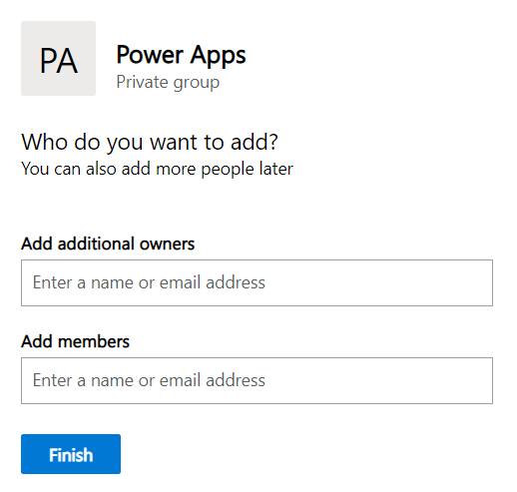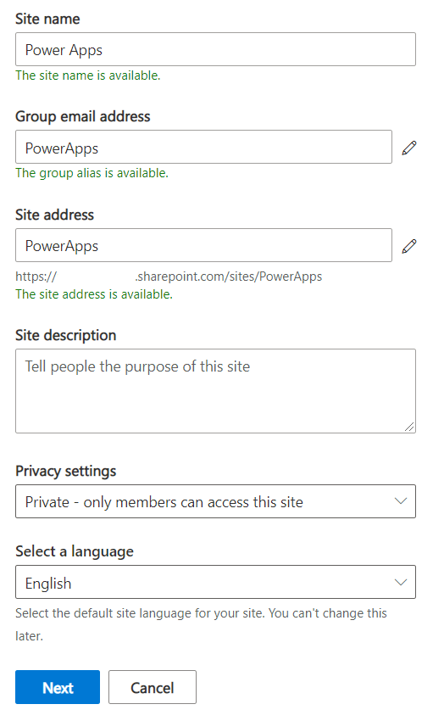

### Task 2: Create a SharePoint list for Device Orders

1. Go to the SharePoint site you created in the previous step and select **+ New** > **List**. Under “Create a list”, select **Blank list**.

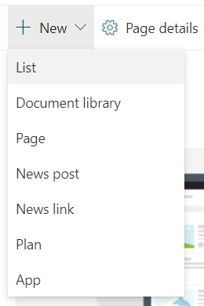 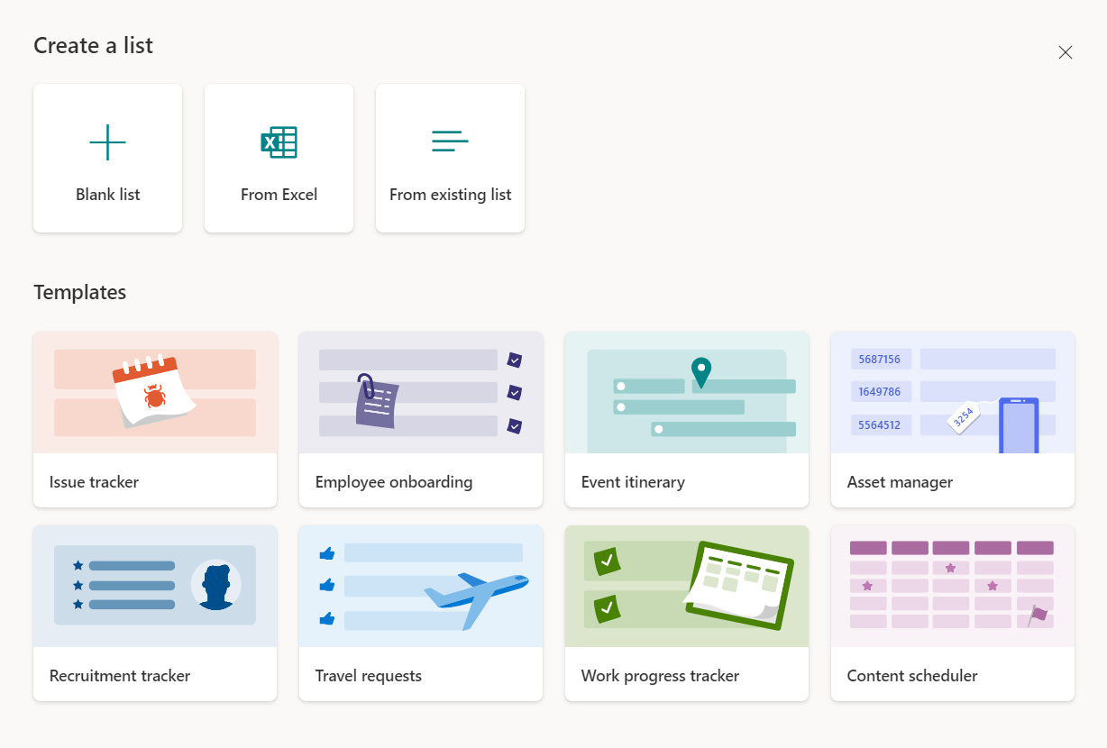

1. Name the list as “**Device Orders**” and select **Create**.

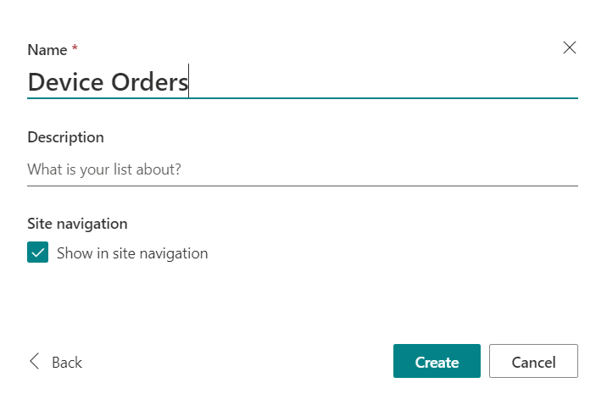

1. Rename the “**Title**” column to “**Device Name**.”

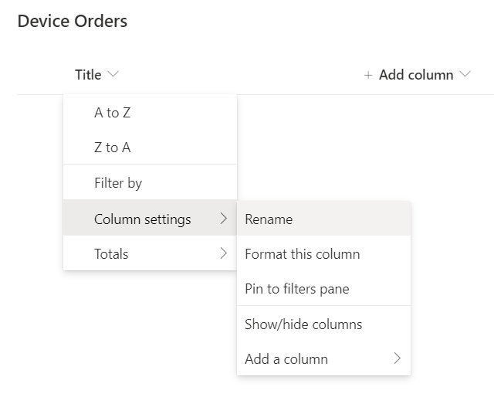

1. Add columns to the newly created list.

* Column Name: **Price**
  + Select **+ Add Column** and select **Currency.**

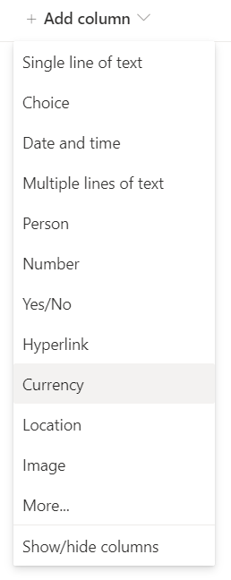

* + Enter column name as “**Price**” and select **Save.**

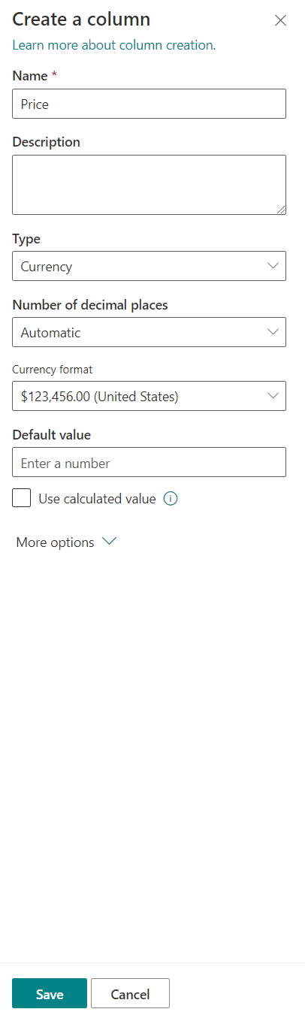

* Column Name: **Approver**
  + Type: Single line of text
* Column Name: **Comments**
  + Type: Multiple lines of text
* Column Name: **Requested By**
  + Type: Single line of text

On adding all columns, **Device Orders** should look as shown below:

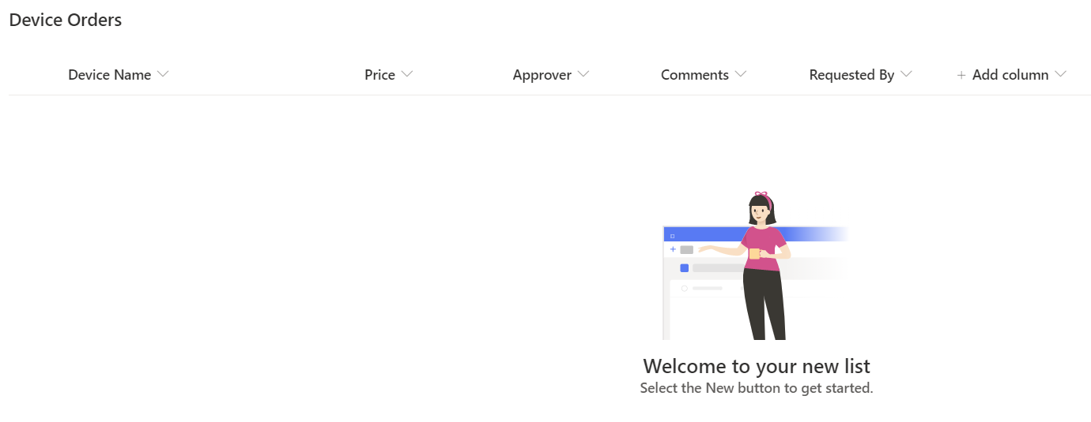

### Task 3: Create a SharePoint list for New Device Requests

1. Go to the SharePoint site you created in the previous step and select **+ New** > **List**. Under “Create a list”, select **Blank list**.

 

1. Name the list as “**New Device Requests**” and select **Create**.

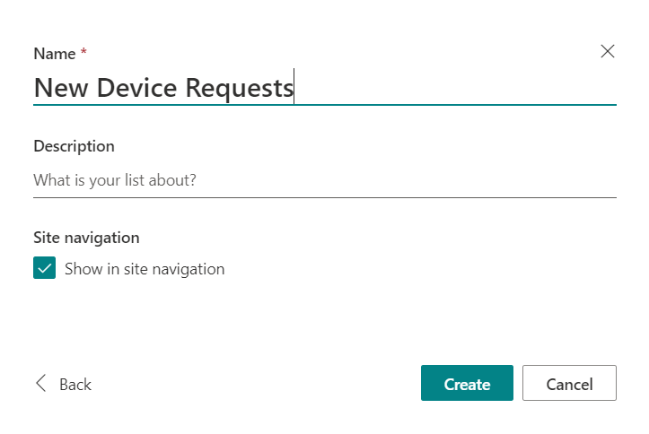

1. Rename the “Title” column to “**Device Name**.”

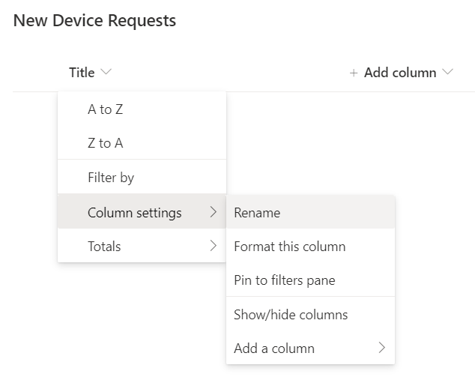

1. Add columns to the newly created list.

* Column Name: **Price**
  + Select **+ Add Column** and select **Currency.**



* + Enter column name as “**Price**” and select **Save.**



* Column Name: **Processor**
  + Type: Single line of text
* Column Name: **Memory**
  + Type: Single line of text
* Column Name: **Storage**
  + Type: Single line of text
* Column Name: **Screen Size**
  + Type: Single line of text
* Column Name: **Requested By**
  + Type: Single line of text

On adding all columns, **New Device Requests** should look as shown below:

