WorkshopPLUS – Power Apps for Power User 1 Day

Module 4.2: Connect the data from the canvas app and submit device request

Student Lab Manual

**Conditions and Terms of Use**

Microsoft Confidential

This training package is proprietary and confidential, and is intended only for uses described in the training materials. Content and software is provided to you under a Non-Disclosure Agreement and cannot be distributed. Copying or disclosing all or any portion of the content and/or software included in such packages is strictly prohibited.

The contents of this package are for informational and training purposes only and are provided "as is" without warranty of any kind, whether express or implied, including but not limited to the implied warranties of merchantability, fitness for a particular purpose, and non-infringement.

Training package content, including URLs and other Internet Web site references, is subject to change without notice. Because Microsoft must respond to changing market conditions, the content should not be interpreted to be a commitment on the part of Microsoft, and Microsoft cannot guarantee the accuracy of any information presented after the date of publication. Unless otherwise noted, the companies, organizations, products, domain names, e-mail addresses, logos, people, places, and events depicted herein are fictitious, and no association with any real company, organization, product, domain name, e-mail address, logo, person, place, or event is intended or should be inferred.

**Copyright and Trademarks**

© 2020 Microsoft Corporation. All rights reserved.

Microsoft may have patents, patent applications, trademarks, copyrights, or other intellectual property rights covering subject matter in this document. Except as expressly provided in written license agreement from Microsoft, the furnishing of this document does not give you any license to these patents, trademarks, copyrights, or other intellectual property.

Complying with all applicable copyright laws is the responsibility of the user. Without limiting the rights under copyright, no part of this document may be reproduced, stored in or introduced into a retrieval system, or transmitted in any form or by any means (electronic, mechanical, photocopying, recording, or otherwise), or for any purpose, without the express written permission of Microsoft Corporation.

For more information, see Use of Microsoft Copyrighted Content at

<http://www.microsoft.com/en-us/legal/intellectualproperty/Permissions/default.aspx>

DirectX, Hyper-V, Internet Explorer, Microsoft, Outlook, OneDrive, SQL Server, Windows, Microsoft Azure, Windows PowerShell, Windows Server, Windows Vista, and Zune are either registered trademarks or trademarks of Microsoft Corporation in the United States and/or other countries. Other Microsoft products mentioned herein may be either registered trademarks or trademarks of Microsoft Corporation in the United States and/or other countries. All other trademarks are property of their respective owners.

Contents

Lab 4.2: Connect the data from the canvas app and submit device order 5

Exercise 1: Add SharePoint list as a data source and device submit form to the app 6

Task 1: Add SharePoint list as data source 6

Task 2: Create the edit form 8

Task 3: Configure the title field 10

Task 4: Configure the price field 12

Task 5: Configure the approver field 14

Task 6: Configure the Comment field 16

Task 7: Configure the Requested By field 17

Task 8: Add a button to submit the form 17

Task 9: On successful submission navigate to a new screen 19

Task 10: Verify successful submission 20

# Lab 4.2: Connect the data from the canvas app and submit device order

**Introduction**

Now that you have created the list to store device order requests, let’s connect Device Ordering App to this list and add a form to submit device approval requests.

**Objectives**

After completing this lab, you will be able to:

#### Connect SharePoint list as data source

#### Configure and add form

#### Submit Form

#### Test the app

**Prerequisites**

Ensure you are using the “Incognito” or “InPrivate” browsing session of your modern browser.

Additionally, use the latest version of [Microsoft Edge](https://support.microsoft.com/en-us/help/4501095/download-the-new-microsoft-edge-based-on-chromium) (aka Edge Chromium) for the best performance.

**Estimated time to complete this lab**

45 mins

#### Scenario

The organization wishes to build apps using the PowerApps platform to take advantage of **No Code/Low Code** application development in the cloud. As part of this effort, you are required to add new data source (SharePoint list), configure, add and submit form, add/remove gallery controls, manipulate the navigation, and test the functionality of your app.

## Exercise 1: Add SharePoint list as a data source and device submit form to the app

### Task 1: Add SharePoint list as data source

1. Navigate to the **Device Ordering App** you created in the previous module, select the app, and click **Edit**.

2. Select the **View** tab and then click **Data sources** to display the Data pane to the right of the canvas.

3. Search SharePoint, click **SharePoint** (SharePoint helps organizations ….), and select **Add a connection**.

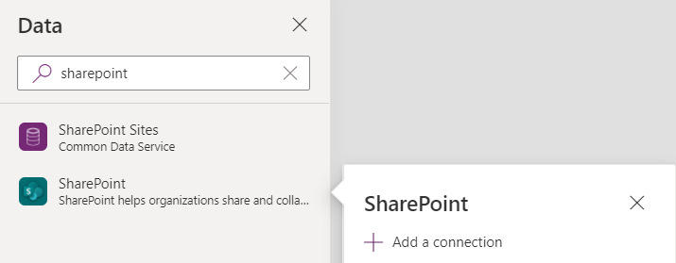

4. On the right-hand pane, leave **Connect directly (cloud services)** selected, and click **Connect** at the bottom.

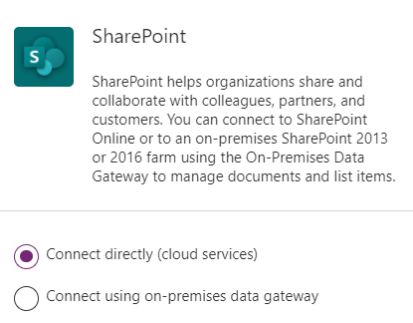

5. Connect to the SharePoint site we created earlier and select the site.

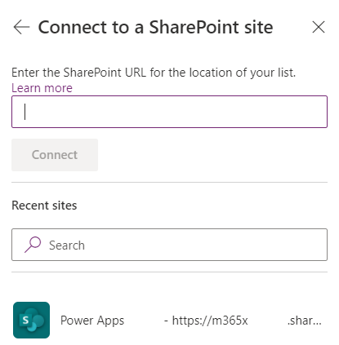

6. Check **Device Orders** and select **Connect** at the bottom.

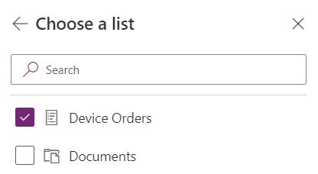

### Task 2: Create the edit form

1. Select the **MainScreen**.

2. Select few devices. Hold the “Alt” key, and then it will allow you to check the compare on the devices.

3. Select the **CompareScreen**. You will now have the selected devices.

4. Select the **Insert** tab, click **Forms**, and select **Edit**. Rename Form1 to **SubmitOrder.**

5. Click the Data Source drop-down in the Data pane on the right and select **Device Orders** (SharePoint data source).

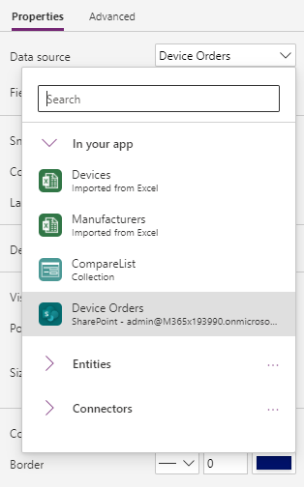

6. Click Edit Fields.

7. Remove the Attachment field.

8. Set **Columns** Property to 1 and **Default mode** to New.

### Task 3: Configure the title field

In the next few steps, you will configure each of the form fields.

Let’s start by configuring the Title to display the manufacturer and device name for the selected device. For example, if the user selects the Surface Pro device, we want the device order to have the title: “Microsoft – Surface Pro.”

* 1. Expand and select Title.

Notice that the default card contains a few controls:

**StarVisible1**: This is a label control that has an asterisk (*) which has its Visible property set to true or false depending on whether the field is Required or not. Since the Title field was marked as Required when you configured the entity, its Required property is set to true.

**ErrorMessage1**: This is a label that is just below the main data entry field which displays error messages.

**DataCardValue1**: This is the text input control where you can enter the Title. For this scenario, we will set the title based on the selected device. DataCardKey1: This is the label that displays the title of the field.

* 1. Select **Title_DataCard1** and click **Advanced**

3. Click unlock so you can customize the card

For the next few steps, we will use the Advanced pane to customize control properties within the form, note that you can perform the same customizations using the property drop-down, and formula bar in the top left of the studio.

4. Change DisplayName and Required fields as below

5. To display the selected item in the Title field, set the Default property to CompareListGallery.Selected.ManufacturerName & " - " & CompareListGallery.Selected.Title

6. Click **More Options** button in the **DESIGN** section of the Advanced pane. We are going to change the Device Name field to be read only so they don’t change it.

7. Change the DisplayMode to DisplayMode.View. This will prevent users from changing the value within the text box.

### Task 4: Configure the price field

In this task, we are going to set the price to the price of the item and then make it read-only.

1. Expand Price.

1. Select the **Data Card.**

3. Select the **Advanced** tab and click **Unlock**.

4. Change the Default property to: Text(CompareListGallery.Selected.Price,"[$-en-US]$##,###.00")

5. Select Price and change the **DisplayMode** property to **DisplayMode.View.**

6. Select the **Advanced** tab and click **Unlock**.

### Task 5: Configure the approver field

Let’s set the default value for the Approver to be the email address of the logged in user’s manager.

You will use the Office 365 graph to retrieve the manager’s email. You can find more about the Office 365 Users Connection provider here: <https://docs.microsoft.com/connectors/office365users/>

1. Select View in the ribbon, then Data sources, search for **Office 365 Users**, and **+ Add a connection**.

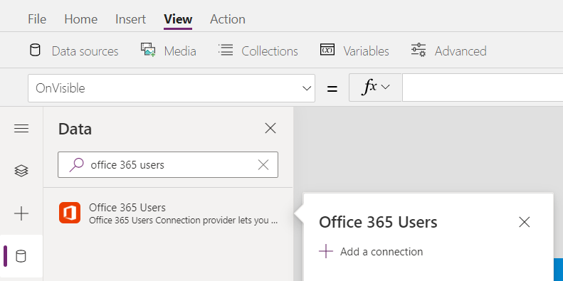

1. On the right-hand pane, select **Connect** at the bottom of the right-hand pane.

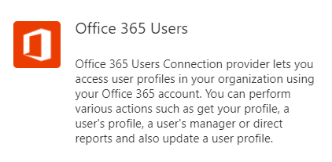

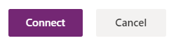

1. Close the Data pane.
2. Select **Approver**.

7. Go to the **Advanced** pane and **Unlock**.

8. Set the Default value to: User().Email This expression will use your user’s email, so you won’t accidentally email your manager to approve your testing.

In a real application or if you wanted to try the expression to use your managers email would be Office365Users.Manager(User().Email).Mail This would make an API call at runtime to get the manager’s email address of the logged-on user. If you try this and hit an error when calling the Office365Users.Manager() function, this may be because a manager is not set up in the system for the logged in Office 365 user. In that case, you can simply go back go User().Email.

The Office 365 User connector has access to many other valuable types of information. You can learn more about the other actions and data available here: <https://docs.microsoft.com/en-us/connectors/office365users/>

### Task 6: Configure the Comment field

1. Expand the **Comments** field and select the **DataCardValue**.

2. Select the **Advanced** tab and **Unlock**.

3. Change the **Mode** to TextMode.MultiLine

4. Select the **Properties** tab and change the **Size -> Height** value to **80**.

Optionally, you may select the Text Input control **DataCardValue4** and set its **HintText** property to: “Enter justification” (without quotes).

### Task 7: Configure the Requested By field

Let’s set the Requested By field to be the current logged on user’s email and disable the control so the user cannot change this value.

1. Select the Requested By card.

2. Go to the Advanced pane and Unlock the card.

3. Change the DisplayMode property to: DisplayMode.View

4. Set the Default value to User().Email. This is the email of the currently logged in user.

### Task 8: Add a button to submit the form

1. Select the **MainScreen**.

2. Copy the **Compare button** from the first screen which has the correct color values.

3. Go back to the CompareScreen and paste (Ctrl-V) the button.

4. Position it in the bottom right of the screen, center aligned with the Form.

5. Make the button larger – you can resize to 280x60 using the Properties pane on the right.

6. Set the button’s Text property to “Submit device request”

7. Rename the button to **SubmitButton**.

8. The button should be enabled only if a device is selected. To do this, change the button’s DisplayMode property to: If(!IsBlank(CompareListGallery.Selected), DisplayMode.Edit, DisplayMode.Disabled)

Note: You might notice the exclamation mark (!) in the formula !IsBlank() Normally if you just have IsBlank() the check is for blank. Adding the exclamation mark (!) in front of it changes it to check if it is NOT blank.

9. Next, we are going to configure what we want to happen when the button is clicked. Set the OnSelect property to SubmitForm(SubmitOrder) & ResetForm(SubmitOrder)

When the button is pressed, the form data will be submitted to the SharePoint list.

Finally, the submit form should look like below:

### Task 9: On successful submission navigate to a new screen

1. Create a **new screen** (Success) and rename it – **Success**

Update the text of the new screen as shown below

2. Select Compare Screen > Form1 > Advanced, set OnSuccess value to Navigate(Success,ScreenTransition.Fade)

### Task 10: Verify successful submission

1. Browse to the SharePoint list – Device Orders

2. Make sure successful submissions are stored in the list.

