WorkshopPLUS – Power Apps for Power User 1 Day

Module 5: Connect the data from the canvas app, implement an AI Builder form processor, and submit new device request

Student Lab Manual

**Conditions and Terms of Use**

Microsoft Confidential

This training package is proprietary and confidential, and is intended only for uses described in the training materials. Content and software is provided to you under a Non-Disclosure Agreement and cannot be distributed. Copying or disclosing all or any portion of the content and/or software included in such packages is strictly prohibited.

The contents of this package are for informational and training purposes only and are provided "as is" without warranty of any kind, whether express or implied, including but not limited to the implied warranties of merchantability, fitness for a particular purpose, and non-infringement.

Training package content, including URLs and other Internet Web site references, is subject to change without notice. Because Microsoft must respond to changing market conditions, the content should not be interpreted to be a commitment on the part of Microsoft, and Microsoft cannot guarantee the accuracy of any information presented after the date of publication. Unless otherwise noted, the companies, organizations, products, domain names, e-mail addresses, logos, people, places, and events depicted herein are fictitious, and no association with any real company, organization, product, domain name, e-mail address, logo, person, place, or event is intended or should be inferred.

**Copyright and Trademarks**

© 2020 Microsoft Corporation. All rights reserved.

Microsoft may have patents, patent applications, trademarks, copyrights, or other intellectual property rights covering subject matter in this document. Except as expressly provided in written license agreement from Microsoft, the furnishing of this document does not give you any license to these patents, trademarks, copyrights, or other intellectual property.

Complying with all applicable copyright laws is the responsibility of the user. Without limiting the rights under copyright, no part of this document may be reproduced, stored in or introduced into a retrieval system, or transmitted in any form or by any means (electronic, mechanical, photocopying, recording, or otherwise), or for any purpose, without the express written permission of Microsoft Corporation.

For more information, see Use of Microsoft Copyrighted Content at

<http://www.microsoft.com/en-us/legal/intellectualproperty/Permissions/default.aspx>

DirectX, Hyper-V, Internet Explorer, Microsoft, Outlook, OneDrive, SQL Server, Windows, Microsoft Azure, Windows PowerShell, Windows Server, Windows Vista, and Zune are either registered trademarks or trademarks of Microsoft Corporation in the United States and/or other countries. Other Microsoft products mentioned herein may be either registered trademarks or trademarks of Microsoft Corporation in the United States and/or other countries. All other trademarks are property of their respective owners.

Contents

Lab 5: Connect the data from the Canvas App, implement an AI Builder form processor, and submit new device request. 5

Exercise 1: Add SharePoint list as a data source, add the AI model, and add the device submit form to the app 6

Task 1: Add SharePoint list as data source 6

Task 2: Create the request new laptop form 8

Task 3: Configure the AI model 14

Task 4: Implement the AI Model 19

Task 5: Add a navigation control 23

Task 6: Verify navigation and successful submission 24

# Lab 5: Connect the data from the canvas app, implement an AI Builder form processor, and submit new device request.

**Introduction**

Now that you have created the list to store device order requests, let’s connect your Device Ordering App to this entity and add a form to submit device approval requests.

**Objectives**

After completing this lab, you will be able to:

#### Connect SharePoint list as data source

#### Configure AI Builder form processor

#### Configure and add form

#### Submit Form

#### Test the app

**Prerequisites**

Ensure you are using the “Incognito” or “InPrivate” browsing session of your modern browser.

Additionally, use the latest version of [Microsoft Edge](https://support.microsoft.com/en-us/help/4501095/download-the-new-microsoft-edge-based-on-chromium) (aka Edge Chromium) for the best performance.

**Estimated time to complete this lab**

45 mins

#### Scenario

The organization wishes to build apps using the PowerApps platform to take advantage of **No Code/Low Code** application development in the cloud. As part of this effort, you are required to add new data source (SharePoint list), configure, add and submit form, add/remove gallery controls, manipulate the navigation, and test the functionality of your app.

## Exercise 1: Add SharePoint list as a data source, add the AI model, and add the device submit form to the app

### Task 1: Add SharePoint list as data source

1. Navigate to the **Device Ordering App** you created previous module, select the app, and click **Edit**.

1. Select the **View** tab and then click **Data sources** to display the Data pane to the right of the canvas.

1. Search SharePoint, click **SharePoint** (SharePoint helps organizations ….), and select **Add a connection**.

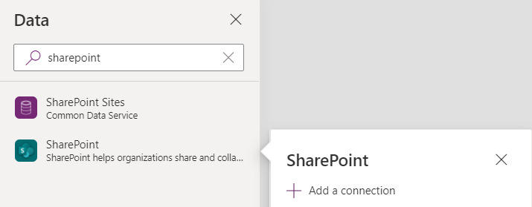

1. On the right-hand pane, leave **Connect directly (cloud services)** selected, and click **Connect** at the bottom.

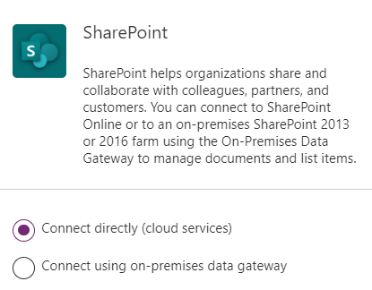

1. Connect to the SharePoint site we created earlier and select the site.

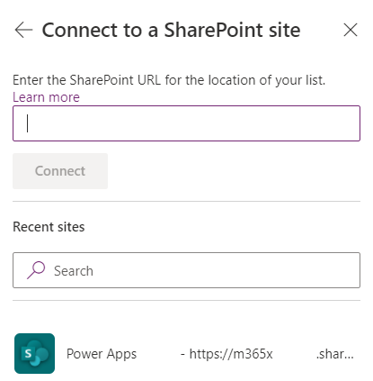

1. Choose a list – New Device Requests and click connect.

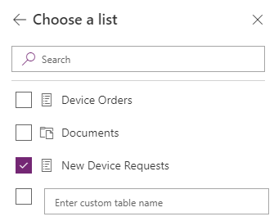

### Task 2: Create the request new laptop form

1. Duplicate the **CompareScreen**

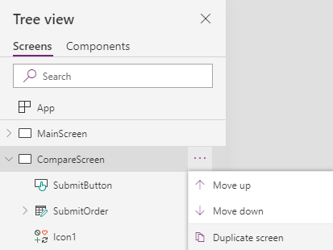

1. Rename the screen to **RequestNewLaptopScreen**

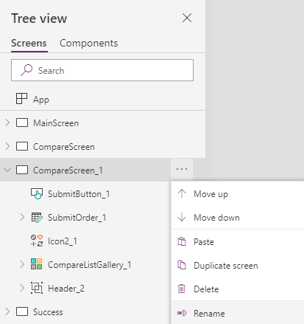

1. Delete the **CompareListGallery_1** control

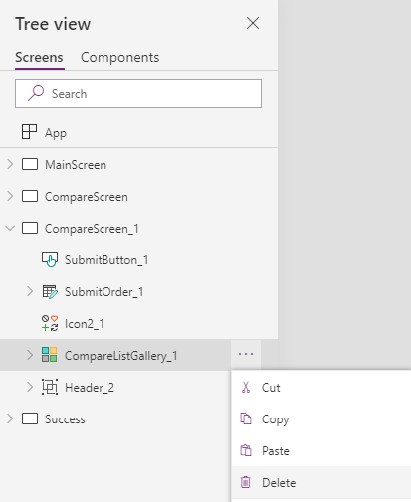

1. Select the **Insert** tab, click **AI Builder**, and select **Form processor**.

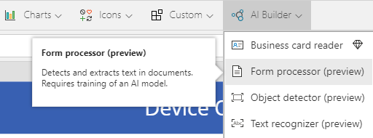

**NOTE:** If you don’t see the AI Builder option, you need to create the CDS for Apps environment and database instance. This is outlined in Module 1, Exercise 2.

1. Position the form processor to take up the left half of the screen.

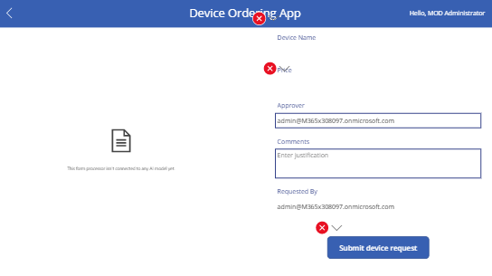

1. As we can see in the screenshot above, we have errors with our copied form fields. First, rename SubmitOrder_1 to **SubmitDeviceRequest.**

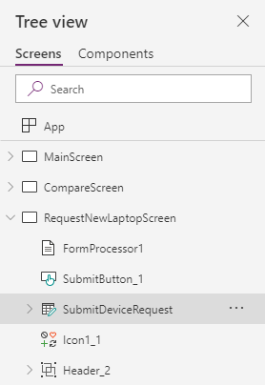

1. Now we’re going to change the fields for the form. Click on **SubmitDeviceRequest,** go to the Properties pane, and change the **Data source** from “Device Orders” to **New Device Requests.**

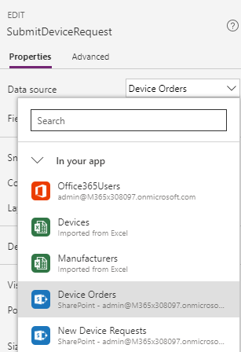

1. A popup will appear asking if you would like to replace the data cards. Select **Replace my data cards.**

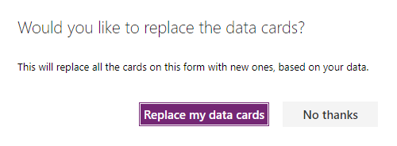

1. Select the SubmitDeviceRequest form, go to the Properties pane, and click **Edit fields**. Click the ellipsis next to the **Attachments** field and select **Remove.**

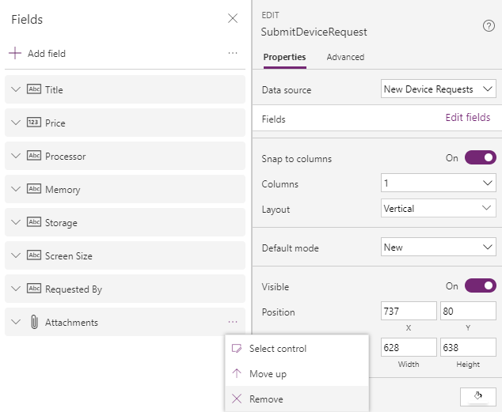

1. Expand SubmitDeviceRequest and select **Title_DataCard2**, click the ellipsis, and click **Unlock.**

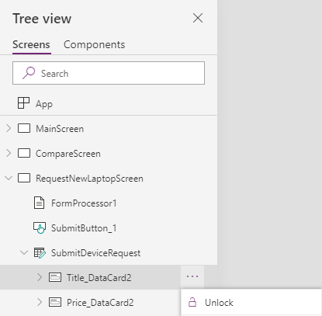

1. Navigate to the properties pane, change the **DisplayName** to “Device Name,” and change **Required** to **false** to remove the asterisk in front of the string.

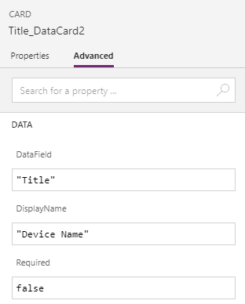

1. Drag the SubmitDeviceRequest form upwards so that the **SubmitButton_1** can fit underneath. The Requested By DataCard can be viewed via scrolling on the form.

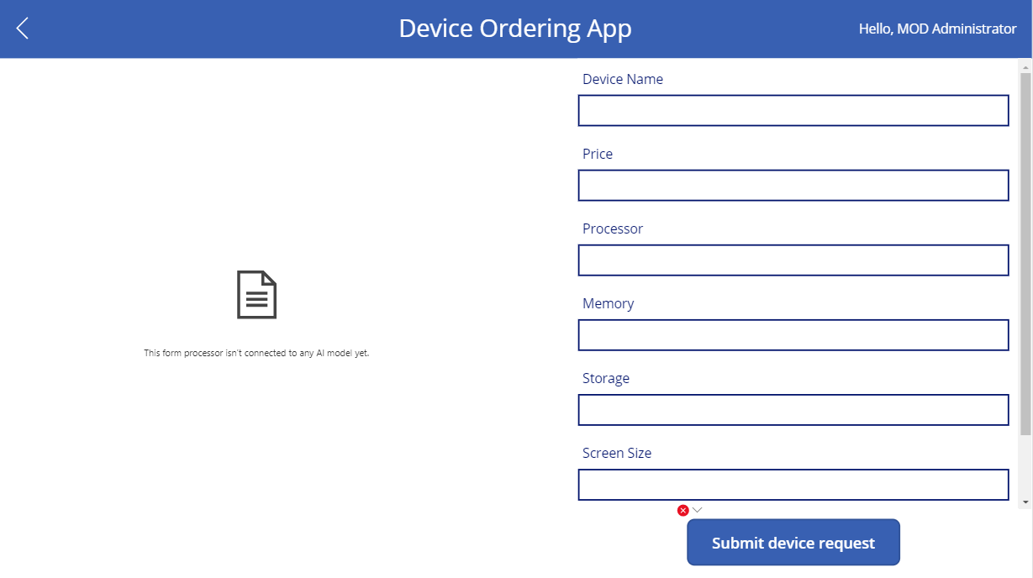

### Task 3: Configure the AI model

In the next few steps, you will configure the AI Model.

1. Navigate to <https://make.powerapps.com/>
2. Click **AI Builder**,click **Build**, and select **Form Processing.**

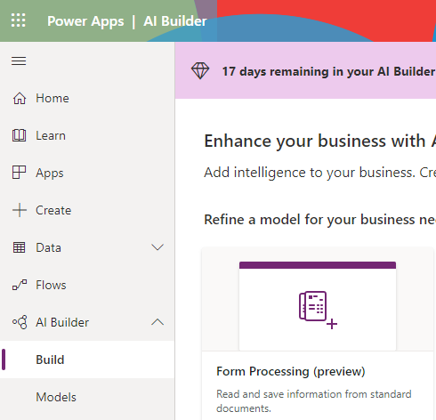

1. Name the model “**Request New Device Model”** and click **Create.**

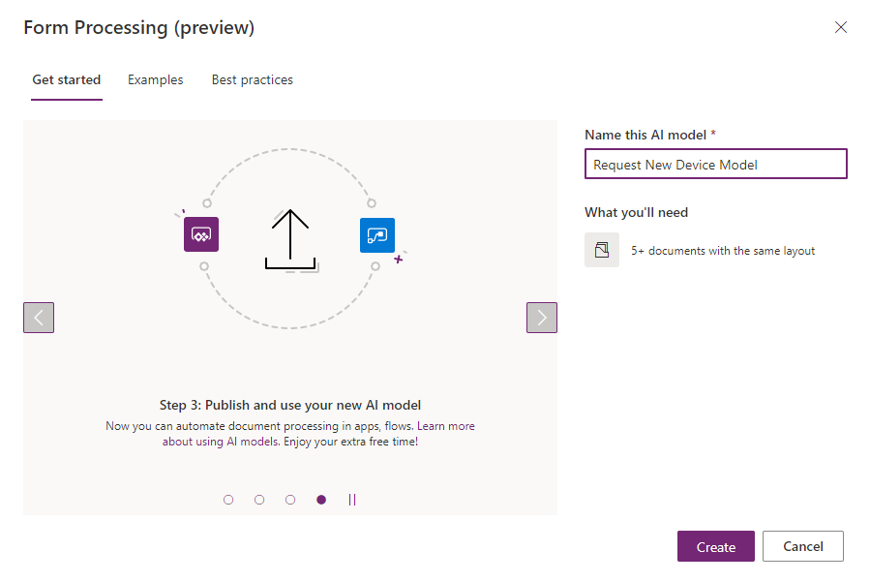

1. Confirm that the following fields are selected on the right pane and click **Done.**

1. Click **Add Documents**, add the first five documents from the Labs -> AI Builder folder, and click **Upload 5 documents**

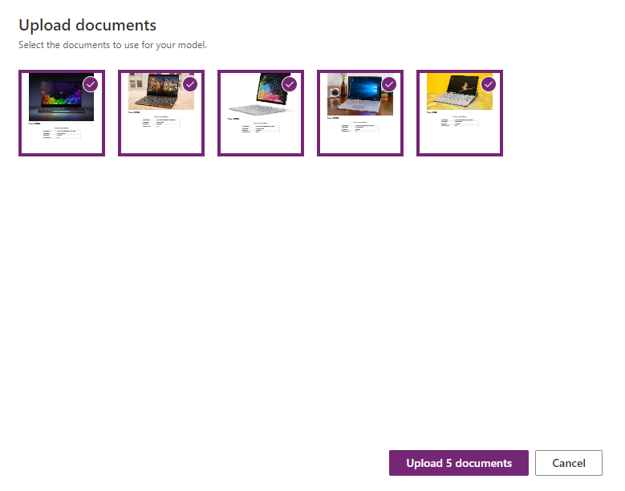

1. Click **Close**, then click the **Analyze** button
2. Select the form fields to train the model with  
   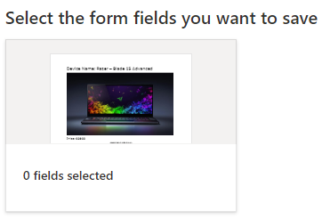
3. Select all the boxes outlined with purple dotted lines:

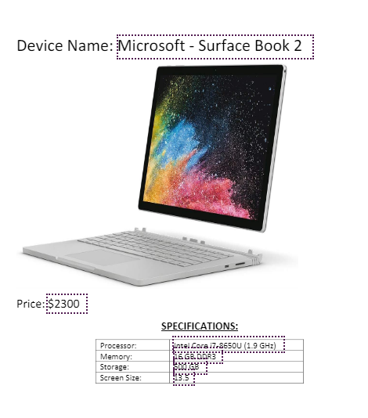

1. Click the **Next** button and subsequently the **Train** button.

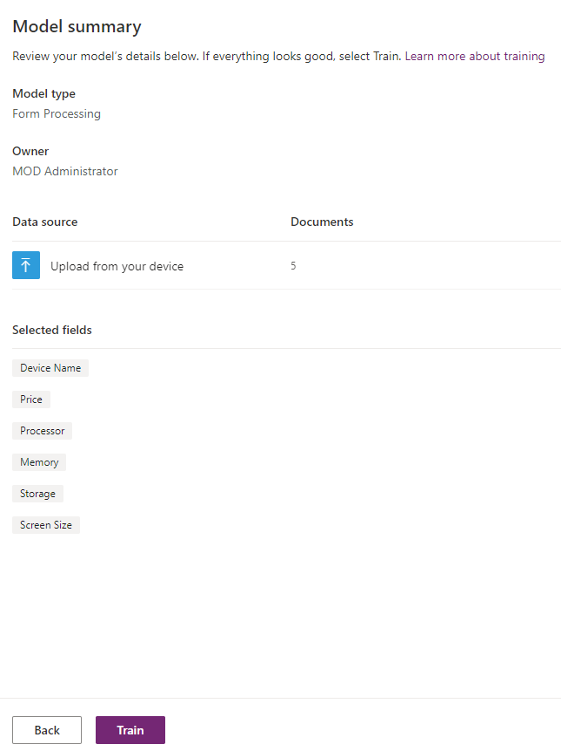

1. Click the **Go to Details page** button

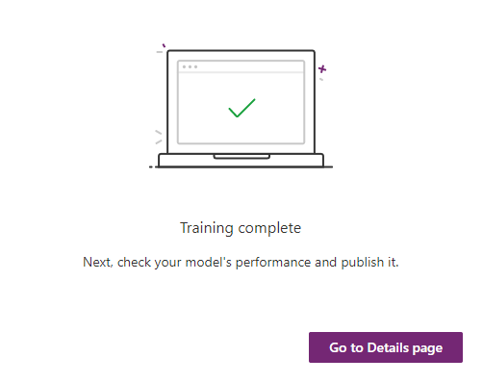

1. Click the **Publish** button to make the model useable within the **Device Ordering App**.

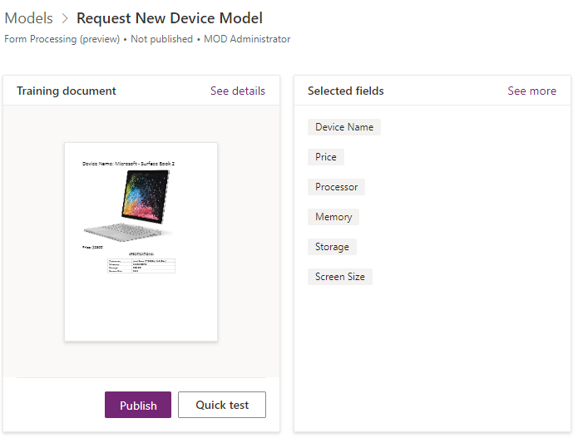

1. Let’s ensure the model is functioning correctly. Click the **Quick Test** button and upload the “Yoga C930.pdf” file from the Labs -> AI Builder folder.

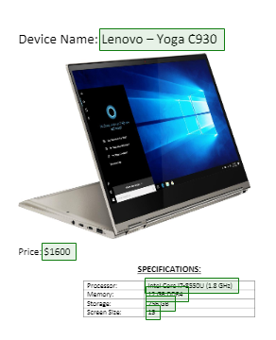

1. As expected, all the fields have been identified. Now it’s time to implement this model into our PowerApp.

### Task 4: Implement the AI Model

In this task, we are going to implement the AI model in the form processor.

1. Navigate back to the PowerApp
2. Select the **RequestNewLaptopScreen** and select **FormProcessor1**

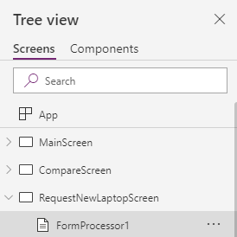

1. Select the **Properties** tab and click **Select model**

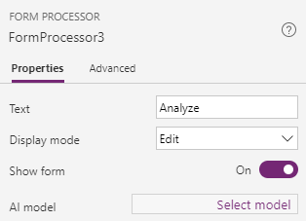

1. Select the **Request New Device Model** that we previously created.

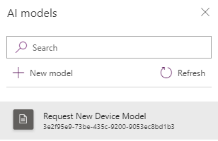

1. Expand the **SubmitDeviceRequest** form and expand the **Title_DataCard** label

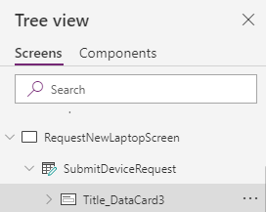

1. Click the **Title_DataCardValue** labeland set the **Default** property to:   
   FormProcessor1.Fields.'Device Name'



1. Change the **DisplayMode** property to DisplayMode.View. This will prevent users from changing the value within the text box.



1. Expand the **Price_DataCard -> DataCardValue** label**,** select the **Advanced** tab, click **Unlock** and set the Default property to: FormProcessor1.Fields.Price



1. Change the DisplayMode to DisplayMode.View



1. Repeat steps 8 and 9, substituting the word “Price” at the end of ‘FormProcessor1.Fields.Price’ for each specification (Processor, Memory, Storage, and Screen Size). These fields will auto populate as you type them into the formula bar.

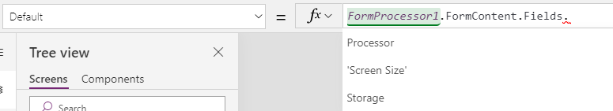

1. Expand the **Requested By -> DataCardValue** label, select the **Advanced** tab, click **Unlock**, set the **Default** to: User().Email, and change the **DisplayMode** property to: DisplayMode.View



1. Test that all fields are displaying the correct text by holding the “Alt” key, click the **Analyze** button on the form processor, and upload the “Razer Blade 15.pdf” file from Labs -> AI Builder.

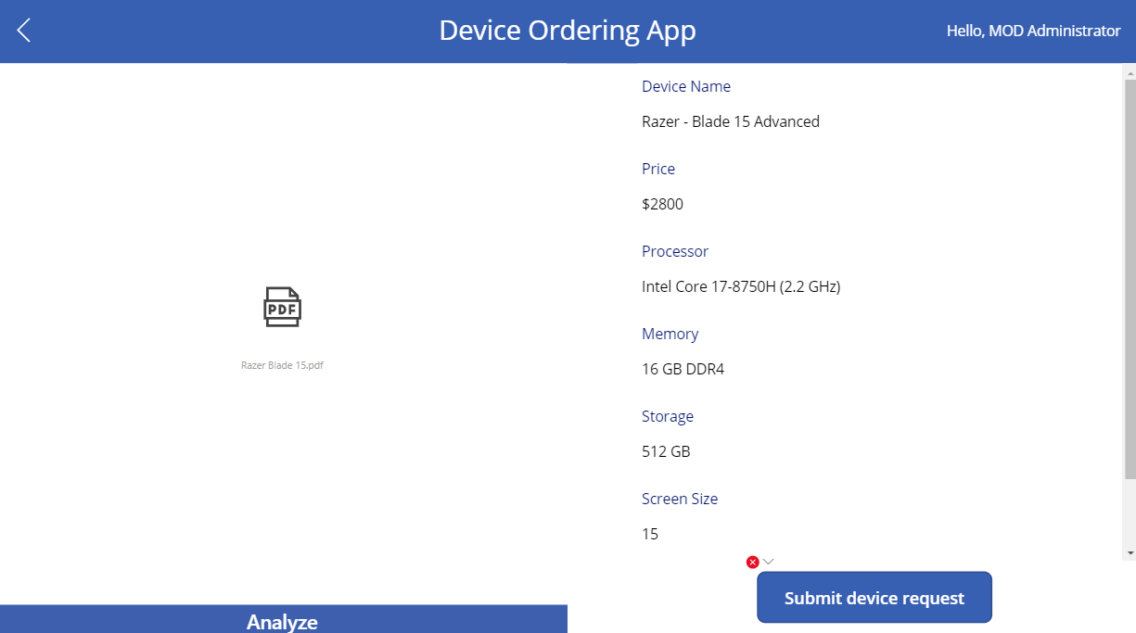

1. There is still an error regarding **SubmitButton_1**: a reference to the CompareListGallery from the previous module. To remove this, select the red X button and click **Edit in the formula bar**.

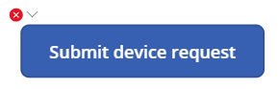 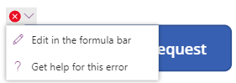

1. We only want to show the button when a form has been analyzed (when text is shown for the TitleDataCard -> DataCardValue), so change the **DisplayMode** property of **SubmitButton_1** to:  
   If(!IsBlank(DataCardValue14.Text), DisplayMode.Edit, DisplayMode.Disabled)



NOTE: You will have to change the number highlighted above to match your **Title_DataCard2** -> **DataCardValueXX** label

1. Click on **SubmitButton_1** and modify the Onselect property to be: SubmitForm(SubmitDeviceRequest)



1. Select **RequestNewLaptopScreen** à **SubmitDeviceRequest** and set the **OnSuccess** property to Navigate(Success,ScreenTransition.Fade)



### Task 5: Add a navigation control

1. Navigate to **MainScreen**.

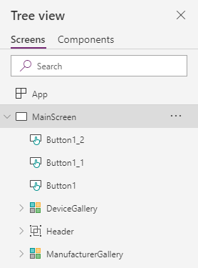

1. Copy **Button1** and paste it on **MainScreen**.
2. Select the new button **Button1_2** and change the **OnSelect** property to: Navigate(RequestNewLaptopScreen, ScreenTransition.None)



1. Change the **Text** property to “Request Device Not Listed”



1. Change the **DisplayMode** property to: DisplayMode.Edit



1. Rearrange the buttons on the bottom of the screen: slide the “Clear selection” button next to the “Compare x item(s)” button and put the new button in its original place.

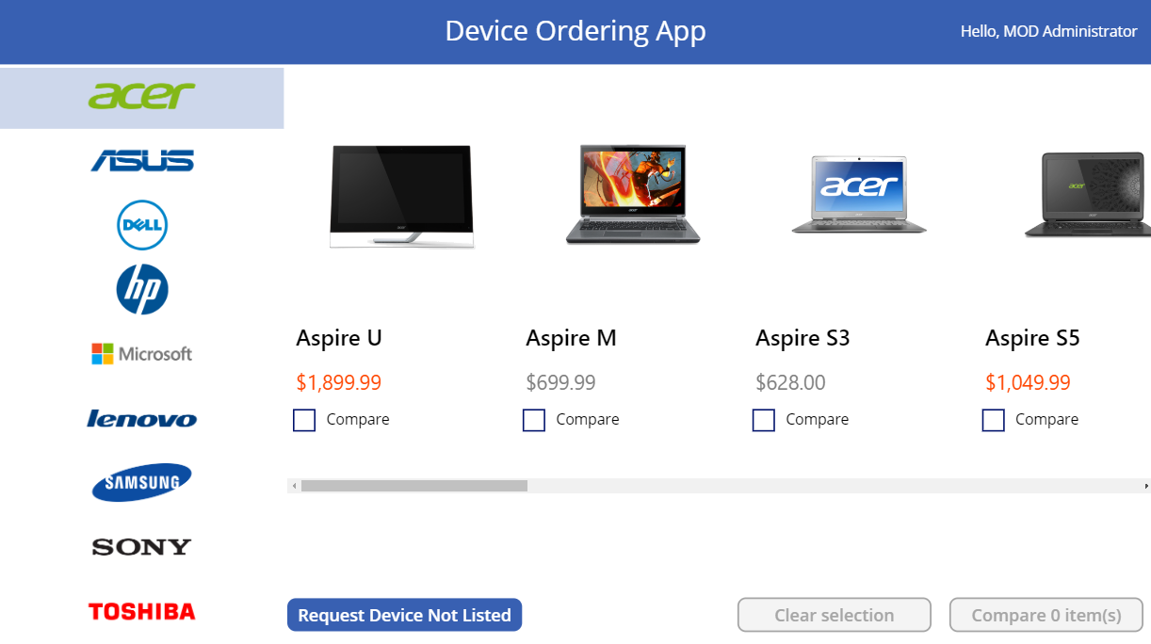

### Task 6: Verify navigation and successful submission

1. Hold the ‘Alt’ key and select the “Request Device Not Listed” button
2. Hold the ‘Alt’ key, click the **Analyze** button, and upload the “Yoga C930.pdf” file from the Labs -> AI Builder folder
3. Hold the ‘Alt’ key and click on the **Submit device request** button
4. Browse to the SharePoint list – New Device Requests
5. Make sure the successful submission is stored in the list.

