USERDAO.JAVA

package com.example.demo1;  
  
import javax.servlet.http.HttpSession;  
import javax.sql.DataSource;  
import javax.xml.transform.Result;  
import java.sql.Connection;  
import java.sql.DriverManager;  
import java.sql.PreparedStatement;  
import java.sql.ResultSet;  
  
public class UserDAO {  
 private Connection con;  
 private PreparedStatement pstmt;  
 private ResultSet rs;  
 private DataSource ds;  
 public UserDAO(){ *// 생성자* try{  
 Class.*forName*("com.mysql.cj.jdbc.Driver");  
 String url = "jdbc:mysql://localhost:3306/jspdb?serverTimezone=UTC";  
 String jdbcId="root";  
 String jdbcpw = "1234";  
 con = DriverManager.*getConnection*(url,jdbcId,jdbcpw);  
*// con = ds.getConnection();* }catch (Exception e){  
 e.printStackTrace();  
 }  
 }  
 public String isExisted(UserVO userVO) {  
 String sql = "select \* from jspdb.user where userid = ? and userpw = ?";  
 PreparedStatement pstmt = null; *// assign null first* try {  
 pstmt = con.prepareStatement(sql);  
 pstmt.setString(1, userVO.getId());  
 pstmt.setString(2, userVO.getPw());  
 rs = pstmt.executeQuery();  
 if (rs.next()) {  
 userVO.setName(rs.getString("username"));  
 return rs.getString("username");  
 }  
 }  
 catch(NullPointerException e){  
 System.*out*.printf("nullpointexception 로그인실패");  
 return null;  
  
 } catch (Exception e) {  
 e.printStackTrace();  
 }  
 System.*out*.printf("로그인실패");  
 return null;  
 }  
  
}

USERVO.JAVA

package com.example.demo1;  
  
public class UserVO {  
 private String id;  
 private String pw;  
 private String name;  
 public String getId() {  
 return id;  
 }  
 public void setId(String id) {  
 this.id = id;  
 }  
 public String getPw() {  
 return pw;  
 }  
 public void setPw(String pw) {  
 this.pw = pw;  
 }  
 public String getName() {  
 return name;  
 }  
 public void setName(String name) {  
 this.name = name;  
 }  
  
}

UserLogin.java

package com.example.demo1;  
  
import javax.servlet.\*;  
import javax.servlet.http.\*;  
import javax.servlet.annotation.\*;  
import java.io.IOException;  
import java.io.PrintWriter;  
  
@WebServlet(value = "/UserLogin")  
public class UserLogin extends HttpServlet {  
 private static final long *serialVersionUID* = 1L;  
 public void init() throws ServletException {  
 System.*out*.println("User login init() 호출");  
 }  
 @Override  
 protected void doGet(HttpServletRequest request, HttpServletResponse response) throws ServletException, IOException {  
 doHandle(request, response);  
 }  
 @Override  
 protected void doPost(HttpServletRequest request, HttpServletResponse response) throws ServletException, IOException {  
 doHandle(request, response);  
 }  
 protected void doHandle(HttpServletRequest request, HttpServletResponse response) throws ServletException, IOException {  
 System.*out*.printf("doHandle method 호출, id : %s, pw : %s", request.getParameter("userID"), request.getParameter("userpw"));  
 request.setCharacterEncoding("utf-8");  
 response.setContentType("text/html;charset=utf-8");  
 PrintWriter out = response.getWriter();  
 String id = (String) request.getParameter("userID");  
 String pw = (String) request.getParameter("userpw");  
  
 HttpSession session = request.getSession(true);  
 if( session.isNew() ) {  
 System.*out*.println("새로운 세션 생성");  
 }  
 System.*out*.println("현재 세션 상태" + session);  
 UserVO userVO = new UserVO();  
 userVO.setId(id);  
 userVO.setPw(pw);  
 UserDAO userDAO = new UserDAO();  
 String result = userDAO.isExisted(userVO);  
 System.*out*.printf("UserLogin uservo객체 이름확인 %s",userVO.getName()); *// 2023 -04 -10 11:30 확인* if (result != null && session != null) {  
 session.setAttribute("id", id);  
 session.setAttribute("pw", pw);  
 session.setAttribute("name",result);  
 session.setAttribute("loginState", true);  
 System.*out*.println("loginState 가 true여야 정상 " + session.getAttribute("loginState"));  
*// System.out.printf("logint state 확인 Userlogin 페이지입니다 true나와야 정상 %b",(boolean) session.getAttribute("loginState"));* RequestDispatcher dispatcher = request.getRequestDispatcher("/Userinfo"); *// 대기* out.println("로그인 성공");  
 out.println("<div>안녕하세요" + request + "님</div>");  
 out.println("<hr widt=300 aligen=left>");  
 out.println("<a href='Userinfo'>사용자정보출력</a>");*//사용자정보추력 페이지 Userinfo로 이동한다* dispatcher.forward(request, response);  
 } else {  
 *// 미구현 수정해야한다 2023.04-10-11:07* out.println("<script>");  
 out.println("alert('로그인 아이디 또는 패스워드가 불일치합니다')");  
 out.println("location.replace('LoginForm.jsp')");  
 out.println("</script>");  
 out.close();  
 }  
 }  
}

UserLogout.java

package com.example.demo1;  
  
import javax.servlet.\*;  
import javax.servlet.http.\*;  
import javax.servlet.annotation.\*;  
import java.io.IOException;  
import java.io.PrintWriter;  
  
@WebServlet(value = "/UserLogout")  
public class UserLogout extends HttpServlet {  
 private static final long *serialVersionUID* = 1L;  
 @Override  
 public void init() throws ServletException {  
 System.*out*.println("User logout init() 호출");  
 }  
 protected void doGet(HttpServletRequest request, HttpServletResponse response) throws ServletException, IOException {  
 response.setContentType("text/html;charset=utf-8");  
 PrintWriter out = response.getWriter();  
 HttpSession session = request.getSession(false);  
 if (session == null) {  
 out.println("<script>");  
 out.println("alert('비정상 접근입니다 로그인을하세요')");  
 out.println("location.replace('LoginForm.jsp')");  
 out.println("</script>");  
 return;  
  
 }  
 if (session.getAttribute("loginState") == null) {  
 out.println("<script>");  
 out.println("alert('비정상 접근입니다 로그인을하세요')");  
 out.println("location.replace('LoginForm.jsp')");  
 out.println("</script>");  
 return;  
 }  
 session.invalidate(); *// 세션초기화* out.println("<script>");  
 out.println("alert('로그아웃완료')");  
 out.println("location.replace('LoginForm.jsp')");  
 out.println("</script>");  
 }  
  
 @Override  
 protected void doPost(HttpServletRequest request, HttpServletResponse response) throws ServletException, IOException {  
 doGet(request, response);  
 }  
}

Userinfo.java

package com.example.demo1;  
  
import javax.servlet.\*;  
import javax.servlet.http.\*;  
import javax.servlet.annotation.\*;  
import java.io.IOException;  
import java.io.PrintWriter;  
  
@WebServlet(name = "Userinfo", value = "/Userinfo")  
public class Userinfo extends HttpServlet {  
 private static final long *serialVersionUID* = 1L;  
 @Override  
 public void init() throws ServletException {  
 System.*out*.println("User info init() 호출");  
 }  
 protected void doGet(HttpServletRequest request, HttpServletResponse response) throws ServletException, IOException {  
 response.setContentType("text/html;charset=utf-8");  
 PrintWriter out = response.getWriter();  
 HttpSession session = request.getSession(false); *// FALSE 기존세션이 존재시 기존세션 반환 기존세션이없으면 NULL반환* if (session == null) {  
 out.println("<script>");  
 out.println("alert('비정상 접근입니다 로그인을하세요')");  
 out.println("location.replace('LoginForm.jsp')");  
 out.println("</script>");  
 System.*out*.println("현재 세션상태 "+ session);  
 out.close();  
 return;  
 }  
*// System.out.println("if문 넘어간후 세션상태" +session);* if (session.getAttribute("loginState") == null) {  
 out.println("<script>");  
 out.println("alert('비정상 접근입니다 로그인을하세요')");  
 out.println("location.replace('LoginForm.jsp')");  
 out.println("</script>");  
 out.close();  
 return;  
 }  
 boolean loginstate = (Boolean) session.getAttribute("loginState"); *// loginState* if (loginstate == false) {  
 out.println("<script>");  
 out.println("alert('비정상 접근입니다 로그인을하세요')");  
 out.println("location.replace('LoginForm.jsp')");  
 out.println("</script>");  
 out.close();  
 }  
 else {  
 String id = (String) session.getAttribute("id");  
 String pw = (String) session.getAttribute("pw");  
 String name = (String) session.getAttribute("name");  
 out.println("<div>안녕하세요" + name + "님</div>");  
 out.println("<div>아이디" + id+ "</div>");  
 out.println("<div>비밀번호" + pw+ "</div>");  
 out.println("<hr widt=300 aligen=left>");  
 out.println("<a href='UserLogout'>로그아웃</a>");*//로그아웃 페이지 UserLogout로 이동한다* }  
 }  
 @Override  
 protected void doPost(HttpServletRequest request, HttpServletResponse response) throws ServletException, IOException {  
 doGet(request, response);  
 }  
}

LoginForm.jsp

*<%--  
 Created by IntelliJ IDEA.  
 User: user  
 Date: 2023-04-10  
 Time: 오후 3:13  
 To change this template use File | Settings | File Templates.  
--%>*<%@ page contentType="text/html;charset=UTF-8" language="java" pageEncoding="utf-8" %>  
<html>  
<head>  
 <title>Title</title>  
 <meta charset="UTF-8">  
</head>  
<body>  
 <form name="Userlogin" method="post" action="UserLogin">  
  
 <table>  
 <tr>  
 <td>아이디</td>  
 <td><input type="text" name="userID" size=20 ></td>  
 </tr>  
 <tr>  
 <td>비밀번호</td>  
 <td><input type="password" name="userpw" size=20></td>  
 </tr>  
 </table>  
 <table>  
 <tr>  
 <td colspan="2" align="center">  
 <input type=submit value="LOGIN">  
 <input type=reset value = "CANCEL">  
 </td>  
 </tr>  
 </table>  
 </form>  
  
</body>  
</html>

1. 비정상접근차단

USERINFO 바로접근

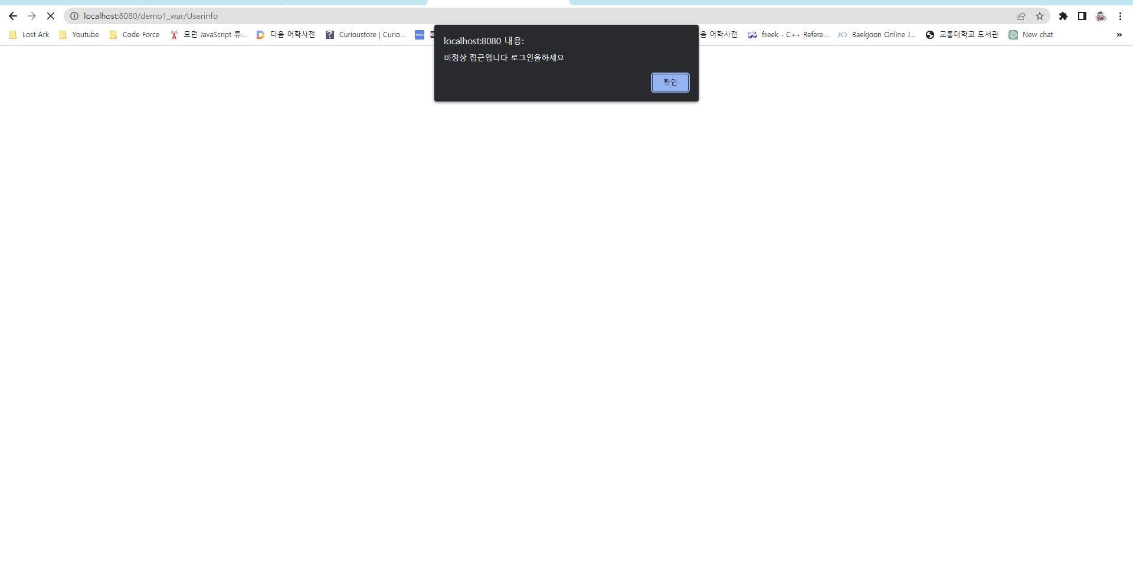

2.id pw 불일치

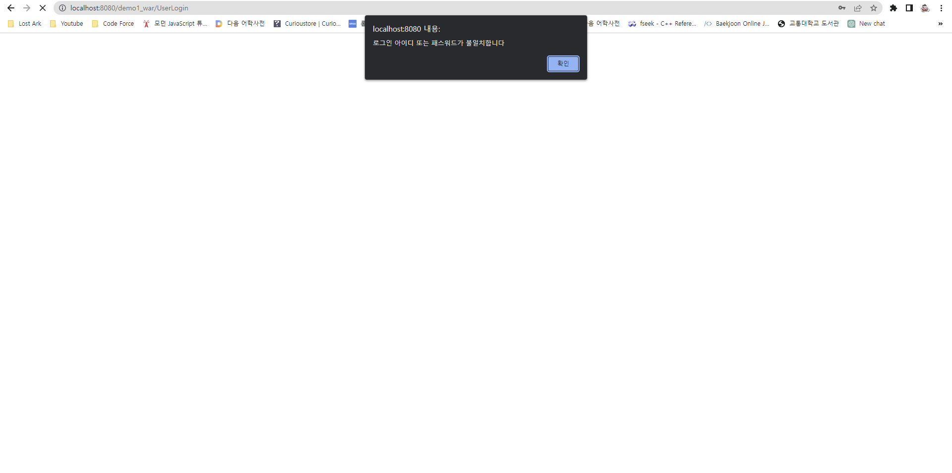

3.접속성공

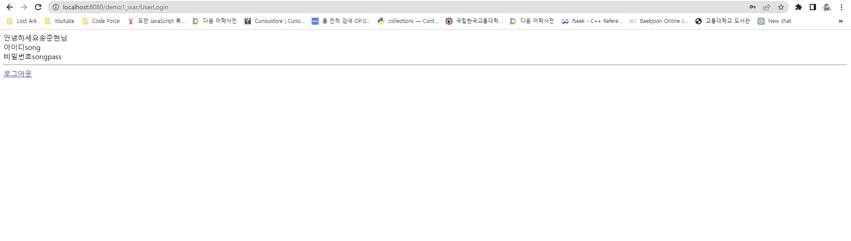

4.로그아웃성공

