
FACULTY OF INFORMATION AND COMMUNICATION TECHNOLOGIES THE
ICT UNIVERSITY

STUDENT GRADE CALCULATOR
Project Documentation
Name : Kenmogne Matchuekam Sergine
Course:

TABLE OF CONTENTS
1. Introduction ............................................... 3
2. Project Description ......................................... 4
3. Technology Used ............................................. 5
4. Excel File Structure ........................................ 6
5. Project Folder Structure .................................... 7
6. Grading Scale ............................................... 8
7. Program Code ................................................ 9
8. Console Output .............................................. 10
9. How to Run the Program ...................................... 11
10. Conclusion .................................................. 12

1-Introduction

This document presents a Student Grade Calculator developed using the Dart programming language. The program is a console application that runs inside the terminal without any graphical interface. It reads student scores from an Excel file (Sheet 1), calculates the average and final grade for each student, and automatically writes the results into a second sheet (Sheet 2) of the same Excel file.

Objectives
- Read student scores automatically from Excel Sheet 1
- Calculate the subject average for each student
- Calculate the final average from all subjects
- Assign a grade and decision (PASS or FAIL) to each student
- Write all results automatically into Excel Sheet 2
- Display all information clearly in the terminal

2. Project Description

The Student Grade Calculator is divided into two parts. The first part is the Excel file (students.xlsx) which contains two sheets. Sheet 1 called Scores is where the teacher manually enters all student information and marks. Sheet 2 called Grades is where the Dart program automatically writes all calculated results.
The second part is the Dart program which reads the data from Sheet 1, performs all calculations, and fills Sheet 2 without any manual intervention.

What the Program Does
Step 1 — Opens the Excel file students.xlsx
Step 2 — Reads all student scores from Sheet 1
Step 3 — Displays Sheet 1 contents in the terminal
Step 4 — Calculates each subject average using the formula:
Average = (CA x 0.8) + (Exam x 0.6)
Step 5 — Calculates the final average from all subjects
Step 6 — Assigns a grade: Excellent, Very Good, Good, Fair, Pass or Fail
Step 7 — Assigns a decision: PASS if average >= 10, FAIL if below 10
Step 8 — Writes all results into Sheet 2 automatically
Step 9 — Writes a class summary at the bottom of Sheet 2
Step 10 — Saves the Excel file and closes the program

3- Excel File Structure:

The Excel file is called students.xlsx and contains two sheets. Sheet 1 called Scores is filled manually by the teacher. Sheet 2 called Grades is filled automatically by the Dart program every time it runs.
Sheet 1 — Scores (filled manually by the teacher)
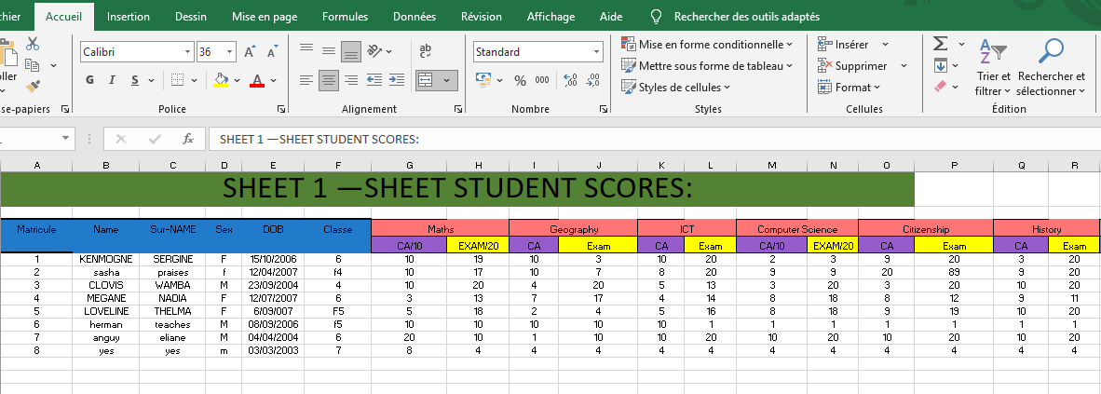
Note:
- CA is marked out of 10. Exam is marked out of 20.
- Each subject average is calculated by the Dart program
- using these two marks.

Sheet 2 — Grades (filled automatically by Dart)
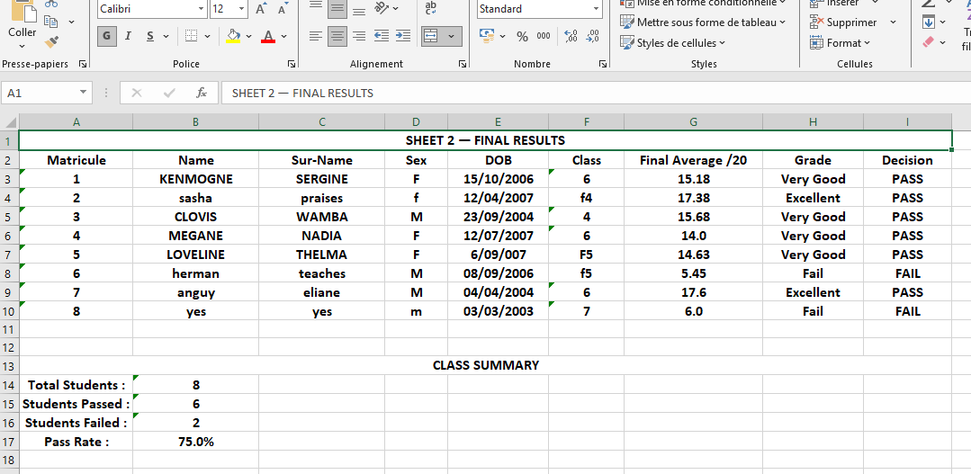
Note:
- Sheet 2 is never filled manually. Every time the
- Dart program runs it deletes the old results and writes
- fresh results automatically.

4. Technology Used

This project uses four main technologies working together to produce the final result. Each technology has a specific role in the program.
TECHNOLOGY | VERSION | ROLE IN THE PROJECT
Dart | SDK 3.x | - The main programming language  - Contains all the logic of the program: reading, calculating and writing.
excel package | excel : ^4.0.2 | A Dart library that allows the program to open, read, edit and save Excel .xlsx files.
Visual Studio Code | VS Code | The code editor used to write the Dart program and run it in the terminal.
Microsoft Excel | .xlsx format | The spreadsheet file that stores student scores in Sheet 1 and receives results in Sheet 2.

- DART
Dart is a programming language created by Google. It is the language used to write all the logic of this program. Dart is fast, clean and easy to read. In this project, Dart is responsible for opening the Excel file, reading the student data, performing all calculations and saving the results back into the Excel file.
- The excel Package
The excel package is a tool created for Dart that allows it to work with Excel files. Without this package, Dart cannot open or edit .xlsx files. It is installed by adding the following line to the pubspec.yaml file:
excel: ^4.0.2
After adding this line, the command dart pub get is run in the terminal to download the package automatically.

- Visual Studio Code (VS Code)
Visual Studio Code is the code editor used to write and run the Dart program. It provides a terminal window where the program output is displayed. The program is run by typing the following command in the VS Code terminal: dart run.

5. Formulas Explained

This section explains every formula used in the program. For each formula the explanation covers what it is, why it is used and how it works with a concrete example.
Formula 1 — Subject Average
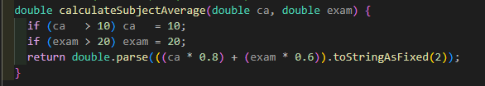
Average = (CA × 0.8) + (Exam × 0.6)
What it is:
This formula calculates the average mark for one subject based on two evaluations the Continuous Assessment (CA) marked out of 10 and the Examination marked out of 20.
Why it is used:
The CA and the Exam do not have the same weight in the final result. The Exam is more important than the CA. This formula gives 40% of the weight to the CA and 60% of the weight to the Exam. This is why the CA is multiplied by 0.8 and the Exam is multiplied by 0.6.
How it works:
The formula takes the CA mark and multiplies it by 0.8 then takes the Exam mark and multiplies it by 0.6. The two results are added together to give the subject average out of 20.
Example:
A student scores 8 out of 10 in CA and 14 out of 20 in the Exam for Mathematics.
Average = (8 × 0.8) + (14 × 0.6)
Average = 6.4 + 8.4
Average = 14.8 / 20
Grade = Very Good
Decision = PASS

Formula 2 — Final Average
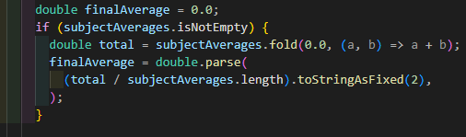
Final Average = Sum of all subject averages ÷ Number of subjects
What it is :
This formula calculates the overall final average of a student by combining the averages of all their subjects into one single mark out of 20.
Why it is used :
A student studies multiple subjects. Each subject has its own average. To get one final result that represents the overall performance of the student, all subject averages are added together and divided by the total number of subjects.
How it works :
The program collects all the subject averages into a list. It then adds all the values in the list and divides the total by how many subjects there are. This gives the final average out of 20.

Formula 3 — Grade Assignment
The grade is assigned based on the final average using the following scale:
Final Average /20 | Grade | Decision
16.00 — 20.00 | A | PASS
14.00 — 15.99 | B+ | PASS
12.00 — 13.99 | B | PASS
10.00 — 11.99 | C+ | PASS
8.00 — 9.99 | C | FAIL
0.00 — 7.99 | D | FAIL

6. Project Folder Structure
The project is organised in a specific folder structure on the computer. Each file has a precise role and must be placed in the correct location for the program to work properly.

Folder Structure
grade_calculator/
│
├── pubspec.yaml
│
├── pubspec. lock
│
├── bin/
│ └── grade_calculator.dart
│
├── students.xlsx
│
└── test/
File / Folder | Role
pubspec.yaml | Contains the project settings and the list of packages needed. The excel package is declared here.
pubspec.lock | Created automatically by Dart. Never modify this file.
bin/grade_calculator.dart | The main code file. This is where all the Dart code is written.
students.xlsx | The Excel file containing student scores in Sheet 1 and results in Sheet 2. Must always be in this folder.
test/ | Created automatically by Dart. Not used in this project.

Important Note:
The file students.xlsx must always be placed directly inside the grade_calculator folder at the same level as pubspec.yaml. If it is placed anywhere else the program will not find it and will give an error.
Also, the Excel file must always be closed before running the program. If it is open in Excel at the same time the program runs, the file cannot be saved and the results will be lost.

7. Console Output
When the program runs, it displays all information directly in the terminal of VS Code. This section
shows exactly what appears in the terminal from start to finish.
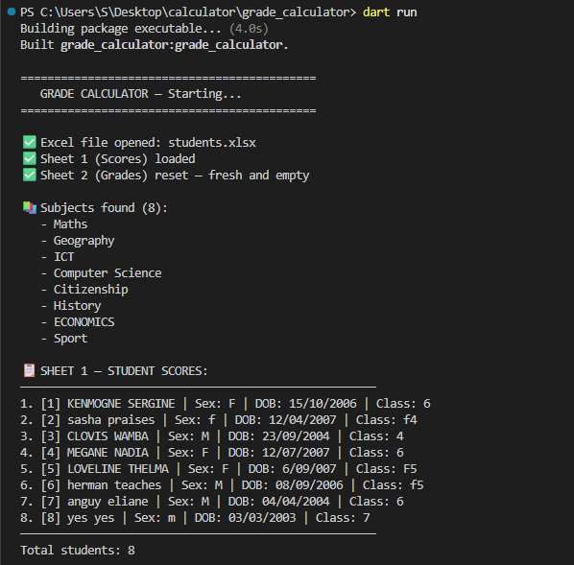
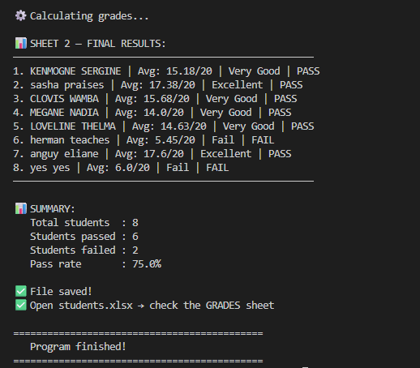
The terminal output is divided into four parts
1. Opening confirmation — confirms the Excel file and both sheets are loaded successfully
2. Sheet 1 display — shows all student names and basic information as they appear in the Excel file
3. Final results — shows the calculated average, grade and decision for every student
4. Summary — shows the total number of students, how many passed, how many failed and the
overall pass rate

8. How to Run the Program
This section explains how to run the Student Grade Calculator step by step. These steps must be followed in the correct order every time the program is used.
Requirement | Details
Dart SDK | Must be installed on the computer
VS Code | Must be installed with the Dart extension
Excel file | students.xlsx must be inside the project folder
Internet | Needed only the first time to run dart pub get

Steps to Run
Step 1 — Make sure students.xlsx is completely closed in Excel before starting
Step 2 — Open VS Code and open the grade_calculator project folder
Step 3 — Open the terminal in VS Code by clicking Terminal then New Terminal at the top menu
Step 4 — If it is the first time running the program type this command and press Enter:
dart pub get, This downloads the excel package automatically. You only need to do this once.
Step 5 — Type this command and press Enter: dart run
Step 6 — Watch the terminal — it shows Sheet 1 scores then calculates and displays all results
Step 7 — When the program finishes open students.xlsx and click on the Grades sheet to see all the results written automatically.
Important Warning
Never open students.xlsx while the program is running. If the Excel file is open at the same time as the program the file cannot be saved and all calculated results will be lost. Always close Excel first then run the program.

9. Conclusion

This project presented the development of a Student Grade Calculator using the Dart programming language. The program successfully reads student scores from an Excel file, calculates the average and grade for each student and writes all results automatically into a second sheet of the same Excel file.
What Was Achieved
- A fully working console application in Dart
- An Excel file with a clean input sheet and an automatic results sheet
- A program that calculates subject averages using the formula (CA x 0.8) + (Exam x 0.6)
- A program that calculates the final average from all subjects automatically
- A program that assigns grades and decisions to every student
- A class summary showing total students, passed, failed and pass rate
- A program that works with any number of students and any number of subjects without
changing the code.

This console version of the Student Grade Calculator forms the first part of the project. It demonstrates that Dart can be used effectively to automate tasks that would otherwise require manual calculations in Excel. The program is reliable, flexible and easy to use for any teacher who needs to calculate and record student grades quickly and accurately.

