Below are real dashboard references. I included official product links plus visual examples so you can quickly see how these systems structure their UI.

1️⃣ SuiteDash (Agency Client Portal)
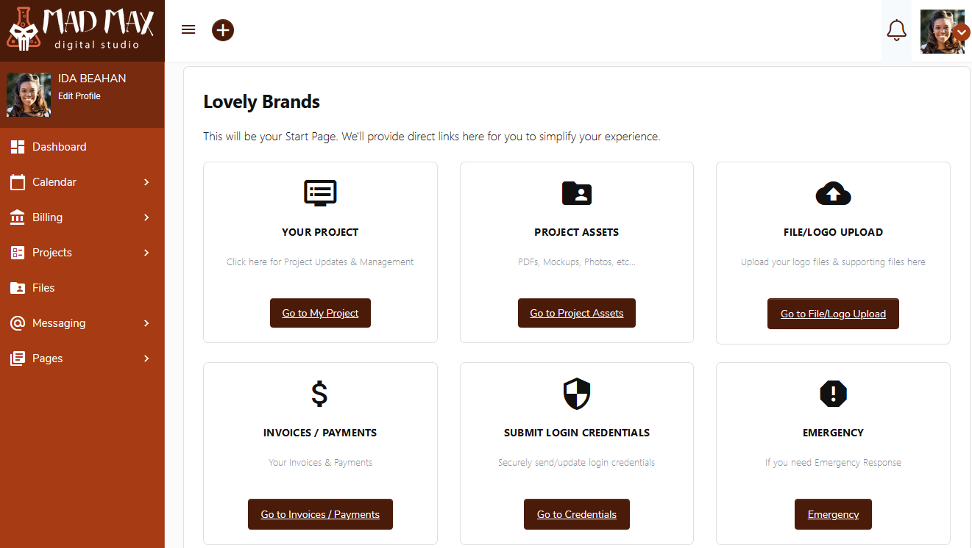
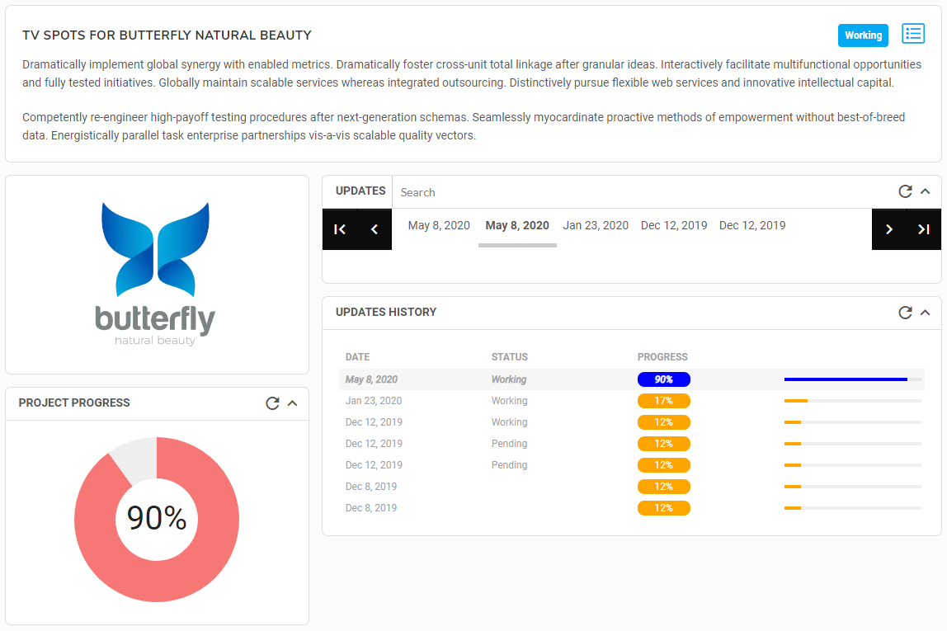
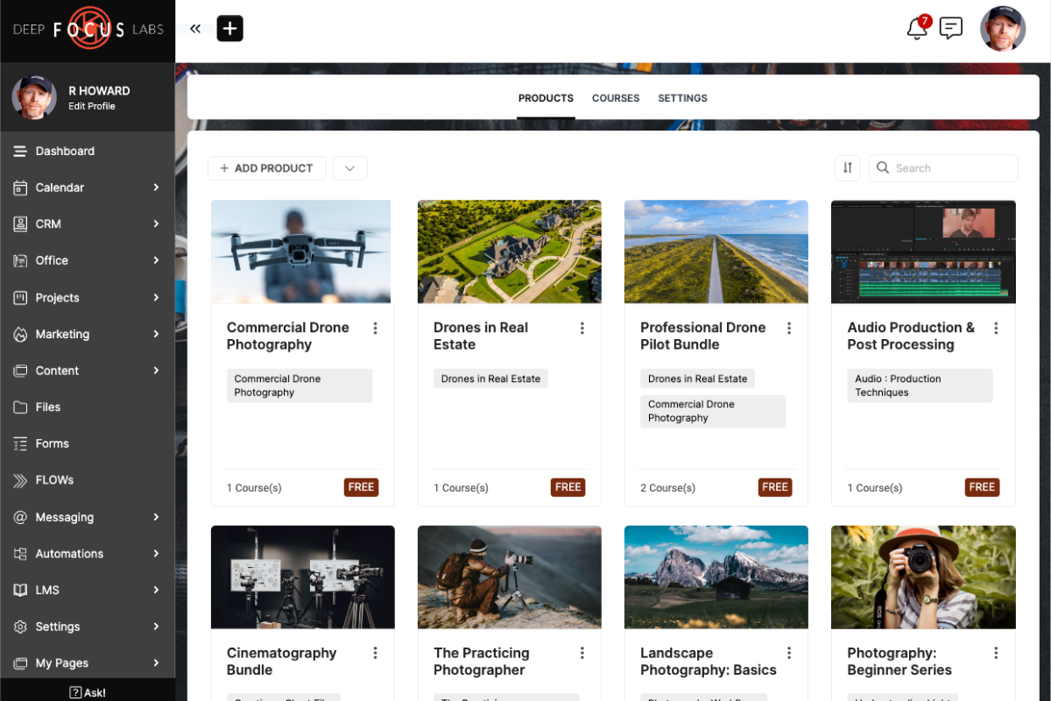
🔗 https://suitedash.com
What to study:
- Client home dashboard
- Project progress panels
- File vault layout
- Invoice/payment widgets
This closely resembles your planned:
- Executive Overview
- Resource Vault
- Billing panel
- Client portal

2️⃣ Clientjoy (Lead → Client → Project System)
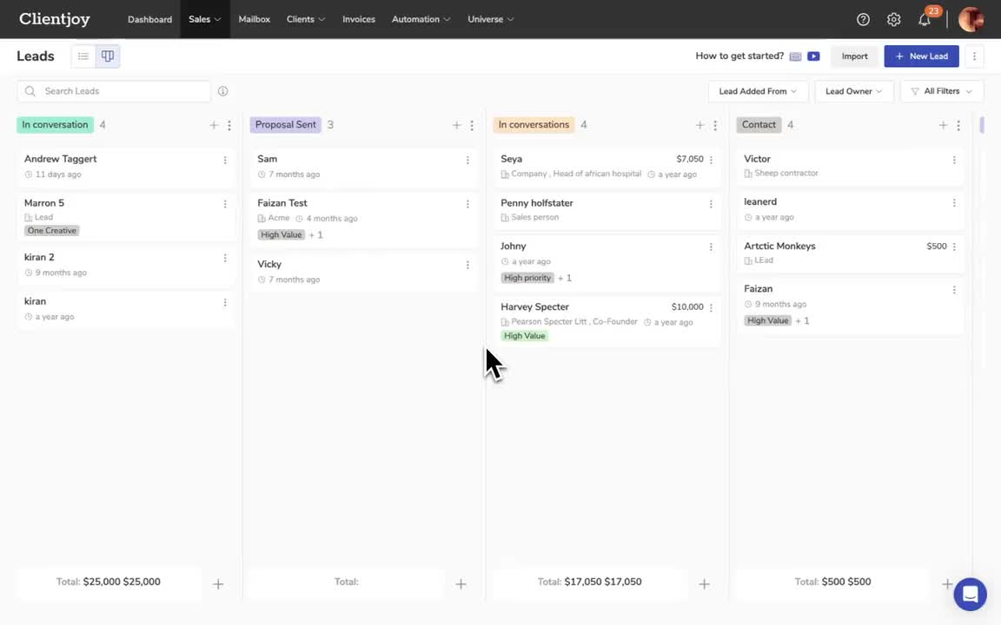
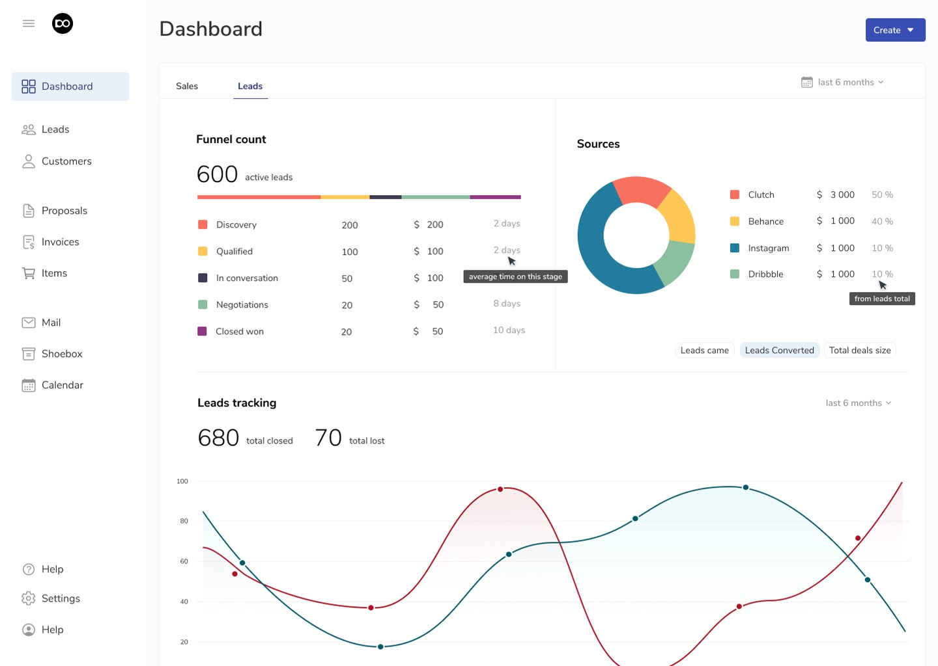
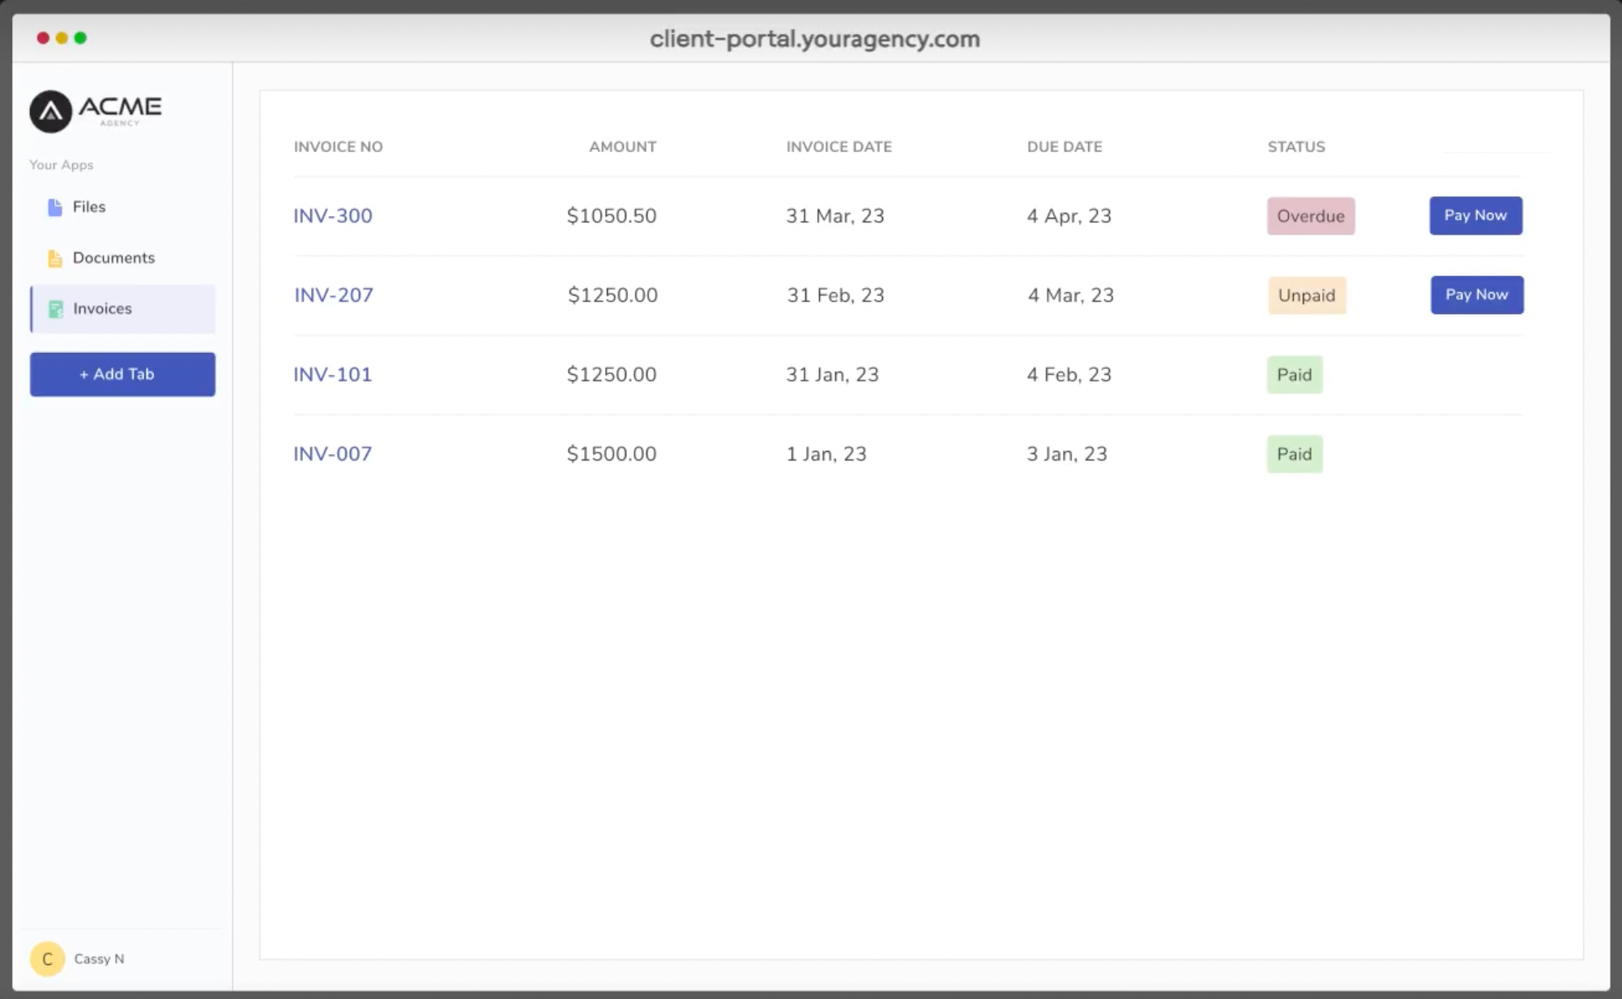
🔗 https://clientjoy.io
Key things to observe:
- lead pipeline board
- proposal tracking
- client workspace
Good inspiration for your:
- Lead board
- Quotation system
- Lead conversion workflow

3️⃣ ManyRequests (Creative Agency Client Portal)
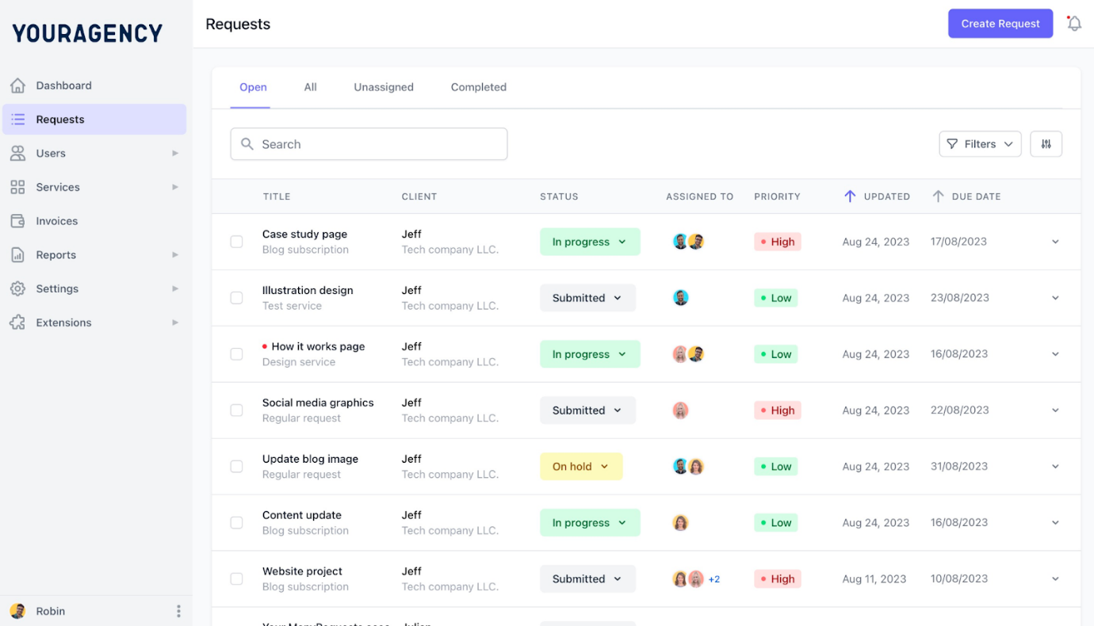

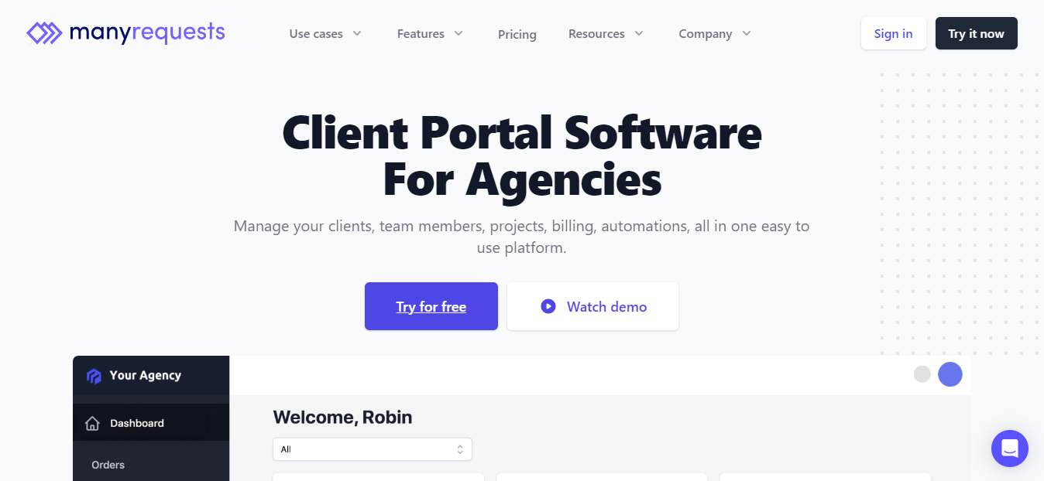
🔗 https://manyrequests.com
Look at:
- client request board
- deliverable status
- task progress cards
Useful for:
- client interaction panels
- deliverable status tracking
- communication threads

4️⃣ Agency Handy
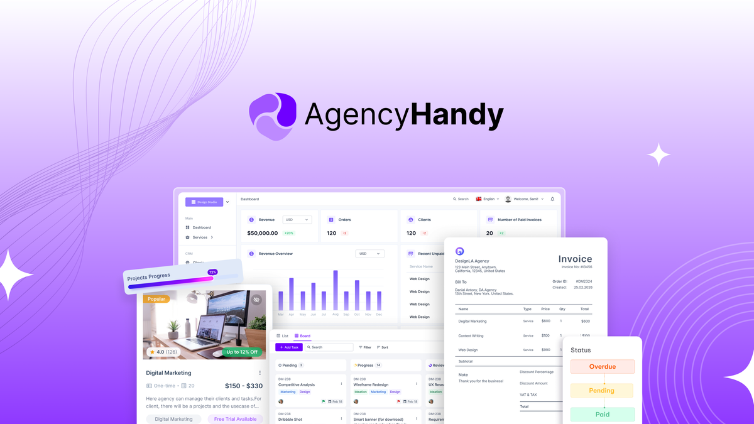
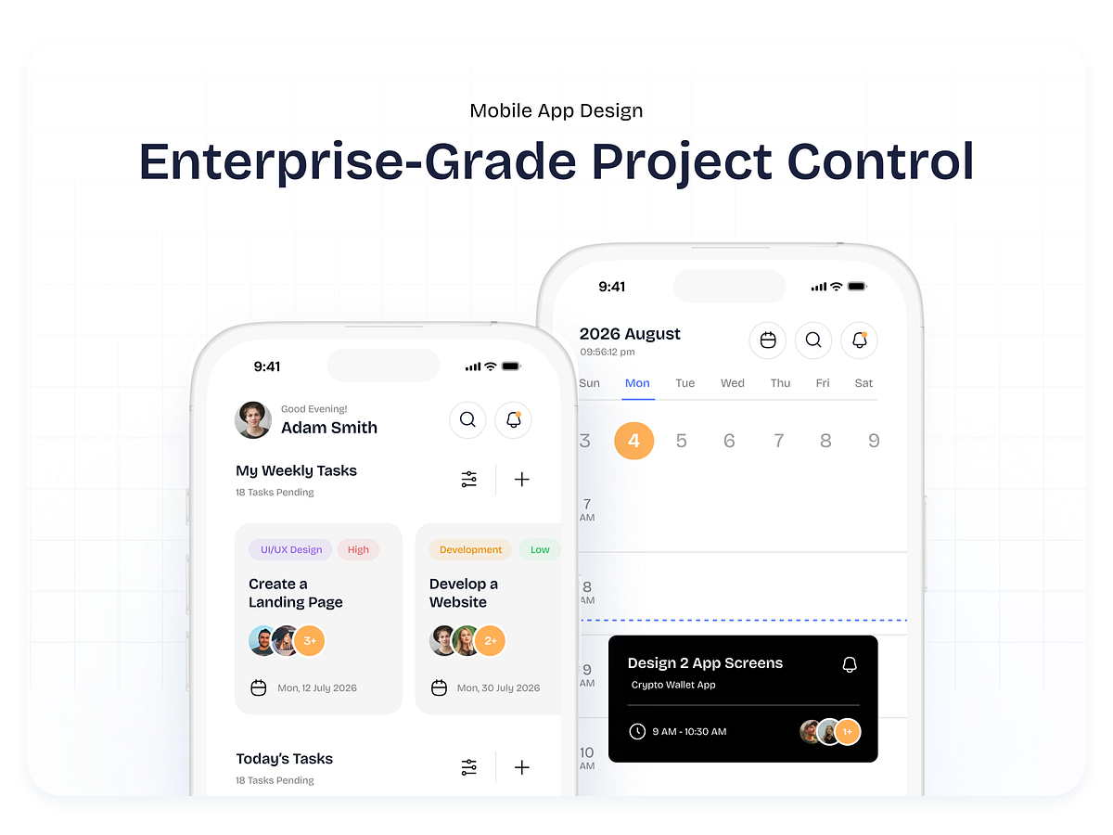
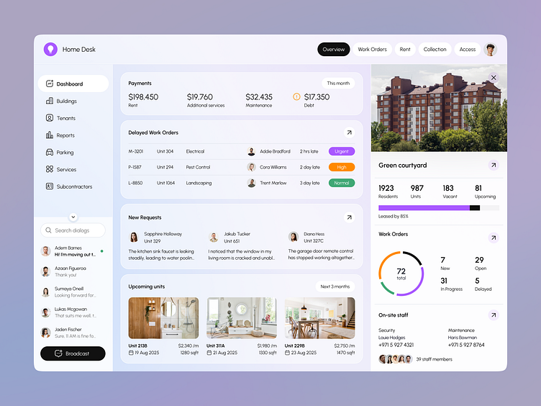
🔗 https://agencyhandy.com
Important UI ideas:
- client dashboard layout
- invoice widgets
- task management board
Closest reference for your:
- client dashboard
- project status cards
- financial overview

5️⃣ ClickUp (Project & Module System)
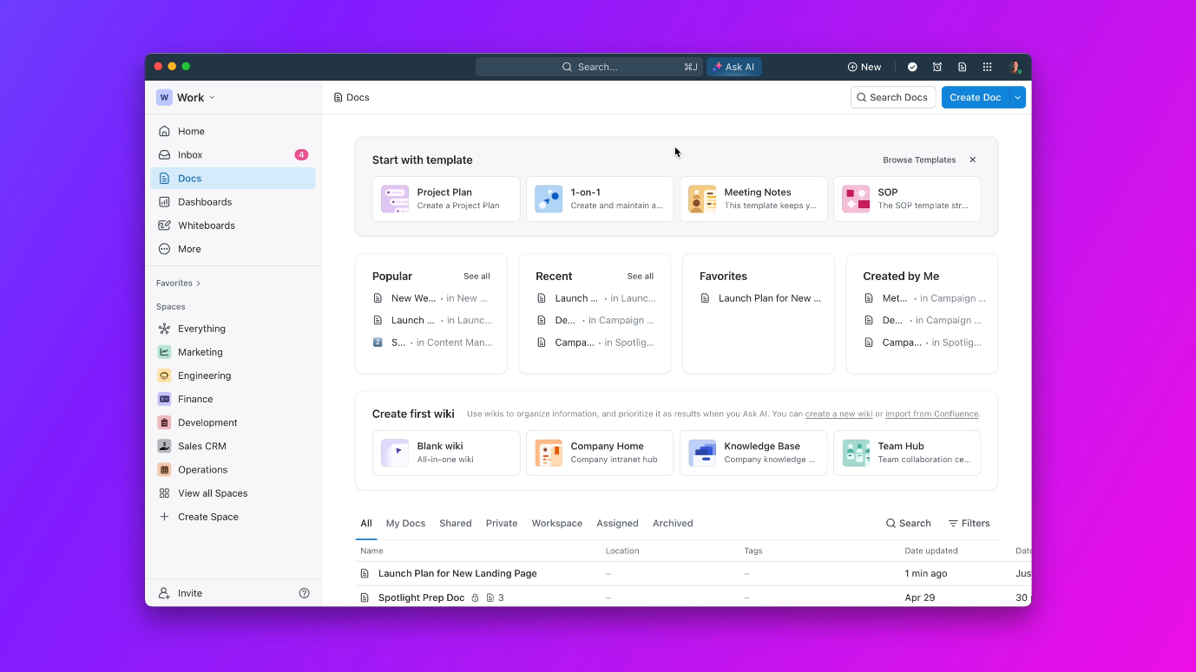

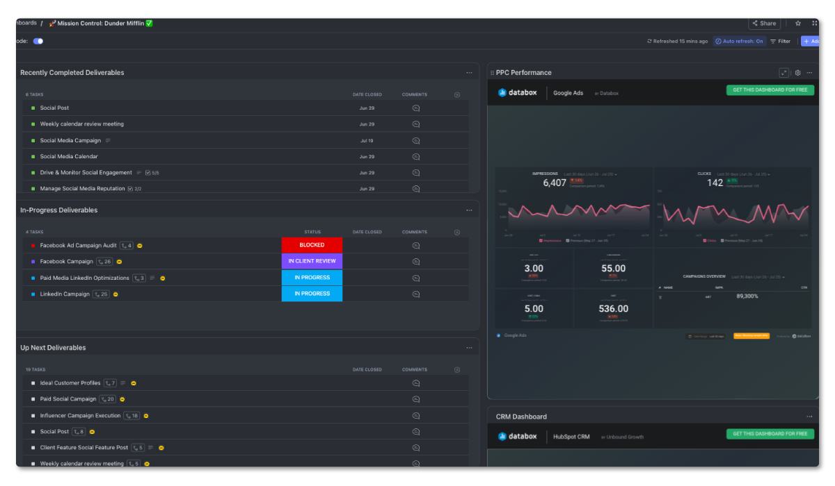
🔗 https://clickup.com
Study:
- module-like task groups
- activity timeline
- project dashboards
Great reference for:
- module workspace
- activity timeline
- status badges

6️⃣ Monday.com (Analytics & Status Dashboards)
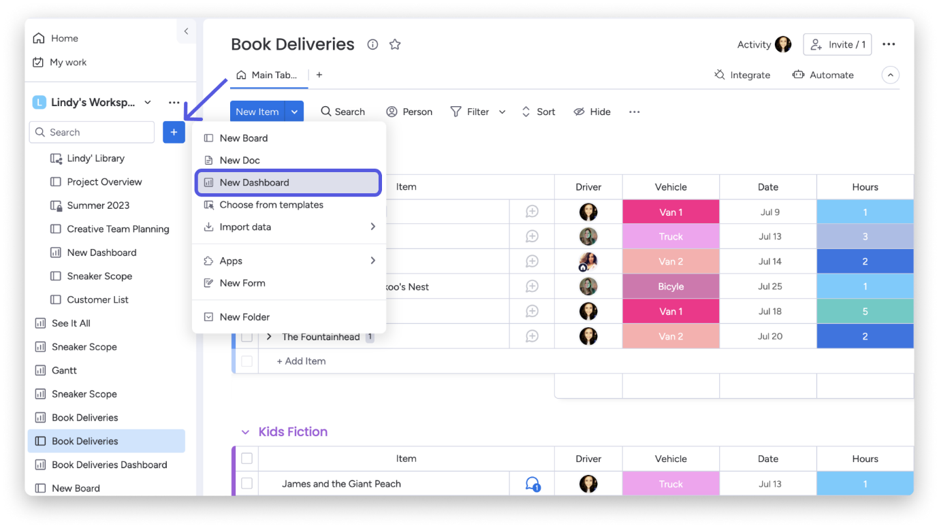
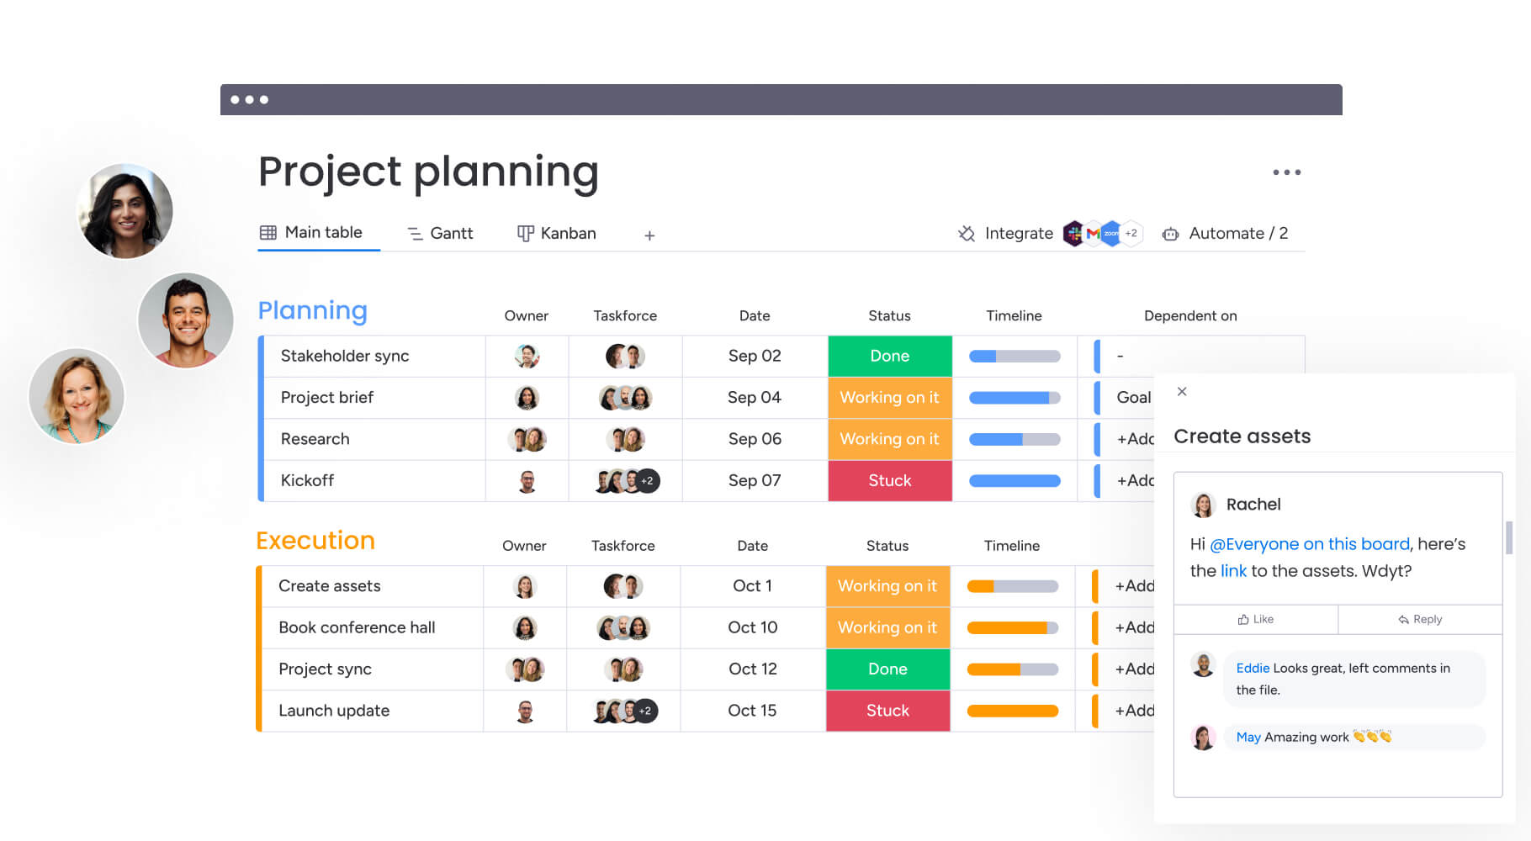
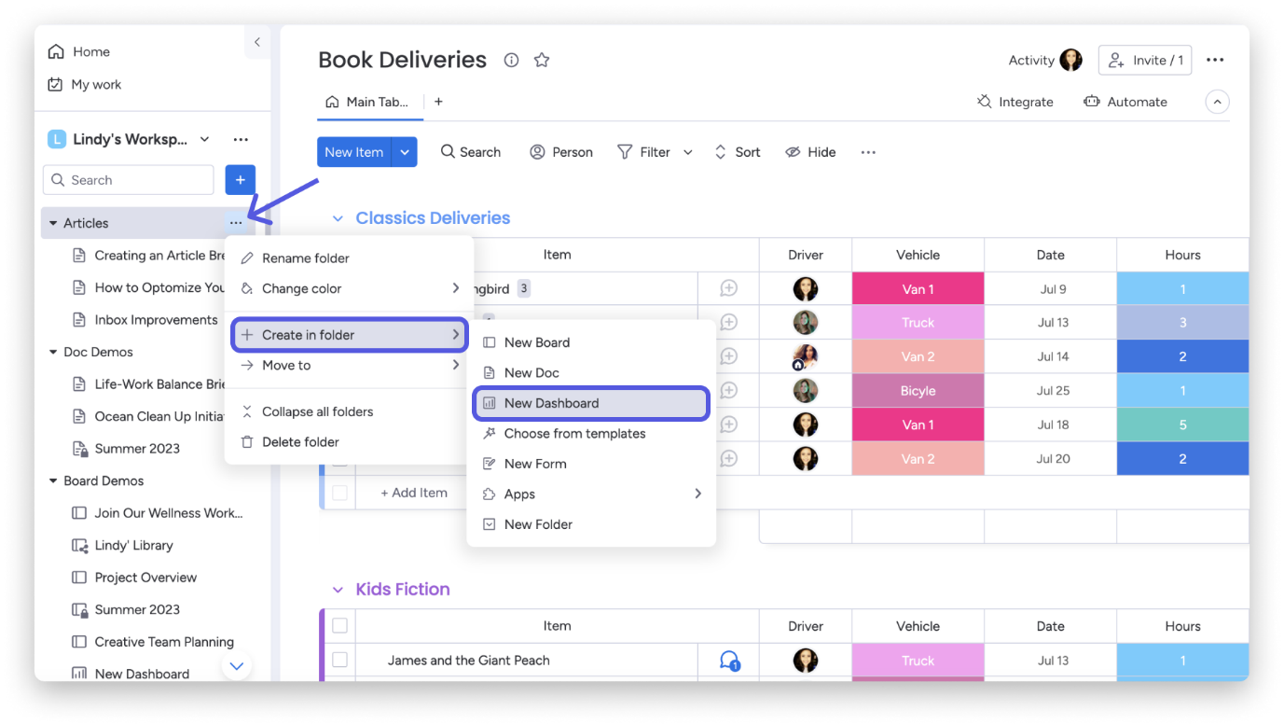
🔗 https://monday.com
Important elements:
- dashboard widgets
- health indicators
- project analytics
Useful inspiration for your:
- project health system
- analytics panels
- progress tracking

7️⃣ Frame.io (Approval & Version Review System)
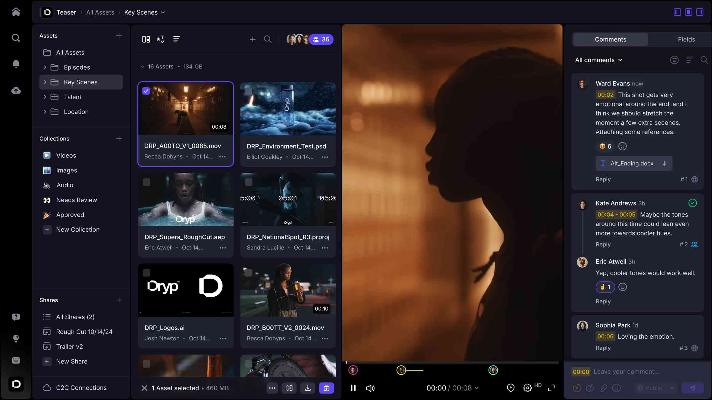

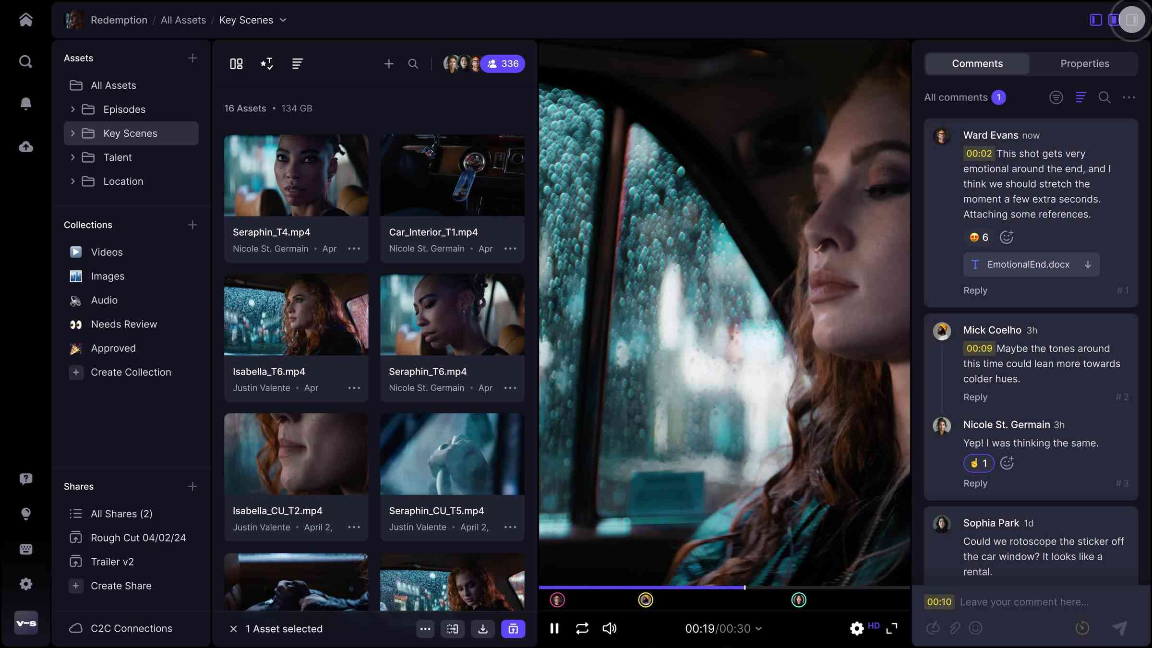
🔗 https://frame.io
Study this carefully for your:
- approve / request changes panel
- version history
- comment threads
Very close to your client approval screen.

8️⃣ Notion (Internal Operations Dashboard)
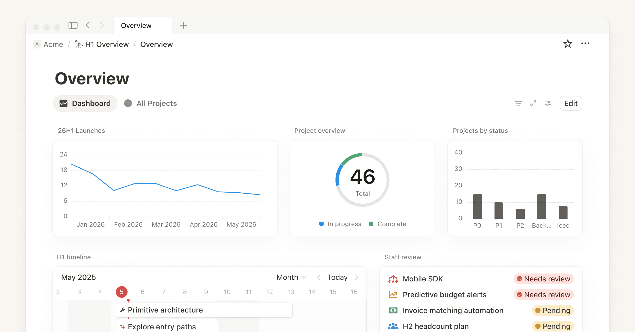
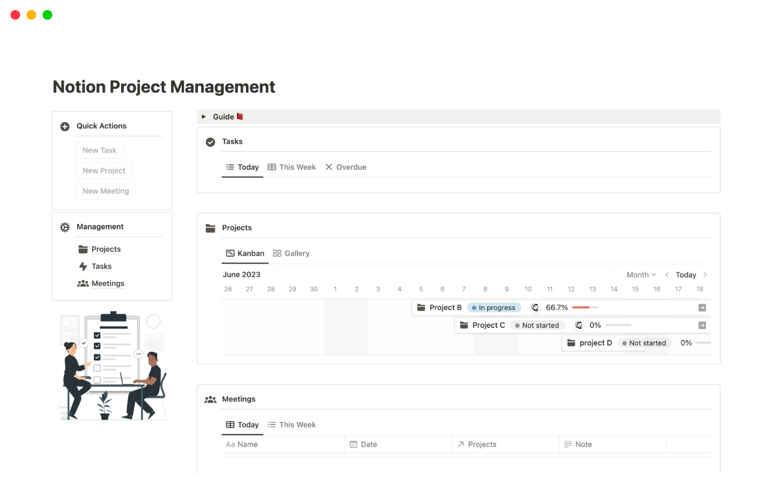
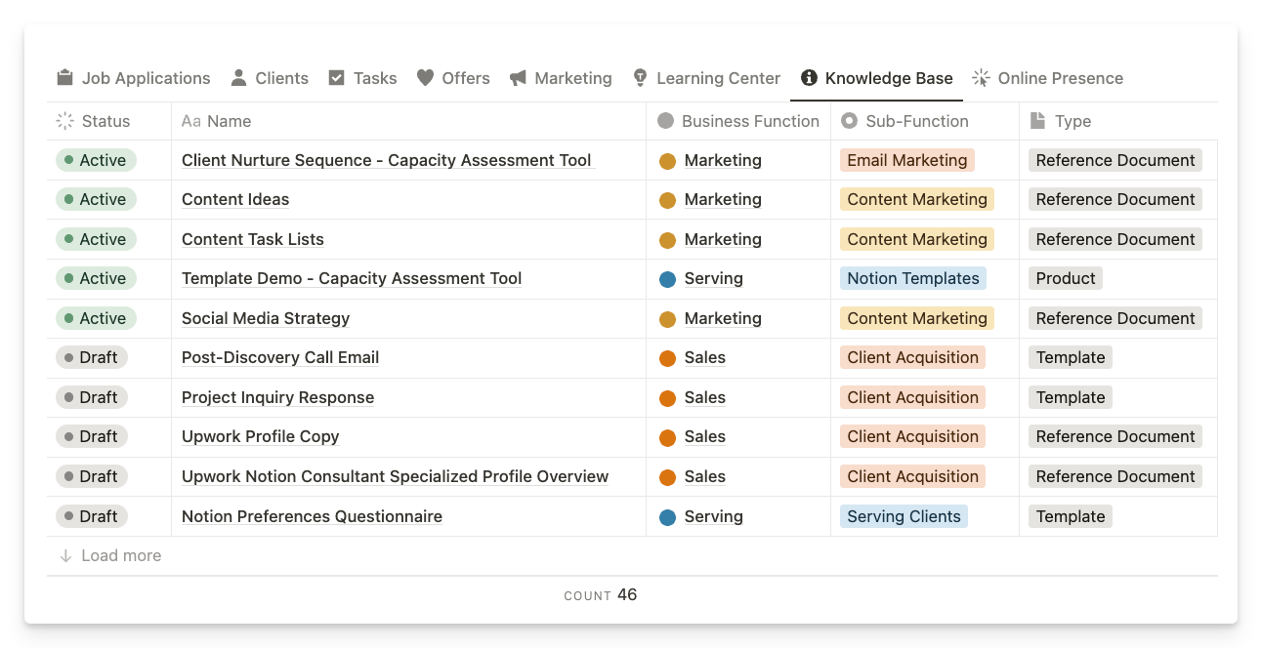
🔗 https://notion.so
Useful ideas:
- modular page layout
- flexible dashboards
- database-driven views
Many startups design dashboards inspired by Notion’s structure.

🧠 The 3 Platforms Most Similar to Kerna
If your developer only studies three, pick these:
1️⃣ SuiteDash
2️⃣ ClickUp
3️⃣ Frame.io
Together they represent almost everything in your architecture:
Kerna Feature |  |  |  |  |  |  |  |  |  |  |  | Reference
Client portal |  |  |  |  |  |  |  |  |  |  |  | SuiteDash
Lead CRM |  |  |  |  |  |  |  |  |  |  |  | Clientjoy
Project modules |  |  |  |  |  |  |  |  |  |  |  | ClickUp
Approval engine |  |  |  |  |  |  |  |  |  |  |  | Frame.io
Resource vault |  |  |  |  |  |  |  |  |  |  |  | ManyRequests
Billing dashboard |  |  |  |  |  |  |  |  |  |  |  | Agency Handy
EXAMPLE DASHBOARD FOR KERNA
