student_depression_dataset.csv

Hospital Patient Record Analysis and Healthcare Performance Review

1. Dataset Overview
Rows: 27901
Columns: 18

Column Details
id (numeric): 2
Gender (categorical): Male
Age (numeric): 33.0
City (categorical): Visakhapatnam
Profession (categorical): Student
Academic Pressure (numeric): 5.0
Work Pressure (numeric): 0.0
CGPA (numeric): 8.97
Study Satisfaction (numeric): 2.0
Job Satisfaction (numeric): 0.0
Sleep Duration (categorical): '5-6 hours'
Dietary Habits (categorical): Healthy
Degree (categorical): B.Pharm
Have you ever had suicidal thoughts ? (categorical): Yes
Work/Study Hours (numeric): 3.0
Financial Stress (categorical): 1.0
Family History of Mental Illness (categorical): No
Depression (numeric): 1

2. Sentiment Summary

3. Key Drivers & Correlations
A strong relationship was found between Depression and Have You Ever Had Suicidal Thoughts ? using spearman (effect=0.546, p=0, n=27901). This indicates that Depression increases with Have You Ever Had Suicidal Thoughts ?.
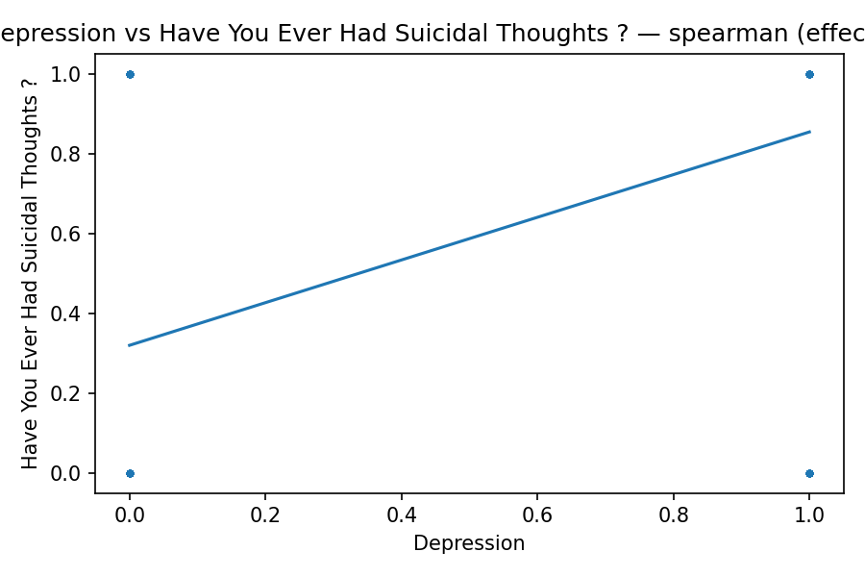
A strong relationship was found between Depression and Academic Pressure using spearman (effect=0.472, p=0, n=27901). This indicates that Depression increases with Academic Pressure.
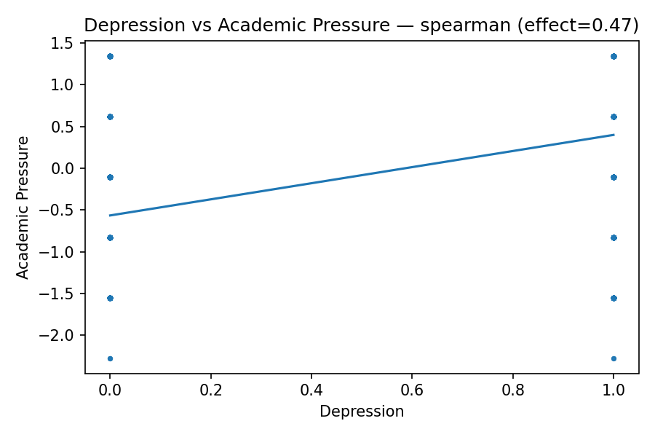
A strong relationship was found between Depression and Financial Stress using spearman (effect=0.363, p=0, n=27901). This indicates that Depression increases with Financial Stress.
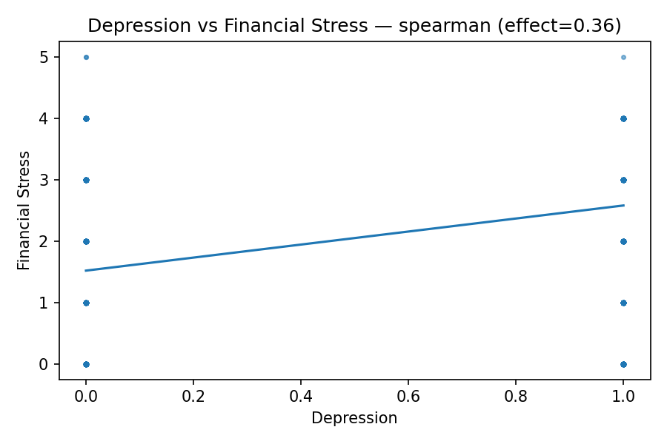
A moderate relationship was found between Depression and Age using spearman (effect=-0.225, p=0, n=27901). This indicates that Depression decreases with Age.
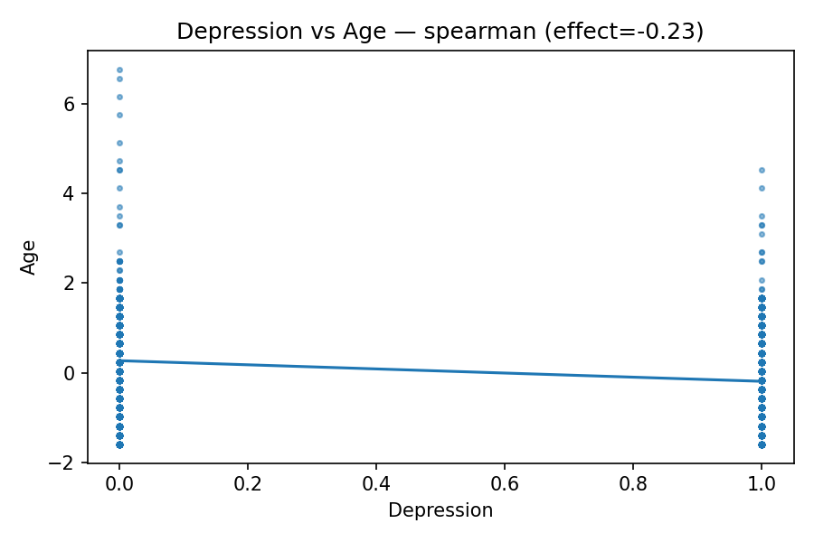

4. Summary
response:
GenerateContentResponse(
done=True,
iterator=None,
result=protos.GenerateContentResponse({
"candidates": [
{
"content": {
"role": "model"
},
"finish_reason": "MAX_TOKENS",
"index": 0
}
],
"usage_metadata": {
"prompt_token_count": 1042,
"total_token_count": 3089
},
"model_version": "gemini-2.5-flash"
}),
)

5. Recommendations

