**A PROJECT REPORT**

**ON**

**Online Bank Management System**

Submitted in partial fulfillment for the requirement of the award of

TRAINING

IN

**Java Programming (Basic + Advanced)**



*Submitted By*

**Keshu Pandre**

(Indian Institute of Technology Varanasi (BHU), Uttar Pradesh)

*Under the guidance of*

**Rashmi Jadaun**

**ACKNOWLEDGEMENT**

This Project report was completed as a result of support from many people, although not all of them can be mentioned.

We wish to express our sincere gratitude to God for his protection, providence, guidance and above all, for sustaining us.

My sincere gratitude and thanks to my project paper guide Rashmi Jadaun. It was only with her backing and support that I could complete the report. He provided me with all sorts of help and corrected me if I ever seemed to need to correct something. I have no such words to express my gratitude.

I acknowledge my sincere gratitude to the HOD of the Mechanical Engineering Department, Indian Institute of Technology (BHU) Varanasi, Uttar Pradesh. He allowed me to do the project work. Without his support, I could not even start the work. So, I am grateful to him.

Moreover, last but not least, I acknowledge my dearest parents for being such a nice source of encouragement and moral support that helped me tremendously. To the best of my knowledge and belief, the Project Work has not been submitted anywhere else.

**Introduction**

The “Bank Account Management System” project is a model Internet Banking Site. This site enables customers to perform basic banking transactions by sitting at their office or home through a PC or laptop. The system provides access to the customer to create an account, deposit/withdraw cash from his account, and view reports of all accounts present. The customers can access the bank’s website to view their Account details and perform the transactions on the account as per their requirements. With Internet Banking, the brick-and-mortar structure of traditional banking gets converted into a click-and-portal model, thereby giving the concept of virtual banking a real shape. Thus, today’s banking is no longer confined to branches. E-banking facilitates banking transactions by customers round the clock globally.

This “Bank Account Management System” aims to provide an improved design methodology, which envisages the future expansion and modification which is necessary for a core sector like banking. This necessitates the design to be expandable and modifiable, so a modular approach is used to develop the application software.

Anybody who is an Account holder in this bank can become a Bank Account Management System member. He has to fill out a form with his personal details and Account Number. Bank is a place where customers feel a sense of safety for their property. In the bank, customers deposit and withdraw their money. Transaction of money also is a part where the customer takes shelter in the bank. Now to keep the belief and trust of customers, there is a positive need for management of the bank, which can handle all this with comfort and ease. Smooth and efficient management indirectly affects customer and staff members' satisfaction. Moreover, of course, it encourages the management committee to make some needed decisions for the future enhancement of the bank.

Now a day’s, managing a bank is a tedious job up to a certain limit. So software that reduces the work is essential. Also, today’s world is a genuine computer world that is getting faster and faster every day. Thus, considering the above necessities, software for bank management has become necessary, which would be useful in managing the Bank more efficiently.

All transactions are done online by transferring from accounts in the same or international Bank. The software is meant to overcome the drawbacks of the manual system.

**Abstract**

The Bank Account Management System is an application for maintaining a person's account in a bank. In this project, I showed the working of a banking account system and covered the basic functionality of a Bank Account Management System. To develop a project for solving financial applications of a customer in a banking environment to nurture the needs of an end banking user by providing various ways to perform banking tasks. Also, it enables the user's workspace to have additional functionalities which are not provided under a conventional banking project.

The Bank Account Management System undertaken as a project is based on relevant technologies. The main aim of this project is to develop software for Bank Account Management System. This project has been developed to carry out the processes easily and quickly, which is impossible with the manual systems, which are overcome by this software. This project is developed using Java language. Creating and managing requirements is challenging for IT, systems, and product development projects or any activity where we must manage a contractual relationship. The organization needs to effectively define and manage requirements to ensure they are meeting the customer's needs while proving compliance and staying on schedule and within budget.

The impact of a poorly expressed requirement can bring a business out of compliance or even cause injury or death. Requirements definition and management is an activity that can deliver a high, fast return on investment. The project analyzes the system requirements and then comes up with the requirements specifications. It studies other related systems and then comes up with system specifications. The system is then designed in accordance with specifications to satisfy the requirements. The system design is then implemented with Java. The system is designed as an interactive and content management system. The content management system deals with data entry, validation, confirmation, and updating, whiles the interactive system deals with system interaction with the administration and users. Thus, the above features of this project will save transaction time and increase the system's efficiency.

**AIM of this project**

The main goal of designing and developing this Internet banking System Java-based engineering project is to provide secure and efficient net banking facilities to banking customers over the Internet. Apache Server Pages, MYSQL database was used to develop this bank application where all banking customers can log in through the secured web page using their account login id and password. Users will have all options and features in that application, like getting money from western union, money transfers to others, and sending cash or money to inter-banking and other banking customers by simply adding them as payees.

**Main Purpose**

The Traditional way of maintaining the details of a user in a bank was to enter the details and record them. Every time the user needs to perform some transactions, he has to go to the bank and perform the necessary actions, which may not always be so feasible. It may be a hard-hitting task for the users and the bankers too. The project provides a real-life understanding of the Online Banking System and activities performed by various roles in the supply chain. Here, we provide automation for the banking system through the Internet. The Online Banking System project captures activities performed by different roles in real-life banking, which provides enhanced techniques for maintaining the required information up-to-date, which results in efficiency. The project provides a real-life understanding of the Online Banking System and activities performed by various roles in the supply chain.

**Main Goal**

**1. Motto:** Our motto is to develop a software program for managing the entire bank process related to Administration and customer accounts and keeping track of their property and various transaction processes efficiently.

As a result of this, our main objective is customer satisfaction considering today's faster in the world.

**2. Customer Satisfaction:** The client can do his operations comfortably without risking his privacy. Our software will perform and fulfil all the tasks that any customer desires.

**3. Saving Customer Time:** The client does not need to go to the bank for small operations.

**4. Protecting the Customer:**It helps the customer to be satisfied and comfortable with his choices; this protection contains the customer's account, money, and privacy.

**5. Transferring Money:**Help clients transfer money to/or another bank or country.

**Methods**

* We need to be able to generate an account number
* Account types: Savings or Current Account
* Maintain/update Balance
* Open/Close Account
* Withdraw/Deposit

**Administrative Modules**

Here in my project, there are two types of modules. This module is the main module that performs all the main operations in the system. The major operations in the system are:

**Admin Module**

Admin can access this project. There is an authorization process. If you log in as an Admin, you will be redirected to the Admin Home Page, and if you are a simple user, you will be redirected to your Account Home Page. This performs the following functions: Create

Individual Accounts, manage existing accounts, View all transactions, Balance enquiry,

Delete/close account etc.

* Admin login
* Add/delete/update account
* Withdrawal/deposit/statements transaction
* Account Information
* User details list
* Active/Inactive account
* View transaction histories

**User Module**

A simple user can access their account and can deposit/withdraw money from their account.

Users can also transfer money from their account to any other bank account. Users can see their transaction report and Balance enquiry too.

* User login, use PIN system
* Creating/opening new account registration
* Funds transfer (local/international/domestic)
* View statements transaction
* User account details
* Change Password and Pin

**Banks terms:**

* All requests received from customers are logged for backend fulfilment and are effective from the time they are recorded at the branch.
* Rules and regulations applicable to normal banking transactions in India will be applicable mutatis mutandis for the transactions executed through this Site.
* The BAMS Bank service cannot be claimed as a right. The Bank may also convert this into a discretionary service anytime.
* Dispute between the customer and the Bank in this service is subject to the jurisdiction of the courts in the Republic of India and governed by the laws prevailing in India.
* The Bank reserves the right to modify the services offered or the Terms of service of BAMS Bank. The changes will be notified to the customers through a notification on the Site.

**Customer’s obligations**

* The customer must maintain secrecy regarding Username & Password registered with the Bank. The Bank presupposes that log-in using a valid Username and Password are valid sessions initiated by the customer.
* Transaction executed through a valid session will be construed by RR to have emanated from the registered customer and will be binding on him/her.
* The customer will not attempt or permit others to access the BAMS Bank through any unlawful means.

**Future Look**

The “Online banking system is a big and ambitious project. I am thankful for being provided with this great opportunity to work on it. As already mentioned, this project has gone through extensive research work. We have successfully designed and implemented a banking online System based on the research work. To know the future of online banking, it is probably worth looking at the present – online banking is not new. When you think of online banking, you probably think about a computer (either a desktop or laptop), a three or four-step security process, and then an interface that lets you view the balance of your various bank accounts and credit cards while allowing you to transfer money and pay bills. And you’re not wrong, either. The most valuable future looks are the below:

* More bank branches; it could be international, which means more ATMs outside.
* Customer issues development based on their needs, so the help desk will be aware of their needs and easy to use.
* Develop a mobile App for a banking system that helps users obtain operations without going to the bank. Only needs to sign in using their A/C NO. Moreover, password, and then use your PIN. Finally, the system will update automatically.

**Conclusion**

This project is developed to nurture the needs of a user in the banking sector by embedding all the tasks of transactions taking place in a bank. A future version of this project will still be much enhanced than the current version. Writing and depositing checks are the most fundamental ways to move money in and out of a checking account. However, advancements in technology have added ATM and debit card transactions. All banks have rules about how long it takes to access your deposits, how many debit card transactions you are allowed in a day, and how much cash you can withdraw from an ATM. Access to the balance in your checking account can also be limited by businesses that place holds on your funds.

Banks are providing Internet banking services also so that customers can be attracted. By asking the bank employees, we learned that the maximum number of Internet bank account holders are youth and business people. Online banking is an innovative tool that is fast becoming a necessity. It is a successful strategic weapon for banks to remain profitable in today's volatile and competitive marketplace. The bank employees should give the customers proper training to open an account will be beneficial. Secondly, the website should be friendlier so customers can directly make and access their accounts.

Thus, the Bank Management System is developed and executed successfully.

**References**

* Online Bank Account Management System

Source- <https://www.slideshare.net> (Collect some info for report documents)

* Learning MYSQL, JavaScript, jQuery, PHP

Sources- <https://www.w3schools.com>

<https://www.mysqltutorial.org/php-mysql>

* PHP and MySQL video tutorials

Sources- <https://www.youtube.com>

* JavaScript validation for empty input field

Sources- <https://stackoverflow.com>

* JavaScript form validation: Validate Password, Email and Phone Number

Sources- <https://stackoverflow.com>

***SOME SNAPSHOTS OF JAVA CLASSES***

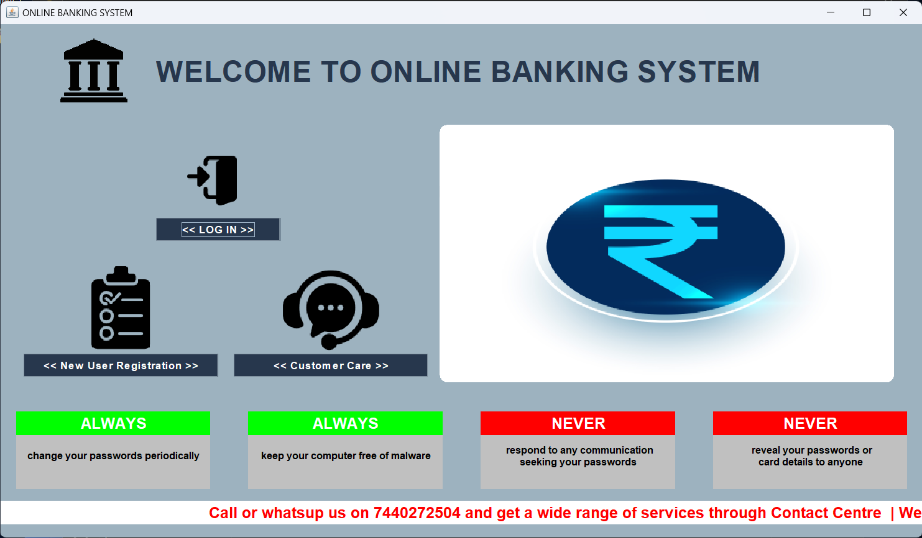1. Home.java

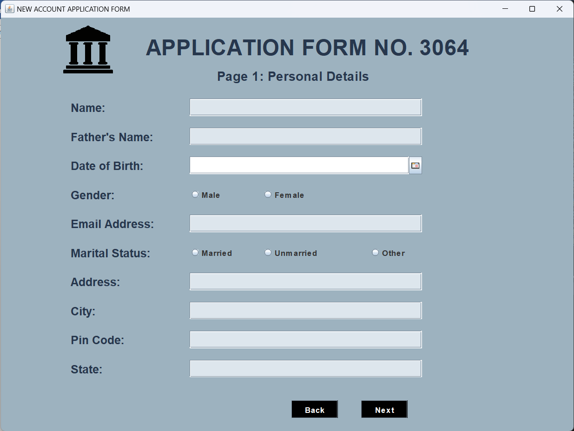2. NewReg.java

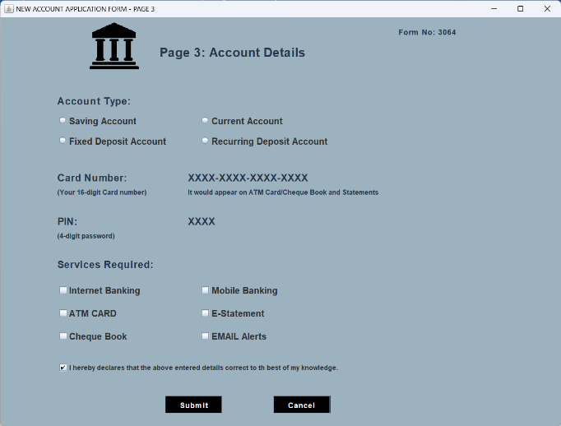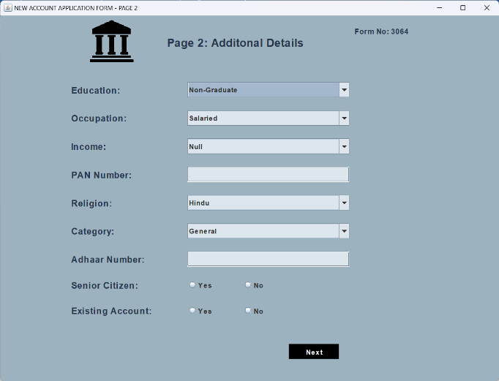3. Reg2.java and Reg3.java

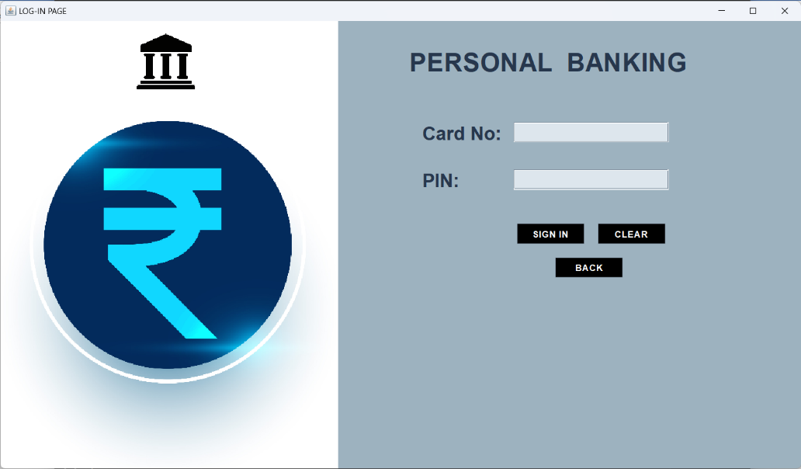4. Login .java

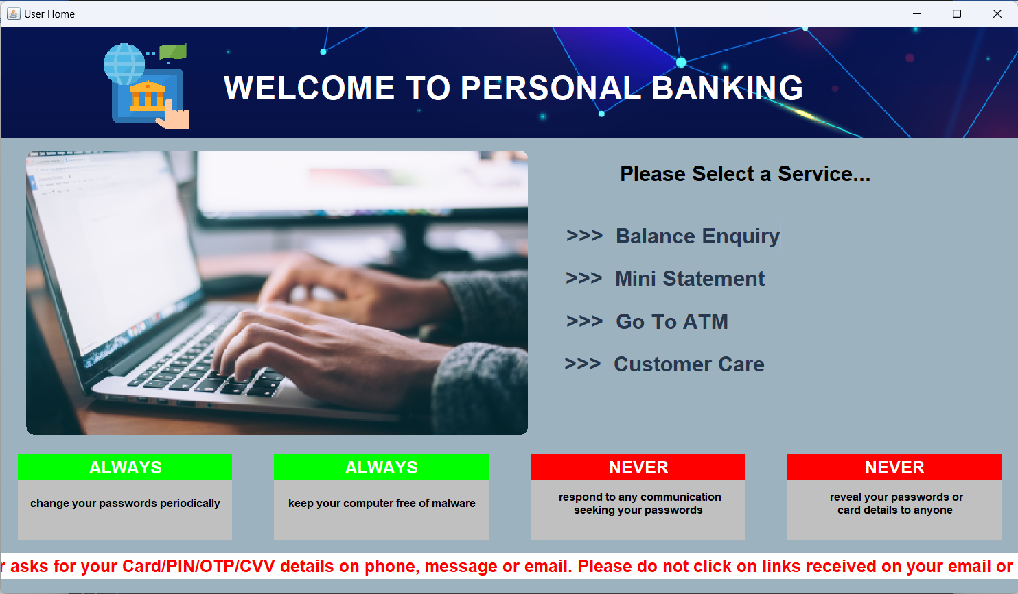5. UserHome.java

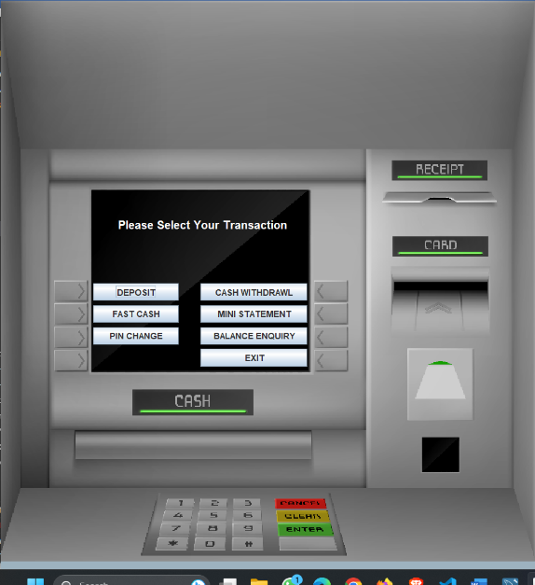6. AtmScreen.java

7.Deposit.java and Withdraw.java

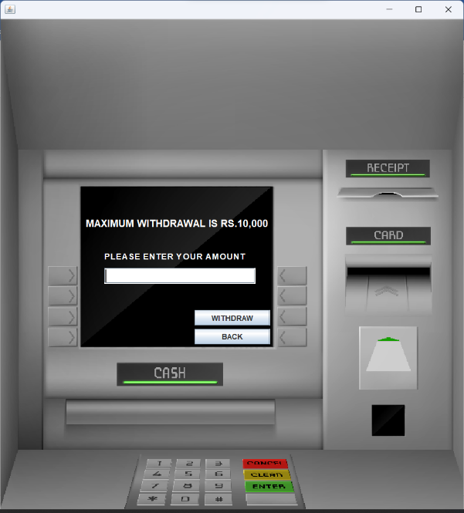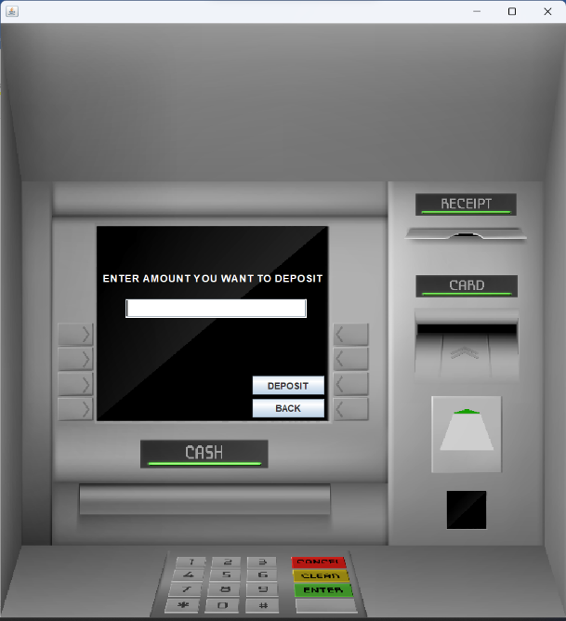

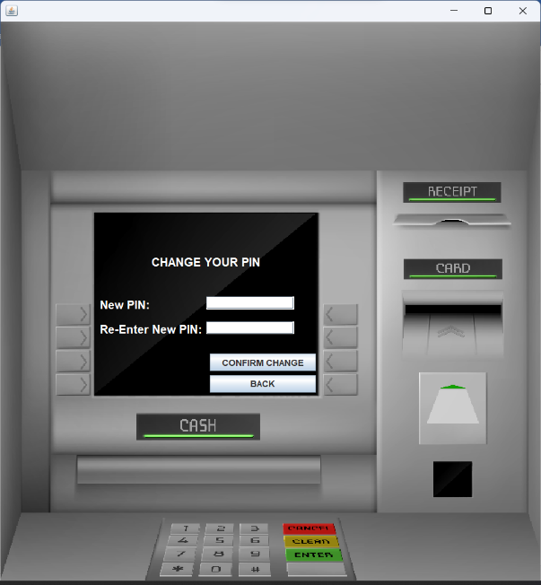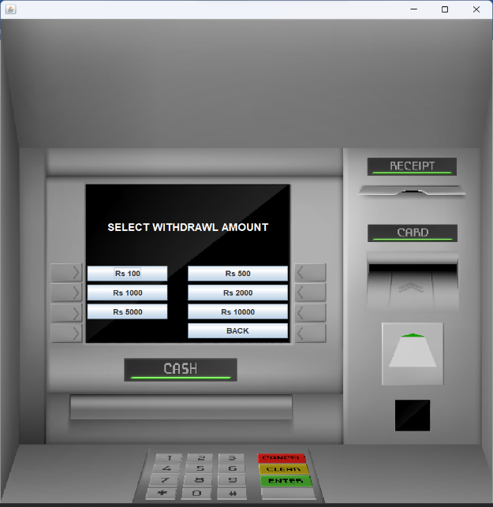8. FastCash.java and Pin.java

9. Balance.java and MiniStatement.java

10. Database connection class Connect.java

