# KAYDEN SYSUM

CS-255

DOCTOR STEFANELLI

SYSTEM DESIGN

# 

# 

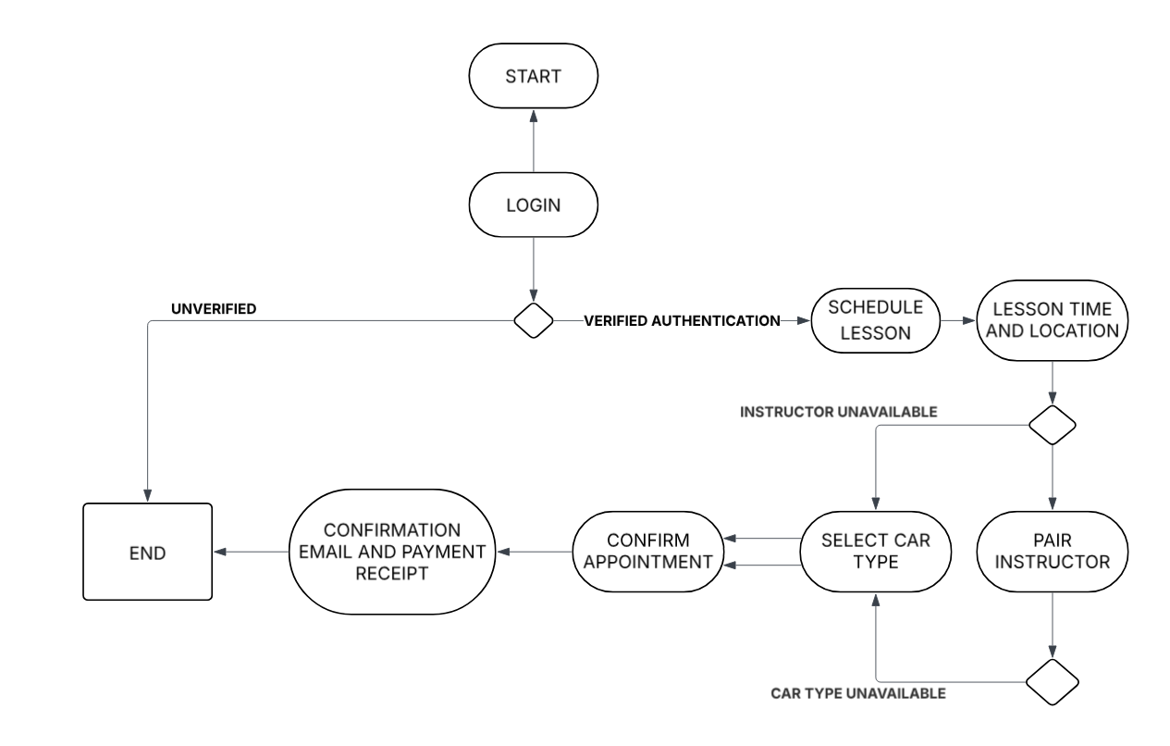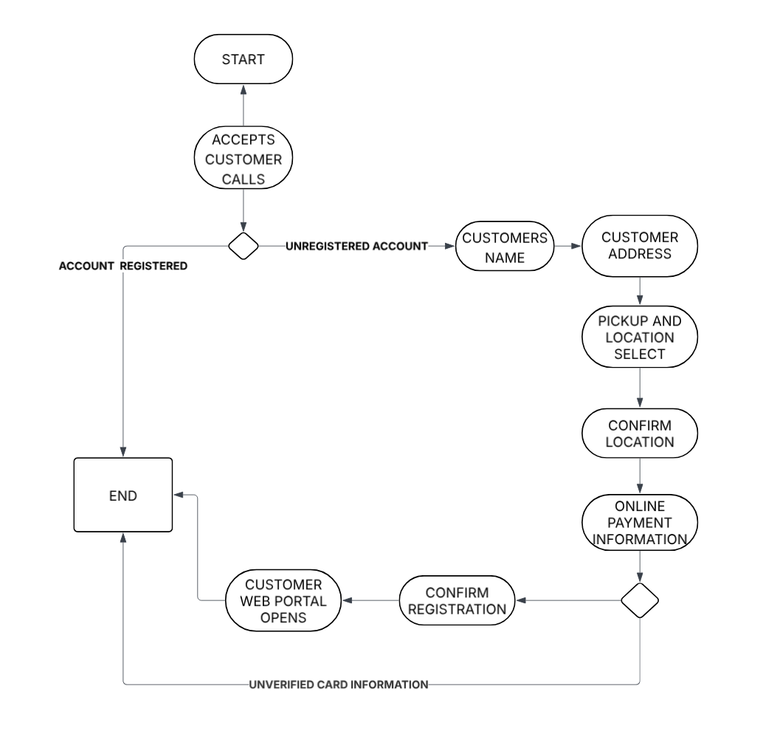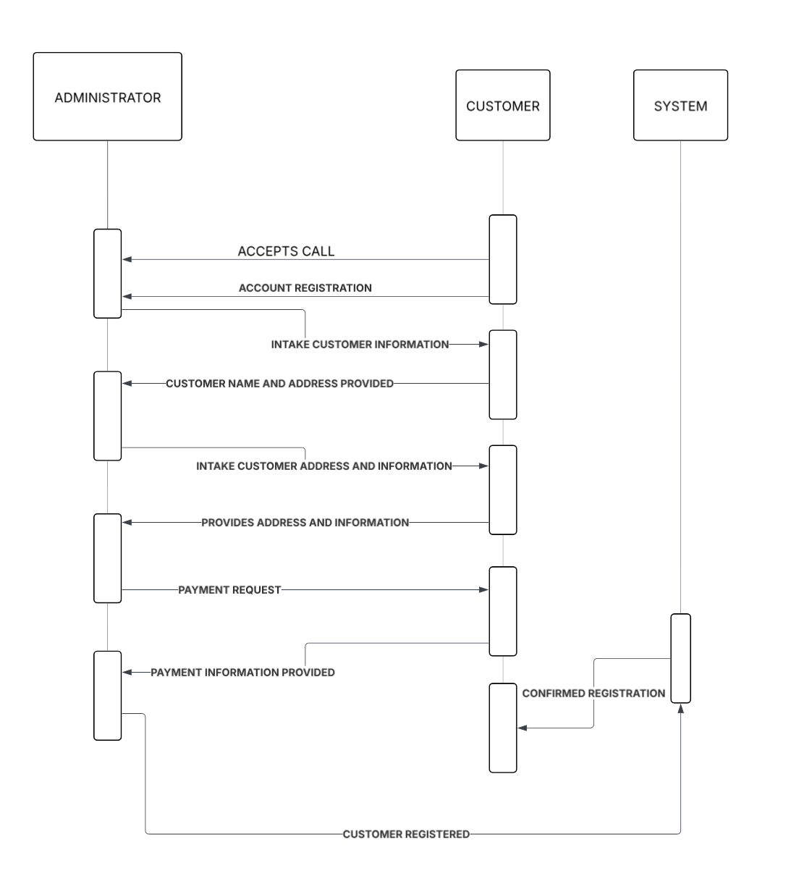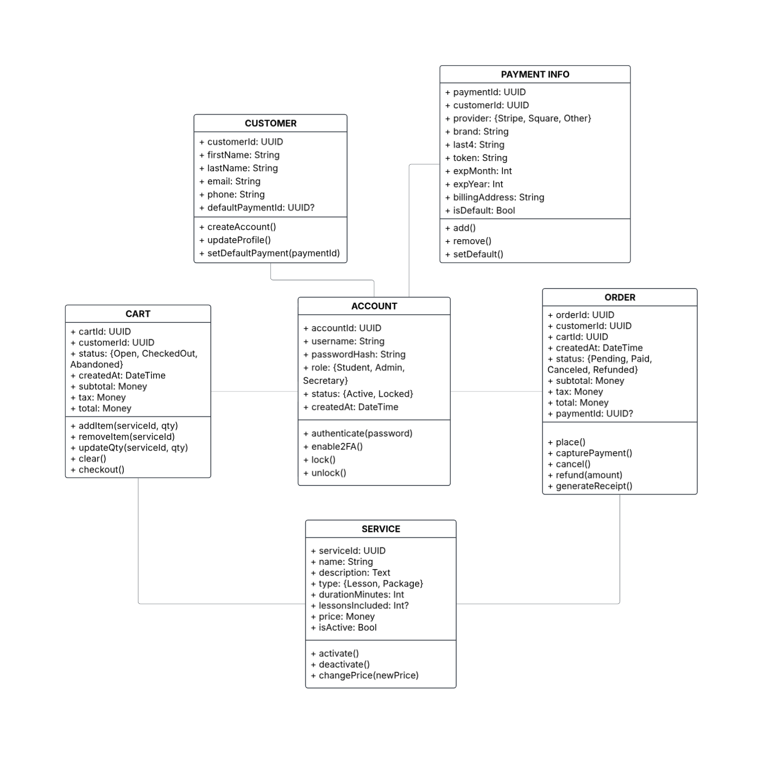

**Overview** Driverpass is a small company that's planning its growth. Driverpass needs a cloud stack that can be managed into autoscaling, backups, and encrypted security. Admins can use Windows or Mac operating systems in order to receive a reliable browser based app that handles scheduling, lessons, and announcements in real time. In order to protect data within the system firstly needs automated backups, endpoint encryption, encrypted storage, and lots of TLS. The web browser works smoothly with Android, macOS, iOS, and Windows allowing users access on whatever device wherever they need. The web app is hosted through a third party provider managed through a SQL database that tracks users, lessons, payment, and account information. User sign in calls for an authenticated service allowing for two factor authentication and role based access to the system. Payments have to be processed through a gateway with tokenization that has PCI compliance which keeps card numbers hidden from the database. Any logging or monitoring is alerted with updates that are passed through a CI/CD pipeline in real time.