**SCKU DATATHON REPORT**

# **HARNESSING DATA FOR SOCIAL IMPACT AND SUSTAINABLE DEVELOPMENT GOALS**

# **Customers Analysis:**

# 1.1 Most Frequent Customers:

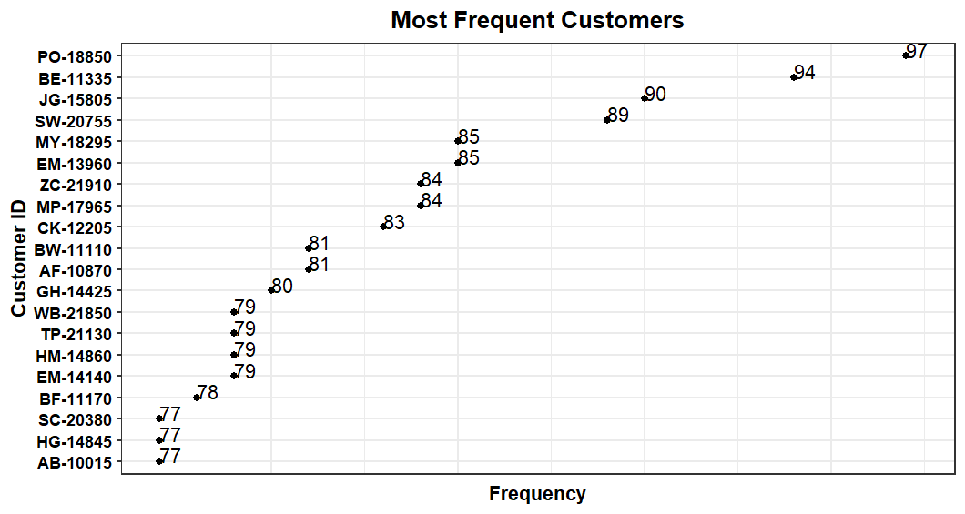

Frequent customer refers to clients that purchase goods more often.

Customer with ID PO-18850 was the most frequent customer within the period 2011-2015 having bought goods ninety seven (97) times followed closely by customer BE-11335 who bought goods ninety four(94) times within the same duration. However, among those who were considered frequent customers, those with IDs AB-10015,HG-14845 and SC-20380 emerged least.

1.2 Most Popular Market Regions

Most popular market regions are the markets from which a lot of customers purchase their products more often per region.

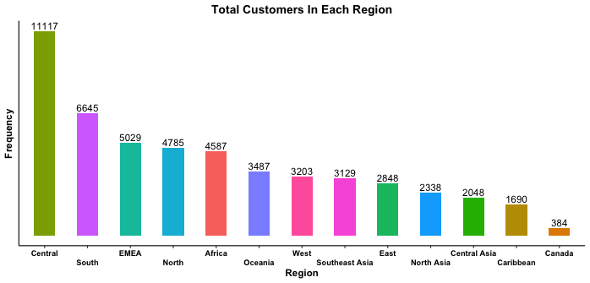

Most customers purchase their products from Central region, approximately eleven thousand one hundred and seventeen customers(11117). On the other hand, Canada region receives less customers of about only three hundred and eighty four customers.(384)

# 1.3 Profit Generated By Each Customer Segment

Customer segments are the categories in which customers are classified either high buyer (frequent) or low buyer (less frequent).

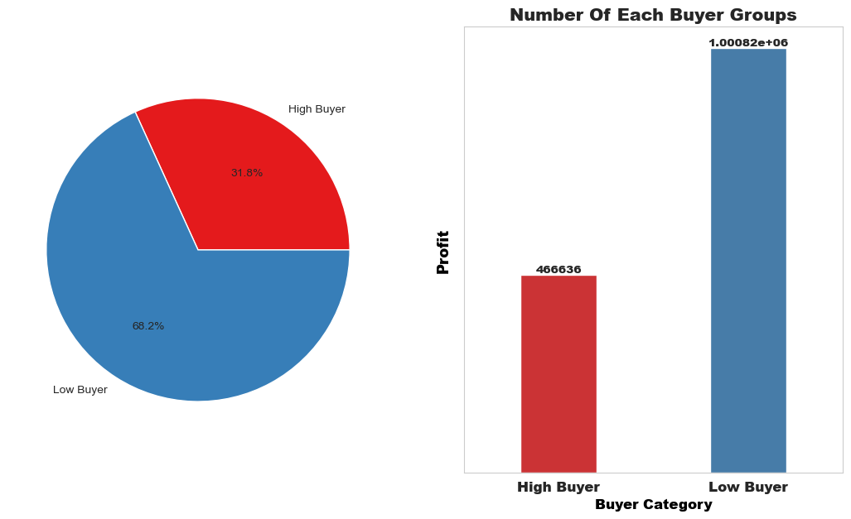

Low buyers were considered to have generated more profit (approximately $1000822) as compared to high buyers who contributed (approximately $466636) within the period 2011-2015.

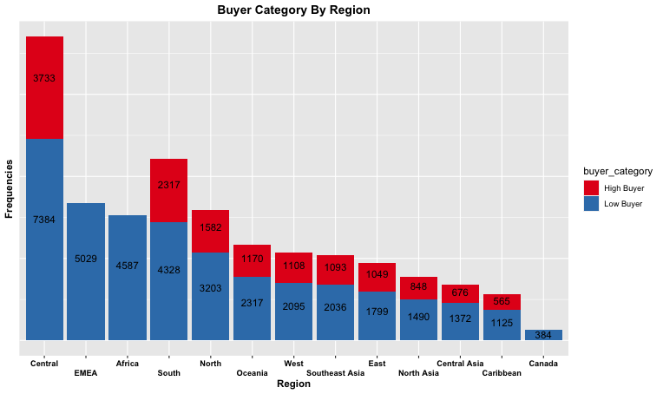1.4 The Total Number of Buyers In Each Category Per Region

In all the regions with the two buyer categories, the size of those considered as low buyers is almost double that of those considered as high buyer customers. i.e(Central,South,North,Oceania,East,North Asia,Cental Asia and Caribbean).

EMEA,Africa and Canada only have customers who are considered low buyers.

Canada has the least number of customers (approximately 384) all of whom are considered low buyers.

Central has the highest number of customers (about 11117) most of whom are also considered low buyers (about 7384) and only three thousand seven hundred and thirty three customers (3733) high buyers.

1.5 Category Of Goods Bought By Each Buyer Group

# 

Generally, low buyers purchase more than the high buyers from all the three product categories.

# **2.Product Analysis**

# 2.1 Countries With Top Sales:

Countries with top sales are those with high product sales.

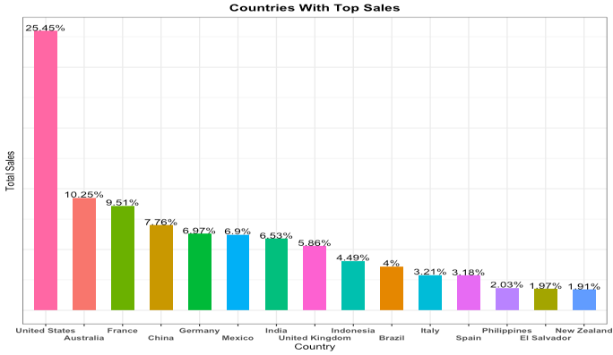

Generally, United States (US) made numerous sales while New Zealand made the least product sales in the period 2011-2015.

US had 25.45 percent of the total sales made by the top fifteen countries.

# 2.2 Top Five Pofit Making Product Types In Each Year:

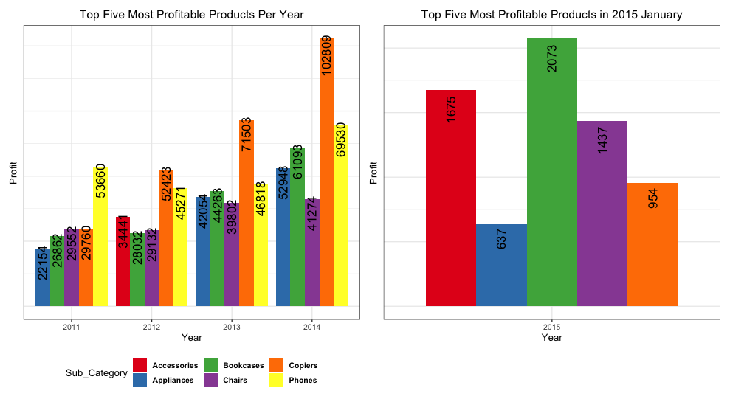

Copiers generated the most profit across the years except in 2011 where phones emerged top in terms of profit production.

Accessories generally produced less profit and only appeared in the top five most profitable products in one year (2012).

In the year 2015, the profits were only made in the month of January since it was the only month of sales.

2.3 Profit Generated In Each Month :

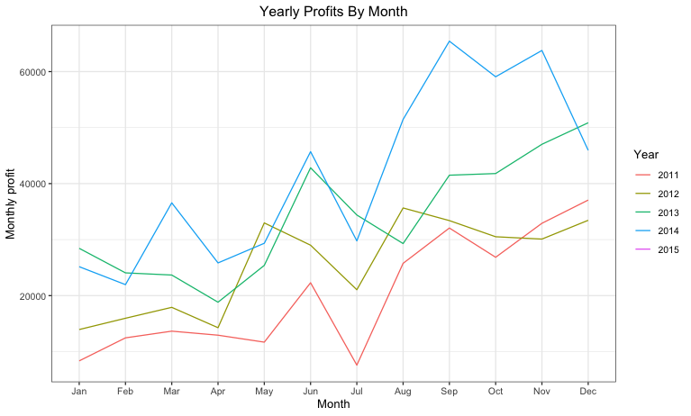

Twenty fourteen (2014) was the most profitable year in the duration 2011-2015.

Twenty eleven(2011) however produced the least profit within the same duration (2011-2015)

2.4 Profit Produced By Each Category:

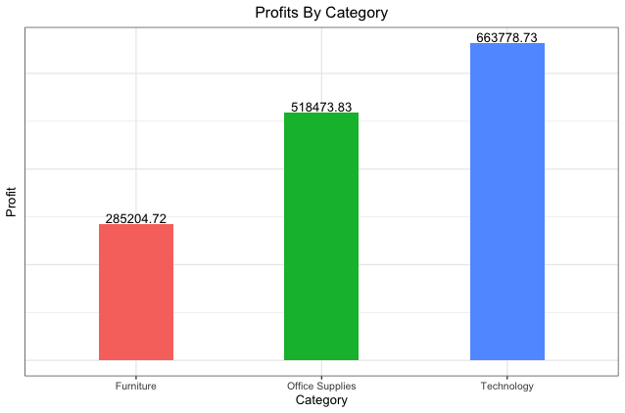

Among the three product categories i.e (Technology,Office Supplies and Furniture), Technology generated a lot of profits (approximately $663778.73).

Furniture however generated the least profit (approximately $285204.72)

2.5 Profit Generated By Each Sub Category:

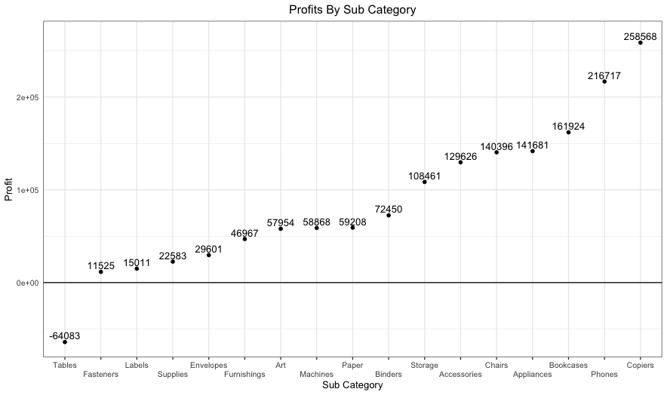

Among the seventeen sub categories, copiers generated the most profit (approximately $258568).

Tables however made a loss of (approximatley $64083).

2.6 Total sales Made Each Month:

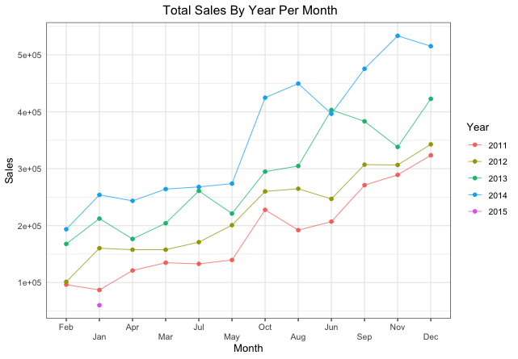The year 2014 had the highest sales across the year with the highest sales hitting above 5 Million ‘’ in November. Its sales capacity experienced steady increase from January through December experiencing only slight drops in April and June.

In 2011, although the sales were generaly low, there was a continuous growth of the amount of sales throughout the year except in August when the sales where there was a slight drop .

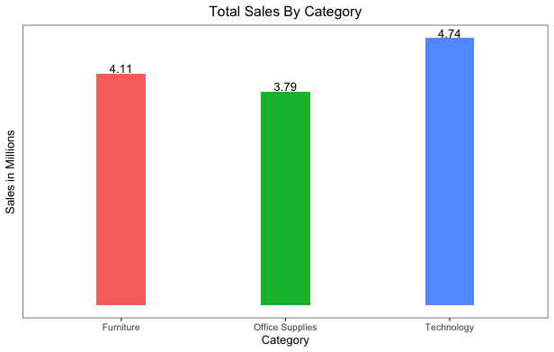2.7 Sales Made By Each Category:

Among all the three categories, a lot of sales were made in the Technology sector (about 4.74 Million).

Office supplies however recorded the least sales (about 3.79 Milion)

2.8 sales Made By Each Sub category:

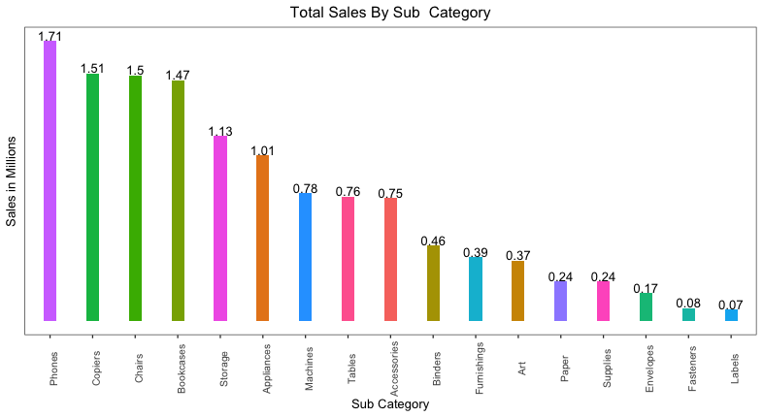Generally, of all the sub categories, a lot of sales were made on the phones (about 1.71 Milion).

Labels however recorded the least sales (about 0.07 Milion).