The Project 2: Linear system solving

Kaiwen Chen[1]

Hong Kong University of Science and Technology, Clear Water Bay, Hong Kong

# The Results

## The optimal relaxation factor:

ωopt=1.78

## The curve of T along x based on ωopt

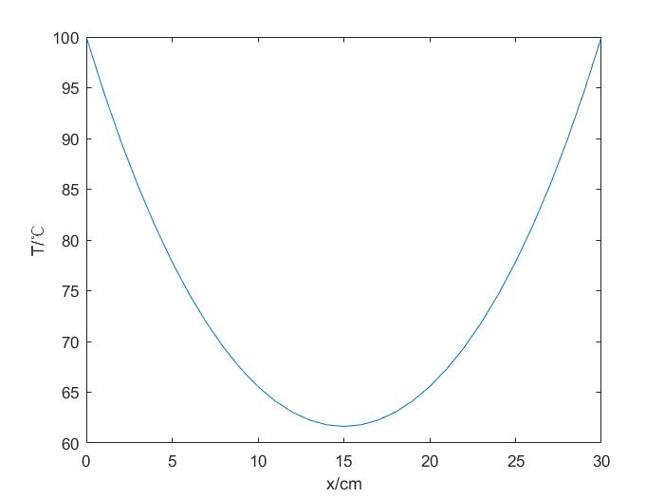



## The relationship between ω and the total number of iteration n before convergence

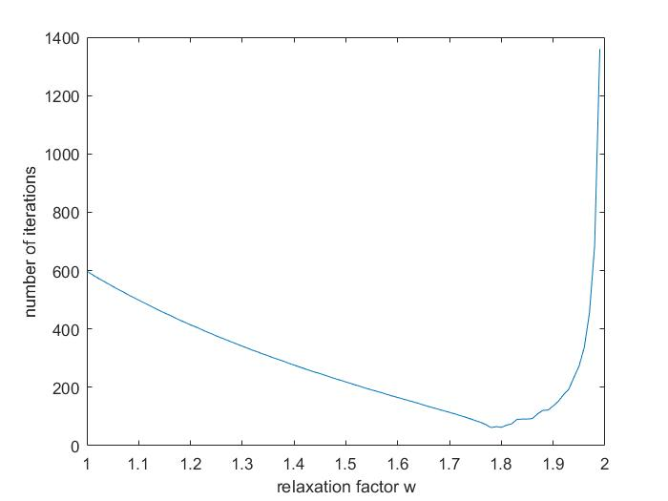

The Data



# The Process

## Mathematical Models

The finite difference approximation form of the ordinary differential equation is:

$$\frac{T_{i+1}-2T_{i}+T_{i-1}}{{(∆x)}^{2}}-GT_{i}=0$$

Since the length of the bar is 30cm and it is divided into 30 parts, the $∆x$ equals 1cm. The constant G is (0.071)2 cm2. The and G have the same unit. So the equation can be written as:

$$T_{i+1}-2T_{i}+T_{i-1}-{0.071}^{2}T_{i}=0$$

which is equal to:

with T0 and T30 are given as 1000C

┆

So the matrix A is

[2.005041 -1 0 0 0 0 0 0 0 0 0 0 0 0 0 0 0 0 0 0 0 0 0 0 0 0 0 0 0

-1 2.005041 -1 0 0 0 0 0 0 0 0 0 0 0 0 0 0 0 0 0 0 0 0 0 0 0 0 0 0

0 -1 2.005041 -1 0 0 0 0 0 0 0 0 0 0 0 0 0 0 0 0 0 0 0 0 0 0 0 0 0

0 0 -1 2.005041 -1 0 0 0 0 0 0 0 0 0 0 0 0 0 0 0 0 0 0 0 0 0 0 0 0

0 0 0 -1 2.005041 -1 0 0 0 0 0 0 0 0 0 0 0 0 0 0 0 0 0 0 0 0 0 0 0

0 0 0 0 -1 2.005041 -1 0 0 0 0 0 0 0 0 0 0 0 0 0 0 0 0 0 0 0 0 0 0

0 0 0 0 0 -1 2.005041 -1 0 0 0 0 0 0 0 0 0 0 0 0 0 0 0 0 0 0 0 0 0

0 0 0 0 0 0 -1 2.005041 -1 0 0 0 0 0 0 0 0 0 0 0 0 0 0 0 0 0 0 0 0

0 0 0 0 0 0 0 -1 2.005041 -1 0 0 0 0 0 0 0 0 0 0 0 0 0 0 0 0 0 0 0

0 0 0 0 0 0 0 0 -1 2.005041 -1 0 0 0 0 0 0 0 0 0 0 0 0 0 0 0 0 0 0

0 0 0 0 0 0 0 0 0 -1 2.005041 -1 0 0 0 0 0 0 0 0 0 0 0 0 0 0 0 0 0

0 0 0 0 0 0 0 0 0 0 -1 2.005041 -1 0 0 0 0 0 0 0 0 0 0 0 0 0 0 0 0

0 0 0 0 0 0 0 0 0 0 0 -1 2.005041 -1 0 0 0 0 0 0 0 0 0 0 0 0 0 0 0

0 0 0 0 0 0 0 0 0 0 0 0 -1 2.005041 -1 0 0 0 0 0 0 0 0 0 0 0 0 0 0

0 0 0 0 0 0 0 0 0 0 0 0 0 -1 2.005041 -1 0 0 0 0 0 0 0 0 0 0 0 0 0

0 0 0 0 0 0 0 0 0 0 0 0 0 0 -1 2.005041 -1 0 0 0 0 0 0 0 0 0 0 0 0

0 0 0 0 0 0 0 0 0 0 0 0 0 0 0 -1 2.005041 -1 0 0 0 0 0 0 0 0 0 0 0

0 0 0 0 0 0 0 0 0 0 0 0 0 0 0 0 -1 2.005041 -1 0 0 0 0 0 0 0 0 0 0

0 0 0 0 0 0 0 0 0 0 0 0 0 0 0 0 0 -1 2.005041 -1 0 0 0 0 0 0 0 0 0

0 0 0 0 0 0 0 0 0 0 0 0 0 0 0 0 0 0 -1 2.005041 -1 0 0 0 0 0 0 0 0

0 0 0 0 0 0 0 0 0 0 0 0 0 0 0 0 0 0 0 -1 2.005041 -1 0 0 0 0 0 0 0

0 0 0 0 0 0 0 0 0 0 0 0 0 0 0 0 0 0 0 0 -1 2.005041 -1 0 0 0 0 0 0

0 0 0 0 0 0 0 0 0 0 0 0 0 0 0 0 0 0 0 0 0 -1 2.005041 -1 0 0 0 0 0

0 0 0 0 0 0 0 0 0 0 0 0 0 0 0 0 0 0 0 0 0 0 -1 2.005041 -1 0 0 0 0

0 0 0 0 0 0 0 0 0 0 0 0 0 0 0 0 0 0 0 0 0 0 0 -1 2.005041 -1 0 0 0

0 0 0 0 0 0 0 0 0 0 0 0 0 0 0 0 0 0 0 0 0 0 0 0 -1 2.005041 -1 0 0

0 0 0 0 0 0 0 0 0 0 0 0 0 0 0 0 0 0 0 0 0 0 0 0 0 -1 2.005041 -1 0

0 0 0 0 0 0 0 0 0 0 0 0 0 0 0 0 0 0 0 0 0 0 0 0 0 0 -1 2.005041 -1

0 0 0 0 0 0 0 0 0 0 0 0 0 0 0 0 0 0 0 0 0 0 0 0 0 0 0 -1 2.005041]

The column vector T is [T1;T2;T3;…;T29]

The column vector b is [100;0;…;0;100]

## The algorithm

Ti =(Ti+1 + Ti-1)/2.005041; i starts from 1 to 29; iteration step by step until the converge condition meets ;

# The Code

## Calculate with different relaxation factors

% Record the relaxation factor w and number of iterations k

recordw=0;

recordk=0;

% n is the index

n=1;

% w is the relaxation factor

for w=1:0.01:1.99

% T is the old temperature differences

% T2 is the new temperature differences

% Initial guess£º0

T=[100;zeros(29,1);100];

T2=[100;zeros(29,1);100];

% k calculate the number of iterations for each relaxation factor

k=0;

while 1

% Gauss-Sidel iteration

for i=2:30

T2(i)=(T2(i+1)+T2(i-1))/2.005041;

T2(i)=w*T2(i)+(1-w)*T(i);

end

% Add the number of iteration

k=k+1;

% Convergence condition

if max(abs(T-T2))<0.0001

break;

else

T=T2;

end

end

% Record the w and k

recordw(n)=w;

recordk(n)=k;

% Change the relaxation factor w and the index n

n=n+1;

end

plot(recordw,recordk);

xlabel('relaxation factor w')

ylabel('number of iterations')

## Calculate with the optimal relaxation factor

%woptimal=1.78

w=1.78;

T=[100;zeros(29,1);100];

T2=[100;zeros(29,1);100];

k=0;

%T1=100 T31=100

while 1

for i=2:30

T2(i)=(T2(i+1)+T2(i-1))/2.005041;

T2(i)=w*T2(i)+(1-w)*T(i);

end

k=k+1;

if max(abs(T-T2))<0.0001

break;

else

T=T2;

end

end

plot(0:1:30,T2);

xlabel('x/cm')

ylabel('T/¡æ')

1. Master of Science, Department of Mechanical and Aerospace Engineering, Email:[kchenau@connect.ust.hk](mailto:kchenau@connect.ust.hk)