PROJECT BLUEPRINT

Real-Time Indian Sign Language
Communication Assistant
  - Software-only recognition, text and speech system
Planning, architecture, data and delivery handbook
RECOMMENDED BUILD Start with 20-30 isolated, high-value ISL signs; landmark sequences; signer-independent evaluation; on-device/browser capture; a Python inference service; and explicit uncertainty handling. Treat continuous translation and LLM reconstruction as later research increments.

Version 1.0 | 21 August 2026 | Architecture baseline

How to use this blueprint
This is the team’s source of truth for scope, interfaces, data rules and delivery gates. Read Sections 1-4 before implementation; use Sections 5-12 while building; use the appendices during reviews and demos.
Reader | Use this document to
AI lead | Own architecture, dataset policy, model choices, evaluation and release decisions.
Team members | Work from module contracts, checklists and acceptance criteria without needing to redesign the system.
Faculty guide | Review scope realism, scientific validity, ethics and measurable outcomes.
Codex | Generate bounded modules, tests and documentation against explicit contracts; never invent data or silently change interfaces.

NON-NEGOTIABLE A polished demo is not proof of recognition quality. Every claimed result must use a signer-independent held-out test set, report uncertainty, and preserve a reproducible model/data version.

Decision summary
Decision | Baseline
Primary problem | Isolated ISL sign recognition into readable text and optional speech.
MVP vocabulary | 20-30 practical signs chosen with ISL-informed review; balanced by signer and condition.
Input | Single RGB webcam; no glove, depth camera or cloud video upload required.
Features | MediaPipe hand landmarks plus selected upper-body pose; face landmarks postponed unless justified.
Model | Sequence baseline (GRU/TCN) plus a simple static baseline; calibrated reject option.
Runtime | React/Vite UI + FastAPI; WebSocket events; inference initially on the same laptop.
Language layer | Deterministic token joining first; optional LLM only as a visibly separate, user-confirmed rewrite.
Success | Useful latency and signer-independent macro-F1, not headline training accuracy.

ISL Domain Primer: Understand the Language Before Building the AI
CORE IDEA Indian Sign Language (ISL) is a natural visual-spatial language used by Deaf communities. It is not mime, not a universal set of gestures, and not English or Hindi converted word-for-word into hand movements. A useful system must model language, not merely classify hand poses.

What is Indian Sign Language?
ISL is a human language expressed primarily through visible actions of the hands, face, head and body, organized in signing space. Like spoken languages, it has a lexicon and systematic patterns for building meaning. Its visual-spatial modality allows information to be expressed simultaneously: the hands may produce a lexical sign while facial expression, head movement, body posture or gaze adds grammatical and discourse information at the same time.
The label “Indian Sign Language” is useful for the widely shared language and resources used across India, but it must not be interpreted as perfectly uniform. Sign forms and preferences can vary by region, school, age, community, language contact and individual experience. The system therefore needs explicit variant handling and should avoid treating one person’s signing as the only correct form.

Language, gesture and signing systems are different
Term | Meaning | Project implication
Natural sign language | A community language that develops and is transmitted among signers, with its own linguistic organization. | ISL must be treated as the source language, not as a collection of poses.
Gesture | A communicative movement that may accompany speech or be understood from context, but is not automatically part of a full linguistic system. | A generic gesture dataset is not an ISL dataset.
Home sign | A family or individual communication system that may arise when a Deaf person lacks access to a shared sign language. | Do not relabel personal signs as standard ISL without community validation.
Signed spoken-language system | A system that combines signs with the word order or structure of a spoken language. | Do not assume it represents natural ISL grammar.
Fingerspelling | Representation of letters using conventional handshapes, often used for names, abbreviations or words without an established sign. | Alphabet recognition is a separate subtask and is not equivalent to ISL translation.

How a sign carries meaning
A sign is not defined by handshape alone. Linguists commonly describe several interacting parameters. Changing one parameter can change the sign, create a different meaning, or make the production unclear. This is why a hand-only static classifier has a hard ceiling.
Parameter | What it describes | What the camera/model must capture
Handshape | Finger and thumb configuration. | Reliable finger-joint landmarks; occlusion and camera angle matter.
Location | Where the sign is articulated relative to the body or signing space. | Hands plus stable body anchors such as shoulders, face region and torso.
Movement | Path, direction, repetition, speed and internal finger movement. | Timestamped sequences, not a single image.
Orientation | Direction of the palm and fingers. | Depth/orientation cues and a consistent mirroring policy.
Two-hand relationship | Whether hands are symmetric, alternating, contacting or serving different roles. | Stable left/right hand slots and inter-hand features.
Non-manual features | Facial expression, eyebrows, mouth actions, head movement, gaze and body posture. | Needed for some lexical or grammatical distinctions; add only with consent and linguistic justification.

The role of space, reference and simultaneity
- Signing space is linguistically meaningful. A signer can establish a person, object or location at a point in space and later refer back to that locus.
- Direction of movement can encode relationships between participants or locations. A model that normalizes every direction away may destroy meaning.
- Both hands can contribute different information at the same time, and non-manual markers can span more than one sign.
- Gaze and body shift can help manage reference, viewpoint, quotation or interaction, depending on context.
- Because information can be simultaneous rather than strictly one-token-after-another, a flat list of English labels is an incomplete representation of ISL.

Grammar and word order
ISL has grammatical structure, but the team should not reduce it to a slogan such as “ISL always follows one fixed word order.” Research describes systematic patterns involving word order, agreement, localization, pluralization, questions and non-manual marking, while actual usage also reflects discourse context and variation. For the MVP, recognize isolated signs and avoid claiming sentence grammar. Continuous translation will require annotated sequences, linguistic expertise and evaluation of meaning—not only token accuracy.
EXAMPLE PRINCIPLE Two clips containing the same approximate lexical signs can convey different meanings if direction, spatial reference, question marking, negation, intensity or facial/head behavior differs. The architecture must preserve these cues whenever they are relevant to the target vocabulary.

What is a gloss?
A gloss is a written annotation label used by researchers to name a sign, often written in uppercase, such as WATER or HELP. It is a convenient identifier—not the sign itself, not a full description of its form, and not automatically an English translation. Different annotation projects may choose different glosses for similar signs, and one gloss can hide variants or context-dependent meanings.
Representation | Example | What it does / does not mean
Class ID | sign_014 | Stable machine identifier; carries no linguistic meaning by itself.
Gloss | WATER | Annotation shorthand for a sign class; not proof that every occurrence translates exactly to the English word “water.”
Recognized token sequence | WATER WANT | Output of a recognition stage; may omit grammar, spatial relations and non-manual information.
Spoken-language sentence | I would like some water. | A translation or reconstruction that adds grammatical words and order; must be evaluated separately.
Sign video / landmark stream | Visual production over time | The richest source representation available to the system; landmarks still lose appearance and some facial detail.

Recognition tasks: do not mix their claims
Task | Input → output | What success means
Fingerspelling recognition | Letter handshape sequence → letters/word | Correct letters and segmentation; limited to fingerspelled content.
Isolated sign recognition (MVP) | Pre-segmented single sign → class/gloss | Correct sign class for unseen signers, with a reliable unknown option.
Continuous sign recognition | Unsegmented signing video → ordered gloss/token sequence | Correct boundaries and sequence, including coarticulation and transitions.
Sign language translation | Signing video → natural spoken-language text | Preserved meaning and fluent target language; not measured by classification accuracy.
Sign language production | Text/meaning → understandable signing video/avatar | Linguistically accurate, natural and acceptable output evaluated with Deaf users.

Context changes meaning
- Lexical context: a form may have related senses or require surrounding signs to disambiguate.
- Discourse context: established people/places in signing space affect later references.
- Non-manual context: eyebrow, head and mouth behavior may mark a question, negation, emphasis or other information.
- Physical context: pointing and spatial reference may depend on people or objects present in the room.
- Sociolinguistic context: region, community, age, education and contact with other languages can influence sign choice.
- Technical context: camera mirroring, crop, occlusion and dropped frames can make a correct sign look different to the model.

ISL, Deaf identity and respectful language
Many sign-language users understand Deafness not only as an audiological condition but also through language, community and culture. Capital-D “Deaf” is often used when referring to this cultural-linguistic identity, while lowercase “deaf” may refer more generally to hearing status; individuals differ in the terms they prefer. The project should ask participants how they wish to be described and should not frame ISL users as broken hearing people whom technology must “fix.”
- Say “Deaf and hard-of-hearing people” or use participants’ preferred terms; avoid labels such as “deaf and dumb.”
- Say “signer,” “sign,” “sign language” and “ISL,” not “hand gesture language.”
- Do not call the prototype an interpreter. Professional interpreters make contextual and ethical judgments that a classifier does not.
- Include Deaf/ISL expertise in vocabulary, annotation, evaluation and claims—not only as data contributors.
- Show uncertainty and provide correction controls; the user remains the authority over intended meaning.

Domain consequences for this architecture
Domain fact | Required design response
Meaning uses hands, body, face and space. | Use hand sequences plus body anchors; add non-manual features only where target signs require them.
Signs unfold over time. | Use timestamped windows and temporal models for dynamic signs.
Variants are normal language behavior. | Model approved variants, record variant metadata and evaluate across signers/regions.
Gloss is only an annotation. | Keep class ID, gloss, display label and translation text as separate fields.
Unknown input is inevitable. | Include no-sign/transition negatives, quality gates and explicit rejection.
Continuous translation is a different problem. | Keep recognizer and language layer separate; evaluate each with appropriate metrics.
User intent cannot be inferred perfectly. | Make output editable and require confirmation before consequential speech/reconstruction.
Language ownership matters. | Use ISL-informed governance for vocabulary, data, errors and public claims.

Minimum domain vocabulary for the team
Term | Working definition
Signer | A person producing a sign language.
Signing space | The visible space around the signer used for articulation and reference.
Manual feature | Information produced by the hands and arms.
Non-manual marker | Meaningful facial, head, gaze, mouth or body behavior accompanying/signalling language.
Lexical sign | A conventional sign associated with a vocabulary item or meaning.
Variant | An accepted difference in how a sign is produced or selected across people/communities/contexts.
Coarticulation | Changes caused by moving between neighboring signs in continuous signing.
Segmentation | Locating where a sign or signing unit begins and ends.
Gloss | A written annotation label for a sign; not a complete translation.
Locus | A location in signing space associated with a referent.
Recognition | Identifying signs/tokens from visual input.
Translation | Producing an equivalent message in another language.

TEAM READINESS GATE Before collecting data, every team member should be able to explain: why ISL is a language; why a sign is more than handshape; why gloss is not translation; why signer-level splits matter; and why Deaf/ISL review is part of technical quality.

1. Problem, users and product boundary

1.1 Problem statement
Deaf and hard-of-hearing ISL users often face communication friction with hearing people who do not know ISL. The project will recognize a deliberately limited vocabulary of isolated Indian Sign Language signs from a live webcam and present the result as text, with optional speech playback. It is an assistive prototype, not a replacement for interpreters and not a claim of full language translation.

1.2 Product objective
- Demonstrate an end-to-end, reproducible AI system: capture → landmarks → temporal model → stable token → text/speech.
- Prioritize local processing, understandable feedback and user control.
- Measure generalization to unseen signers and realistic room conditions.
- Create an architecture that can evolve toward continuous signing without pretending the MVP already solves it.

1.3 In scope / out of scope
In scope for MVP | Explicitly out of scope
Isolated word signs with manual or automatic start/end; one or two hands; upper-body framing. | Open-vocabulary or sentence-level ISL translation.
20-30 agreed signs plus “unknown/no sign”; text history; replayable speech. | Medical, legal, emergency or safety-critical reliance.
Local dataset collection, consent, manifests, quality review and versioned splits. | Identification of a signer, emotion inference or demographic prediction.
Landmark-sequence and simple RGB baseline comparison. | Always-on recording or raw-video retention by default.
English output initially; UI can later add Hindi or regional spoken-language text. | Claiming English word order is equivalent to ISL grammar.

1.4 Personas and user stories
Persona | Need | Acceptance signal
ISL signer | Communicate a known sign quickly without being recorded unnecessarily. | Sees camera framing, detected hands, confidence/uncertainty and editable output.
Hearing conversation partner | Read or hear recognized content. | Caption arrives promptly and speech never plays without user setting/intent.
Data contributor | Understand consent and how recordings are used. | Can review consent, skip sensitive metadata and request deletion before release.
AI lead | Reproduce experiments and diagnose failures. | Every run stores config, split, metrics, model hash and error samples.
Team member | Implement one bounded module safely. | Module has typed inputs/outputs, fixtures and a short runbook.

2. User flows and experience requirements

2.1 Live conversation flow
- Open the app; choose camera and preferred spoken output language/voice.
- Read a short privacy notice; camera processing starts only after explicit consent.
- Position upper body and hands inside the framing guide; the UI reports readiness.
- Press “Start sign” (MVP) or hold a deliberate ready pose (later).
- Perform one sign; the UI shows collecting → processing → result.
- If confidence and stability pass thresholds, append the token. Otherwise show “Not sure—try again,” never a forced guess.
- Review/edit/delete the token; optionally play text-to-speech.
- End session; by default, discard frames and retain no video.

2.2 Data collection flow
- Create an anonymous participant ID and capture consent version.
- Explain each target sign using an approved reference; do not teach from a machine-generated description.
- Record repetitions across deliberate variations: distance, background, clothing and speed.
- Run automatic checks for duration, frame count, landmark visibility and duplicate files.
- Have a reviewer mark valid, retry or ambiguous; preserve reasons.
- Freeze a dataset version and signer-level splits before training.

2.3 Accessibility requirements
- The core experience must work without audio; all states have text and color-independent icons/labels.
- Keyboard operation, visible focus, large targets, adjustable text and high contrast.
- Mirror preview only for comfort; never mirror feature coordinates inconsistently between training and inference.
- Avoid strobing feedback and unnecessary animation.
- Offer pause, clear history and editable output.
- Test with Deaf/ISL users where possible and compensate participation when feasible.

3. Target architecture
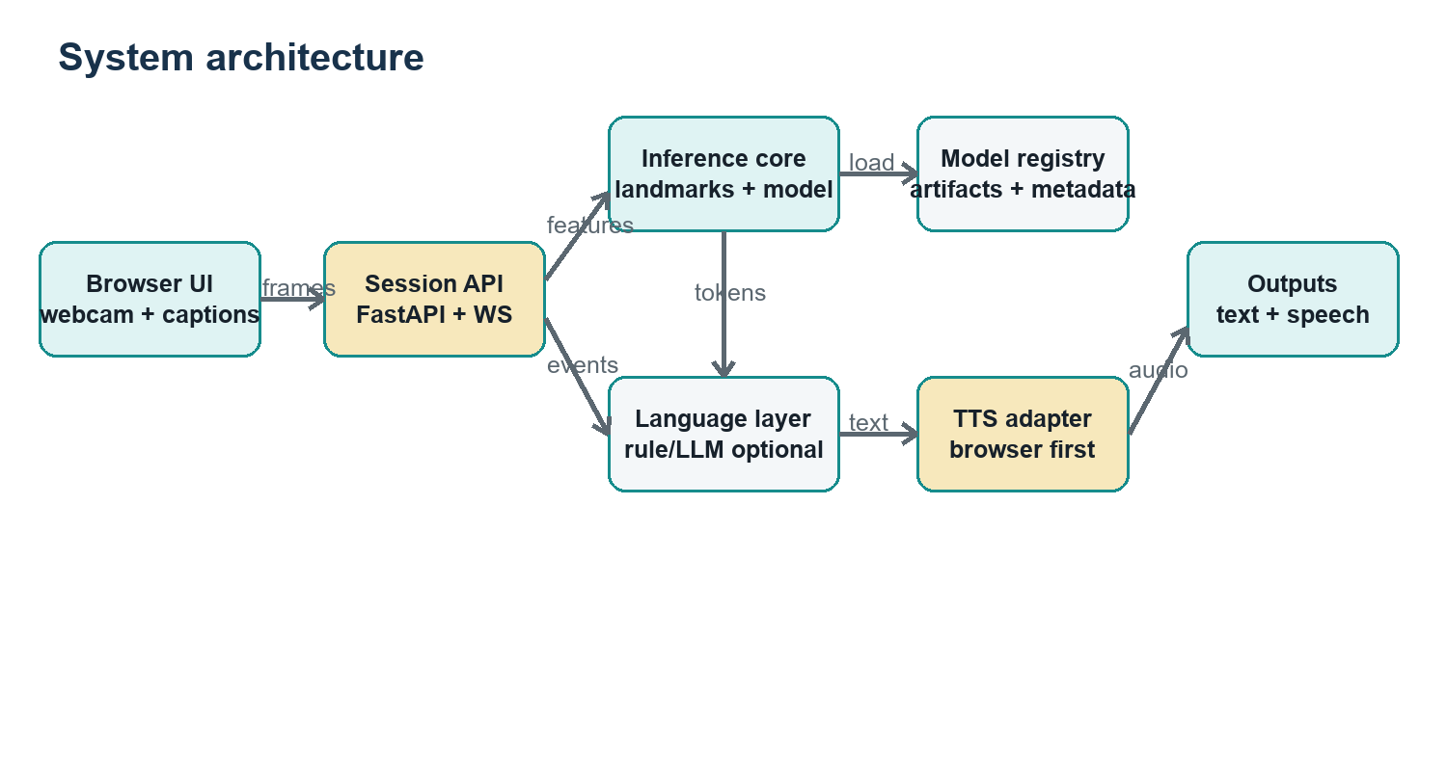
Figure 1. Logical system architecture and runtime boundaries.

3.1 Architectural principles
- Local-first video: keep frames in the browser or local process wherever practical; transmit landmarks rather than raw video in the normal path.
- Separate perception, classification and language presentation so each can be tested and replaced.
- One canonical feature schema shared by training and inference.
- Event-driven real-time path; REST for configuration, metadata and health.
- Fail closed: missing hands, stale model, malformed events or low confidence yield “unknown,” not a word.
- Model artifacts are immutable and carry vocabulary, feature schema and preprocessing metadata.

3.2 Deployment modes
Mode | When to use | Trade-off
A. Single laptop (recommended) | Development, collection and college demo. Browser + API + model on one machine. | Simplest privacy and debugging; limited device portability.
B. LAN edge server | Multiple lab clients share a GPU workstation. | Higher throughput; requires authentication and transport security.
C. Browser inference | Later, export compatible model and run landmarks/classifier client-side. | Best privacy/offline behavior; WebAssembly/model compatibility work.
D. Cloud service | Only after consent, security and operational maturity. | Scalable but privacy, cost and network latency are harder.

4. Data strategy

4.1 Dataset choices
Source | Best use | Cautions / decision
INCLUDE / INCLUDE-50 | External isolated-sign benchmark and transfer-learning source; INCLUDE reports 263 word signs and a smaller 50-sign subset. | Verify current license and exact class overlap before use; do not mix official test samples into training.
iSign benchmark | Research path for SignVideo2Text, SignPose2Text and related ISL processing tasks. | Too ambitious for MVP; useful roadmap and pretraining research.
ISLTranslate | Continuous phrase/sentence research and translation experiments. | Not a substitute for your isolated-sign test protocol.
Government ISL dictionary | Vocabulary consultation and sign references. | Dictionary media is not automatically a training dataset; verify reuse rights.
Team-collected dataset | Matches your camera, vocabulary and deployment conditions. | Requires consent, signer diversity, quality control and leakage-safe splits.

DATASET RECOMMENDATION Use public data to bootstrap and compare, but build a small, carefully controlled local dataset for the chosen vocabulary. Freeze the vocabulary only after an ISL-informed reviewer confirms sign variants and labels.

4.2 Vocabulary selection rubric
Criterion | Rule
Utility | Favor conversational needs: help, water, yes/no, stop, thank you, name, repeat, washroom, doctor—subject to ISL validation.
Visual separability | Avoid an initial set dominated by near-identical signs.
Motion coverage | Include static, short dynamic, one-hand and two-hand signs, but cap hard cases.
Ethical fit | Avoid collecting stigmatizing, intimate or high-risk content in the first dataset.
Representativeness | Record multiple fluent signers and variants; document region/context rather than treating one signer as universal.
Class balance | Target equal valid repetitions per signer per class; include no-sign/transition negatives.

4.3 Collection protocol
Recommended pilot: 8-12 signers × 20 signs × 10 valid repetitions = 1,600-2,400 clips, plus structured “no sign” and transition samples. If access to fluent signers is limited, reduce vocabulary before reducing signer diversity. The AI lead should approve the actual target after a 2-signer pilot.
Field | Example / rule
sample_id | UUID; never encode a participant name.
participant_id | P### pseudonym; identity mapping stored separately and access-controlled.
label_id / gloss | Stable machine label plus human display text; keep spelling and casing canonical.
variant_id | Optional regional/acceptable variant identifier reviewed by an ISL expert.
capture | camera ID, resolution, FPS, orientation, lighting bucket, background bucket.
timing | start/end frame, duration_ms, dropped_frames.
quality | hand visibility, pose visibility, blur score, reviewer_status, rejection_reason.
governance | consent_version, permitted_use, retention_until, dataset_version.

4.4 Split policy and leakage prevention
- Primary split is by participant: no signer appears in more than one of train, validation or test.
- Keep all repetitions from one recording session together.
- Freeze the held-out test identities before tuning.
- If external datasets are combined, track source and deduplicate by file hash/perceptual similarity.
- Report a second stress set for new background, clothing or camera if available.
- Never select thresholds on the test set.

5. MediaPipe feature extraction
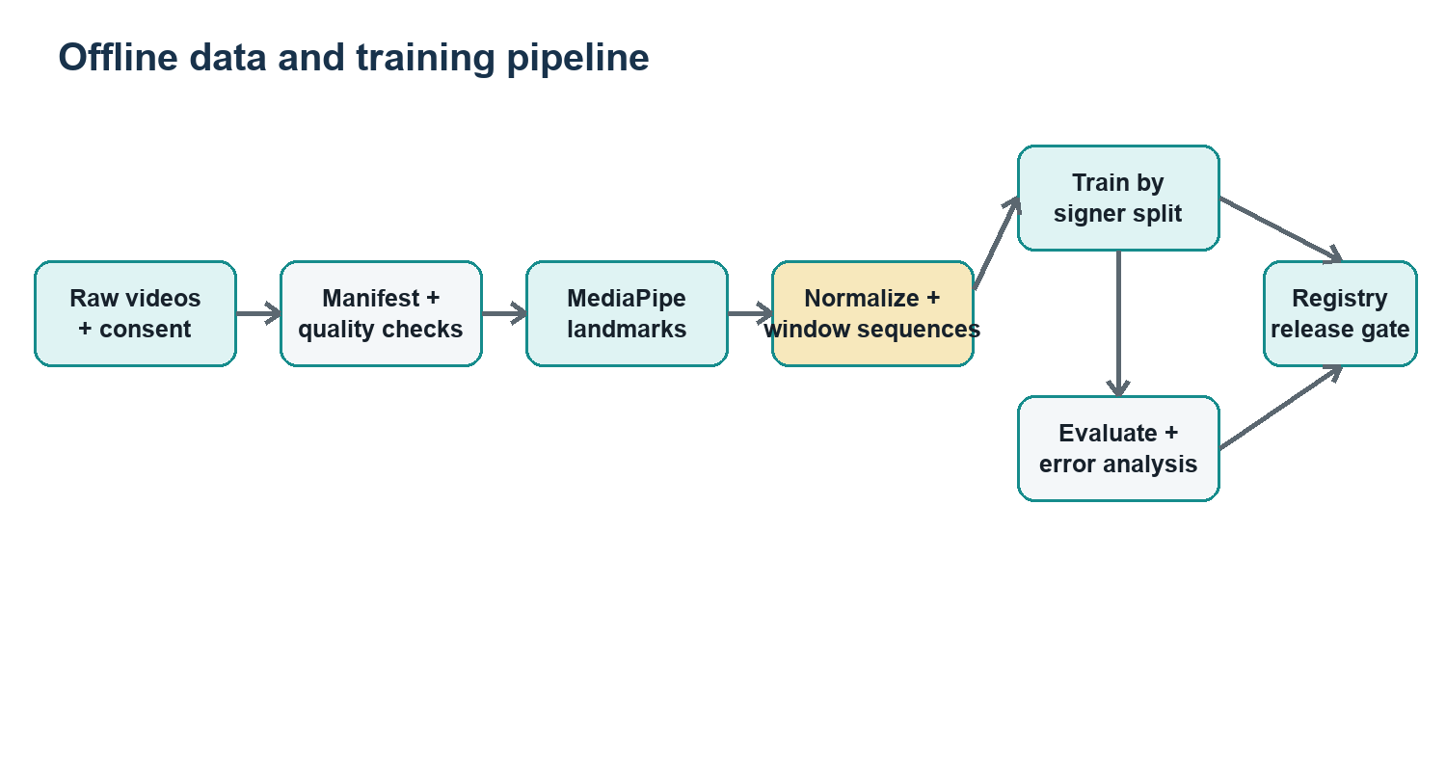
Figure 2. Reproducible offline extraction, training and release pipeline.

5.1 Landmark schema
Feature group | MVP choice | Shape per frame
Hands | Up to two hands × 21 landmarks × (x,y,z), plus presence and handedness. | 126 coordinates + masks/metadata.
Upper body pose | Shoulders, elbows, wrists and selected torso anchors from Pose/Holistic. | Small selected subset, not every landmark.
Face | Excluded initially; add only for classes where non-manual markers are essential and consent permits. | Versioned optional group.
Temporal | Frame timestamp, delta time, velocity/acceleration derived after normalization. | Per-frame or window statistics.
Quality masks | Per-hand/pose presence and visibility; do not encode missing landmarks as plausible zeros without masks. | Boolean/float mask vector.

5.2 Extraction contract
- Decode video using its true timestamps; sample to a configured target FPS without assuming every file is constant frame rate.
- Apply the same orientation/mirroring policy used at inference.
- Run MediaPipe in VIDEO mode offline and LIVE_STREAM mode for asynchronous real-time capture when appropriate.
- Map detected hands to stable left/right slots using handedness plus temporal continuity; log swaps.
- Extract only the selected pose joints and quality values.
- Write one versioned feature file per sample plus a manifest row; include extractor model/version and configuration hash.
- Validate dimensionality, finite values, timestamp monotonicity and minimum visibility.
IMPORTANT IMPLEMENTATION DETAIL MediaPipe live-stream processing may drop a new frame while busy. Design for timestamps and backpressure; do not assume one inference result per captured frame.

5.3 Canonical feature record
Use a compact NumPy/Parquet artifact for arrays and JSON/CSV for manifests. The exact names may change once, before the pilot; after that, bump feature_schema_version for any dimensional or semantic change.
Key | Type | Meaning
sample_id | string | Joins features to the immutable manifest.
timestamps_ms | int[T] | Monotonic source timestamps.
hand_xyz | float32[T,2,21,3] | Normalized coordinates; stable hand slots.
hand_mask | bool[T,2,21] | Observed/usable landmarks.
pose_xyz | float32[T,J,3] | Selected body anchors.
pose_mask | bool[T,J] | Pose validity.
label_id | int | Training label; omitted for unlabeled runtime windows.
schema/config | string | Feature schema and extractor configuration hashes.

6. Preprocessing and sequence construction

6.1 Normalization
- Translate coordinates relative to a stable anchor (wrist per hand; shoulder midpoint for body context).
- Scale hand coordinates by palm size or wrist-to-middle-MCP distance with epsilon protection; scale body by shoulder width.
- Optionally rotate to a canonical palm/body orientation only if ablation tests show benefit; preserve orientation cues needed to distinguish signs.
- Interpolate short gaps only below a documented limit; otherwise retain masks or reject the sample.
- Resample valid clips to a fixed length (for example 32 or 48 steps) or use padded variable windows with masks.
- Compute first-order motion features after resampling and normalization.
- Fit any dataset-level statistics on training data only and serialize them with the model.

6.2 Augmentation
Safe starting augmentation | Avoid / gate carefully
Small coordinate jitter, temporal crop/shift, mild speed change, short landmark dropout. | Horizontal flip unless label semantics and handedness mapping are correctly transformed.
Small global translation/scale before canonical normalization. | Large rotations or warps that create anatomically impossible signs.
Background/lighting augmentation only for RGB baseline. | Augmentation applied to validation/test or before signer split.

6.3 Segmentation strategy
Use a push-to-sign button for the first reliable MVP. Automatic segmentation is a separate model/problem: it must distinguish idle, transition and signing, and should not be hidden inside classifier heuristics. Later, add a lightweight activity detector with hysteresis and a maximum-duration timeout.

7. Model plan, training and evaluation

7.1 Model ladder
Stage | Model | Purpose / exit criterion
B0 | Majority and last-class sanity baselines | Verify metrics and labels; every real model must beat them.
B1 | Random Forest or SVM on aggregated/static features | Fast pipeline check and static-sign baseline.
M1 | GRU or temporal convolution on landmark sequences | Recommended MVP; stable unseen-signer macro-F1 and acceptable CPU latency.
M2 | Transformer/ST-GCN or multimodal landmark+RGB model | Only after M1 error analysis shows a justified ceiling.
R1 | Continuous recognition/translation | Future research; new segmentation, alignment and sequence metrics required.

7.2 Training protocol
- Seed all libraries; capture environment lockfile, commit ID and data/feature versions.
- Train B0/B1 before sequence models.
- Tune only on validation signers; use class-balanced loss or sampling only if needed.
- Track per-epoch loss, macro-F1, balanced accuracy and calibration; early stop on validation macro-F1.
- Run at least three seeds for the selected architecture; report mean and variation.
- Calibrate probabilities on validation data (temperature scaling or equivalent).
- Select class-specific or global reject thresholds using the desired false-accept trade-off.
- Evaluate once on the frozen test set, then lock the release artifact and model card.

7.3 Metrics and release gate
Category | Required metric / evidence | Suggested MVP gate
Recognition | Macro-F1, balanced accuracy, per-class precision/recall, confusion matrix. | Macro-F1 ≥ 0.80 on unseen signers; no critical class precision < 0.65.
Uncertainty | Coverage vs selective accuracy; false accepts on no-sign/transition. | At chosen threshold, selective accuracy ≥ 0.90 and no-sign false accept < 5%.
Latency | Capture-to-stable-token p50/p95 on target laptop. | p50 < 500 ms after sign end; p95 < 1,000 ms.
Robustness | Results by signer, lighting, background and handedness. | No subgroup slice with enough samples is silently omitted; gaps documented.
Reproducibility | Fresh-environment evaluation from tagged commit and manifest. | One-command evaluation reproduces metrics within tolerance.
Usability | Task completion and correction rate with representative users. | Pilot users understand uncertainty and can correct output.

DO NOT OPTIMIZE THE WRONG NUMBER Frame-level accuracy is not the product metric. Measure clip/token recognition on unseen signers, false accepts during idle/transition, stable-token latency and correction burden.

7.4 Error-analysis loop
- Review the largest confusion pairs with synchronized video and landmark plots.
- Tag root causes: label ambiguity, signer variant, occlusion, hand swap, segmentation, insufficient pose/face cues, or model failure.
- Fix data/labels before escalating model complexity.
- Create a regression set for every important bug.
- Document known limitations in the model card and UI.

8. Real-time inference pipeline
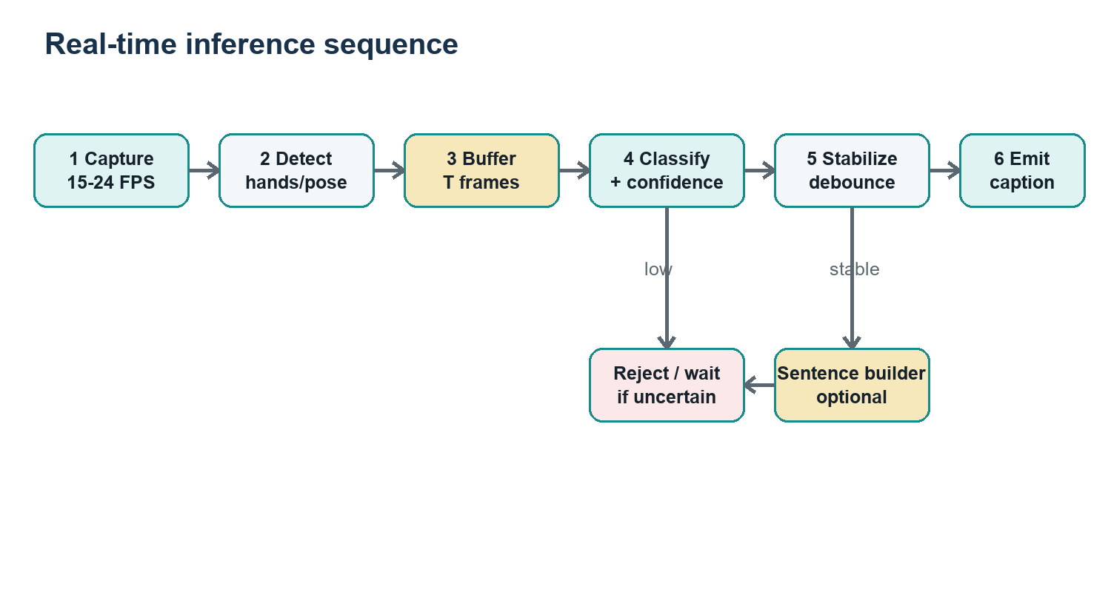
Figure 3. Streaming sequence, uncertainty rejection and optional language layer.

8.1 Runtime state machine
State | Entry / behavior | Exit
IDLE | Camera available; frames may be previewed but no sign window is committed. | User starts or activity gate triggers.
COLLECTING | Buffer timestamped landmarks; show progress and hand/pose readiness. | End button, inactivity, or max duration.
PREDICTING | Normalize with model-bundled config; run model once per completed window. | Prediction available or timeout.
STABILIZING | Require threshold, margin and repeated/temporal agreement. | Emit token or reject.
RESULT | Append editable token and offer TTS. | Next sign or clear.
ERROR | Camera/model/schema failure; no prediction emitted. | User retry or successful recovery.

8.2 Confidence and debouncing
- Use calibrated probability, top-1/top-2 margin, landmark quality and minimum duration as separate gates.
- Keep an UNKNOWN class/decision; never map every window to the nearest sign.
- Suppress duplicate tokens until hands return to neutral, timeout elapses or user explicitly starts again.
- Emit prediction_id, model_version and confidence with every token so bugs are traceable.
- Never expose raw probability as “percent correct”; label it model confidence.

8.3 Performance budget
Stage | Target p95 | Notes
Capture + transfer | 40 ms | Prefer compressed frames only if server-side extraction; landmarks are cheaper.
Landmark extraction | 35 ms/frame | Drop stale frames; preserve timestamps.
Window preprocessing | 15 ms | Preallocate arrays where possible.
Classifier | 50 ms/window | Measure CPU baseline; GPU is optional.
Stability + UI | 100-300 ms | This deliberate wait prevents flicker and false accepts.
TTS start | < 500 ms after user action | Cache voice list; speech is not on the recognition critical path.

9. Application architecture, APIs and events

9.1 Recommended stack
Layer | Choice | Responsibility
Web app | React + TypeScript + Vite | Camera permissions, framing overlay, session controls, captions, history, corrections, TTS.
API | FastAPI + Pydantic | Health, model metadata, sessions, feedback and WebSocket lifecycle.
Inference | Python, MediaPipe Tasks, PyTorch or scikit-learn | Feature extraction, normalization, windowing, prediction and confidence gates.
Storage | Filesystem + SQLite for MVP | Consent/manifest metadata, feedback, model registry; no raw video in runtime path.
Experiment tracking | MLflow locally or structured run directories | Configs, metrics, artifacts and model cards.
Packaging | uv/locked Python env; npm lockfile; Docker optional | Repeatable setup and deployment.

9.2 REST endpoints
Method / path | Purpose | Response / rule
GET /api/v1/health | Liveness/readiness. | Includes model loaded, feature schema and dependency status; no sensitive data.
GET /api/v1/models/current | UI compatibility and display. | model_id, vocabulary, schema_version, thresholds, created_at.
POST /api/v1/sessions | Create ephemeral recognition session. | session_id, websocket_url, expiry; authenticate if not localhost.
DELETE /api/v1/sessions/{id} | Stop and clear ephemeral buffers. | Idempotent 204.
POST /api/v1/feedback | User correction or reject report. | Opt-in; store token IDs and metadata, not frames by default.
GET /api/v1/config | Client-safe settings. | Frame/window limits, supported modes and feature flags.

9.3 WebSocket contract
Endpoint: /api/v1/ws/sessions/{session_id}. Use a versioned envelope: {type, version, session_id, seq, timestamp_ms, payload}. Reject out-of-order or oversized messages. Prefer landmarks from a trusted client extractor only after schema validation; for the first MVP, server-side extraction may be simpler.
Direction / event | Key payload | Behavior
C→S client.ready | camera, fps, frame size, schema capability | Negotiates mode and limits.
C→S sign.start / sign.end | client timestamp | Manual segmentation commands.
C→S frame or landmarks | seq, timestamp, encoded frame OR typed arrays + masks | Bound size/rate; apply backpressure and stale-frame drop.
S→C pipeline.status | state, hands_detected, quality, dropped_frames | Drives accessible status text.
S→C prediction.partial | top candidates, confidence, quality | Debug/optional UI only; do not append token.
S→C prediction.final | prediction_id, label, confidence, model_id | Append only after server gate.
S→C prediction.rejected | reason code, retry guidance | Expected outcome, not a transport error.
Either error | code, recoverable, message | No stack traces or sensitive paths to client.

9.4 Security and resilience
- Bind to localhost by default; if exposed on LAN, use TLS, origin allowlist and short-lived session tokens.
- Enforce frame/message size and rate limits; close stale sessions and bound buffers.
- Never log raw frames, full landmark streams or user text at info level.
- Validate model/feature schema compatibility at startup and reject incompatible clients.
- Provide offline degraded operation: captions continue if TTS/LLM is unavailable.

10. Text-to-speech and language reconstruction

10.1 TTS baseline
Use the browser Web Speech API first because it keeps the architecture simple and may operate locally depending on the platform. The user chooses voice and language; speech occurs only after a stable token or explicit Play action. Add a server TTS adapter later only if consistent voices or downloadable audio are required.
- Always show the exact text that will be spoken.
- Cancel/stop speech immediately when requested; do not queue stale utterances.
- Do not speak low-confidence predictions.
- Treat voice availability as device-dependent and provide a text-only fallback.

10.2 Optional LLM sentence reconstruction
DEFAULT OFF An LLM must never be placed inside the recognition truth path. It may propose a fluent rewrite of already accepted tokens, visibly labeled “Suggested sentence,” with the original tokens preserved and user confirmation required before speech/copy.
Guardrail | Implementation
Grounding | Prompt contains only accepted tokens and a tiny allowed context; model must not add names, numbers, negation or factual content.
Structured output | Return {suggestion, used_token_ids, warnings}; validate schema and token coverage.
Conservative mode | Prefer minimal word-order/function-word edits; offer “keep original.”
Uncertainty | If tokens are incomplete/contradictory, return no suggestion and ask user to edit.
Privacy | Local model preferred; if remote, explicit opt-in and clear data disclosure.
Safety | Disable by default for medical/legal/emergency contexts; never claim interpreter equivalence.
Auditability | Store only user-approved final text and token lineage when feedback is opted in.
Fallback | Deterministic joiner remains fully functional when LLM times out or fails.

10.3 Reconstruction acceptance tests
- Negation, quantity, person and tense tests: the suggestion must not alter them.
- Unknown-token test: no invented replacement.
- Prompt-injection-like token text: treated as data, not instruction.
- Timeout and malformed JSON: deterministic original output remains.
- User rejects suggestion: TTS reads original or edited text only.

11. Module responsibilities and repository
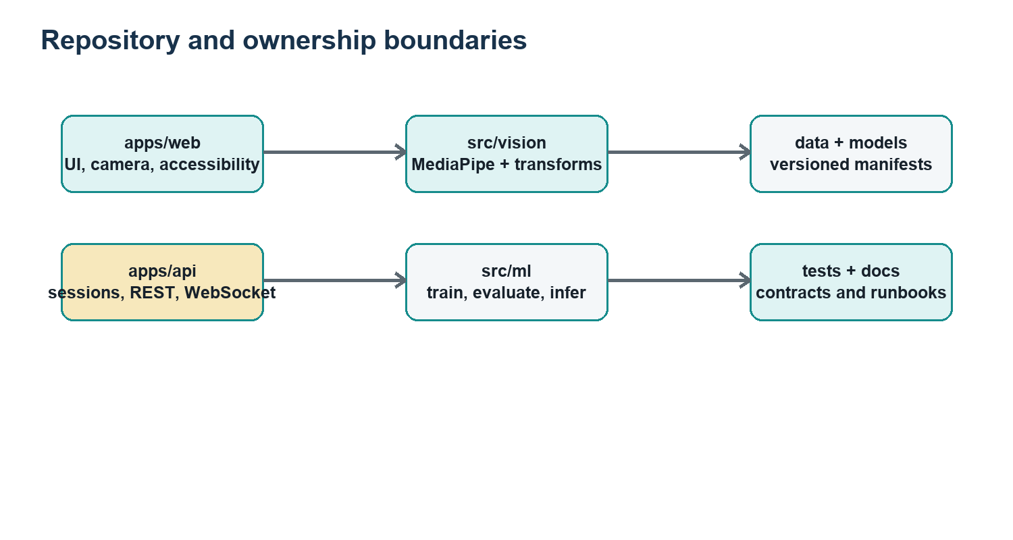
Figure 4. Repository boundaries that allow parallel work without hidden coupling.

11.1 Recommended repository structure
Use a monorepo so schema and fixture changes are reviewed together. Generated data and model binaries do not belong in Git; commit manifests, small fixtures and checksums instead.
Path | Owner / responsibility
apps/web/ | Frontend owner: capture, accessible UI, WebSocket client, browser TTS.
apps/api/ | Backend owner: REST/WS routes, sessions, validation, orchestration.
src/vision/ | AI lead: MediaPipe adapters, hand-slot tracking, feature schema, quality signals.
src/ml/ | AI lead: datasets, preprocessing, models, calibration, inference service.
src/language/ | AI lead + reviewer: deterministic joiner, optional guarded LLM adapter.
contracts/ | Shared: Pydantic/JSON schemas, generated TypeScript types, version policy.
data/manifests/ | Data steward: versioned metadata and split files; no identities.
models/registry/ | Model metadata/model cards/checksums; binaries via release storage or DVC.
tests/{unit,integration,e2e,fixtures}/ | Every module owner; small consent-safe fixtures.
scripts/ | Thin supported commands: collect, extract, train, evaluate, serve, demo-check.
configs/ | Versioned extraction/training/runtime settings; no secrets.
docs/adr/ | AI lead: architecture decision records and changed assumptions.

11.2 Definition of done for every module
- Typed public interface and one minimal usage example.
- Unit tests for normal, missing, malformed and boundary inputs.
- Structured errors with actionable messages.
- No hidden constants: thresholds/config are named and versioned.
- Logging excludes sensitive payloads.
- Short runbook: start, test, common failure and owner.
- Reviewed against the matching contract and integrated into CI.

11.3 Using Codex effectively
Good delegation unit | Required prompt context
Implement one extractor adapter | Exact input/output schema, MediaPipe mode, missing-hand policy, fixture and tests.
Create one API endpoint | Pydantic contracts, status codes, auth assumption and integration test.
Add one model baseline | Frozen manifest, feature shape, metrics, seed and output artifact contract.
Build one UI component | State diagram, accessibility behavior, event schema and visual acceptance criteria.
Investigate a bug | Reproduction command, expected vs actual, logs/fixture and “diagnose before changing” instruction.

CODEX WORKING RULE Ask for small, reviewable changes. Require tests and a summary of assumptions. Never ask Codex to “build the whole system” without frozen contracts, and never accept fabricated metrics, dataset claims or silently downloaded data.

12. Deployment, observability and operations

12.1 Local demo deployment
- Run a preflight command that checks camera, model checksum, feature schema, ports and TTS availability.
- Start API/inference; wait for readiness, then start the web app.
- Load only the approved release model and vocabulary.
- Run a 2-minute demo checklist with known signs, unknown/no-sign samples, retry and camera denial.
- Keep a prerecorded consent-safe fallback clip set for hardware/camera failure; label it as prerecorded.
- Export no logs or feedback unless the user explicitly opts in.

12.2 Model artifact contract
Artifact | Required content
model file | Weights or serialized estimator; immutable checksum.
model.json | model_id, code commit, created_at, framework/runtime versions.
feature_schema.json | Landmark groups/order, dimension, masks, coordinate conventions.
preprocess.json | FPS, window, normalization, interpolation and scaler parameters.
vocabulary.json | label IDs, display strings, approved variants and excluded classes.
thresholds.json | Calibration method, reject threshold(s), stability/debounce settings.
metrics.json | Validation/test summary, slices and evaluation manifest hash.
model_card.md | Purpose, data, limitations, ethical considerations and release owner.

12.3 Observability
- Metrics: sessions, processed/dropped frames, landmark failures, inference latency, reject rate and error codes—aggregated, without raw biometrics.
- Logs: request/session ID, model ID, schema version and state transitions; never raw frames or landmarks by default.
- Health: distinguish liveness from readiness; readiness fails if model/schema load fails.
- Demo dashboard can show rolling latency and drop rate locally, with a one-click reset.

13. Testing strategy
Layer | Core tests
Schema/unit | Coordinate conventions, masks, serialization, invalid shape, NaN/Inf, timestamp order.
Vision | Zero/one/two hands, occlusion, hand-slot stability, mirrored input, dropped frames.
Preprocessing | Training/inference parity (“golden vector”), resampling, interpolation limit, deterministic output.
Model | Known fixture predictions, calibration, threshold/reject, batch vs streaming parity.
API/WS | Handshake, rate/size limit, ordering, disconnect/reconnect, errors, backpressure.
Frontend | Permission denial, keyboard path, visible focus, state labels, correction and TTS stop.
Integration | Video fixture → final token/reject with pinned artifact.
Performance | Long session memory, p50/p95 latency, CPU usage and frame-drop behavior.
Data | Manifest uniqueness, label vocabulary, split leakage, consent status and file checksums.
Safety/LLM | No hallucinated entities/negation/quantity; timeout and remote service unavailable.

13.1 Golden test fixtures
Maintain a tiny, consent-cleared set: one clean clip per class for smoke tests, difficult clips for expected reject behavior, no-sign/transition clips, and serialized landmark arrays. Golden fixtures catch training/inference drift but must never be confused with statistical evaluation.

13.2 CI gates
- Format/lint/type-check; unit and contract tests on every change.
- Feature golden-vector parity and schema compatibility test.
- No large media/model files or secrets committed.
- Integration tests with a tiny model artifact.
- Full evaluation and performance tests on release candidates, not every commit.

14. Delivery plan and milestones
Phase / duration | Deliverables | Exit gate
0. Alignment (Week 1) | Vocabulary draft, personas, scope, ethics/consent review, architecture decision records. | Faculty + ISL-informed reviewer approve MVP boundary.
1. Thin slice (Weeks 2-3) | Camera UI, manual segmentation, one feature schema, 3-sign toy data, baseline end to end. | One command produces token/reject; contracts frozen v1.
2. Pilot data (Weeks 4-5) | 2-signer pilot, quality dashboard, collection runbook, split script. | Collection defects fixed; final vocabulary/data target approved.
3. Dataset v1 (Weeks 6-8) | Balanced multi-signer collection, reviewed manifest, frozen splits, feature cache. | Leakage audit passes; dataset card complete.
4. Modeling (Weeks 9-11) | B0/B1/M1, calibration, error analysis, model card. | Release metrics/latency gates met or scope reduced transparently.
5. Product integration (Weeks 12-13) | Stable WS pipeline, accessible UI, TTS, feedback and preflight. | End-to-end test and 30-minute soak pass.
6. Validation (Week 14) | Unseen-user usability pilot, robustness slices, risk review. | Known limitations and demo claims match evidence.
7. Finalization (Weeks 15-16) | Packaging, report, poster/demo script, prerecorded fallback, handoff. | Fresh laptop rehearsal and reproducibility check pass.

14.1 Scope-control decision gates
- If landmark visibility is poor: fix capture/framing and data before changing models.
- If unseen-signer macro-F1 misses target: reduce vocabulary or collect more signers; do not report train accuracy.
- If dynamic signs fail: keep static subset for MVP and present dynamic recognition as measured future work.
- If latency misses target: reduce frame rate/window/model, profile, then consider browser/server placement changes.
- If no ISL-informed review is available: label the project a technical prototype and avoid linguistic correctness claims.
- Add the LLM only after recognition, correction and fallback paths are complete.

15. Team roles and operating cadence
Role | Primary responsibilities | Suggested owner
AI/architecture lead | Scope, contracts, data policy, feature pipeline, modeling, evaluation, release approval. | You
Data steward / collection lead | Consent, scheduling, manifests, quality review, retention and dataset card. | Most organized teammate
Frontend + UX owner | Camera UI, accessibility, captions, correction, TTS and user testing. | Teammate A
Backend + QA owner | FastAPI/WS, sessions, integration tests, packaging, preflight and demo operations. | Teammate B
ISL/domain reviewer | Vocabulary/sign validation, variants, usability and claims review. | External adviser / participant
Faculty guide | Ethics, research method, resources and assessment alignment. | Project supervisor
Codex | Bounded implementation, tests, docs, refactors and debugging under human review. | Tool, never accountable owner

15.1 Weekly cadence
- Monday: 30-minute planning; choose at most three integration outcomes.
- Daily: each owner records done/next/blocker in the issue tracker.
- Wednesday: integration hour; merge only passing thin slices.
- Friday: demo from main branch, metric review and short architecture/data decision log.
- Every dataset/model release: checklist sign-off by AI lead and data steward.

15.2 Work-item template
Field | Required content
Outcome | Observable user/system behavior, not “work on model.”
Contract | Inputs, outputs, errors, versions and performance bound.
Acceptance tests | Concrete normal + failure examples.
Dependencies | Files/services/decisions that must already exist.
Privacy impact | Data read/stored/transmitted and retention.
Owner/reviewer | One accountable owner and one reviewer.
Evidence | Test output, screenshot or metrics linked to commit/artifact.

16. Risks, ethics and accessibility
Risk | Likelihood / impact | Mitigation / trigger
Insufficient signer diversity | High / High | Reduce vocabulary; prioritize more signers; signer-independent split.
Label or regional variant ambiguity | High / High | ISL-informed review, variant IDs, disagreement log; remove unresolved classes.
Overclaiming translation | High / High | Use “isolated sign recognition” in claims; preserve limitations prominently.
False confident output | Medium / High | Calibration, UNKNOWN/reject, no-sign negatives, visible confidence wording.
Biometric/privacy harm | Medium / High | Local-first, minimal retention, pseudonyms, consent, deletion and access control.
Occlusion/background failures | High / Medium | Framing guide, quality gate, diverse collection and stress tests.
Team integration failure | Medium / High | Frozen contracts, thin vertical slice, ownership boundaries and CI.
LLM changes meaning | Medium / High | Default off, grounding, structured output, user confirmation, original preserved.
Dependency/model drift | Medium / Medium | Lockfiles, checksums, model registry, compatibility test and offline assets.
Demo hardware/network failure | Medium / Medium | Preflight, local deployment and labeled prerecorded fallback.

16.1 Ethical commitments
- Co-design and test with Deaf/ISL users where feasible; do not treat hearing researchers as sole language authorities.
- Use voluntary, understandable consent and avoid coercive classroom participation.
- Separate identity/consent records from ML manifests; limit access and retention.
- Publish dataset/model cards and negative results relevant to safe use.
- Do not deploy for surveillance, identity inference, discipline or high-stakes decisions.
- Credit and compensate language expertise; avoid describing ISL as a collection of gestures.

16.2 Accessibility acceptance checklist
- All recognition states announced visually and to assistive technology.
- Text remains readable at 200% zoom; responsive layout avoids horizontal scrolling for core flow.
- Focus order is logical; shortcuts are documented; no pointer-only control.
- Confidence is paired with plain language (“recognized,” “not sure,” “hands not visible”).
- Color is never the only signal; captions/history can be edited, copied and cleared.
- Audio is optional and never the only output.

17. Future roadmap
Horizon | Capability | Prerequisites
R1 | Automatic sign activity segmentation and continuous token stream. | Strong no-sign/transition data, boundary metrics and streaming tests.
R2 | Larger vocabulary with hierarchical or metric-learning classifier. | More diverse signers; ontology/variant governance; efficient retrieval.
R3 | Non-manual markers (face/head) for linguistically required signs. | Explicit consent, domain validation and ablation evidence.
R4 | Sentence-level ISL recognition/translation. | Continuous aligned corpus, signer-independent BLEU/chrF plus human semantic evaluation.
R5 | Multilingual spoken-language output. | Translation quality review; locale-aware TTS; preserve original recognized tokens.
R6 | On-device/browser inference and offline PWA. | Compatible exported model, performance/privacy validation.
R7 | Two-way communication with text-to-ISL avatar/video retrieval. | Deaf-led evaluation; avoid uncanny or linguistically incorrect generation.

18. Final demo and assessment plan

18.1 Demo script
- Show the scope statement and model/data version.
- Open camera, demonstrate readiness and privacy behavior.
- Recognize three easy signs, one dynamic sign and one two-hand sign.
- Show an unknown/poor-framing rejection and successful retry.
- Edit a token and play TTS.
- Show latency/quality panel and unseen-signer evaluation summary.
- Briefly show architecture, error analysis and known limitations.
- If enabled, demonstrate an LLM suggestion with original tokens and confirmation; then show fallback with LLM disabled.

18.2 Evidence pack
- Dataset card, consent template and collection protocol.
- Frozen split manifests and leakage audit.
- Experiment table, per-class metrics, confusion matrix, calibration/coverage plot and latency distribution.
- Model card and immutable artifact checksums.
- Architecture diagram, API/event contracts and test report.
- Usability notes, accessibility checklist and risk register.
- Reproducible setup instructions and a 3-minute fallback video.

Appendix A. Configuration baseline
Setting | Initial value | Tune / note
Capture | 640×480, 15-24 FPS | Prefer stable exposure; measure actual timestamps.
Window | 32 frames at target 20 FPS | Manual segmentation may resample full clip.
Landmarks | 2×21 hands + shoulders/elbows/wrists | Masks required; face off initially.
Normalization | Wrist-relative hand; palm scale; shoulder-relative pose | Serialize all parameters.
Model | 2-layer GRU, 64-128 hidden, dropout 0.2-0.4 | Compare against RF/SVM and small TCN.
Optimizer | AdamW, early stopping | Tune on validation signers only.
Decision | Calibrated top-1 threshold + margin + quality gate | Select for false-accept target.
Stability | 2-3 agreeing windows / end-of-sign decision | Balance latency and flicker.
Retention | No runtime frames by default | Collection data follows consent schedule.

Appendix B. Release checklist
- Vocabulary and UI labels approved; limitations match actual capability.
- Dataset version, consent status, split hashes and leakage audit recorded.
- Training and inference share feature schema and golden vectors.
- Test metrics and slices generated from frozen test manifest.
- Thresholds calibrated on validation only; unknown/no-sign behavior tested.
- Model artifact contains schema, preprocessing, vocabulary, thresholds and checksums.
- API/WS contracts versioned; malformed/out-of-order/rate-limit tests pass.
- Camera-denied, no-hands, one-hand, two-hand, reconnect and long-session flows pass.
- Accessibility review and target-laptop latency/soak tests pass.
- Fresh-environment installation and demo preflight pass.
- LLM/TTS outages do not break captions; LLM remains optional and confirmed.
- Model card, dataset card, risk register and evidence pack are complete.

Appendix C. Key references
- Indian Sign Language Research and Training Centre - ISL Dictionary: https://islrtc.nic.in/isl-dictionary/
- Indian Sign Language: A Linguistic Analysis of Its Grammar (Sinha): https://doi.org/10.2307/j.ctv2rcnfqg
- Considerations for meaningful sign language machine translation based on glosses: https://aclanthology.org/2023.acl-short.60/
- Sign Language Recognition, Generation, and Translation: An Interdisciplinary Perspective: https://www.microsoft.com/en-us/research/publication/sign-language-recognition-generation-and-translation-an-interdisciplinary-perspective/
- MediaPipe Hand Landmarker for Python: https://developers.google.com/mediapipe/solutions/vision/hand_landmarker/python
- MediaPipe Pose Landmarker for Python: https://developers.google.com/mediapipe/solutions/vision/pose_landmarker/python
- INCLUDE dataset record (Zenodo): https://zenodo.org/records/4010759
- INCLUDE paper (ACM DOI): https://doi.org/10.1145/3394171.3413528
- iSign benchmark (ACL Anthology): https://aclanthology.org/2024.findings-acl.643/
- ISLTranslate resource paper: https://arxiv.org/abs/2307.05440
- Indian Sign Language Dictionary (Government of India): https://data.gov.in/catalog/indian-sign-language-dictionary
- FastAPI WebSockets documentation: https://fastapi.tiangolo.com/advanced/websockets/
- W3C Web Content Accessibility Guidelines: https://www.w3.org/TR/WCAG22/
- Model Cards for Model Reporting: https://doi.org/10.1145/3287560.3287596
Reference note: verify licenses, access conditions and current software versions before downloading or publishing any dataset/model. Dataset size and task descriptions above are planning guidance, not a substitute for reading the corresponding dataset card and paper.

