Supplementary material for  
Bayesian multi-proxy reconstruction of the early Eocene latitudinal temperature gradient

Kilian Eichenseer[1] and Lewis A. Jones[2]

## S1. Convergence checks

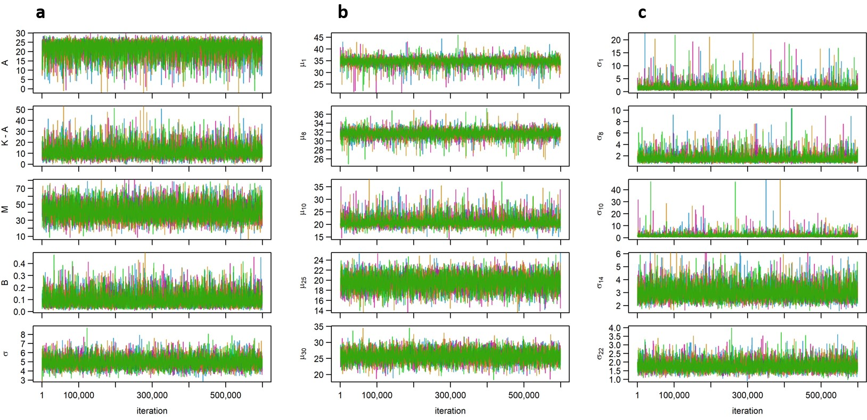

Fig S1. Traceplots of a subset of the unknown model parameters. The four colours correspond to the four independent model runs. a) Traceplot of A, K-A, M, B and ; b) Traceplot of five selected ; c) Traceplot of five selected . All traceplots display mixing of the chains, and relatively quick convergence.

## S2. Gradient with just the geochemical proxy data

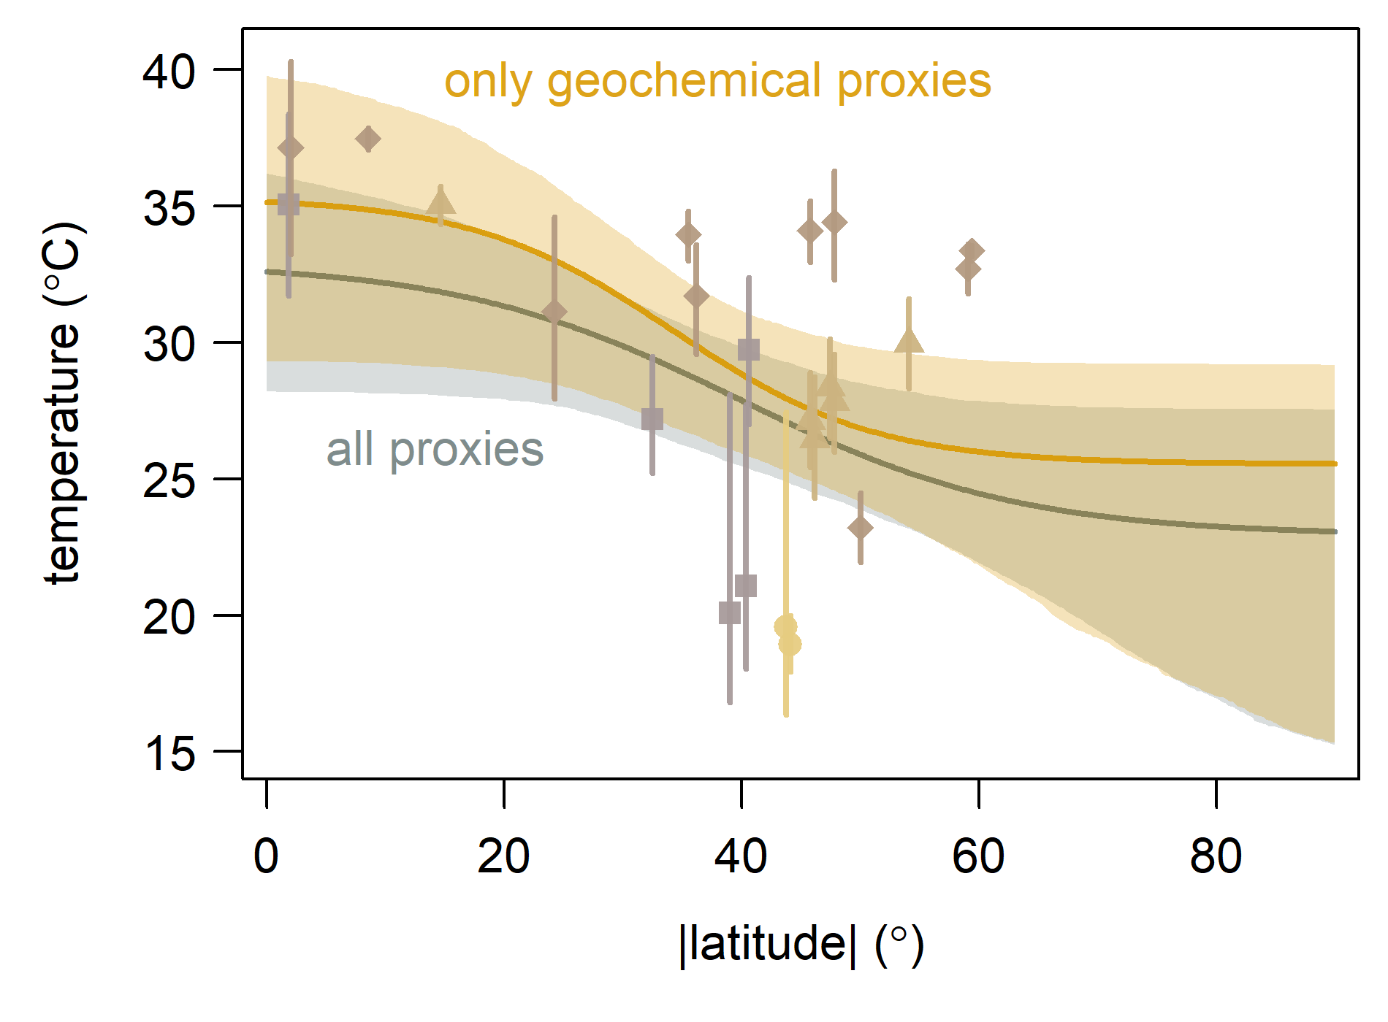

Fig S2. Latitudinal temperature gradient with just the geochemical proxies (orange), showing the median (line) and 95% credibal interval (shading). Symbols with vertical lines show the median and 95% credible intervals of . The grey line and shading in the background show the latitudinal temperature gradient with the geochemical and ecological proxy data.

## S3. Seperate gradients on the northern and southern hemisphere

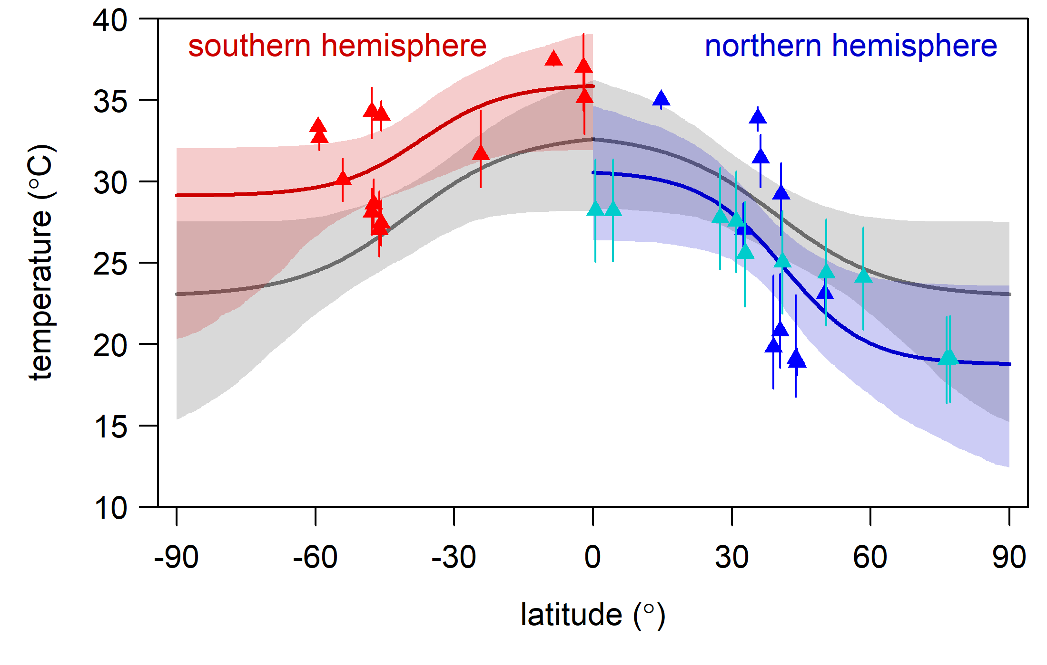

Fig S3. Latitudinal temperature gradient in seperate hemispheres, showing the medians (lines) and 95% credibal intervals (shadings) in the southern (red) and northern hemisphere (blue). Symbols with vertical lines show the median and 95% credible intervals of . Turquoise symbols in the northern hemisphere highlight the ecological proxy data. The grey line and shading in the background show the latitudinal temperature gradient with the data from both hemispheres combined, plotted in both hemispheres.

1. Department of Earth Sciences, Durham University, South Road, DH1 3LE, Durham, United Kingdom
2. Centro de Investigación Mariña, Grupo de Ecoloxía Animal, Universidade de Vigo, 36310 Vigo, Spain