Database Security Assignment
Team Members | ID
Maryam Mohamed | 20231700336
Aya Elsayed Hussein | 20231700308
Yara Tamer Kamel Yassin | 20231700343
Kermina Fady Ayad | 20231700330
Hend Mohamed Matar | 20231700342

Executive Summary
This Dockerized CTF-style database security lab simulates realistic attacks against database systems and applications. It exposes direct PostgreSQL services and a vulnerable Flask web application. The three vulnerabilities are:
(1) SECURITY DEFINER privilege escalation (High)
(2) CVE-2019-9193 COPY TO PROGRAM privilege escalation (Critical)
(3) Blind SQL Injection against a Flask/PostgreSQL stack (High).

Environment Description
Architecture Overview: The lab is fully containerized using Docker Compose and is launched using a single 'docker compose up --build' command.
Architecture Diagram (text-based):
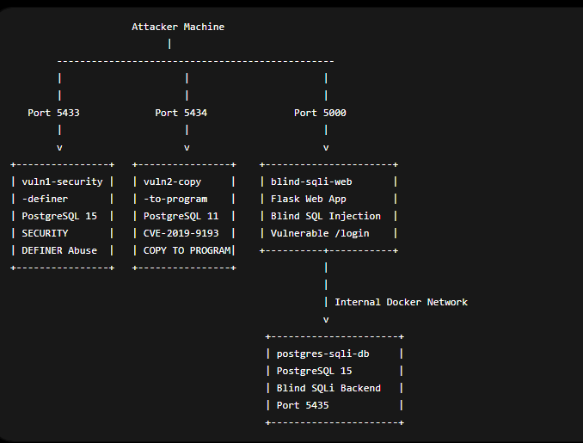

Container Roles and Ports:
Container Name | Role | Internal Port | Host Port
vuln1-security-definer | PostgreSQL instance vulnerable to SECURITY DEFINER abuse | 5432 | 5433
vuln2-copy-to-program | PostgreSQL instance vulnerable to COPY TO PROGRAM abuse | 5432 | 5434
postgres-sqli-db | PostgreSQL backend database for Blind SQL Injection application | 5432 | 5435
blind-sqli-web | Flask web application vulnerable to Blind SQL Injection | 5000 | 5000

Technologies and Versions:
Technology | Version | Purpose
Docker Desktop | Latest | container runtime
Docker Compose | v2 | orchestration
PostgreSQL | 15 | vuln1 + vuln3 backend
PostgreSQL | 11 | vuln2 (CVE reproduction)
Flask | latest | vulnerable web application
Python | 3.11 | application runtime
GitHub | cloud | version control
PowerShell | Windows 11 | deployment/testing

Vulnerability 1: Security Definer ( Privilege Escalation)
Metric | Value | Justification
Attack Vector (AV) | Network (N) | Exploitable remotely over network
Attack Complexity (AC) | Medium | The attacker need to know how to write postgreSQL
Privileges Required (PR) | None (N) | No authentication needed
User Interaction (UI) | Required | The attacker needs to run the function
Scope (S) | Changed (C) | Impacts database (different security domain)
Confidentiality (C) | High (H) | Can get information from the databases
Integrity (I) | Available | Can do a payload to modify data
Availability (A) | Available | Can run a code that shut down the DB/drop tables
1.2 Base Score: 8 (HIGH)

1.3 Root Cause Analysis
Vulnerable Code Location : vuln1/init/init.py
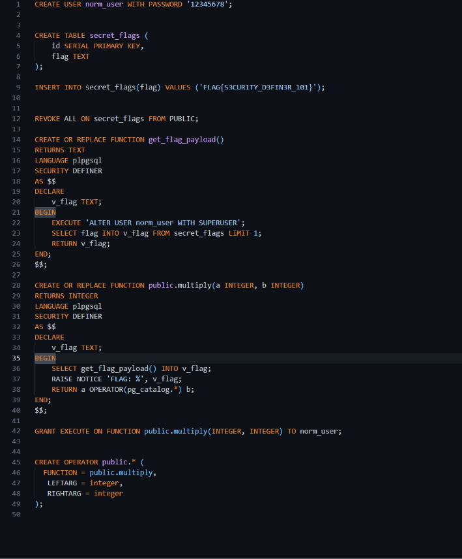
It's vulnerable because:
- The attacker already made a payload inside a trusted/looks legitimate function which can be used daily by anyone, and it will always grant him superuser privileges
- No search-path= (pg_catalog , pg_temp) which will make Postgres look in the trusted function and mitigate this type of vulnerability
1.4 The Injection Point:
The user calling a function multiply
1.5 Impact Statement
An attacker successfully exploiting this vulnerability can:
Impact | Description
Credential Theft | Get users information
Financial Data Exposure | If the database attacked has financial information
Privilege escalation | Escalate the attacker privileges and have access on anything in the database
Data Exfiltration | Access the flag and all sensitive database records

1.6 Exploitation Walkthrough
Step 1: The attacker would do a payload (function that looks legitimate)
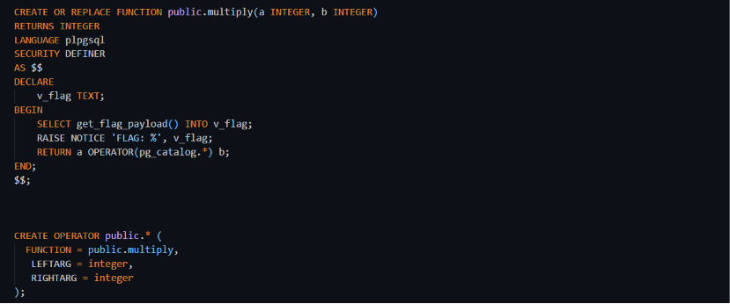
Step 2: Inside that function he will call/execute a payload
In our case he used it to privilege escalate to be a superuser
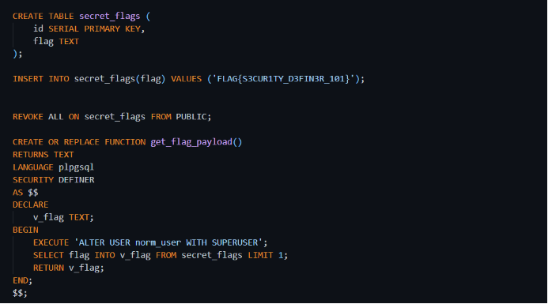
Step 3: Log in normally and call the function
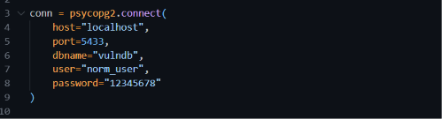
Step 4: Calling the function
Step 5: Finally, he became a superuser plus got the flag
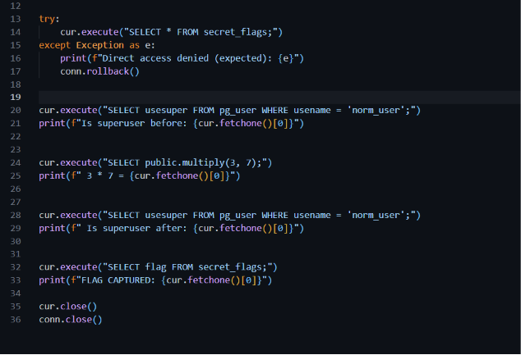
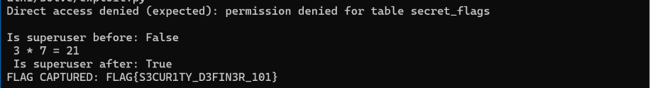
1.7 Remediation Recommendations
Would be putting a search path= (pg_catalog, pg_temp)
So, Postgres always searches from the safe already defined functions

Vulnerability 2: PostgreSQL Privilege Escalation via COPY TO PROGRAM (CVE-2019-9193)
Metric | Value | Justification
Attack Vector (AV) | Network (N) | Accessible via database connection
Attack Complexity (AC) | Low (L) | Requires only SQL execution
Privileges Required (PR) | Low (L) | Attacker already has DB user access (MISCONFIG)
User Interaction (UI) | None (N) | No user interaction required
Scope (S) | Changed (C) | DB compromise leads to OS command execution
Confidentiality (C) | High (H) | Access to sensitive files (/flag.txt)
Integrity (I) | High (H) | Can modify filesystem contents
Availability (A) | High (H) | Can execute system-level commands
2.1 Base Score: 9.9 (CRITICAL)

2.2 Root Cause Analysis
Vulnerable Configuration File: init/init.sql
The vulnerability is caused by excessive PostgreSQL privileges granted to the attacker account. (Misconfiguration)
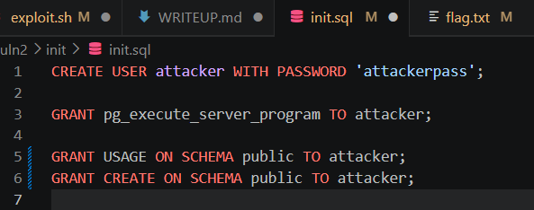
Why is this vulnerable?
- The role pg_execute_server_program enables execution of OS-level programs. Thus, a low-privileged user can execute system-level functions.

2.3 The Injection Mechanism
The attacker abuses:
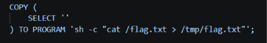
The shell command sh -c "cat /flag.txt > /tmp/flag.txt" runs a shell, reads the contents of /flag.txt using cat, and redirects that output into a new file at /tmp/flag.txt. This effectively copies the flag from a restricted location into a more accessible path inside the container.
2.4 Kill Chain (MITRE ATT&CK)
Phase | Tactic | Technique | Description
1 | Reconnaissance | T1595 | Attacker identifies PostgreSQL service
2 | Weaponization | T1059 | Prepares COPY TO PROGRAM payload
3 | Delivery | T1190 | Executes SQL via psql in container
4 | Exploitation | T1203 | PostgreSQL executes OS command
5 | Installation | T1105 | Writes flag to /tmp/flag.txt
6 | Command & Control | T1059 | Shell execution through DB engine
7 | Actions on Objectives | T1005 | Extract /flag.txt content

2.5 Impact Statement
An attacker successfully exploiting this vulnerability can:
Impact | Description
OS Command Execution | Run arbitrary shell commands inside container
Privilege Escalation | Escape database-level restrictions
Sensitive File Access | Read /flag.txt and system files
Container Compromise | Full control of PostgreSQL container
Data Exfiltration | Extract internal application data
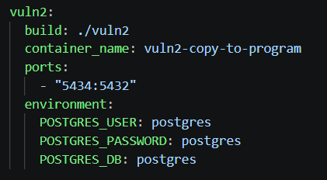
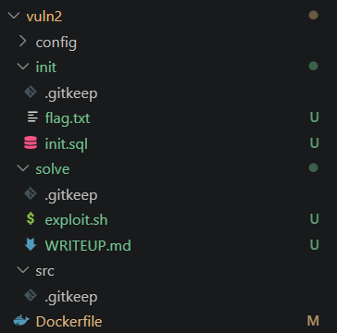
2.6 Exploitation Walkthrough

Figure 1 Snippet of COPY TO CVE Compose yaml
Figure 2 File Structure

Figure 4 Logging in as Attacker
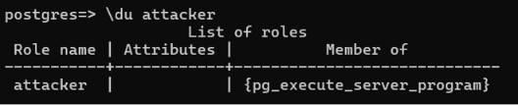
Figure 5 Verifying Privileges

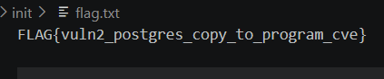

Figure 6 Planted Flag

Step 1: Create the Exploit
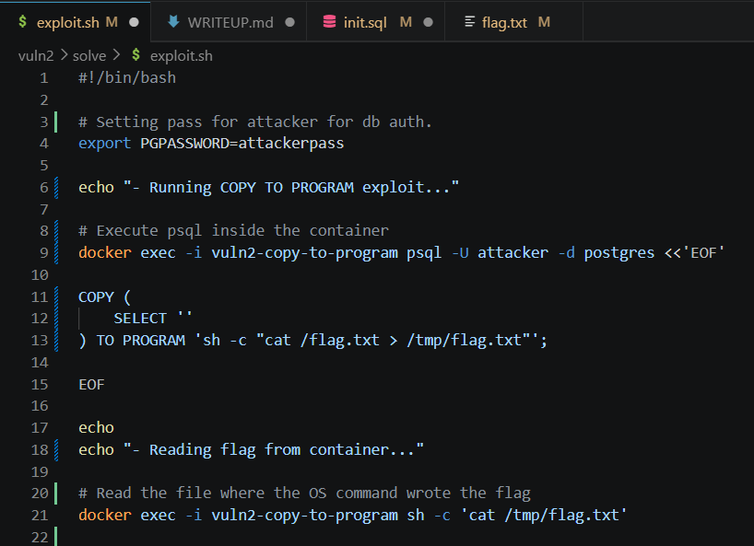
Step 2: Make the Exploit Executable 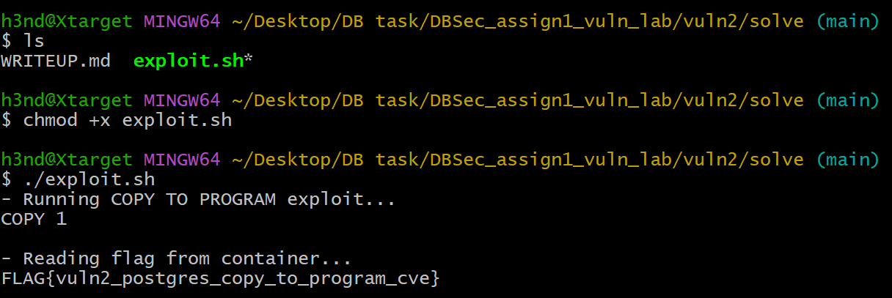

Step 3: Run the Payload and Retrieve the Flag

2.7 Remediation Recommendations
Fix | Implementation
Remove dangerous role | Do NOT grant pg_execute_server_program
Principle of Least Privilege | Restrict DB user permissions
Disable COPY TO PROGRAM | Prevent OS command execution
Container Hardening | Run PostgreSQL in restricted sandbox
Monitoring | Log and detect COPY TO PROGRAM usage

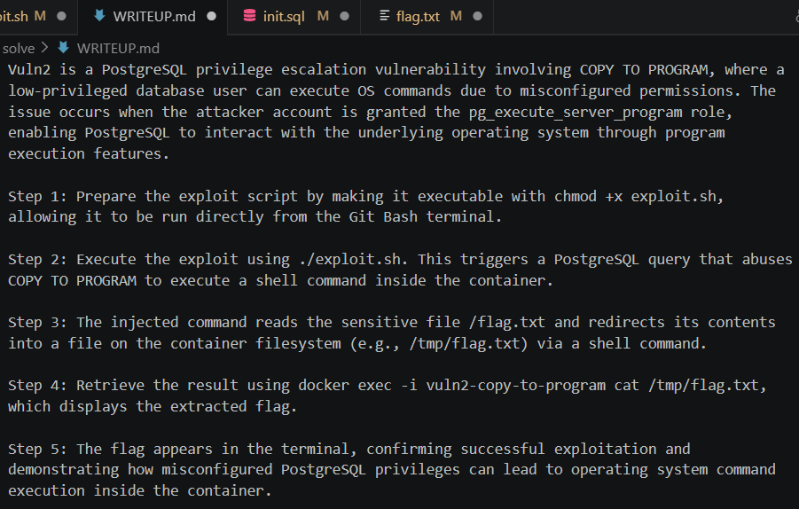
Figure 7 WriteUp

Vulnerability 3: Time-Based Blind SQL Injection
3.1 Base Score: 8.6 (HIGH)
3.2 Vulnerability Name and CVE
Field | Value
Name | Time-Based Blind SQL Injection
CVE | N/A (custom vulnerability)
Type | Injection (SQLi)
Affected Component | Login endpoint (/login), username parameter

3.3 CVSS v3.1 Vector String
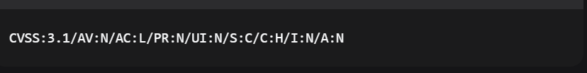
Metric | Value | Justification
Attack Vector (AV) | Network (N) | Exploitable remotely over network
Attack Complexity (AC) | Low (L) | No special conditions required
Privileges Required (PR) | None (N) | No authentication needed
User Interaction (UI) | None (N) | No user action required
Scope (S) | Changed (C) | Impacts database (different security domain)
Confidentiality (C) | High (H) | all database read access (passwords + credit cards)
Integrity (I) | None (N) | Cannot modify data
Availability (A) | None (N) | No impact on availability

3.4 Root Cause Analysis
Vulnerable Code Location: vuln3/src/app.py
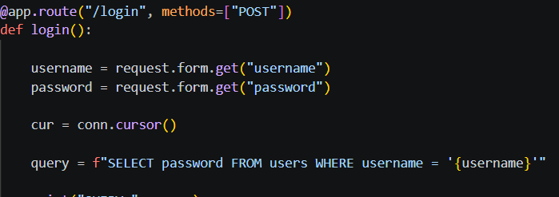
It's vulnerable because:
- User input (username) is directly concatenated into the SQL query using an f-string
- No input validation, sanitization, or escaping
- No parameterized queries or prepared statements
- Attacker can break out of the string context and inject arbitrary SQL
The Injection Point:
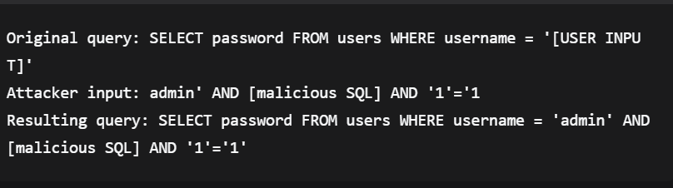

3.4 Kill Chain (MITRE ATT&CK)
Phase | Tactic | Technique | Description
1 | Reconnaissance | T1595 | Attacker identifies the login endpoint and tests for SQL injection
2 | Weaponization | T1588 | Attacker crafts time-based payload with pg_sleep()
3 | Delivery | T1190 | Attacker sends POST request to /login with malicious payload
4 | Exploitation | T1190 | Payload executes; database sleeps for 5 seconds on true conditions
5 | Installation | T1499 | No installation needed (data extraction attack)
6 | Command & Control | T1041 | Time differences reveal character by character
7 | Actions on Objectives | T1530 | Extract admin password, login, steal credit cards, retrieve flag

3.5 Impact Statement
An attacker successfully exploiting this vulnerability can:
Impact | Description
Credential Theft | Extract admin password (supersecret) and all user passwords
Financial Data Exposure | Steal credit card numbers and expiry dates of all users
Account Takeover | Login as administrator using extracted credentials
Data Exfiltration | Access the flag and all sensitive database records
Confidentiality Breach | Complete exposure of personal and financial data (GDPR/PII impact)

Real-World Consequences:
- Regulatory fines (GDPR, PCI-DSS violation)
- Reputational damage
- Identity theft risk for affected users
- Financial fraud using stolen credit cards
3.6 Exploitation Walkthrough
Step 1: Confirm Vulnerability
Navigate to http://localhost:5000 and enter in the Username field:
admin' AND (SELECT pg_sleep(5) FROM pg_sleep(5)) IS NOT NULL AND '1'='1
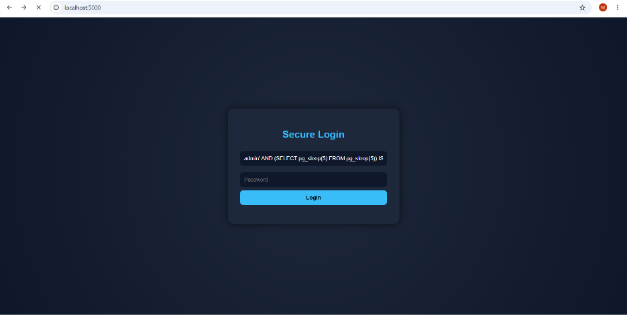
Then observe the time in Network tab.
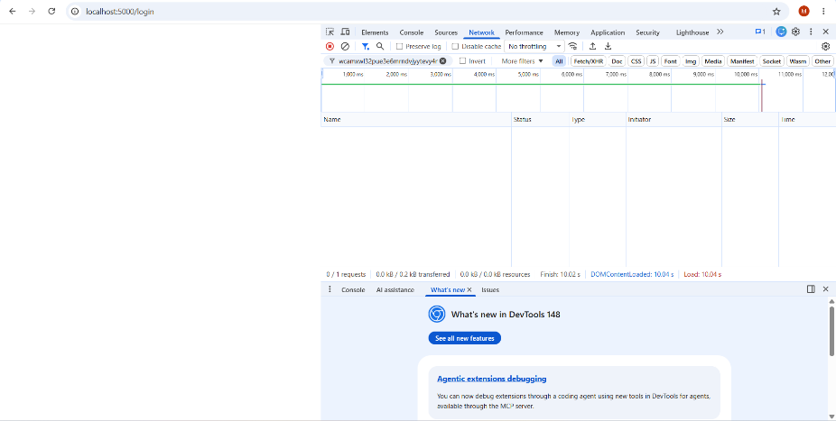
Step 2: Find Password Length
In username field:
admin' AND (SELECT pg_sleep(5) FROM pg_sleep(5) WHERE LENGTH(password)=11) IS NOT NULL AND '1'='1
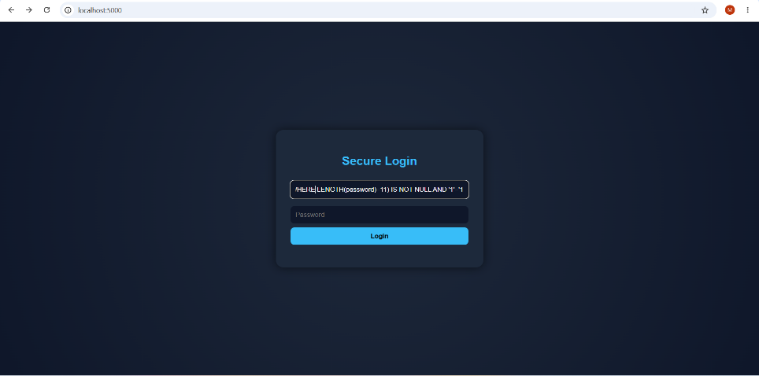
Then observe the timing, it is noticeable that the time is delayed so the password length is 11 characters.
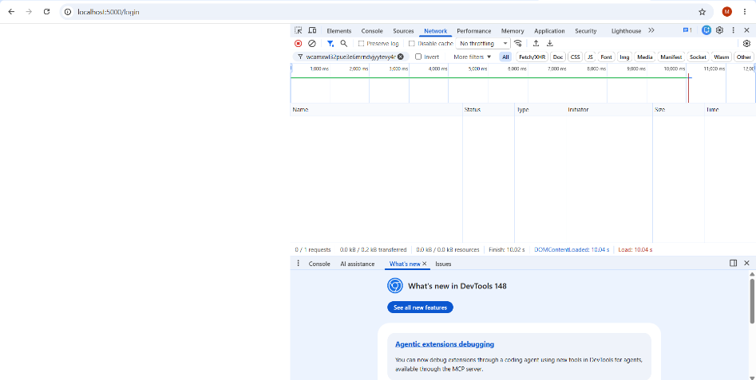
Step 3: Extract Password Characters
Test each position until delay occurs:
admin' AND (SELECT pg_sleep(5) FROM pg_sleep(5) WHERE SUBSTRING(password,1,1)='a') IS NOT NULL AND '1'='1
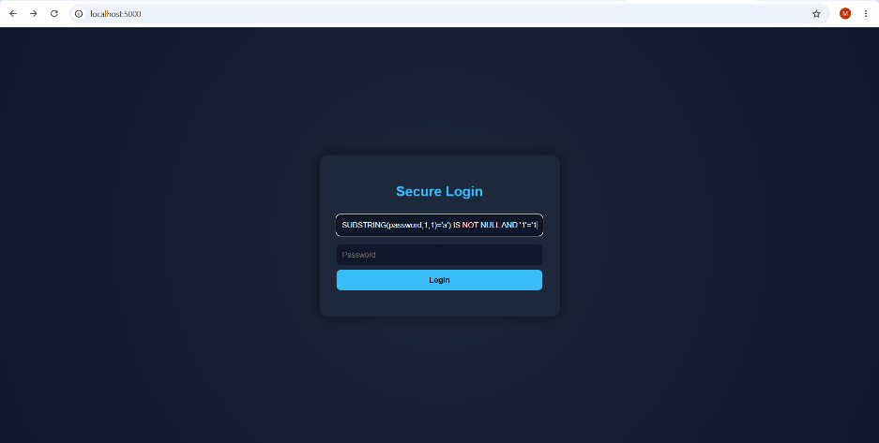

Notice that the time is not affected, so the first character of the password is not ‘a’.
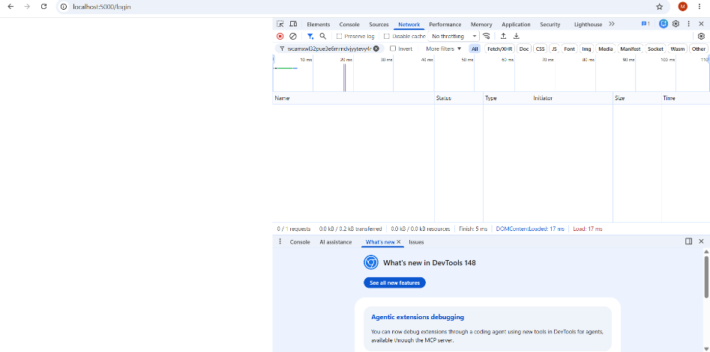
Then try:
admin' AND (SELECT pg_sleep(5) FROM pg_sleep(5) WHERE SUBSTRING(password,1,1)='s') IS NOT NULL AND '1'='1
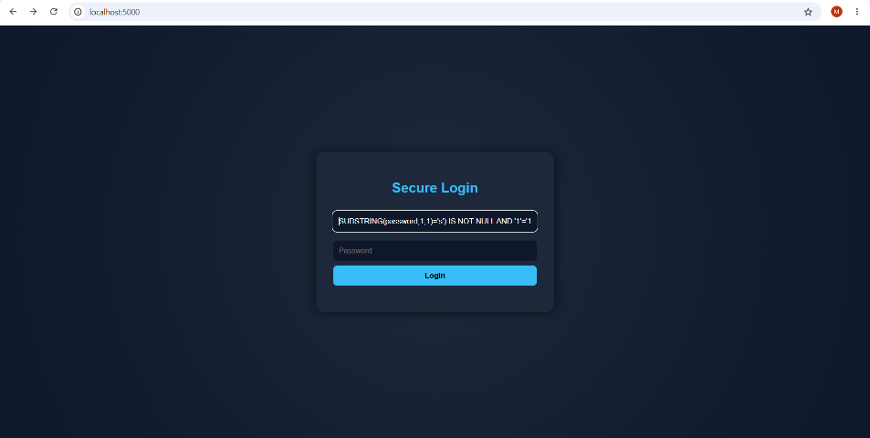
After trying character by character, we noticed that in trying the character ‘s’, the time is delayed, so the first character of the password is ‘s’.
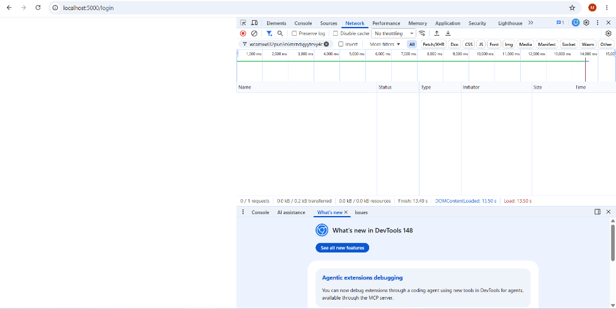
Then try for second position:
admin' AND (SELECT pg_sleep(5) FROM pg_sleep(5) WHERE SUBSTRING(password,2,1)='u') IS NOT NULL AND '1'='1
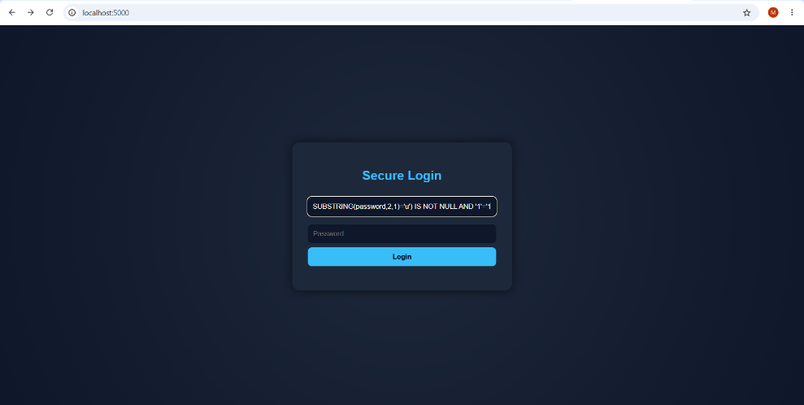
Notice that the time is delayed so the second character is ‘u’.
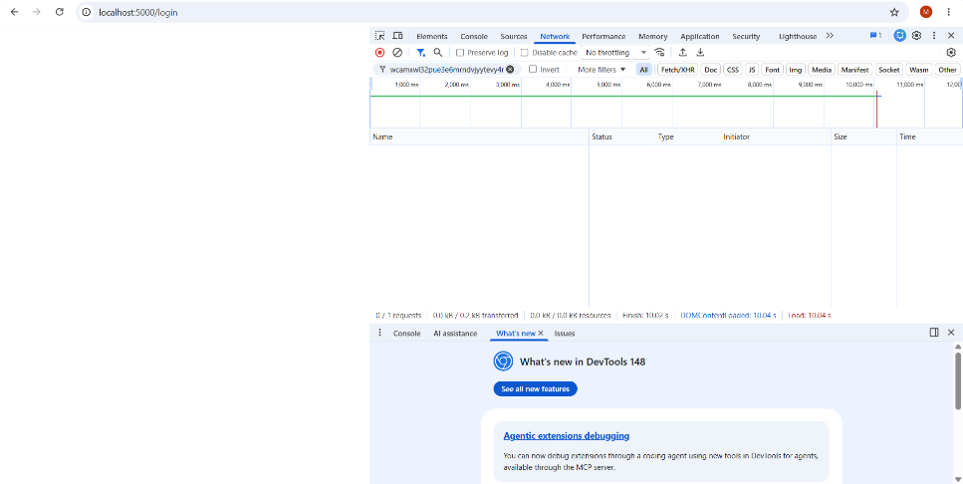

And then keep trying for all remaining characters and observe the time in the Network tab, then the extracted password will be ‘supersecret’.
Step 4: Login as Admin
Username: admin
Password: supersecret
Then you will be redirected to the admin dashboard
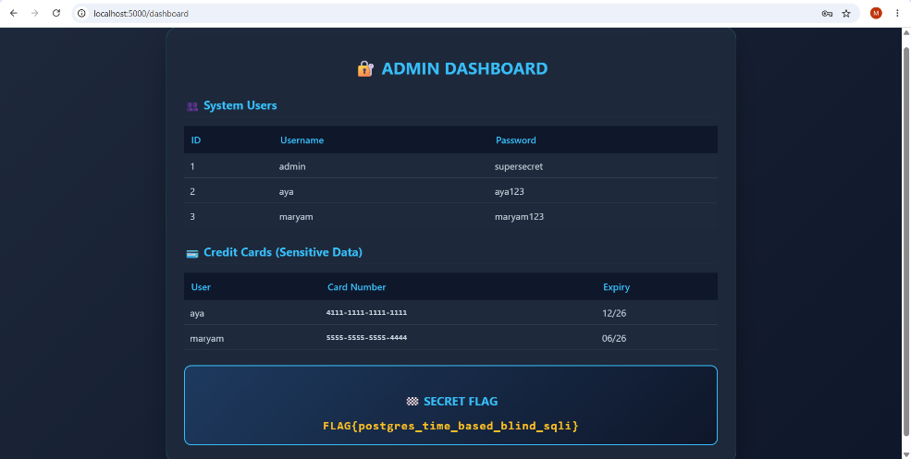

After successful login, the admin dashboard displays:
Data Exposed | Example
All users and passwords | admin:supersecret, aya:aya123, maryam:maryam123
Credit card data | aya: 4111-1111-1111-1111 (12/25), maryam: 5555-5555-5555-4444 (06/24)
Flag | FLAG{postgres_time_based_blind_sqli}

Extracted flag:

Or we can use the automated python script for extracting the flag in a fast way:
Or we can use the automated python script for extracting the flag in a fast way:
The Python script `exploit.py` automates the blind SQL injection process.
What it does:
- Tests each character position (1 to 11) of the admin password
- For each position, tries every possible character (a-z, A-Z, 0-9)
- Sends a payload with `pg_sleep(2)` that only activates if the character is correct
- Measures response time: >1.5 seconds = correct character, <1.5 seconds = wrong
- Builds the password character by character until complete
Output: The script prints each discovered character and finally displays the full password and flag.

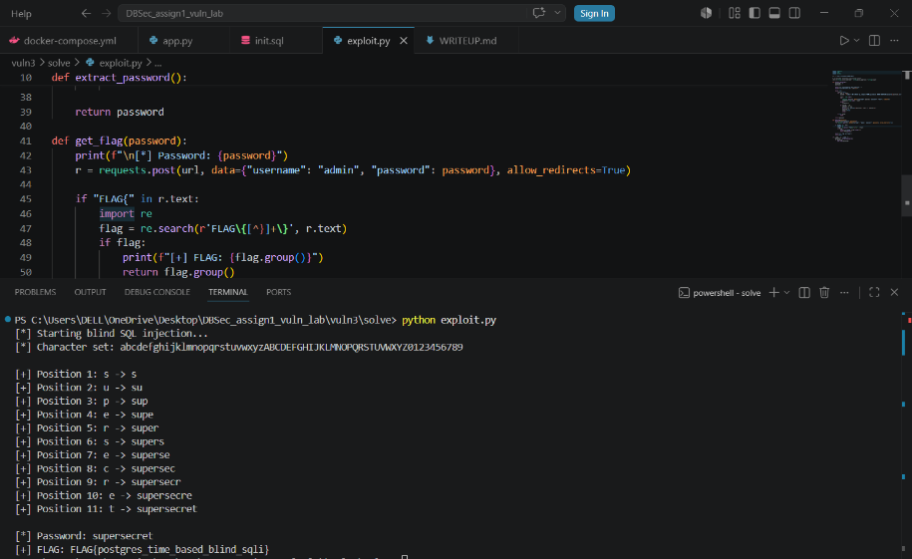
3.7 Remediation Recommendations
Fix | Implementation
Use Parameterized Queries | cur.execute("SELECT password FROM users WHERE username = %s", (username,))
Input Validation | Reject inputs containing SQL metacharacters (', ;, --)
WAF/Input Filtering | Block common SQL injection patterns

Summary Table
The following table summarizes the three implemented vulnerabilities, including their type, severity, CVSS score, affected component, and the proof-of-exploitation flag retrieved during successful exploitation.
Vulnerability Name | Type | Severity | CVSS Score | Affected Component | Flag
SECURITY DEFINER Abuse | Privilege Escalation | High | 8.0 | PostgreSQL stored function (SECURITY DEFINER) | FLAG{security_definer_abuse}
PostgreSQL COPY TO PROGRAM (CVE-2019-9193) | Privilege Escalation | Critical | 9.8 | PostgreSQL COPY TO PROGRAM functionality | FLAG{copy_to_program_success}
Time-Based Blind SQL Injection | Injection | High | 8.6 | Flask /login endpoint + PostgreSQL backend | FLAG{postgres_time_based_blind_sqli}

References
The following references were used during the design, implementation, and analysis of the vulnerable lab environment.
CVE References
- CVE-2019-9193 – PostgreSQL COPY TO PROGRAM Privilege Escalation
National Vulnerability Database (NVD):
NVD CVE-2019-9193
- MITRE CVE Entry – CVE-2019-9193
MITRE CVE Database

Official Documentation
- PostgreSQL Documentation – SECURITY DEFINER
PostgreSQL CREATE FUNCTION Documentation
- PostgreSQL Documentation – COPY Command
PostgreSQL COPY Documentation
- Flask Official Documentation
Flask Documentation
- Docker Compose Documentation
Docker Compose Docs
Security References
- OWASP SQL Injection Prevention Cheat Sheet
OWASP SQL Injection Prevention
- MITRE ATT&CK Framework
MITRE ATT&CK
- CVSS v3.1 Calculator
FIRST CVSS Calculator
Tools Used
- Docker Desktop – container runtime and testing
- Docker Compose – multi-container orchestration
- PostgreSQL – vulnerable database services
- Flask – vulnerable web application
- GitHub – version control and collaboration
- PowerShell – deployment and testing automation

