Baseline Experiment

Data and Model Generation:
Data generation methods:
- generate event log from model, Petri net or some rules??
  - ProM:: StochasticPetriNets/ Perform a simple simulation of a Petri net
plugins/stochasticpetrinet/simulator/PNSimulatorPlugin.java
Input:: Petri net
Configuration on dialog
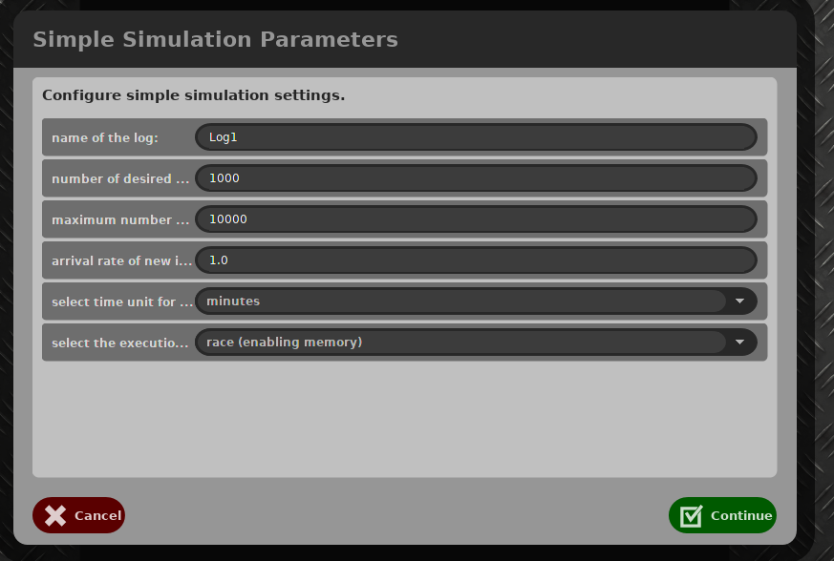
Output:: event log
  - ProM :: PTAndLogGenerator
Generate Event Logs (XES) from Process Trees (Newick Trees). It calles codes from Python.
Input:: Process Tree
--Traces Numberget
Output:: event log
  - ProM :: ProcessLogGenerator , the same application in PLG
Input:: Process Model
Configuration
--Traces Numberget
PercentOfInterval
– getPercentOfNoise
Output:: event log
  - CPN tools
  - Python from https://github.com/pm4py/pm4py-source Ale and Bas
Input:: Petri net in pnml
initial marking
Traces Number
Max Trace Length:
Output:: event log
  - Python from https://github.com/delas/plg Processes and Logs Generator
Input:: Petri net in pnml
initial marking
Traces Number
Max Trace Length:
Output:: event log
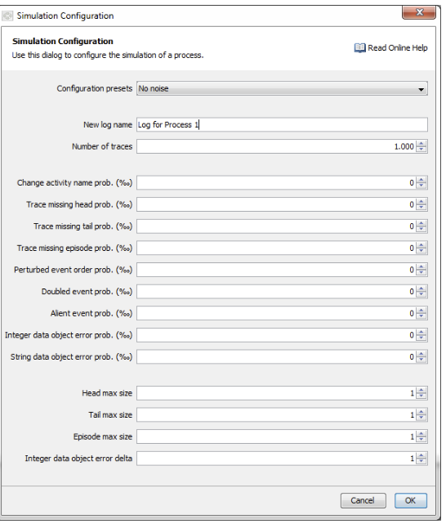
The graph is the event log generator options.
- generate event log from existing event log
- generate event log randomly but given event sets
- design some event log by own
  - Write Simple Log using Editor https://svn.win.tue.nl/repos/prom/Packages/SLog/Trunk/
This is a simple event log generation tool:
Input:: 3x Case1 a b c d
2x Case2 a c b d
1x Case3 a e d
Output: event log
  - RichEventLogGenerator

Model Generation:
- generate from event log
Plugin in ProM
  - Inductive Miner
  - Alpha Miner
- generate model from randomness
  - Python from https://github.com/delas/plg Processes and Logs Generator & Evolution
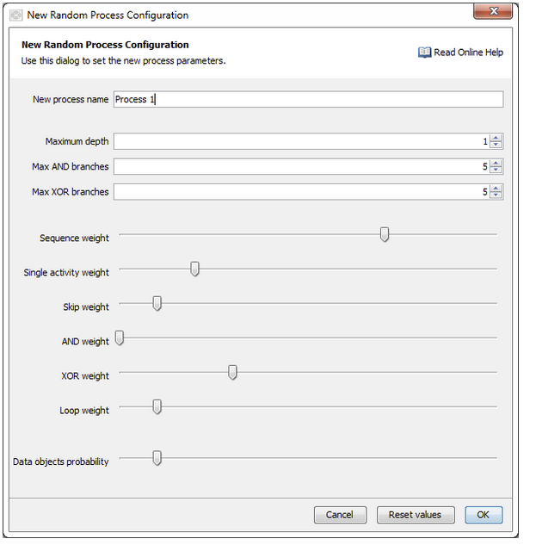
- design by own to create pnml file???

The relation ship of event log and model
- Corresponding

- Not corresponding to model &

- What they deviate

- how many they deviate

Data and Model Correspondence
Preliminary is a good fit model with all pos and neg traces!!! ..So, we don’t have unfit traces!!!
But for model repair, it repairs the unfit traces, how about this one?
To think of the best cases for repair log::
add subprocess, add loops , remove infrequent traces…

ID | Data |  |  | Existing Model |  | Solution
ID | Pos:neg | Fit : not fit | Comment | Enforce pos | Avoid Neg
1.1 | 1.0:  0 | 1.0 :  0 |  | Yes | No | Label Algorithm:  No overlap: overlap  1.0:0  0.3:0.7  0.5:0.5  0.7:0.3  0:1.0  (the rate means,  1.0:0, pos and neg belong to different trace variant.  0.3:0.7 0.3 of all variant(we see only variant) overlap, has pos and neg  0:1.0 all variant has neg and pos  One by one??  Relation: EOX, Seq, Par,Loop
1.2 | 0.7:  0.3 | 1.0:  0 |  | Yes | No
1.3 | 0.5:  0.5 | 1.0:  0 |  | Yes | No
1.4 | 0.3:  0.7 | 1.0:  0 |  | Yes | No
1.5 | 0:  1.0 | 1.0:  0 |  | They fit the model, so all enforce pos | can’t avoid neg
2.1 | 1.0:  0 | 0.7:  0.3 | Not fit:  not complete:  -missing tail  -length limit  noisy:  -change name  -order  -alien  -double  -missing head | Yes  all examples are positive | No  unfit are also positive.
2.2 | 1.0:  0 | 0.5:  0.5 | -add subprocess,  -add loops  -remove infrequent traces  The unfit traces should work to do such behavoir for repair model
2.3 | 1.0:  0 | 0.3:  0.7
2.4 | 1.0:  0 | 0:  1.0 | All traces not fit, a total changes?? Or we see the changes kind of local, then it’s fine, else, no.
3 | 0.5:  0.5 | 0:5:  0.5

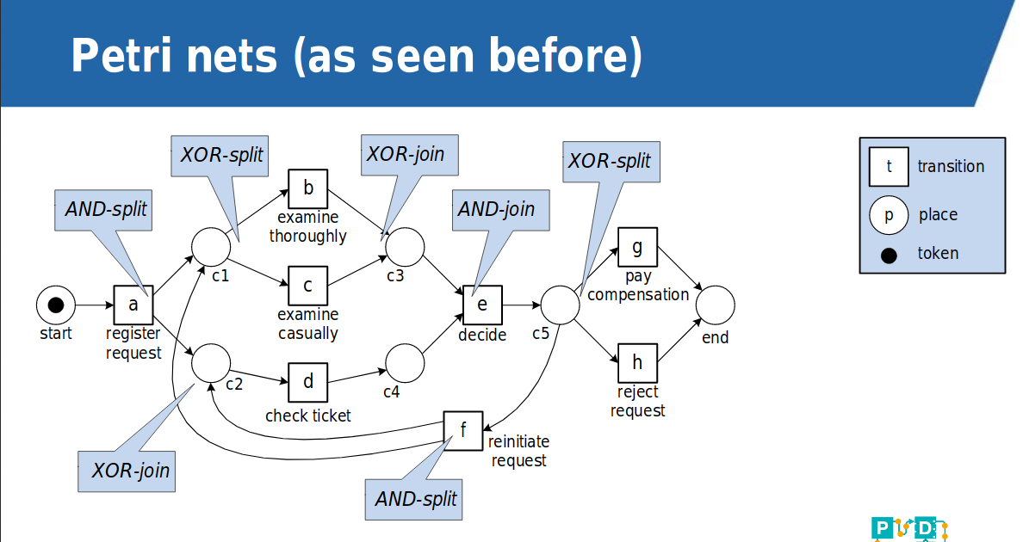
Steps:
<1.1> import the existing model
<1.2> design a model
<2.1> generate fit traces
<2.2> generate noisy traces, too
<3> label event log under distribution
– this is the code for me!!
– how to assign labels w.r.t. different distribution
<4> use Inductive Miner or repair log
<5> evaluate model

Experiment with Inductive Miner:
ID | Data ID | Pos:neg | Overlap:not | Positive Set | Complement Set | Noise setting | Result:  PA : PN  NA: NN  Recall  Precision  Accuracy  F1-score
1.1 | D1 | 0.7:0.3 | 0 | Yes: 388 :: 112 | Yes: 388  Because no overlap, so the same | No | M1.1  388 :: 0  0 :: 112  1.0 :: 1. :: 1.0 ::1.0
1.2 | D1 | 0.7:0.3 | 0 | Yes:  388 :: 112 | No | 0.2 | Same model M1.1  388 :: 0  0 :: 112  1.0 :: 1. :: 1.0 ::1.0
1.3 | D1 | 0.5:0.5 | 0 | Yes: 147 :: 353 | No | 0.2 | Same model M1.1  147 :: 0  0 :: 353  1.0 :: 1. :: 1.0 ::1.0
1.4 | D1 | 0.3 < | 0 |  |  |  | We can’t get positive traces, so no model generation
2.1 | D1 | 0.7:0.3 | 0.3:0.7 | Yes: 280 :: 220 | No | No | M2.1  280 :: 0  73 :: 147  1.0  0.7932011331444759 0.854 0.8846761453396524
2.2 | D1 | 0.7:0.3 | 0.3:0.7 | No | Yes:  112 | No  [NO need to set the noise setting to get only frequent traces, so to avoid negative ones | M2.2  112 :: 168  0 :: 220  0.4  1.0  0.664  0.5714285714285714
2.3 | D1 | 0.7:0.3 | 0.5:0.5 | Yes:  180 :: 320 |  | Change value, it doesn’t change resulted model | M 2.3  180 :: 0  79 :: 241  1.0  0.694980694980695 0.842 0.8200455580865603
2.4 | D1 | 0.7:0.3 | 0.7:0.3 | No | Yes, but set is empty
3.1 | D2 | 0.7:0.3 | 0 | Yes: 364 :: 136 | NO | No | M3.1_02  0 :: 364  0 :: 136  0 :: Nan :: 0.272 ::0.0  [here, because of noise the initial marking matters a lot for fit checking]
3.2 | D2 | 0.7:0.3 | 0 | No | Yes  364 :: 136 | 0.2 | Same model M3.2  0 :: 364  0 :: 136  0 :: Nan :: 0.272 ::0.0  [here, because of noise the initial marking matters a lot for fit checking]
3.3 | D2 | 0.5:0.5 | 0 | Yes:  358 :: 142 | No | No | 0 :: 358  0 :: 142  0 :: Nan :: 0.284 ::0.0
4.1 | D4 | 0.7:0.3 | 0 | Yes | No | No | M4.1  783 275  338 104  //  0.7400756143667296 0.6984834968777877 0.5913333333333334 0.7186782927948601
4.2 | D5 | 0.7:0.3 | 0 | Yes  1050: 450 | No | No | M4.2
4.3
4.4

Data ID | Data Overview
D1 | 8 event classes, 500 traces generated form model M1, all fit, no noise
D2 | Same model but with noise only on the control-flow
D3
D4

D2 setting
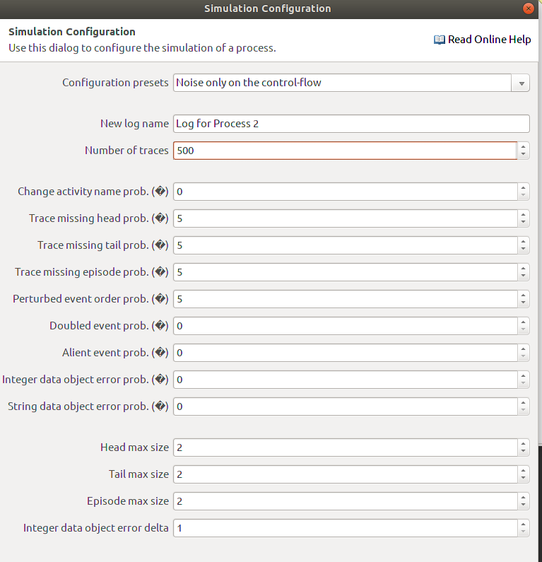
M4 setting
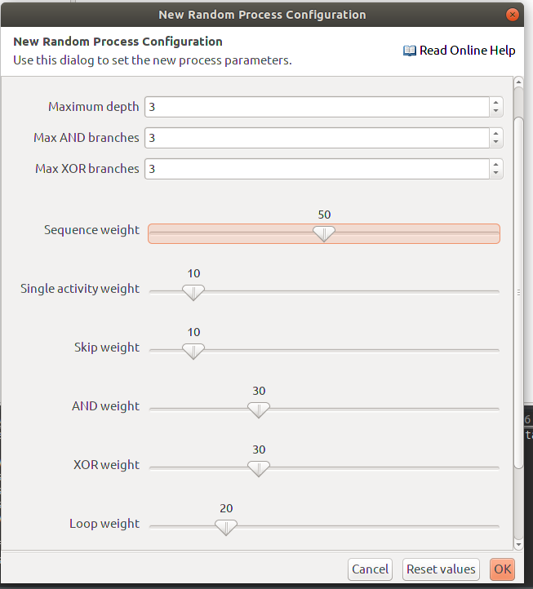
M4 Model

M 1.1
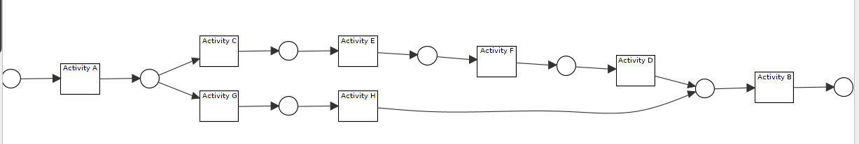
M 1.3
M2.1
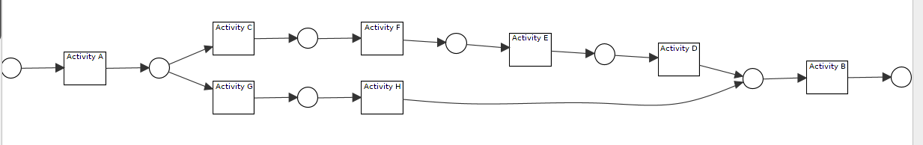
M2.2
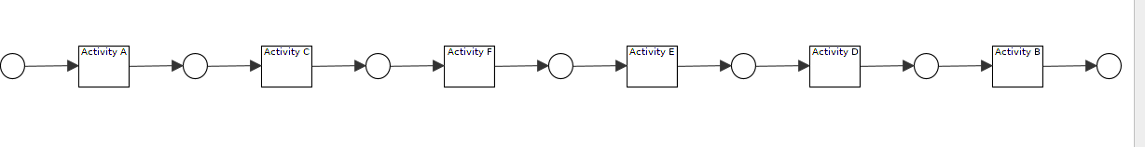
M 2.3
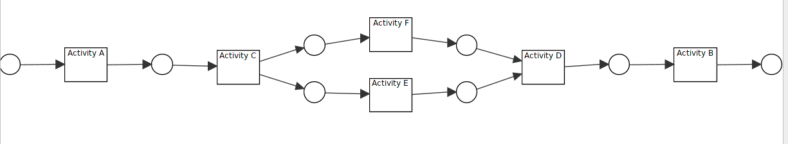
M 3 directly from Inductive Miner
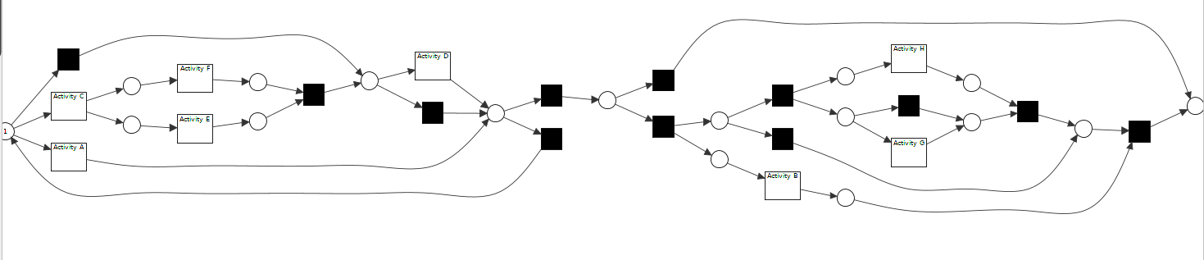
M3.1
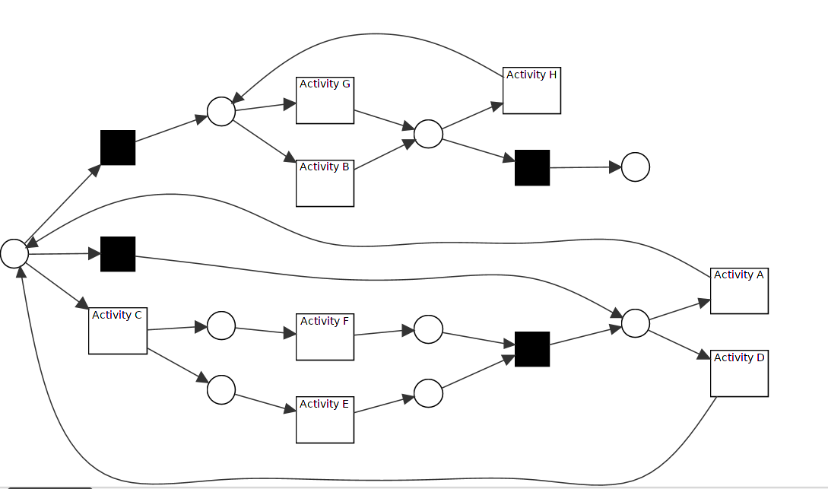
M3.1._02 second model generated
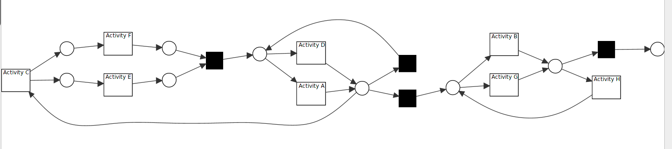
M3.2
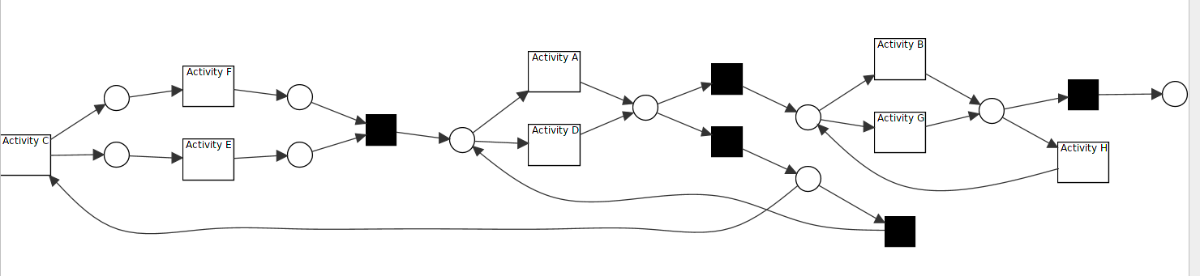
M4.1
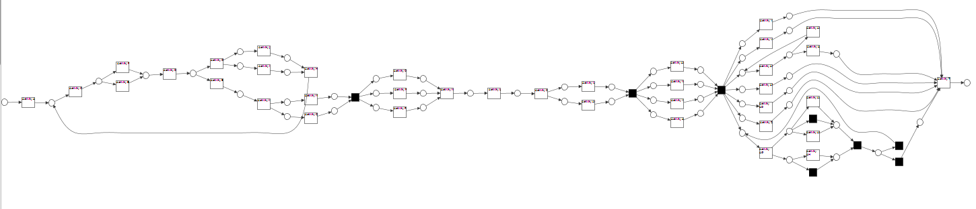
M4.2
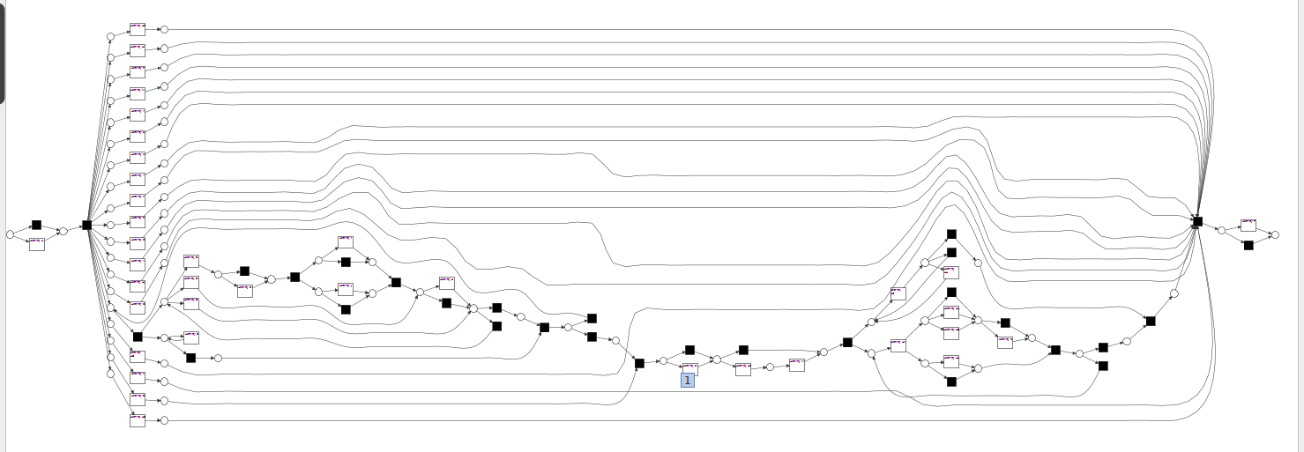
Experiment with Repair Model:
We need one existing model, it is : fit all the neg and pos traces, and then we fit it ?? No, it doesn’t work, because all new traces fit. So the existing model, could be ???
<1> model in sequence
<2> model from inductive miner, but now how about the data then ??
<3> the complement to create the existing model and then all positive ones comes to fix it???
M 5
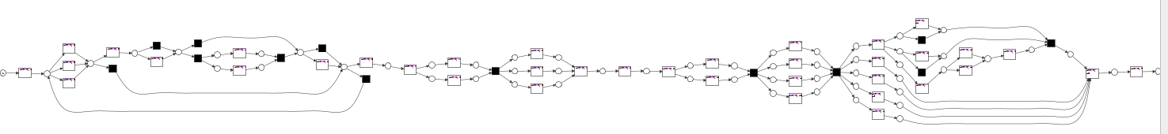
M 2.2 repaired model
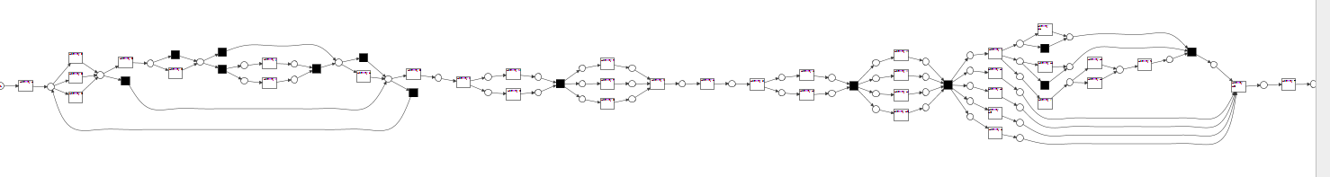
ID | Data ID | Model ID | Pos:neg | Overlap:not | Positive Set | Complement Set | Repair setting | Result:  PA : PN  NA: NN  Recall  Precision  Accuracy  F1-score
1.1 | D1 | M2.2 | 0.7:0.3 | 0 | Yes: 388 :: 112 |  | default | 2 Events in log additional  M1.1  0 :: 864  0 :: 636  0.0 NaN 0.424 0.0
1.2 | D6 | M5  824 : complement to generate | 0.7:0.3 | 02:0.8 | Yes:  864 |  | Default setting | Same model M1.1  388 :: 0  0 :: 112
1.3 | D1 |  | 0.5:0.5 | 0 | Yes: 147 :: 353 | No | 0.2 | Same model M1.1  147 :: 0  0 :: 353
1.4 | D1 |  | 0.3 < | 0 |  |  |  | We can’t get positive traces, so no model generation
2.1 | D1 |  | 0.7:0.3 | 0.3:0.7 | Yes: 280 :: 220 | No | No | M2.1  280 :: 0  73 :: 147  1.0  0.7932011331444759 0.854 0.8846761453396524
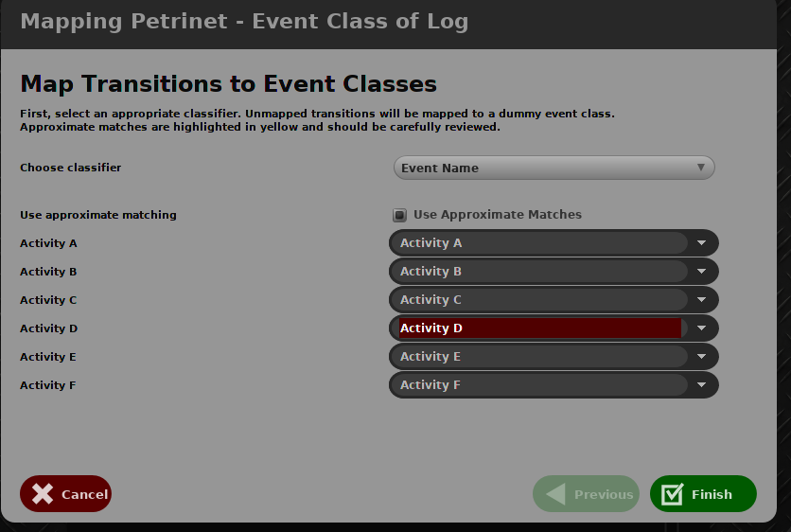

M5

Exceptions happen, when there is more events!!!
Plug ILP Miner produce 0 results, while 2 results were declared.

we want to compare our work with the following related works, and use them as the baseline. To achieve them, we create until now 3 plugin in ProM, Label Event Log, Build Base Model, Evaluate Result.
- Label Event Log : random or on through put time
- Build Model for inductive Miner or repair log
- Evaluate Result for confusion matrix generation

 | Inductive Miner ::  rediscover model | Repair Log ::  similar method comparison | KPI ::  similar method comparison
Method | – event log labeled  – [existing model to make sure traces fit, but no worry, we don’t need it]  --1. Positive examples used to generate a new model  --2. frequent pos generate model  – 3. difference to generate model  --whole event used to generate results. | - Existing model not fit for traces  1. unfit traces to generate model, but how to get it??? Mainly for adding, and removing at last.  – existing model::  1. frequent pos to build model  2. difference to build model  3. Or we have an existing model for inductive miner  – event log has unfit traces.  – Repair model  --1. pos examples to repair model  --2. frequent pos to repair model  --3. difference to repair model  --whole event log to generate confusion matrix | Because of the different classification method, we can’t compare it now..
Plugin | - Generate Log  - Assign Label Random  - Petrinet with naive conformance checking | - Generate Log  - Assign Label Random  - Petrinet with naive conformance checking  - Repair Log
Input
Output | Petrinet | Petrinet + marking
Confusion matrix | TP FN TP TN  3 0 3 0
Recall | 1
Precision | 1
Accuracy | 1
F1-score | 1
Comment |  | First try fails, because of lack of one map from event to model

Model 01_01
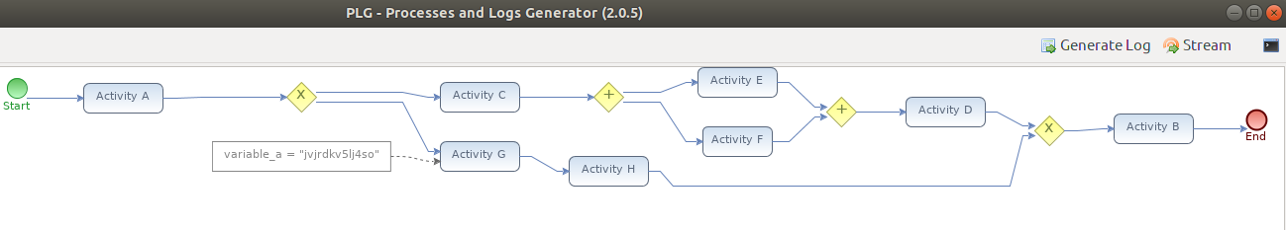
Petri net 01_01 is:
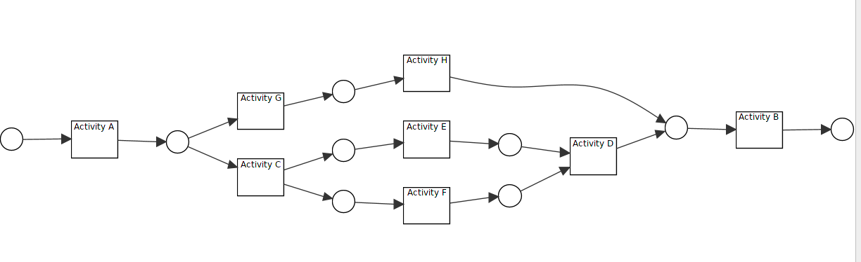
Event Log:
log_01_fit_20.xes ,
Label:
8 pos, 12 neg
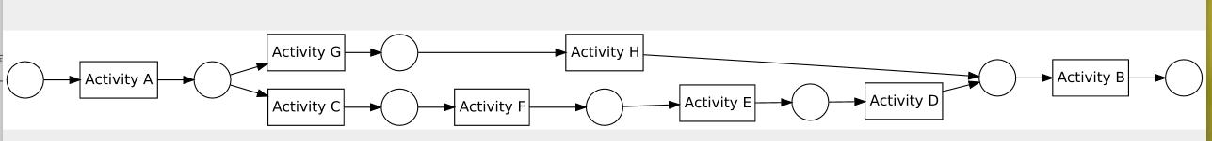
Generated Petri net 1 _02:
Evaluation Result:
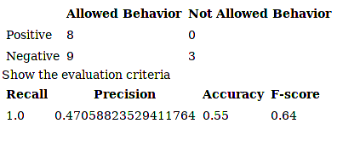

Formal Experiments:
ID | Method | Input | Output | Confusionmatrix  Recall: Precison: Accuracy: F1_score | Similarity
1 |  | -EM: Model 1  -Log: | Model_1_01 | 8 0  9 3  1.0 :0.47: 0.55:0.64
2
3
4
5

