My proposal::

The repaired model has higher fitness but less precision due to added loops and subprocesses. After this phrase, negative examples are used to improve the model, by reinforcing the good examples while avoiding the negative examples.
The inputs are:
– fit process model
– event log with good and bad examles

Some other improvements focus on the examples classification by using multiple KPI and quantifying the goodness degree.

How to evaluate it??
we will build one confusing matrix in the following table to evaluate the methods. It should improve the diagonal ratio in the table, and lower the percentage of reverse diagonal.
 | Allowed behavior | Not allowed behavior
Positive Traces | High | Low
Negative Traces | Low | High

How to compare it with others??
Firstly, only the positive examples are used to create the model, it means we only add positive subprocess on it ???

Input:: fitted model from which examples?? Does it mean, that we repair model at first to let it allow all behaviors??? And then to get impact from good and bad examples??
How to reinforce the good ones and avoid bad ones???

The process is Dirk Fahland method to create fitting models;;
Then output

Another one is ::
we use Dees method, to create a model already improve with good examples. But now, we need to consider the impact of negative ones.. ??

Which better??

Dias:
it has more works to do with it at first step, maybe the model is quite complicated, \

Second one create simpler models for it;; then when we add the negative ones, maybe it doesn’t fit the model, [well, already considered good;; but if it fits, then we need to remove its impact… But will it affect the existing good ones ??? If it does, then we can’t remove it !! we need to balance it to good ones and bad ones]

First one changes model based on the already fit model, but only consider the good and bad performance on it , okkkkk.. much clearer,
Later improvement is to add weighted classification on it..

More work is on repair model at first, a connection is needed..

How to give one example???

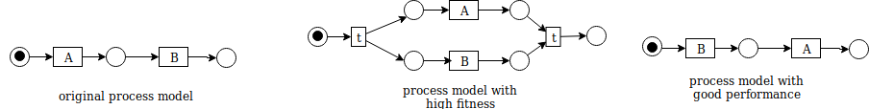

we have original process model shown in the figure above, during its execution, we have event log [<A,B>30 , <B, A>105].
After repair model for high fitness, we have process model in the middle. With analyze the impact on performance, we have divided event log into this set:
Positive examples: [ <A,B>10, <B,A>100]
Negative examples; [ <A,B>20, <B,A>5 ]

So to get a better performance, we have gotten this model in the right part.

But now how about the fitness, we have actually less fitness than before. But with good performance?? How’ s the confusion matrix?? 1

 | Allowed behavior | Not allowed behavior
Positive Traces | 100 | 10
Negative Traces | 5 | 20

(fitness , good performance )

 | Allowed behavior | Not allowed behavior
Positive Traces | High (AP) | Low (PN)
Negative Traces | Low (AN) | High (NN)

Goodness::

performance:: [ allowed behavior: AP/(AP+AN) +
disallowed behavior : NN/(PN + NN) ] /2
Or should we consider the attribution on this??? Like we don’t have enough negative traces, so we may have overestimated value for disallowed behavoir?? ?

fitness:

How to conduct it?? the process??

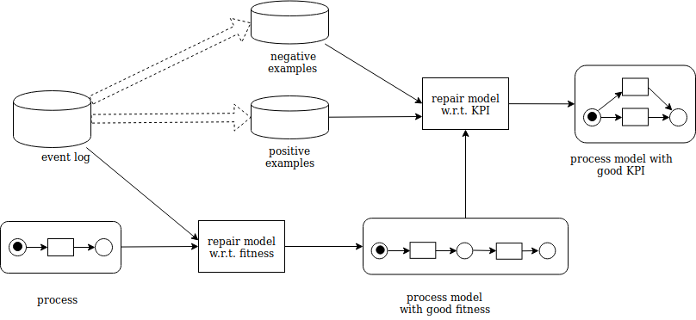
My approach to achieve this goal is :

Methods:
Hypothesis:

<1> it improves the model compared to state-of-the-art methods to repair model
<2> If we quantify the goodness of event trace, and imply the weighted impact on it, we could get better result than only use the classification method.

How to test them??

Do background research:

Need to read more paper to propose the methods.

Sometimes I feel it so awkward to write in Latex, because I need to consider the format at the same time..

