Simple Experiments with my own methods

I do the experiments from in the order of before, and check the effect of them.

ID | Model ID | Data ID | Method | Result | Conclusion
1.1_2  Case 1.1 | M1 | D1.2 | Dfg with directly follow relation  Assign Df: 0.2  weights: 1.0 1.0 1.0 | R1.1 | New Model:  TP: 50 FN: 0  FP: 0 TN: 50  good recall and precision.
Case 1.2  // add multiple events at same position | M1 | D1.11 | Dfg with directly follow relation  Assign Df: 0.2  weights: 1.0 1.0 1.0  weights: 1.0, 0, <1.0 => sequence model like before | R1.16 | New Model:  TP: 200 FN: 0  FP: 50 TN: 0  create the same model like inductive miner
Case 1.2  // add multiple events at different position | M1 | D1.8 | Dfg with directly follow relation  Assign Df: 0.2  weights: 1.0 1.0 1.0  But weights::  1.0, 0.1, 1.0 sequnece model  1.1, 0.0, 0.5 model M1 | R1.10  R1.10_2  M1 | New Model:  TP: 50 FN: 100  FP: 0 TN: 50  create the same model like inductive miner
1.12_13 Case 1.3 | M1 | D1.9 | Dfg with directly follow relation  Assign Df: 0.2  weights: 1.0 1.0 1.0 | R1.12 | New Model:  TP: 50 FN: 0  FP: 0 TN: 50  good recall and good precision.
1.3_4  Case 1.4 | M1 | D1.3 | Dfg with directly follow relation  Assign Df: 0.2  Weight: 1.0, 1.0 , 1.0 | R1.3 | New Model:  TP: 100 FN: 0  FP: 0 TN: 100  good recall and precision.
1.5_6  Case 1.5 | M1 | D1.5 | Inductive Miner with positive labels  Assign Df: 0.2  Weight: 1.0, 1.0 , 1.0 | R1.5 | New Model:  TP: 55 FN: 0  FP: 0 TN: 55  good recall and precision.
Case 1.6  1.7 | M1 | D1.1 | Inductive Miner with positive labels  Assign Df: 0.2  Weight: 1.0, 1.0 , 1.0 | R1.7 | New Model:  TP: 55 FN: 0  FP: 0 TN: 55  good recall and precision.
Case 1.6  1.8 | M1 | D1.6 | Inductive Miner with positive labels  Assign Df: 0.2  Weight: 1.0, 1.0 , 1.0 | Case1.6_R1.7 | New Model:  TP: 50 FN: 5  FP: 5 TN: 50  0.91, 0.91, 0.91,0.91  It predicts the effect of overlapped data and give the good result
Case 1.6  1.9 | M1 | D1.7 | Inductive Miner with positive labels  Assign Df: 0.2  Weight: 1.0, 1.0 , 1.0 | Case1.6_R1.8 | New Model:  TP: 50 FN: 5  FP: 5 TN: 50  0.91, 0.91, 0.91,0.91  It predicts the effect of overlapped data and give the good result
Case 2.1 | M2 | D2.1 | Inductive Miner with positive labels  Assign Df: 0.2  Weight: 1.0, 1.0 , 1.0 | R2.1_1 | New Model:  TP: 50 FN: 0  FP: 0 TN: 50  quite different result, but better than both
Case 2.3 | M2 | D2.2 | Inductive Miner with positive labels  Assign Df: 0.2  Weight: 1.0, 1.0 , 1.0 | R2.3_1 | New Model:  TP: 50 FN: 0  FP: 0 TN: 50  like inductive miner
Case 2.4 | M2 | D2.3?? | Inductive Miner with positive labels  Assign Df: 0.2  Weight: 1.0, 1.0 , 1.0  pos 50<A,B>, neg 50<B,A> |  | New Model:  TP: 50 FN: 0  FP: 0 TN: 50  like inductive miner
Case 2.5.1 | M2 | D2.6 | Inductive Miner with positive labels  Assign Df: 0.2  Weight: 1.0, 1.0 , 1.0  Pos: 50<A,B>, 5<B,A> neg: 5<A,B>, 50<B,A> :: |  | New Model:  TP: 50 FN: 5  FP: 5 TN: 50  0.91, 0.91, 0.91,0.91  It predicts the effect of overlapped data and give the good result
Case 2.5.2 | M2 | D | Inductive Miner with positive labels  Assign Df: 0.2  Weight: 1.0, 1.0 , 1.0  Pos: 50 <A, B>, 5<B,A>, 1<A> , 2<B>neg: 5<A,B>, 50<B,A> | R2.5_2 | New Model:  TP: 50 FN: 8  FP: 5 TN: 50  0.86 0.91 0.88 0.88
Case 3.1 add self-loop to sequence | M3.1 | D3.1 | Inductive Miner with positive labels  Assign Df: 0.2  Weight: 1.0, 1.0 , 1.0  Pos: 50<A,C> 50 <A,B,C>, 50<A,B,B,C>, 50<A,B,B,B,C> | R3.1_3 | New Model:  TP: 200 FN: 0  FP: 0 TN: ?
Case 3.2 delete loop but change them into duplicate events | M3.2 | D3.3 | Inductive Miner with positive labels  Assign Df: 0.2  Weight: 1.0, 1.0 , 1.0  Pos: 50<A,C> 50 <A,B,C>, 50<A,B,B,C>,  Neg: 50<A,B,B,B,C> | R3.2_3 | New Model:  TP: 100 FN: 50  FP: 0 TN: 50
Case3.3  change sequence to 2-length loop | M3.1 | D | Need to correct it and see the effect
Case3.4.1  delete loop | M3.3 | D3.7 | Inductive Miner with positive labels  Assign Df: 0.2  Weight: 1.0, 1.0 , 1.0  Pos: 50<A> Neg: 50<A,B,C> , 50<A,B,B,C> | R3.4.1_3  // same as IM | New Model:  TP: 50 FN: 0  FP: 0 TN: 100  good recall, good precision.
Case3.4.2  delete events from loop | M3.3 | D3.8 | Why can’t I get the same model like in the IM?? Something wrong is??  ==> nothing wrong with my methods, only the dfg coverts into process tree has sth wrong in the codes.. what we could do :: 1. change the dfg into new methods,  2. keep it this way!!  ==> keep it in this way | R3.4.2_3 | New Model:  TP: 150 FN: 0  FP: 0 TN: 100  some small bugs in the evaluation methods, I’m afraid there are more…
Case3.4.3  delete events in the middle of loop | M3.3. | D3.9 |  | R3.4.3_3 | New Model:  TP: 150 FN: 0  FP: 0 TN: 100
Case3..5.1 add events in the loop branch | M3.2 | D3.5 |  | R3.5.1_3 | New Model:  TP: 150 FN: 0  FP: 0 TN: 100
Case3..5.1 add events in the loop branch | M3.2 | D3.5 |  | R3.5.1_3 | New Model:  TP: 50 FN: 200  FP: 0 TN: 0  0.2 1.0 0.2 0.33  bad result
Case3.6 modify order | M3.3 | D3.10 |  |  | New Model:  TP: 50 FN: 50  FP: 0 TN: 100  0.5 1.0 0.75 0.67
Case4 like IM, then so need to write down
Case 5.1 | M5.2 | D5.1.2 | Inductive Miner with positive labels  Assign Df: 0.2  Weight: 1.0, 1.0 , 1.0 | R5.3 | New Model:  TP: 150 FN: 0  FP: 0 TN: ?  without negative info, it has good model fitting and precision.
Case 5.2 | M5.2 | D5.2.2 | Inductive Miner with positive labels  Assign Df: 0.2  Weight: 1.0, 1.0 , 1.0 | R5.7 | New Model:  TP: 100 FN: 0  FP: 0 TN: 50  good recall and precision.
Case 5.3 | M5.2 | D5.3 | Same | R5.9 | New Model:  TP: 50 FN: 0  FP: 0 TN: 50  good recall and precision.
Case 5.4 | M5.2 | D5.4 | same | R5.11 | New Model:  TP: 100 FN: 0  FP: 0 TN: 50  good recall and precision.
Case5.5 | M5.2 | D5.5 | same | R5.13 | New Model:  TP: 100 FN: 0  FP: 0 TN: 100  good recall and precision.
Case 5.6 | M5.2 | D5.6 | same | R5.6_2 | New Model:  TP: 100 FN: 0  FP: 0 TN: 100  good recall and precision.

Case1.6_R1.7
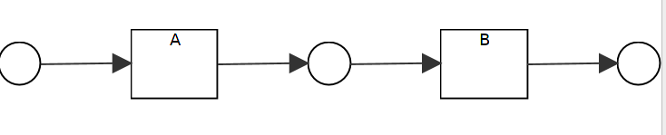
Case 1.6 R1.8
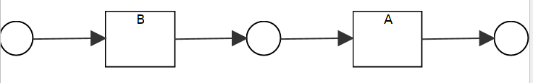
R1.10_2
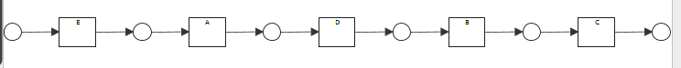
R2.1_1
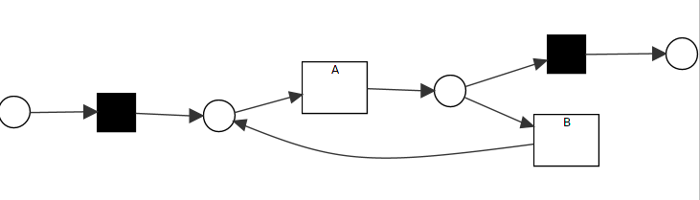
R2.3_1

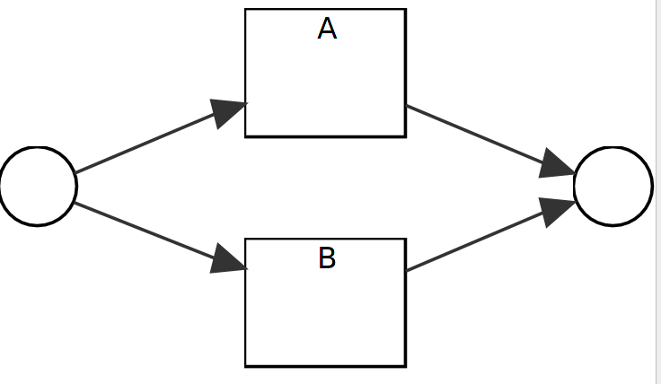
R2.4_1
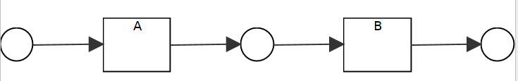
R2.5_2
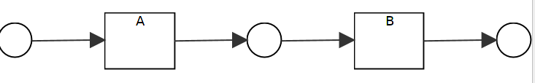
R5.6_2

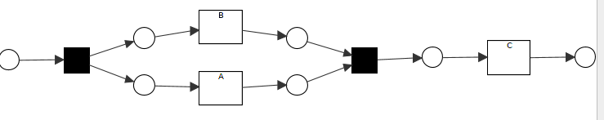
R3.1_3
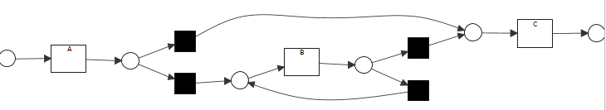
R3.2_3
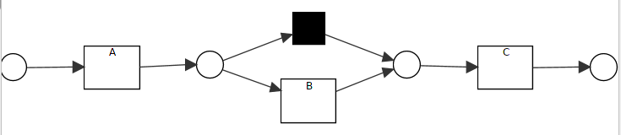
R3.4.1_3
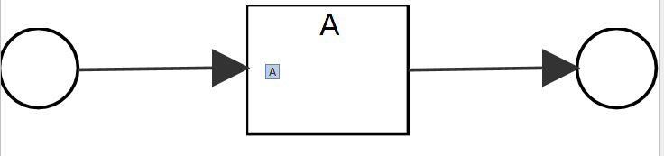
R3.4.1_1??

R3.4.1_2??

R3.4.2_3
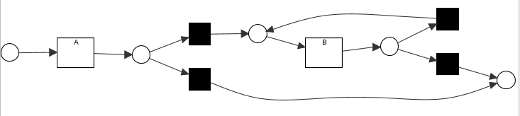
R3.4.3_3
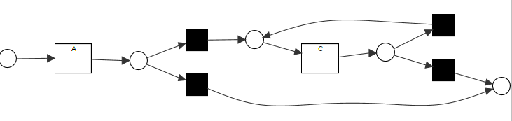
R3.5.1_3
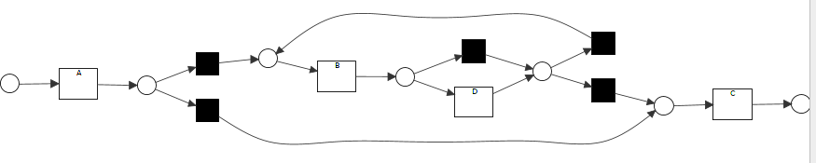
R3.5.2_3
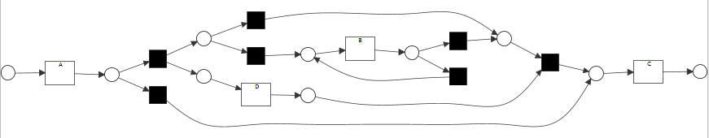
R3.6_3
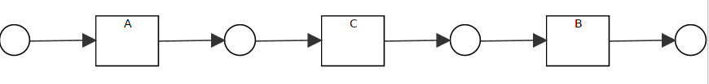

Original Model Logic Expression | Changed Expression
A: pre(A,S), res(A,C), not-coext(A,B)  B: pre(B,S), res(B,C), not-coext(B,A)  C: pre(C,A), pre(C,B) | A: pre(A,S), res(A,C), not-coext(A,B), not-coext(A,D)  B: pre(B,S), res(B,C), not-coext(B,A), not-coext(B,D)  C: pre(C,A), pre(C,B), pre(C,D)  D: pre(D,S), res(D,C), not-coext(D,A),not-coext(D,B)
A: pre(A,S), res(A,C), not-coext(A,B)  B: pre(B,S), res(B,C), not-coext(B,A)  C: pre(C,A), pre(C,B) | A: pre(A,S), res(A,D), res(A,C), not-coext(A,B)  B: pre(B,S), res(B,C), not-coext(B,A), not-coext(B,D)  C: pre(C,A), pre(C,D),pre(C,B)  D:pre(D,A), res(D,C), non-coext(D,B)
A: pre(A,S), res(A,C), not-coext(A,B)  B: pre(B,S), res(B,C), not-coext(B,A)  C: pre(C,A), pre(C,B) | A: pre(A,S), res(A,C), not-coext(A,B)  B: pre(B,S), res(B,C), not-coext(B,A)  C: pre(C,A), pre(C,B)
A: pre(A,S), res(A,C), not-coext(A,B)  B: pre(B,S), res(B,C), not-coext(B,A)  C: pre(C,A), pre(C,B)  //if delete one event type, we should delete all related rules | A: pre(A,S), res(A,C), not-coext(A,B),not-coext(A,D)  B: pre(B,S), res(B,C), not-coext(B,A)  C: pre(C,A), pre(C,B), pre(C,D)  D: pre(D,S), res(D,C),not-coext(D,A)
A: pre(A,S), res(A,C), not-coext(A,B)  B: pre(B,S), res(B,C), not-coext(B,A)  C: pre(C,A), pre(C,B)  // if pos fits, then insist on pos;; in neg, there must be one rule which violates the pos sets of rules;and only one is good. | A: pre(A,S), res(A,C), res(A,B),not-coext(A,B)  B: pre(B,S),pre(B,A), res(B,C), not-coext(B,A)  C: pre(C,A), pre(C,B)  // put some constraints in KB, and also give relation on them, like if  res(X,Y) → coext(X,Y)  non-coext(X,Y) -→Not res(X,Y) nor pre(X,Y)
A: pre(A,S), res(A,C), not-coext(A,B)  B: pre(B,S), res(B,C), not-coext(B,A)  C: pre(C,A), pre(C,B)  // we build rules for one activity w.r.t. all traces??  or we go through all traces and list all relation to each activity..  [last is better, ]  // if neg rules are subset of pos, how to solve?? | A: pre(A,S), res(A,C), res(A,B),pre(A,B),not-coext(A,B)  B: pre(B,S), res(B,A), pre(B,A),res(B,C), not-coext(B,A)  C: pre(C,A), pre(C,B)  // add all possible relation from pos and then delete them from neg // KB constraints deleted automatically after each step  // or we need to define the trace on it?? like  pre(A,S)^res(A,B)  V pre(A,B)^res(A,C)  //so when we check the satisfaction, we violate the model due to the lack of B!!!  // one problem is if it overfits??
A: pre(A,S)^res(A,B)  B: pre(B,A) | A:pre(A,S)^res(A,B)  B: pre(B,A)
A: pre(A,S)^res(A,B)  B: pre(B,A) | A: pre(A,S)^res(A,B) V pre(A,E)^res(A,B)  V pre(A,S)^res(A,D)  // I can’t deal with this model.. So must do some choices…  1. address pos, we need to remove it!! then we sacrifice, choose one the pos with most weight, and fix it ??  2. avoid neg, check the rules which it satisfies, common parts of negative examples, add <A,C>, then we know,that they have common pre(A,S) with <A,B>. Then we get rid of it in rules  // one thing on the explicit relation is on the parallel rela, too many relation!!  // anyway, I need to create connection into the graphical template and logic rules
A: pre(A,S)^res(A,B)  B: pre(B,A) | A: pre(A,S)^ res(A,B)  B: pre(B,A)
// from this part, I use the directlyFollow relation to test if it works better than normal one  df(S,A), df(A,B) | df(A,C),df(S,A), df(A,B)
df(S,A), df(A,B) | df(S,A), df(S,B), df(A,B)  // it could be also over one threshold to delete or just seen and then delete it
df(S,A), df(A,B) | df(S,B), df(B,A), df(A,B), df(S,A)
df(S,A), df(A,B) | df(S,A), df(A,B), df(S,B), df(B,A)
df(S,A), df(S,B), df(A,B), df(B,A) | df(S,A), df(S,B), df(A,B), df(B,A)
df(S,A), df(S,B), df(A,B), df(B,A) | df(S,A), df(S,B), df(A,B), df(B,A),  df(S,C), df(A,C), df(C,A), df(C,B), df(B,C),  // how about neg df(A,B) & df(B,A)
df(S,A), df(S,B), df(A,B), df(B,A) | df(S,A), df(S,B), df(A,B), df(B,A)  df(A,C), df(B,C),  df(D,A), df(D,B), df(S,D)  df(A,E), df(E,B),  df(B,E), df(E,A),
df(S,A), df(S,B), df(A,B), df(B,A) | df(S,A), df(S,B), df(A,B), df(B,A)  df(B,C), df(D,A), df(A,E), df(E,B),  !!!! not(A,C)
df(S,A), df(S,B), df(A,B), df(B,A) | df(S,A), df(S,B), df(A,B), df(B,A)  df(A,C), df(B,C), df(S,C),  df(D,A), df(B,E)  // only one part of pos, then keep it
df(S,A), df(S,B), df(A,B), df(B,A) | df(S,A), df(A,C)  df(S,C), df(C,A)  df(A,B), // in existing and neg, then delete them;  df(B,C), // only in neg, then delete it, no shown it dfg  df(A,C) // in pos and neg, keep it then.
df(S,A), df(S,B), df(A,B), df(B,A) | df(S,A), df(S,B)  df(A,B) // in existing and neg, delete it  df(B,A)// in existing and neg, delete it
df(S,A), df(S,B), df(A,B), df(B,A) | df(S,B), df(B,A)  df(S,A)// in ext and neg  df(A,B) // in ext and neg
df(S,A), df(S,B), df(A,B), df(B,A) | df(S,A), df(S,B), df(A,B), df(B,A)  // now we need to consider the distribution of pos and neg!!!  // neg and pos rules are the same  P(df(A,B)) > N(df(A,B))  keep df(A,B)  *** but only simple comparation??***  P(df(B,A)) < N(df(B,A))  delete df(A,B)
???? | ?????  // some methods to filter out the noise, or we also consider like the IM, different types, then all data considered, we have then a fine model?? Somehow..
df(S,A), df(A,B), df(B,C) | df(S,A), df(A,B), df(B,C)  df(B,B),// self-loop but we need to add it into relation, that’s all.
df(S,A), df(A,B), df(B,C), df(B,B) | df(S,A), df(A,B), df(B,C)  df(B,B),// we see in pos and neg, then we need to compare distribution??  N(df(B,B)) > P(df)(B,B) .. not logic.  // can’t see it actually.
df(S,A), df(A,B), df(B,C) | df(S,A), df(A,B), df(B,C),  df(C,B),
df(S,A), df(A,B), df(B,C), df(C,B), | df(P,A), df(A,C)  df(A,B),// in neg not in pos  df(B,C), // in neg not in pos  df(C,B), // in neg not in pos  df()
df(S,A), df(A,B), df(B,C), df(C,B), | df(S,A), df(A,B),  df(B,B) //in pos  df(B,C), // delete in in neg and ext  df(C,B), // delete in neg and ext
df(S,A), df(A,B), df(B,C), df(C,B), | df(S,A),  df(A,C), // in pos  df(C,C) //in pos  df(A,B), // delete in in neg and ext  df(C,B), // delete in neg and ext  df(B,C), // delete in neg and ext
df(S,A), df(A,B), df(B,C),df(B,B),df(A,C) | df(S,A), df(A,B),  df(B,D), df(D,C) // add in pos  df(B,C), // delete it not in pos  df(B,B),??? // what if there is no neg for it, what should we do ?? or there is some neg examples expecting  one rule is : pos has this transition, then keep it..  df(B,B) // in ext, pos has the transition, then keep it..
df(S,A), df(A,B), df(B,C), df(B,B), df(A,C) | df(S,A), df(A,B), df(B,C), df(A,C)  df(B,D), df(D,B), df(D,C),df(A,D)// in pos  df(B,B), // ext but not in pos keep it, but actually we need to delete it //  ??
df(S,A), df(A,B), df(B,C), df(C,B), | df(S,A),  df(A,C) // in pos not in ext  df(A,B),// in ext and neg  df(B,C) , df(C,B)// in neg and pos, keep it
df(S,A), df(A,C), df(C,D),  df(S,B), df(B,C), df(C,E), | df(S,A), df(A,C), df(C,D),  df(S,B), df(B,C), df(C,E),  // we deal with it at post processing, if we check out the free choice structure, then we go to neg examples, if  df(C,E) // in neg not in ext, to avoid it, we add one place from A to D,to choose other choice  df(C,D) // choose another choice, not this one
df(S,A), df(A,C), df(C,E),
df(S,B), df(B,C), df(C,D),
df(S,A), df(A,C), df(C,E),
df(S,B), df(B,C), df(C,D),

