Test Cases Design
This document lists the outlines of test cases for my method.
Inputs:
- event log
- petri net
- KPIs( due to simplification of our methods, KPIs are defined subjectively. )
Outputs:
- petri net with long-term dependency
Synthetic data:
+++ example scenirois cases::
Inductive Miner:: on positive, add long-term dependency, without LT:
Getting result of this::
TO check the confusion matrix, fitness somehow.

Flow Variables:: Implementation to show the changes of weight parameters.

Methods:
- Inductive Miner :
  - full-generated model
  - default setting [+ other settings??]
  - positive instances, full
- Fahland’s method: Real life
  - with existing model
  - default setting [+ other settings??]
  - positive instances :: filtered event log
- Marcus’s Method: Real life / Case study only for specific company
  - with existing model
  - default setting
  - positive instance
    - ===> changes on it, if we introduce this method, we need another working hours on it, and then reading files method is on the data file.. which could I use it?? Might use it.. But now syntactic data of our data setting, let us checking the effect on it..
- Our method – dfg-method:
  - with existing model
  - default setting [+ other settings]
  - full event log

Control Variables:
Because we have no real data life labeled under real KPIs, so the major experiments are simulated to show the possible applications of our methods. Our work is to incorporate negative instances on model enhancement. So the distribution of negative instances is important. The distribution can be reflected on the percentage of negative traces in event log, named as P(log_neg). Further, for one specific trace variant, it can lead to negative and positive instances. This possibility of negative instances is remarked as P(trace_variant_neg).
Also, the complexity of existing model might affect the result of algorithms. So event logs with different complexity should be presented.
Last, the type of model can play a role on the success of methods.
There are control variables in the followings:
- complexity of existing model
  - simple models with events size < 10, types of relations (Seq, Parallel, Xor, Loop), 0<type num <3, 0< each num <3
    - under a fixed setting but different models… 5 times
1). generate by plg https://github.com/delas/plg
Process and Logs generation table Normal one::: default setting
Row  ID | Process Name | Maximum Depth | Max And branches | Max XOR branches | Sequence Weight | Single Activity Weight | Skip Weight | And Weight | XOR weight | Loop Weight | Data Objects Probability | File Name
1:: normal one | Process-Normal-01-PN | 3 | 3 | 5 | 43 | 21 | 2 | 30 | 30 | 5 | 10 | Process-Normal-01-PN.pnml
2::  Simple | Process-Normal-02 | 3 | 3 | 5 | 43 | 21 | 2 | 30 | 30 | 5 | 10 | Process-Normal-02-PN.pnml

The generated event log https://github.com/delas/plg/wiki/DialogSimulationConfiguration
RowId | Process name | Log Name | Configuration presets | Number of traces | Change activity name prob | Trace mining head pro | Trace missing tail pro | Trace missing eposide prob | Perturbed event order pro | Doubled event prob | Alient event prob | Integer data object error prob | String data object error prob | Head max size | Tail max size | Episode max size | Integer data object error delta
1.1 | Process-Normal-01 | Process-Normal-01-Log-01.xes | No noise | 500 | 0 | 0 | 0 | 0 | 0 | 0 | 0 | 0 | 0 | 1 | 1 | 1 | 1
1.2 | Process-Normal-01 | Process-Normal-01-Log-02.xes | No noise | 1000 | 0 | 0 | 0 | 0 | 0 | 0 | 0 | 0 | 0 | 1 | 1 | 1 | 1
1.3  ::  difference to 1.1?? With noise at 1000, so the noise stable?? | Process-Normal-01 | Process-Normal-01-Log-03.xes | No noise | 500 | 0 | 0 | 0 | 0 | 0 | 0 | 0 | 0 | 0 | 1 | 1 | 1 | 1
1.4 | Process-Normal-01 | Process-Normal-01-Log-04.xes | No noise | 200 | 0 | 0 | 0 | 0 | 0 | 0 | 0 | 0 | 0 | 1 | 1 | 1 | 1
2.0 | Process-Normal-02 | Process-Normal-02-Log-00.xes | No noise | 200 | 0 | 0 | 0 | 0 | 0 | 0 | 0 | 0 | 0 | 1 | 1 | 1 | 1
2.1 | Process-Normal-02 | Process-Normal-02-Log-01.xes | No noise | 500 | 0 | 0 | 0 | 0 | 0 | 0 | 0 | 0 | 0 | 1 | 1 | 1 | 1
2.2 | Process-Normal-02 | Process-Normal-02-Log-02.xes | Noise only on the control-flow | 500 | 0 | 5 | 5 | 5 | 5 | 0 | 0 | 0 | 0 | 2 | 2 | 2 | 1
2.3 | Process-Normal-02 | Process-Normal-02-Log-03.xes | Noise only on the control-flow | 500 | 0 | 10 | 10 | 10 | 10 | 0 | 0 | 0 | 0 | 3 | 3 | 3 | 2
2.4 | Process-Normal-02 | Process-Normal-02-Log-04.xes | Complete noise | 1000 | 10 | 10 | 10 | 10 | 10 | 10 | 10 | 10 | 10 | 1 | 1 | 1 | 5

  - normal models, 10< event size <20, 2< relations num < 4, each is 3<?<5
  - complex models with events size > 20, 3<type num< 5, each is 5<??
  - In total, we will use 6*3 models for simulation tests.
- P(log_neg): the possibility of negative trace variants in data
  - // challenge:: performance, how to act;; 50% pos, 50% neg;;
  - all traces of one trace variant are labeled the same
  - Randomly label those variant and then apply the method
- P(trace_neg): the possibility of negative instances in one trace variant, to make the result convincing, we use 3 different P(log_neg) to conduct this experiment
  - trace variant contains different labels
  - Randomly label those variant

Measurements:
The measurements for those methods are partially based on confusion matrix, model simplicity, and fitness. To avoid random errors, each experiment with one control variable will be conducted over 5 times, and the trimmed mean is chosen to represent this experiment.
- Confusion matrix
- Confusion matrix on classification in the following format.
 | Allowed behavior | Not allowed behavior
Positive Traces | AP(High) | NP(Low)
Negative Traces | NA(Low) | NN(High)

- Other measurements driven from confusion matrix
  - Precision
  - Accuracy
  - Recall
  - F-score
- Simplicity :: ProM plugin in
- subjectively judged by the events number in the model, and the types of relation
- Fitness :
  - the number for positive instances in event log to the model by using plugin in ProM
- Precision: ProM in way
- Generality: to divide data set into train and test.. event log, to check the generality..
  - test confusion matrix
  - test sampled from the same event log
- Similarity:

Representation Samples:
F-score:: to represent it, explain it additionally…
For a certain event log, but varied P(log_neg), we get a plot for precision shown in the following: [Fake Data at first]
For a fixed P(log_neg), but varied on the P(trace_log), we have result on recall on it.

The total number of experiments can will be:
For P(log_neg): 4(methods num)*5(single test unit)*10(control values) = 200
For P(trace_neg): 4*5*10*3(fixed log_neg types) = 600
For Simplicity: 3*6 = 18
18*(200 + 600) = 14400!!!
!!!!!
It is a lot of those tests!!! I can’t afford this!!! Must automate it!!! Even automation can’t help it!!! My goddess!!

How to automate the experiments in KNIME???? Workflow:
- Generate Petri net [Flow Variables to control complexity]
- Generate Event Log[ Flow Variables to control noises]
- Label Event Log [Flow Variables to control negative percentage, one in log, one in trace]
- Repair Model in 4 methods
  - Inductive Miner
  - Fahland’s method
  - Marcus’ method
  - My Method
- Output Petri net
- Evaluate result with event log and petri net
  - Inductive Miner
  - Fahland’s method
  - Marcus’ method
  - My Method

TO achieve this workflow, I need to do:
- Add Flow Variables into the whole processes to change the control parameters
- Introduce my method into KNIME
  - Introduce Generate Petri net into KNIME
  - Introduce Simulate Event log into KNIME
  - Introduce Label Log and Variant into KNIME
  - Introduce Split Event Log into KNIME
  - Introduce repair method into KNIME
- Introduce Fahland’s method into KNIME
- Introduce Marcus’ method into KNIME
- Introduce ProM Fitness Evaluation into KNIME
The nodes colored orange which can be implemented into KNIME, but the others might difficult. So it can be fully-automated in KNIME.
The purple nodes are necessary for experiments here and in consideration to implement it in KNIME.

The data set used by Fahland, I need to use the filtered data as negative information to get out of it… Be careful about the data set
https://data.4tu.nl/repository/uuid:31a308ef-c844-48da-948c-305d167a0ec1

Workflow of testing: fixed order
<1> Compare the event log and petri net in plg work, if a lot of models are generated, then fine, else to introduce the flow variables
- But I’d like to develop a tool for editing efficient tree, manually. It’s already save a lot of work,
- consider the existing model at first!! If they are enough to use, then stop thinking of other method
<2> Import the assign label node into KNIME to assign random labels on the work, to generate the event log on it.
- Pos and neg instances 50% percent on it
<3> Import the FlowVariable into Inductive Miner to control it?? But do we need it?? Actually, not really, but it should follow the rules in node.
<4> Import my repair method into KNIME to output a Petri net
<5> Compare the confusion matrix on it

So the most important thing is to learn flow variable in KNIME.
===> introduce flow variable into Inductive Miner.

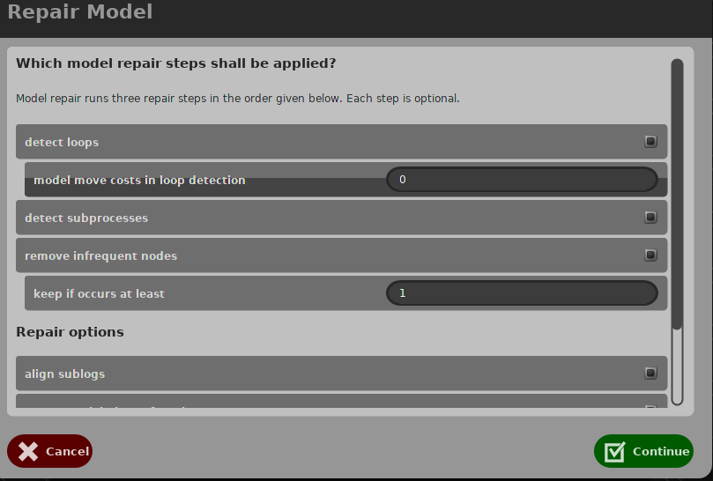
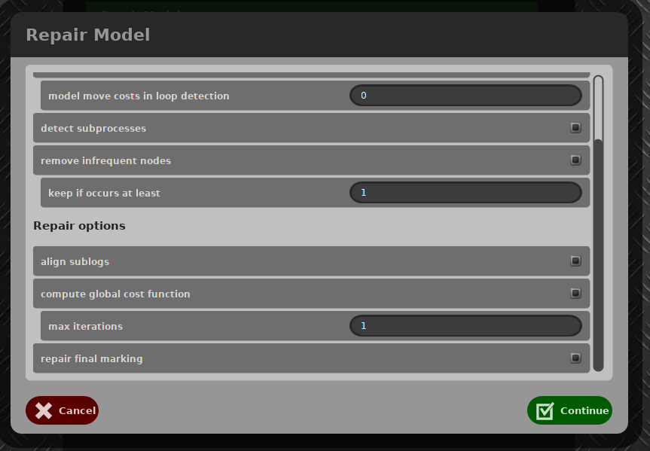

02. April. 2019
Real life data::
already changed it into the right format.. Do it bravely, don’t worry about the effect!!
We are going to compare all the information generated model form it
 | Log File | Generated Model |  | Fitness&Precision in Multi-perspective Process Explorer | Comment
Inductive Miner |  |  |  |  | Clear model
Repair Model
KPI Repair
Negative Info |  |  |  |  | The model is full of self-loop, and the silent transition to keep it out

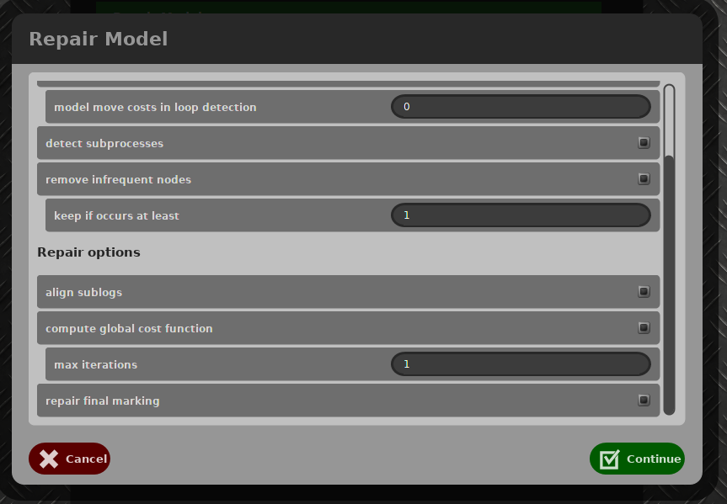
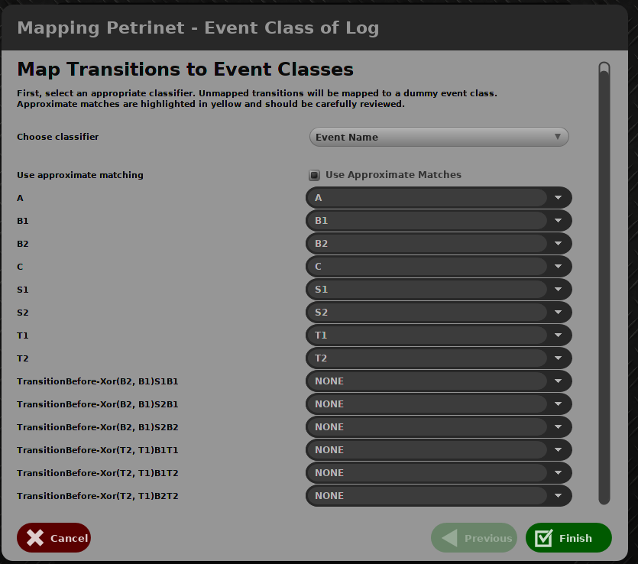
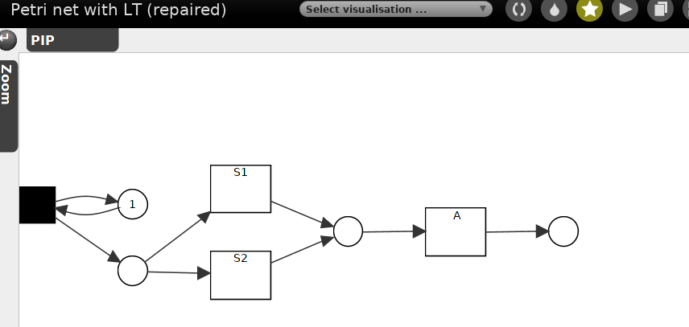

Test 1,2, I want to check the effect of noise distribution, and we can have it...How about that we use five times to test the same noise setting, and then 3 different data on it???
I will say yes, let’s do it, now..with different noise rates..

Simplify it to repeat each row five times ?? and then read it, but

