Test Summary on Weight Change
Tests of this type investigates the tendency of measurements change with control parameter changes.
Weight changes design:

Test Cases:
<1> On property data specific for one situation changes, specific labeling to address need
<2> On synthetic data, the whole changes, randomly labeling
<3> On real life data, with proper labeling
The results are listed in separate sections below.

On property data
1.1 change parallel to xor structure: Measurements tendency with the existing,pos and neg weight changes:
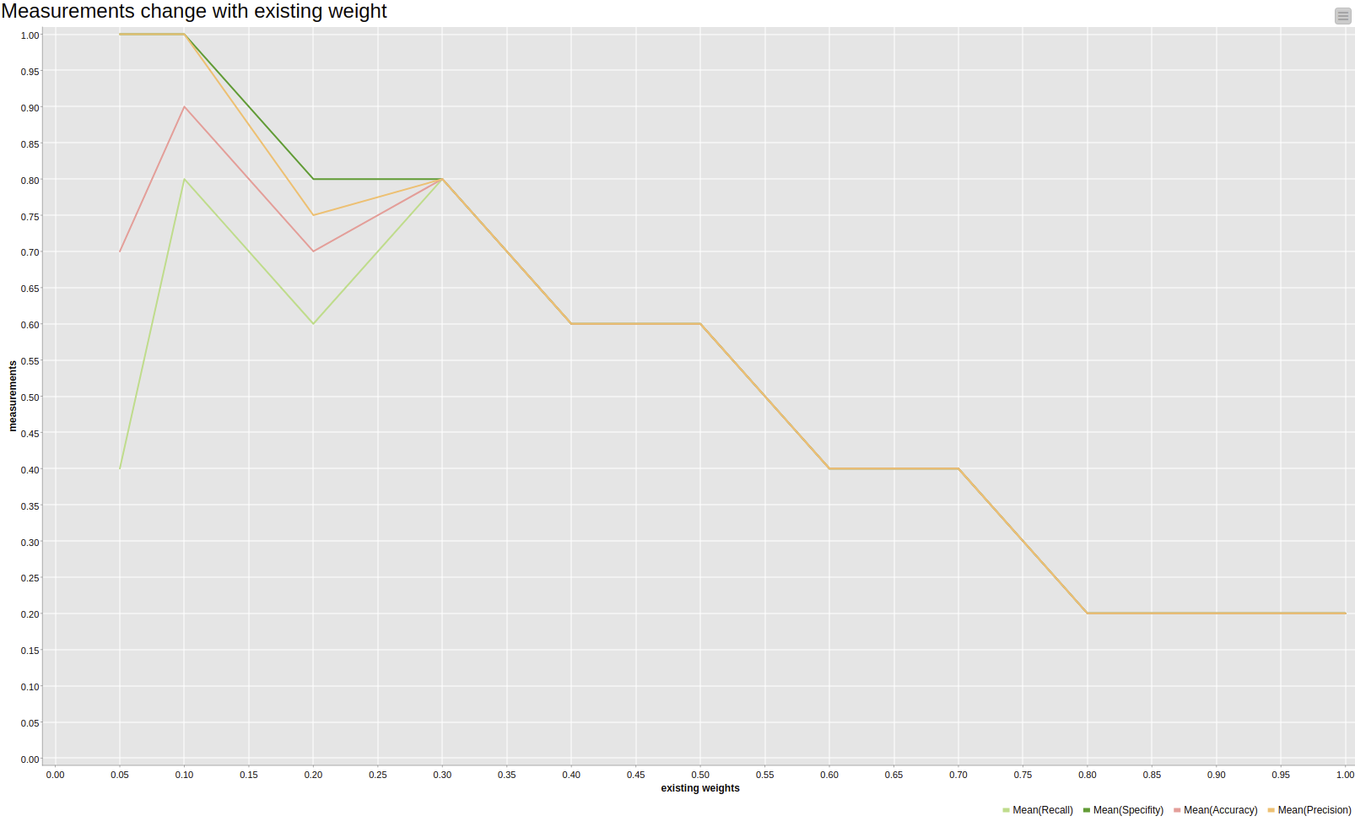
Accuracy goes down and precision: TP less and FP increases, but why?? Existing model deviates from the old model. True negative goes down. Because the model supports more negative instances. Specificity: TN goes down and the models is unable to reject the resuls.
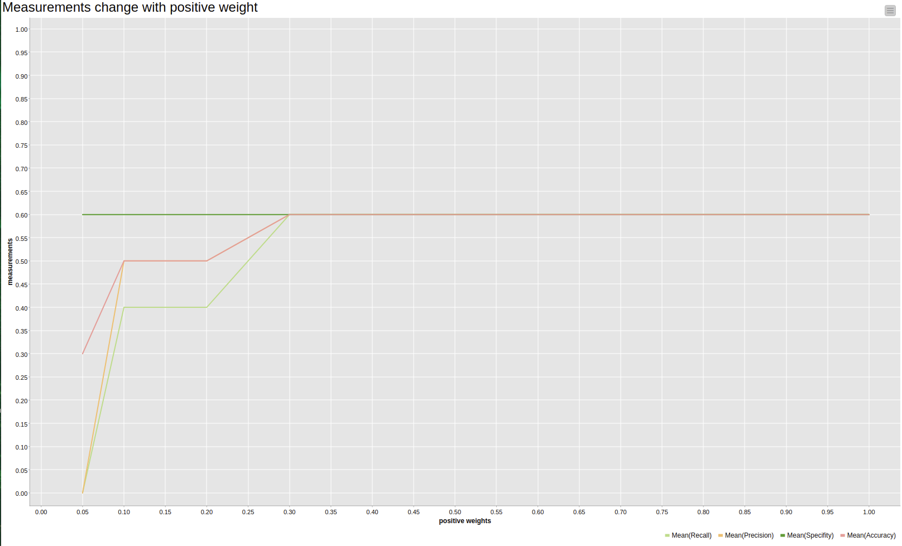
Positive goes up, the other goes up, except the specificity stays same.
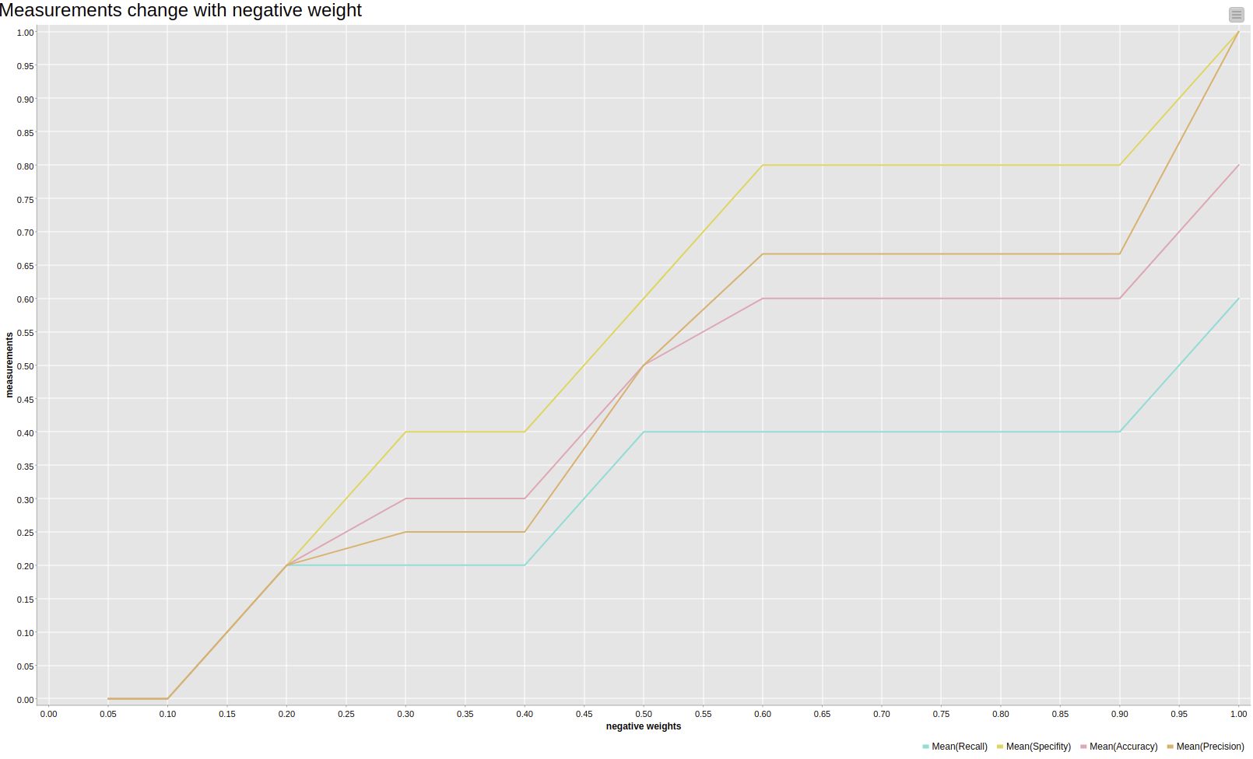

With the negative weights goes, it grows up all the measurements.
Reason: negetive weights more, then Precision and accuracy: the true positive got support and blocked from the model.
Tp up, FP down, TN up, FN down.
Observation:
the figures show that with the weights of negative increases, the model becomes more power to address the accuracy. The effect at existing model varies so much, is because of the model generated by weighted data. It depends on the deviations of model and actual data. If they deviate a lot, then no need to keep the existing model;; Else, there is some ideas to keep the model.
1.2 change parallel to sequence with overlapped labels.
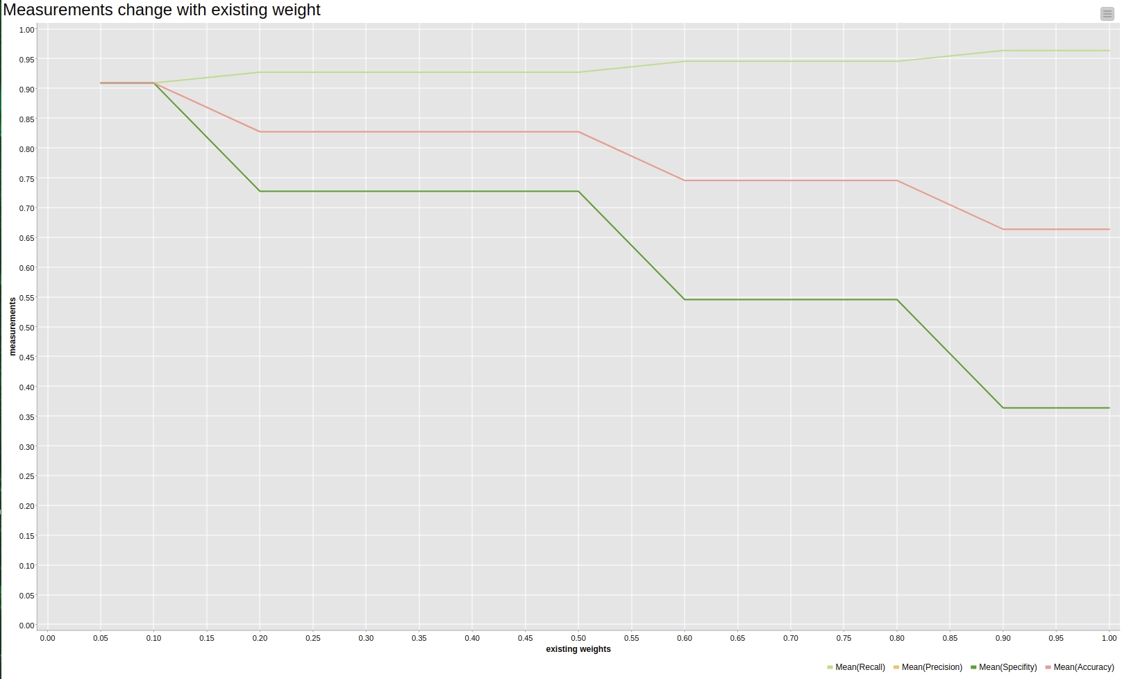
Recall goes a bit up slowly, while accuracy and precision overlap and go down. The same wityh specificity.
TP up, FP up, TN down, FN down
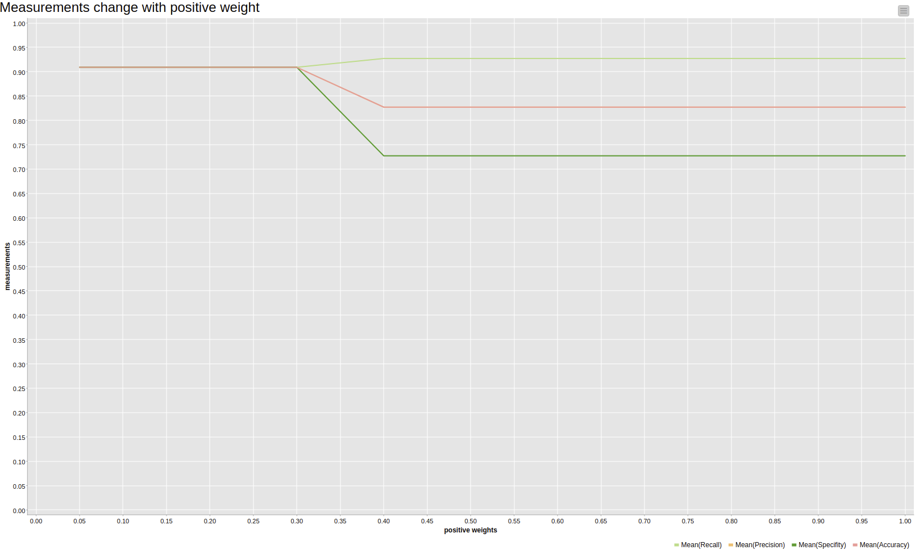
Recall goes a bit up slowly, while accuracy and precision overlap and go down. The same wityh specificity.
TP up, FP up, TN down, FN down

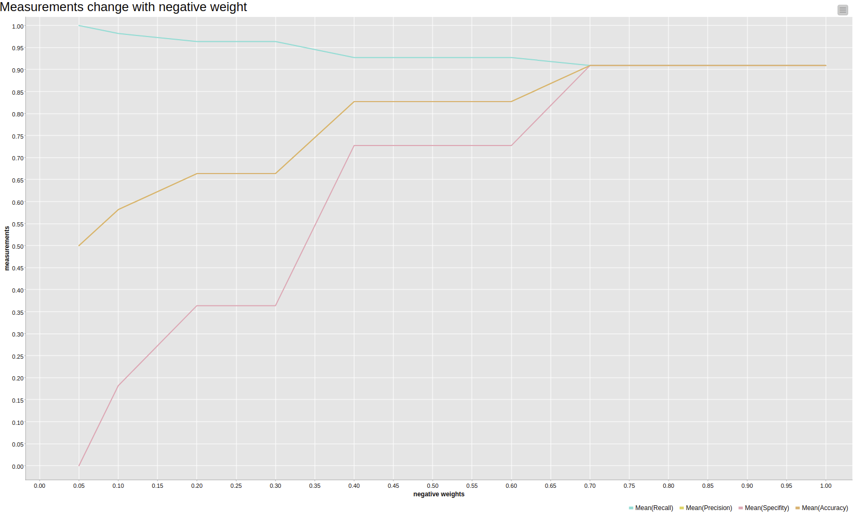
Accuracy and precision overlaps, the other goes up, recall and specificity.
TP down, Fp down, TN up, FN up.

1.3 delete loop
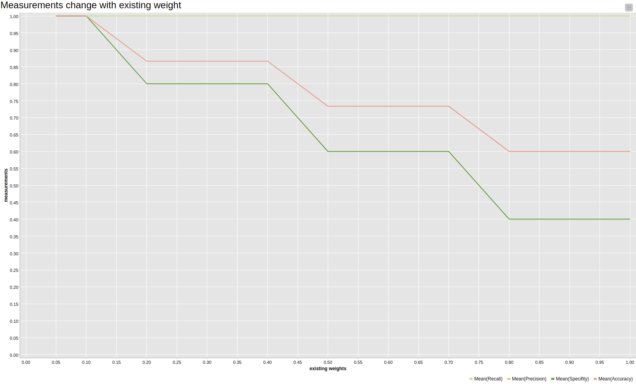
Accuracy and precision overlaps and go up. Recall keep stable.
TP same, Fp down, TN up, FN 0.
Why false negative 0?? The model not change any positive choices, so it adjust the effect to avoid the negative isntances. Because TN up.

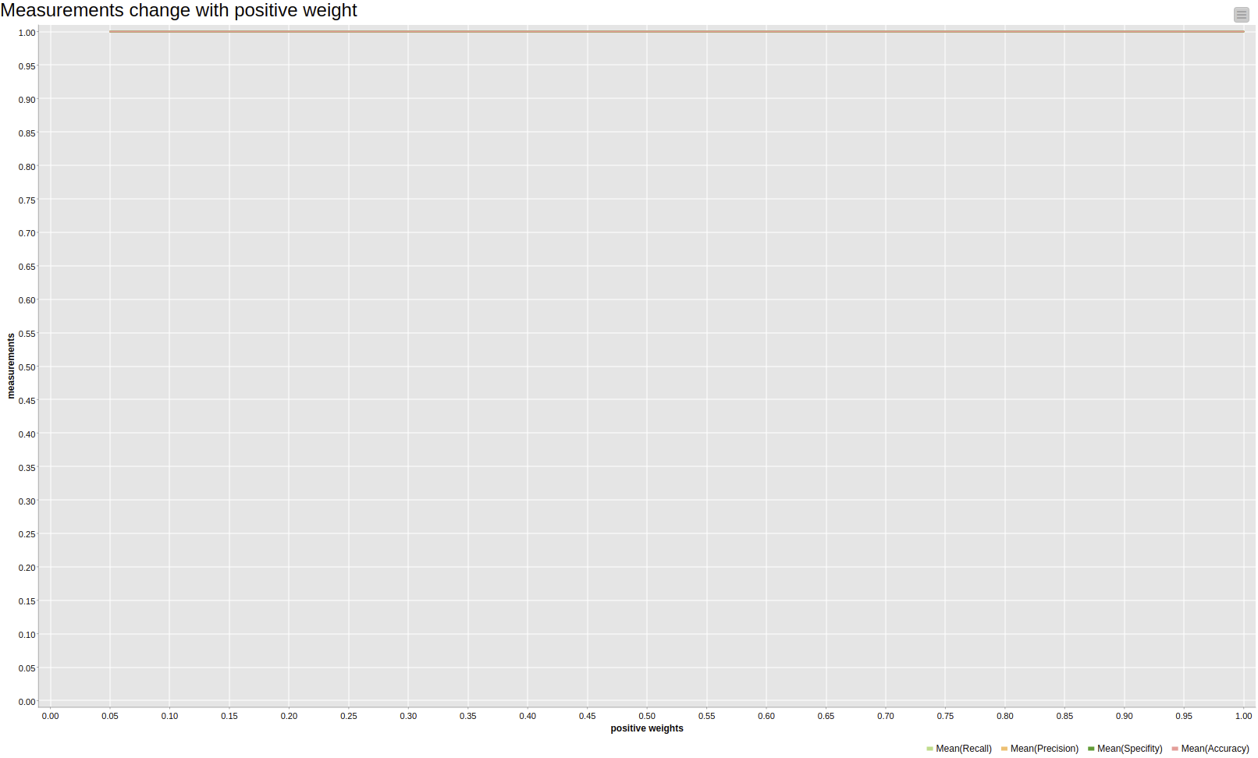
All keep 1.0. Because the TN and TN keeps same, other 0.

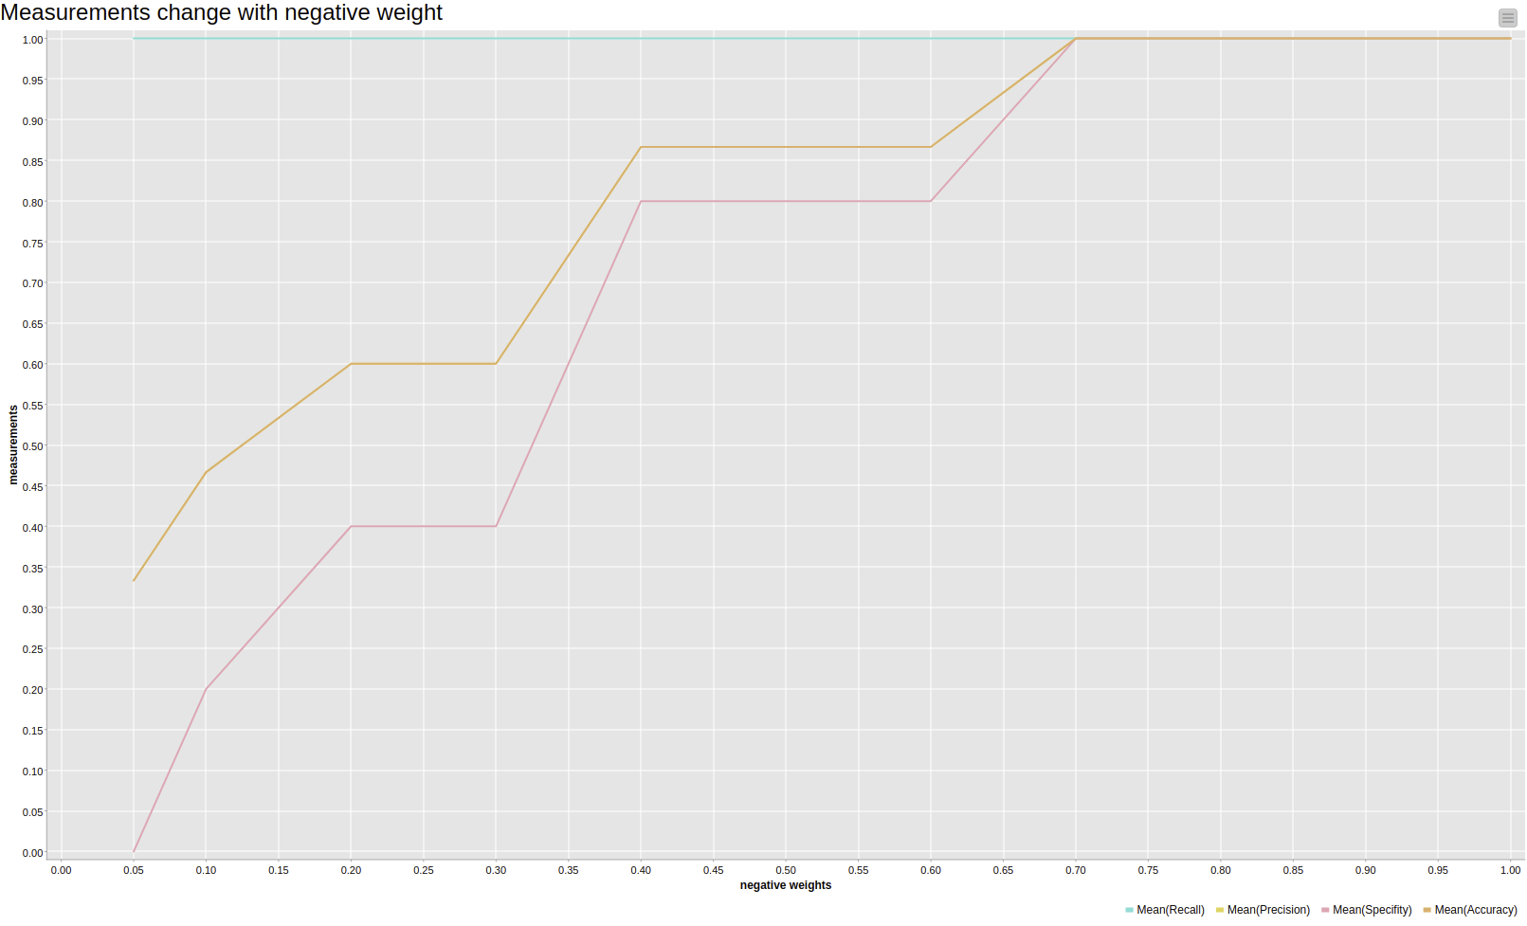
Accuracy and precision overlaps and go up. Recall keep stable.
TP same, Fp down, TN up, FN 0.
Why false negative 0?? The model not change any positive choices, so it adjust the effect to avoid the negative isntances. Because TN up.

On Synthetic Data

On real life data

