Simple experiments records 2 – result figures

XOR
Existing Model:
M1
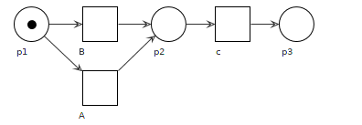
Case 1.1 add events in XOR
- IM:: Fig 1.1_1
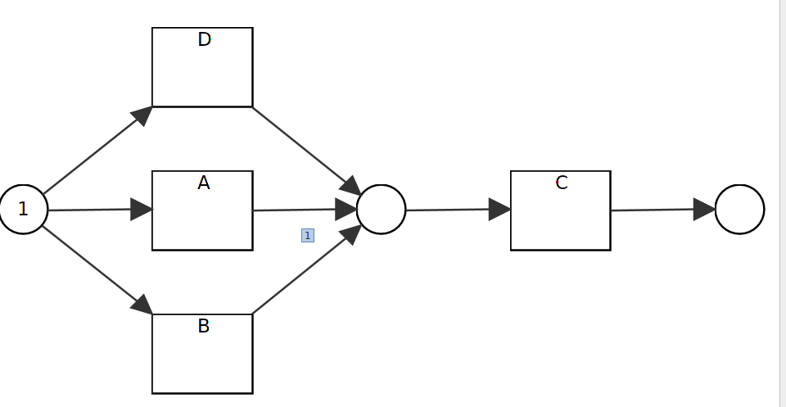
- RM:: Fig 1.1_2
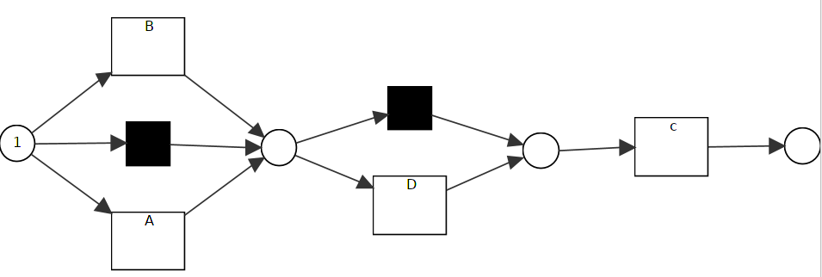
- Dfg: Fig 1.1_1

Case 1.2 delete events from XOR
- IM Fig 1.2_1
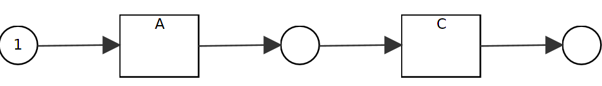
- RM Fig 1.2_1

- Dfg Fig 1.2_1

Case 1.3 change XOR to sequence
- IM Fig 1.3_1
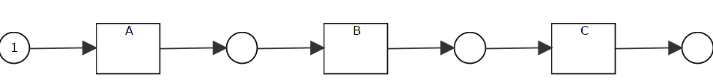
- RM Fig 1.3_2
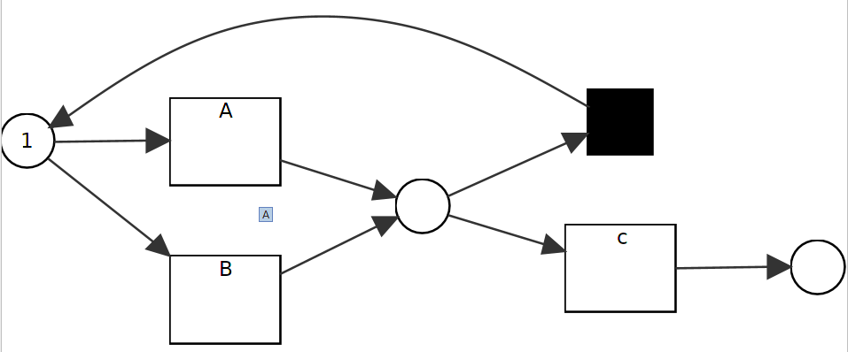
- Dfg Fig 1.3_1

Case 1.4
- IM Fig 1.4_1
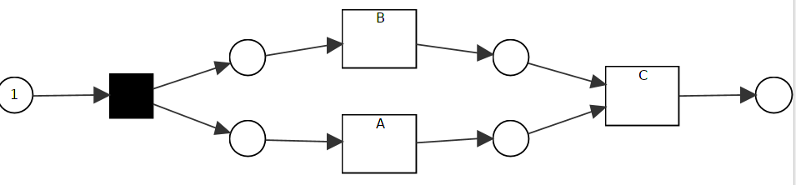
- RM same as Fig 1.3_2

- Dfg Fig 1.4_3
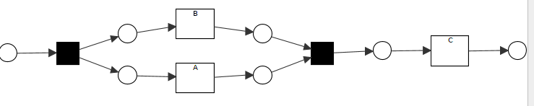
Case 1.5 add events on xor branch
- IM Fig 1.5_1
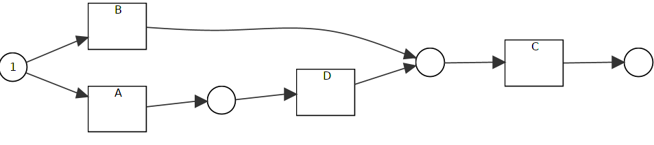
- RM Fig 1.5_2
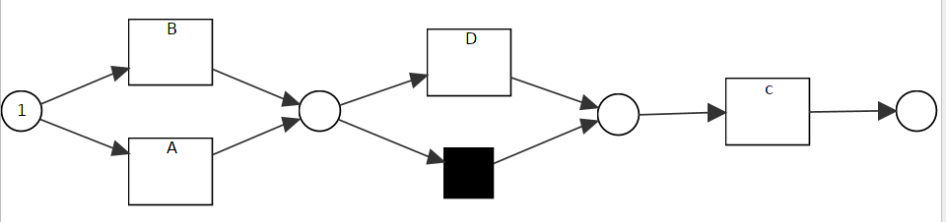

- Dfg Fig 1.5_1

Case 1.6 add while deleting events
- IM Fig 1.6_1
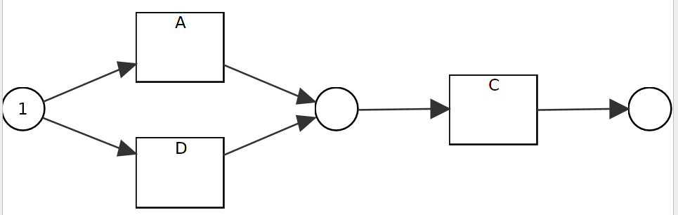
- RM Fig 1.6_2
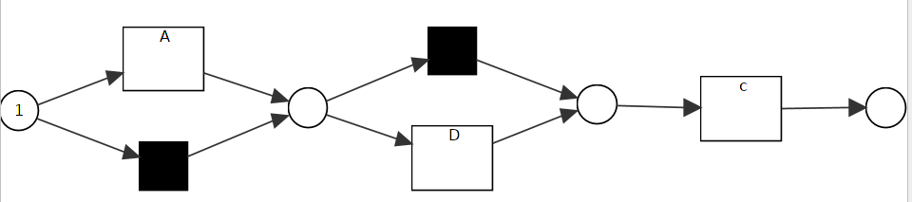
- Dfg Fig 1.6_1

Sequence M2
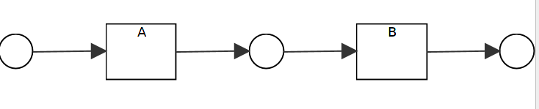
Case 2.1 delete events from sequence
- IM Fig 2.1_1
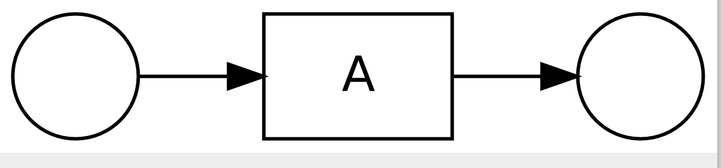
- RM Fig 2.1_2
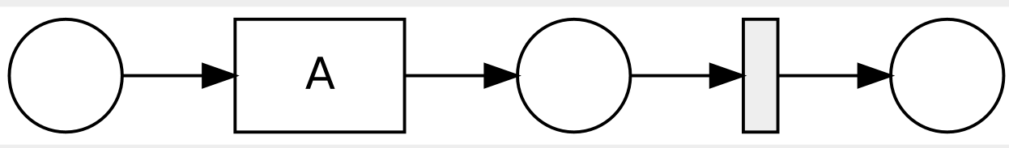
- Dfg Fig 2.1_1

Case 2.2 change sequence to xor
- IM Fig 2.2_1
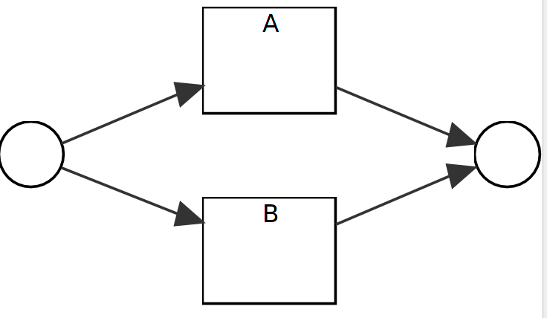
- RM Fig 2.2_2
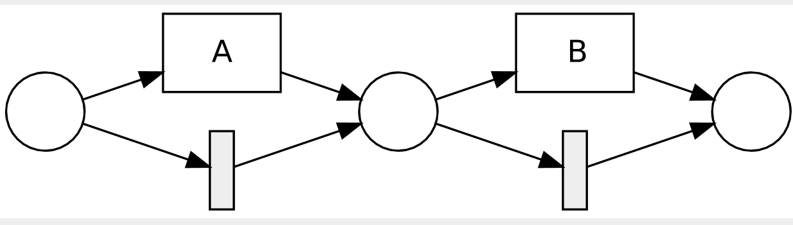
- Dfg Fig 2.2_1

Case 2.3 sequence to parallel
- IM Fig 2.3_1
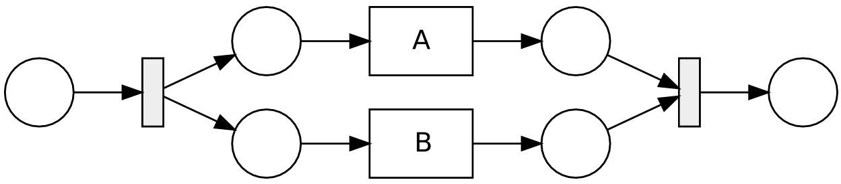
- RM Fig 2.3_2
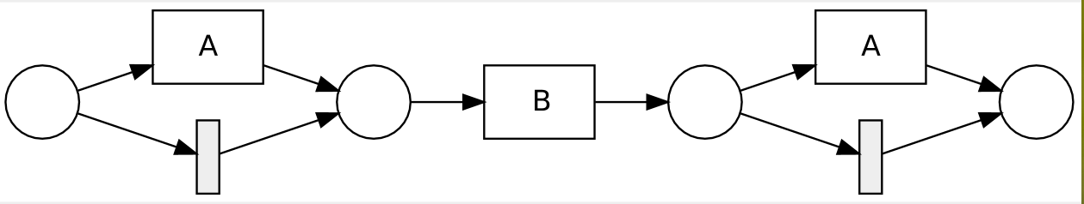
- Dfg Fig 2.3_1

Case 2.4 add single events at different positions
- IM Fig 2.4_1
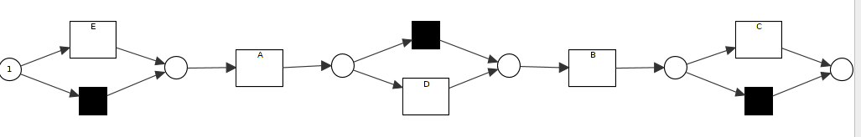
- RM Fig 2.4_1
- Dfg Fig 2.4_1
- Dfg Fig 2.4_3
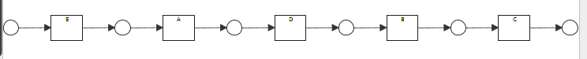
Case 2.5
- IM Fig 2.5_1
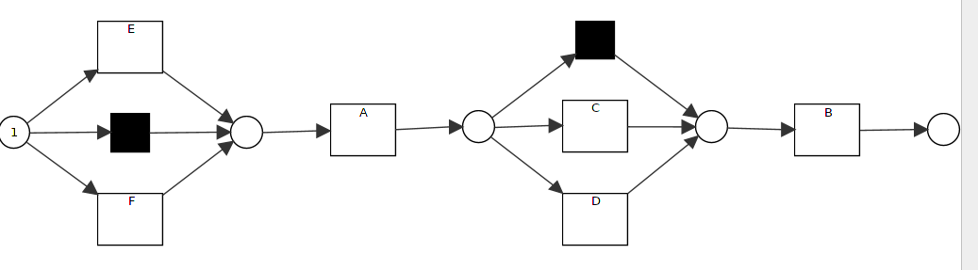
- RM Fig 2.5_2
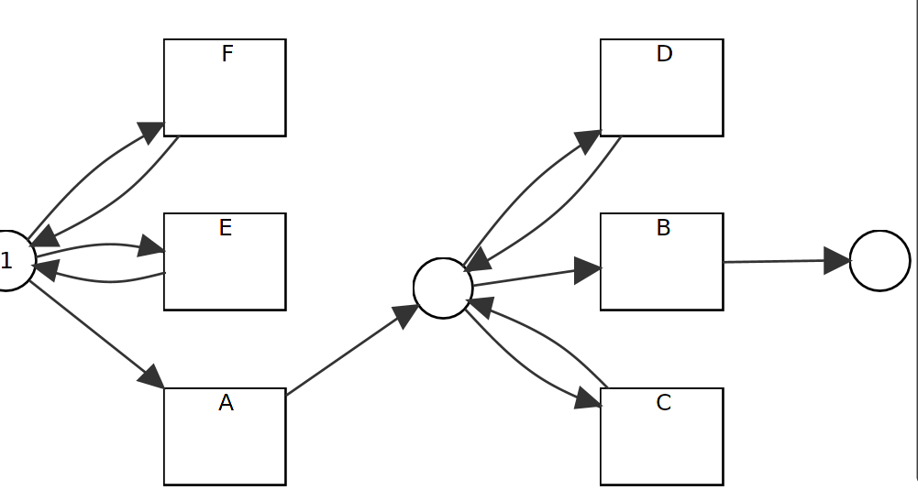
- Dfg Fig 2.5_1

Parallel M3
Case 3.1 add events to parallel relation
- IM Fig 3.1_1
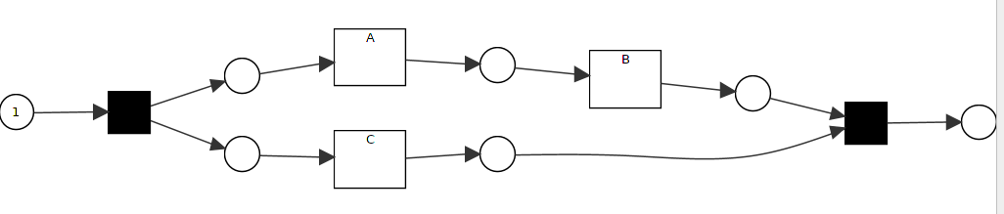
- RM Fig 3.1_2
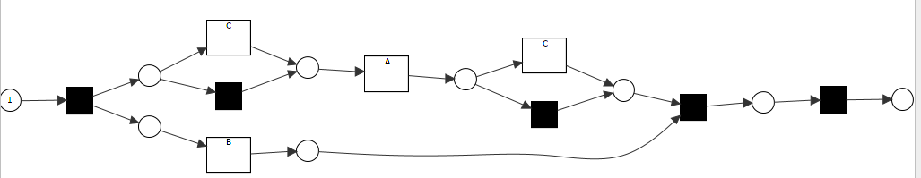
- Dfg Fig 3.1_1

Case 3.2 change parallel to sequence with overlapped labels
- IM M3
- RM M3
- Dfg M3.2_3
Case 3.3 change parallel to sequence with overlapped labels and noise
- IM M3 with filering
- RM M3.3_2
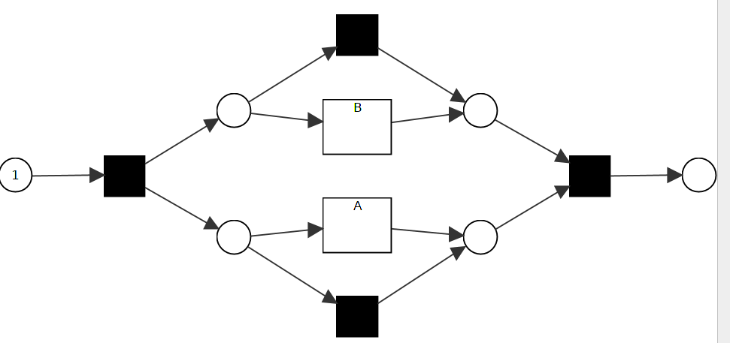
- Dfg M3.2_3

Loop M4.1
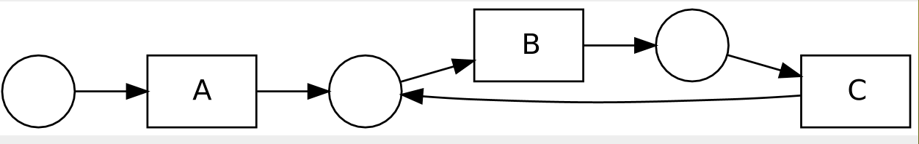
M4.2
Case 4.1 delete loop
- IM Fig 4.1_1
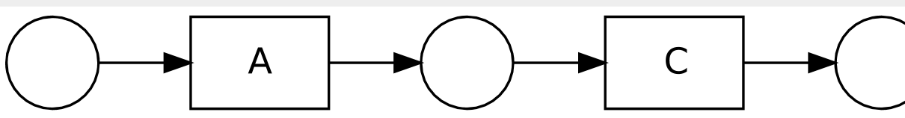
- RM Fig 4.1_1
- Dfg Fig 4.1_1

Case 4.2 add loop to sequence
- IM Fig 4.2_1
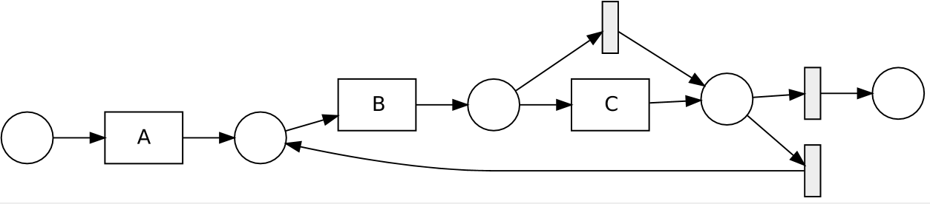
- RM Fig 4.2_2
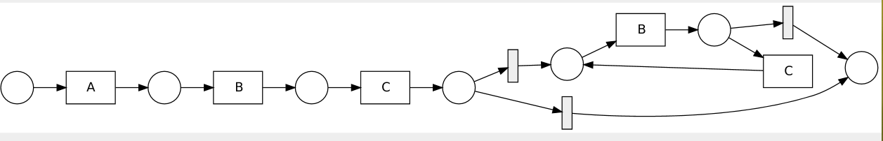
- Dfg Fig 4.2_3
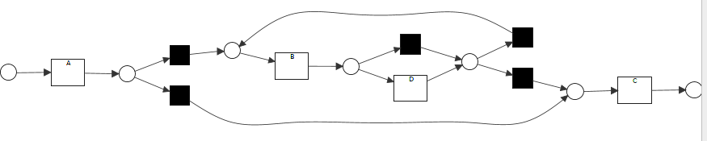
global dependency M5.1
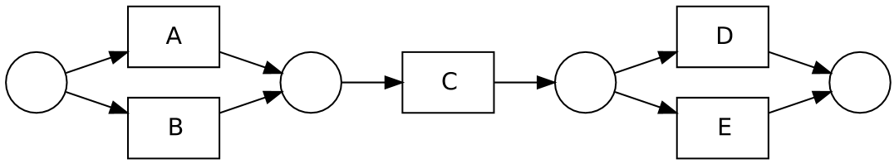

M 5.2
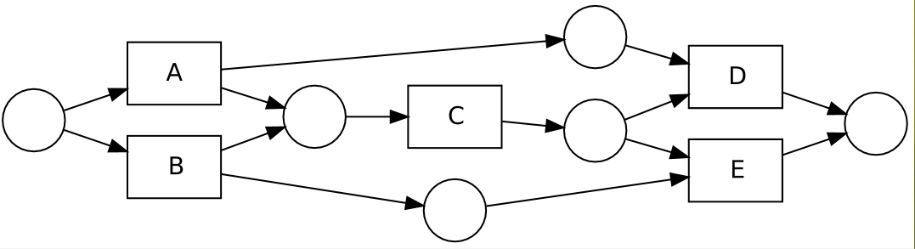
Case 5.1 add global dependency
- IM Fig M5
- RM M5
- Dfg M5

Case 5.2 delete global dependency
- IM M5
- RM Fig 5.2_2
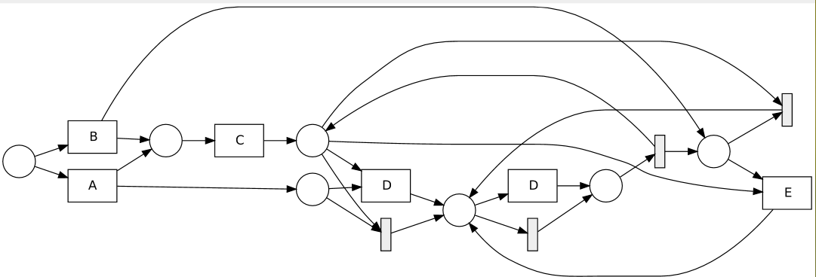
- Dfg M5

Case 6 complex models M6
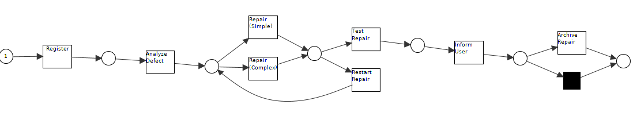
1)IM
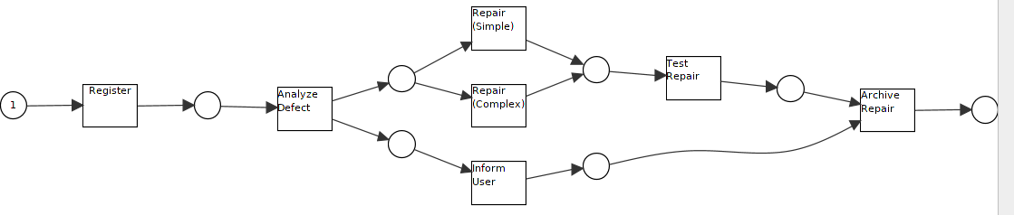
2)RM:
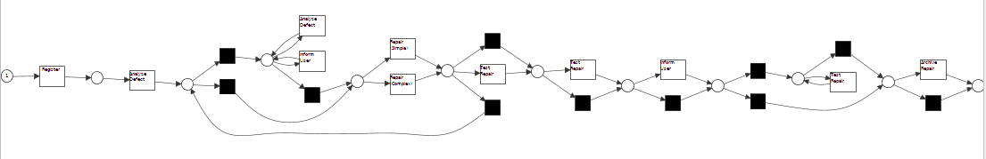
3) Dfg:
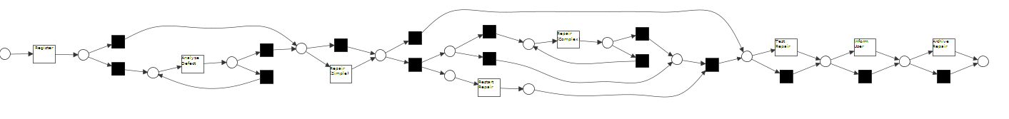

Case 7: real life test
- IM
- RM
- Dfg

Case 8: real life test
- IM
- RM
- Dfg

Case 7: real life test
- IM
- RM
- Dfg

