Simple Baseline Experiments

1. Sequence Relationship
Model Data M1:
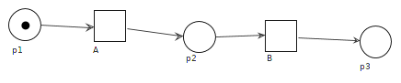

Log Data:
Data ID | File Name | Data Description
D1.1 | 01_log_sequence_01.xes | 55 <A,B>, 55<B,A>
D1.2 | 01_log_sequence_02.xes | Pos: 50 <A>, Neg: 50 <A,B> ::
D1.3 | 01_log_sequence_03.xes | //change sequence to xor  Pos: 50<A>, 50<B>, Neg: 50<A,B>, 50<B,A>::
D1.4 | 01_log_sequence_04.xes | 50<A,B>::
D1.5 | 01_log_sequence_05.xes | Pos: 55<B,A>, Neg: 55<A,B>
D1.6 | 01_log_sequence_06.xes | Pos: 50<A,B>, 5<B,A> neg:5<A,B>, 50<B,A> ::
D1.7 | 01_log_sequence_07.xes | Pos: 5 <A,B>, 50<B,A> neg:50<A,B>, 5<B,A> ::
D1.8 | 01_log_sequence_08.xes | // add events at different positions  pos: 50 <A,B,C> , 50 <A,D,B>, 50<E,A,B> neg: 50 <A,B>
D1.9 | 01_log_sequence_09.xes | // add events but meanwhile delete one event  pos: 50 <A,C> neg: 50 <A,B>
D1.10 | 01_log_sequence_10.xes | // add multiple events at different positions  pos: 50 <A,B,C> , 50 <A,B,D>, 50<E,A,B> neg: 50 <A,B>
D1.11 | 01_log_sequence_11.xes | // add different number events at different positions  pos: 50 <A,C,B> , 50 <A,D,B>, 50<E,A,B> 50 <F,A,B>neg: 50 <A,B>

Simple Experiment:
ID | Model ID | Data ID | Method | Result | Conclusion
1.1 | M1 | D1.2 | Inductive Miner with positive labels | R1.1
1.2 | M1 | D1.2 | Repair model with positive labels;; same as with pos complement | R1.2
1.3 | M1 | D1.3 | Inductive Miner with positive labels | R1.3
1.4 | M1 | D1.3 | Repair model with positive labels;; same as with pos complement | R1.4
1.5 | M1 | D1.5 | Inductive Miner with positive labels | R1.5
1.6 | M1 | D1.5 | Repair model with positive labels;; same as with pos complement | R1.6
1.7 | M1 | D1.6/  D1.7 /  D1.1 | Inductive Miner with positive labels | R1.7
1.8 | M1 | D1.6 /  D1.7 /  D1.1 | Repair model with positive labels; | R1.8
1.9 | M1 | D1.6  / D1.7 | Repair model with positive complement labels; | Null, since complement empty | Methods can’t see the data distribution changes and still generate same models.
1.10 | M1 | D1.8 | Inductive Miner with positive labels | R1.10
1.11 | M1 | D1.8 | Repair model with positive labels;; same as with pos complement | R1.11
1.12 | M1 | D1.9 | Inductive Miner with positive labels | R1.12
1.13 | M1 | D1.9 | Repair model with positive labels;; same as with pos complement | R1.13
1.14 | M1 | D1.10 | Inductive Miner with positive labels | R1.14
1.15 | M1 | D1.10 | Repair model with positive labels;; same as with pos complement | R1.15
1.16 | M1 | D1.11 | Inductive Miner with positive labels | R1.16
1.17 | M1 | D1.11 | Repair model with positive labels;; same as with pos complement | R1.17

R1.1
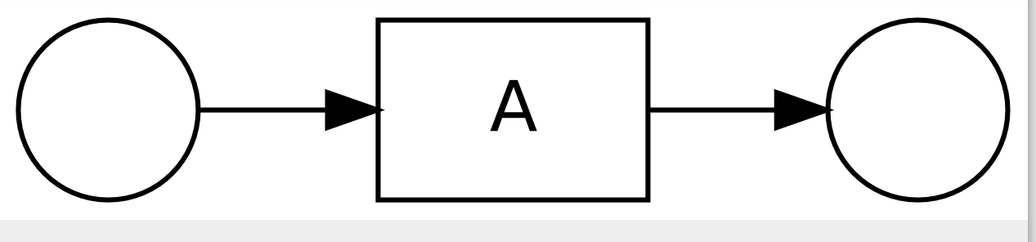
R1.2
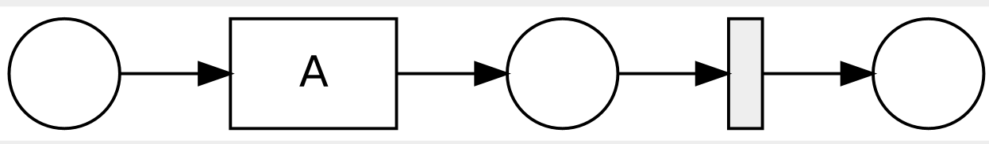
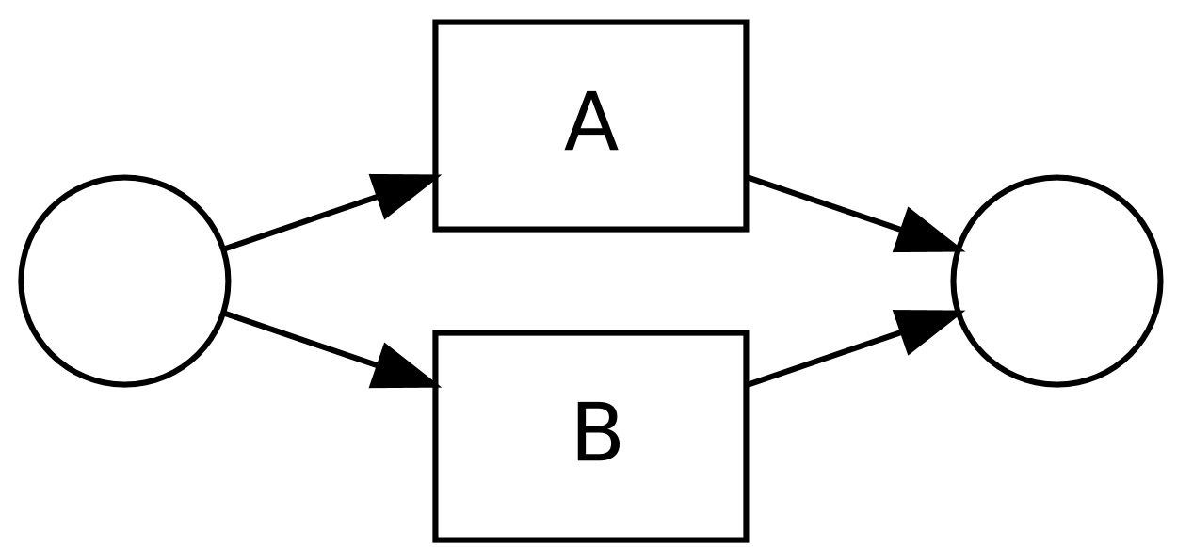
R1.3

R1.4
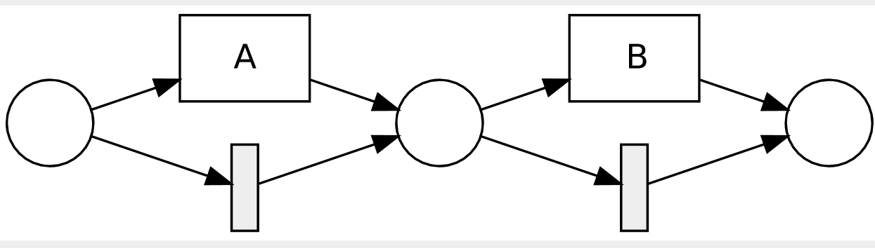
R1.5
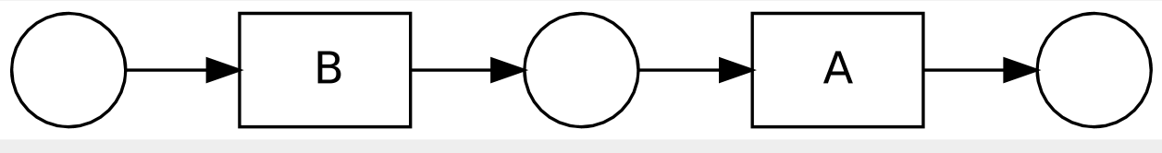
R1.6
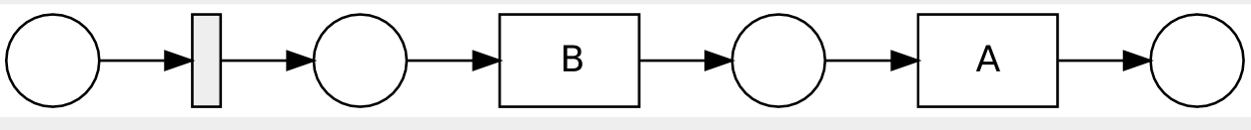
R1.7
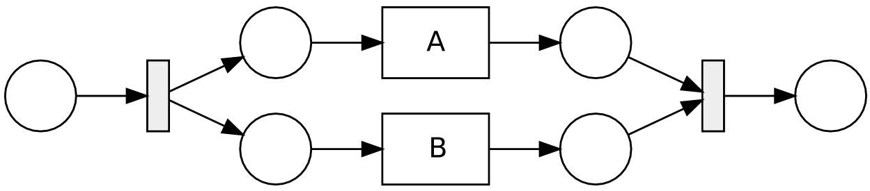
R1.8
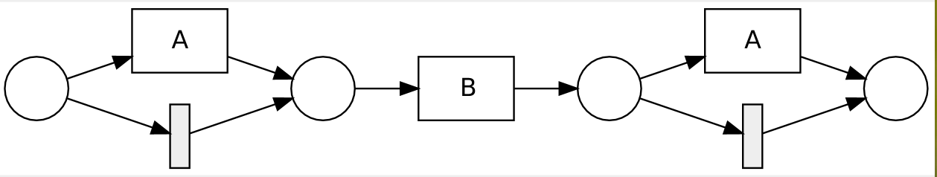
R1.10, R1.11
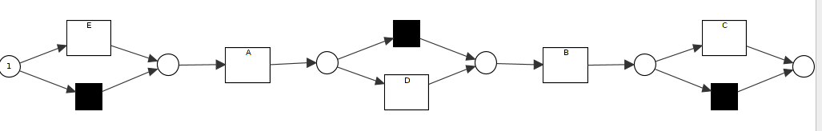

R1.12
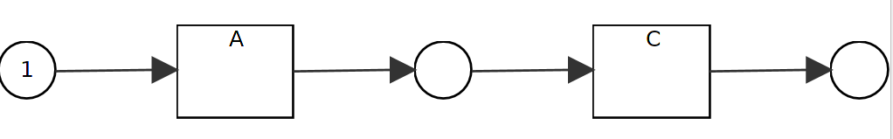
R1.13
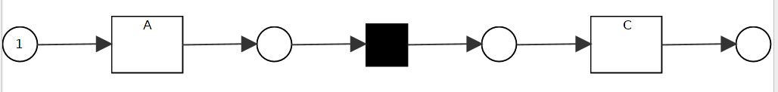
R1.15
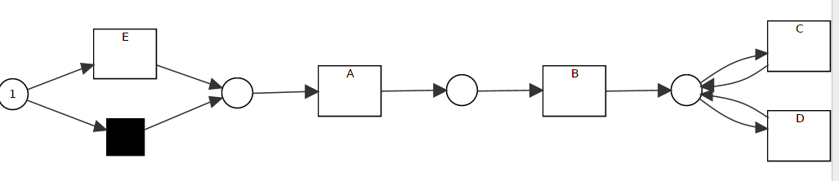
R1.16
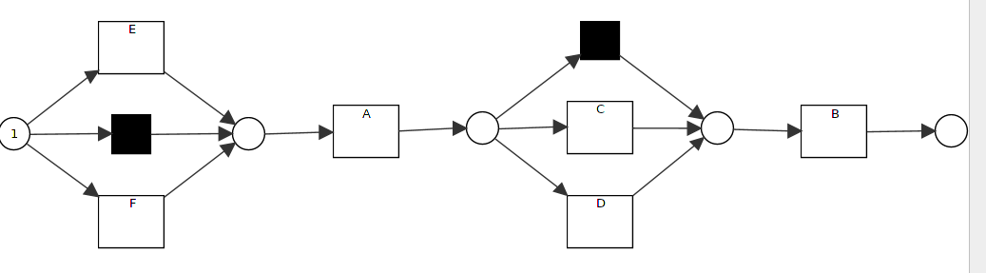
R1.17
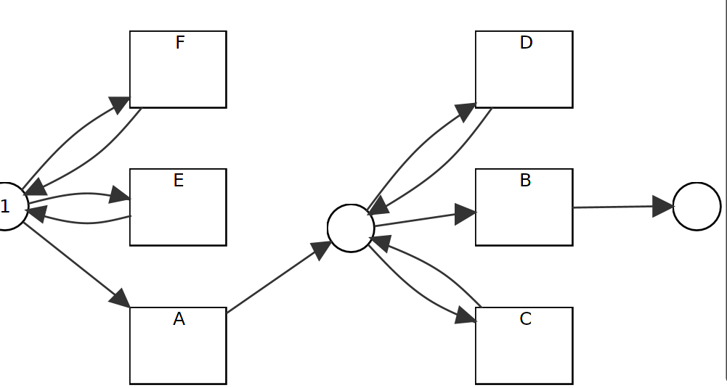

2. Parallel Relationship
Model Data M2:
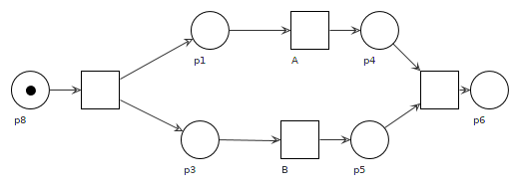
Log Data:
Data ID | File Name | Data Description
D2.1 | 02_log_parallelism_01.xes | Pos: 50<A>, Neg: 50 <B>
D2.2 | 02_log_parallelism_02.xes | Pos: 50 <A>, 50<B>, Neg: 50 <A,B> , 50 <B,A>::
D2.3 | 02_log_parallelism_03.xes | Pos: 50<A ,B >, Neg: 50<B, A>::
D2.4 | 02_log_parallelism_04.xes | Pos: 50 <A>, 50<B>, 50 <A,B>, Neg: 50<B,A> ::
D2.5 | 02_log_parallelism_05.xes | Pos: 50 <A>, 50<B>, 50 <A,B>, 50 <B,A> ::
D2.6 | 02_log_parallelism_06.xes | Pos: 50<A,B>, 5<B,A> neg: 5<A,B>, 50<B,A> ::
D2.7 | 02_log_parallelism_00.xes | 50 <A>, 50<B>, 50 <A,B> , 50 <B,A> , no labels
D2.8 | 02_log_parallelism_08.xes | // add one events for parallel relationship  Pos: 50 <A, B, C>, 50<A, C, B>, 50 <C, A,B> neg: 50<A,B>, 50 <B,A>::
D2.9 | 02_log_parallelism_09.xes | // add events for parallel relationship but at different position..  Pos: 50 <A, B, C>, 50 <D,A,B> 50 <A,E,B>, 50<B,A,C>, 50<D,B,A> 50<B,E,A> neg: 50<A,B>, 50 <A,C>::
D2.10 | 02_log_parallelism_10.xes | // add more events for parallel relationship but at different position..D and E should be in sequence, but C is parallel  Pos: 50 <A, B, C>, 50<B,A,C>,50 <D,A,C, B> 50 <C,A,B, E> neg: 50<A,B>, 50 <B,A>::
D2.11 | 02_log_parallelism_11.xes | // add events while deleting events  Pos: 50<A,C>, 50<C,A> neg: 50<A,B,C>, 50<A,B> ::
D2.12 | 02_log_parallelism_12.xes | // add events for parallel relationship but at different position..  Pos: 50 <A, B, C>, 50 <D,A,B> 50<A,E,B>,neg: 50<A,B>, 50 <A,C>::
D2.12 | 02_log_parallelism_13.xes | // change parallel to sequence with noise  Pos: 50 <A, B>, 5<B,A>, 1<A> , 2<B>neg: 5<A,B>, 50<B,A>

Simple Experiment:
ID | Model ID | Data ID | Method | Result | Conclusion
2.1 | M2 | D2.1 | Inductive Miner with positive labels | R1.1
2.2 | M2 | D2.1 | Repair model with positive labels;; same as with pos complement | R2.2
2.3 | M2 | D2.2 | Inductive Miner with positive labels | R1.3
2.4 | M2 | D2.2 | Repair model with positive labels;; same as with pos complement | R2.4
2.5 | M2 | D2.3 | Inductive Miner with positive labels | R2.5
2.6 | M2 | D2.3 | Repair model with positive labels;; same as with pos complement | M2 | Not change
2.7 | M2 | D2.4 | Inductive Miner with positive labels | R1.4
2.8 | M2 | D2.4 | Repair model with positive labels; | R2.4
2.9 | M2 | D2.5 | Inductive Miner with positive labels | R2.4
2.10 | M2 | D2.5 | Repair model with positive labels; | R2.4
2.11 | M2 | D2.6 | Inductive Miner with positive labels | M2 | Not change
2.12 | M2 | D2.6 | Repair model with positive labels; | M2 | Not change
2.13 | M2 | D2.8 | Inductive Miner with positive labels | R2.13 | // for parallel relationship, IM needs more cases;
2.14 | M2 | D2.8 | Repair model with positive labels; | R2.14 | // for repair model, it uses less, but as opposite, no..  My points are, by using existing model, we could see more relationship of it, or just because of our hope, so we think it’s not good enough??
2.15 | M2 | D2.9 | Inductive Miner with positive labels | R2.15
2.16 | M2 | D2.9 | Repair model with positive labels; | R2.16
2.17 | M2 | D2.12 | Inductive Miner with positive labels | R2.17 | // NOT see the parallel relationship
2.18 | M2 | D2.12 | Repair model with positive labels; | R2.18
2.19 | M2 | D2.11 | Inductive Miner with positive labels | R2.19
2.20 | M2 | D2.11 | Repair model with positive labels; | R.2.20
2.21 | M2 | D2.10 | Inductive Miner with positive labels | R2.21
2.22 | M2 | D2.10 | Repair model with positive labels; | R2.22
2.23 | M2 | D2.13 | Inductive Miner with positive labels | M2 | can’t remove the 5<B,A>
2.24 | M2 | D2.13 | Repair model with positive labels; | R2.4 | Consider all traces

R2.2
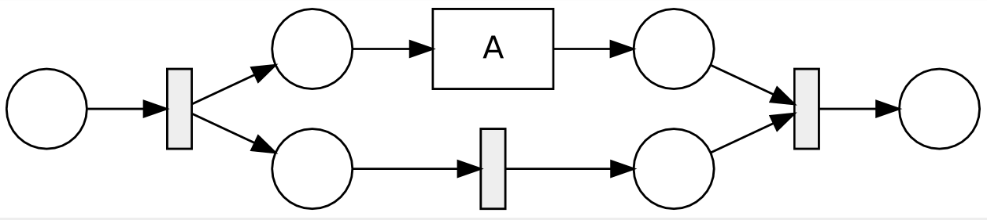
R2.4
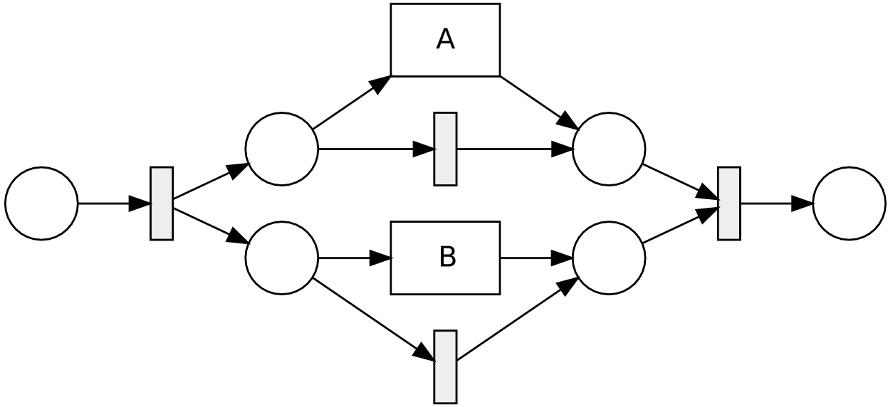
R 2.5
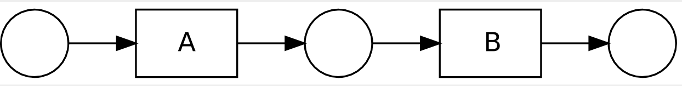
R2.13
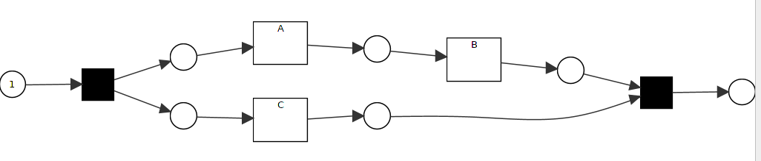
R2.14
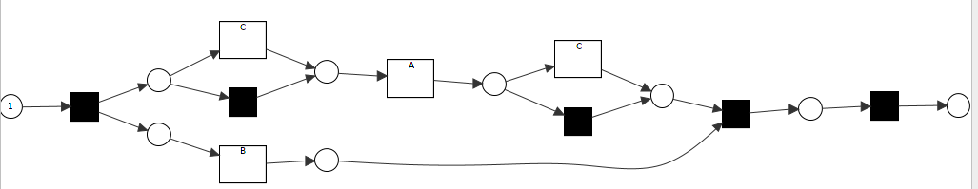
// not really what I expect. I thought , it just add it directly into this relationship… but we don’t know.. Whatever, it shouldn’t change it too much.
R2.15
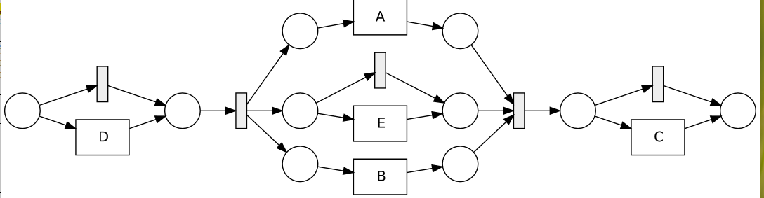
R2.16
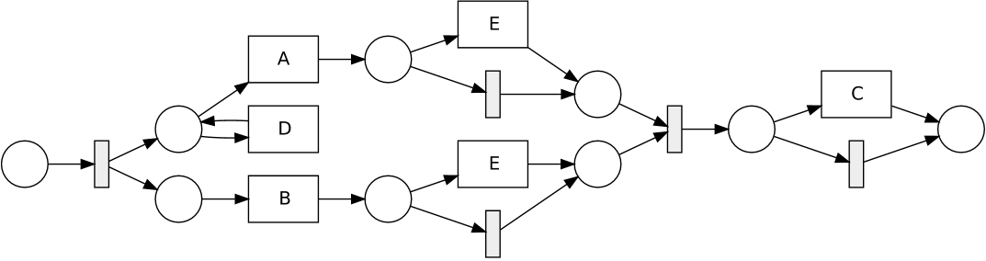
R2.17
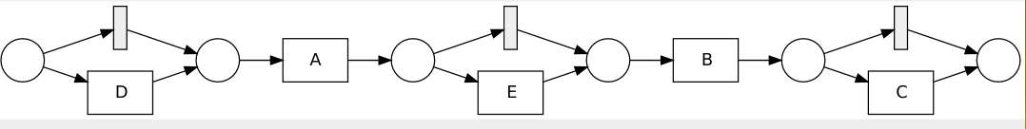
R2.18
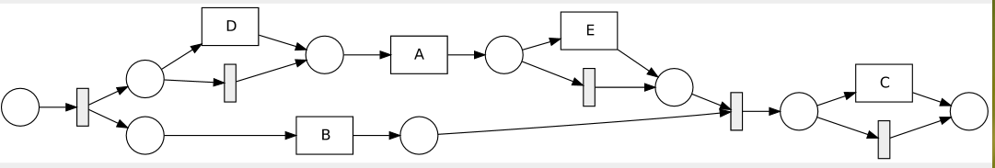
R2.19
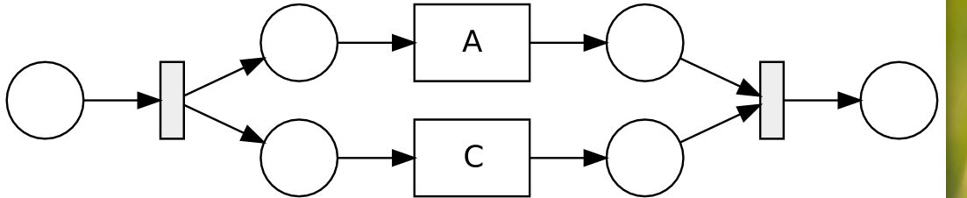
R2.20
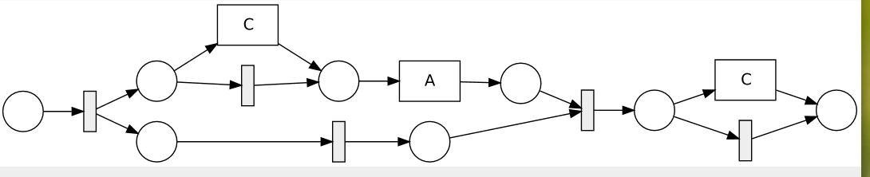
R2.21
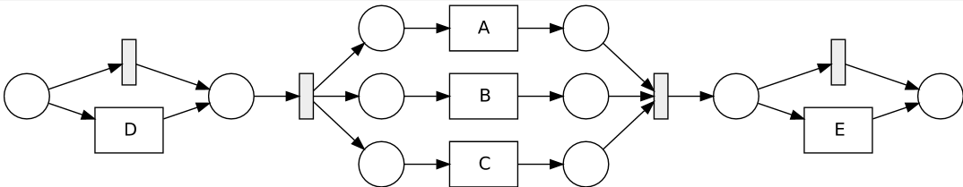
R2.22
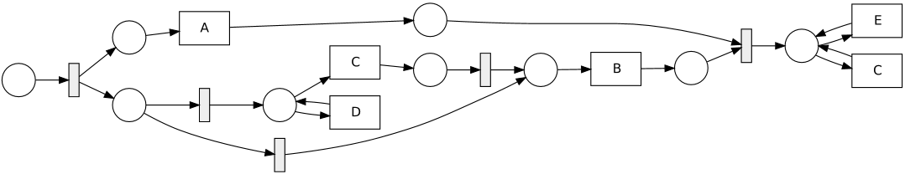

3. Loop Relationship
Model Data M3.1 : with loop or add loop??
with loop to add new behavior
M3.2
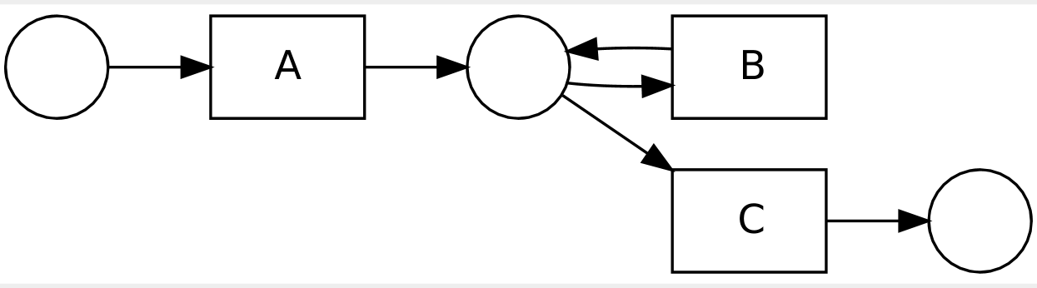
M3.3
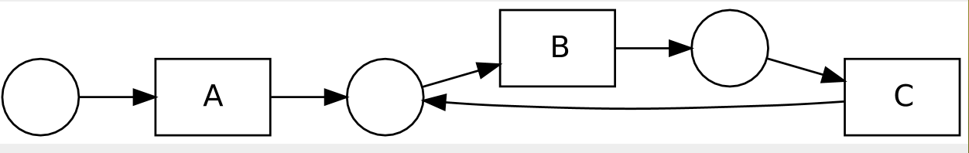
– new events in the loop
– delete events in the loop
– modify loops, like increase loop length
– unfold loop

Log Data:
Data ID | File Name | Data Description
D3.1 | 03_log_loop_01.xes | Pos: 50<A,C> 50 <A,B,C>, 50<A,B,B,C>, 50<A,B,B,B,C>
D3.2 | 03_log_loop_02.xes | Pos: 50 <A, B,C>, 50<A,B,C,B>, 50 <A,B,C,B,C,B>
D3.3 | 03_log_loop_03.xes | // here we make another restriction to make duplicate events;; not over 3 B, only two B  Pos: 50<A,C> 50 <A,B,C>, 50<A,B,B,C>,  Neg: 50<A,B,B,B,C>
D3.4 | 03_log_loop_04.xes | // to erase loop  pos: 50<A,B,C> neg: 50<A, B, B, C>::
D3.5 | 03_log_loop_05.xes | Pos: 50 <A,C>, 50 <A,B,D C>, 50<A,B,D,B,D,C> ::  //check if add sequence events in the loop.  // else add parallel events in the loop??
D3.6 | 03_log_loop_06.xes | Pos: 50 <A,C>, 50 <A,B,D C>, 50<A,B,D,B,D,C>, 50 <A,D,B,C>, 50<A,D,B,D,B,C> ::
D3.7 | 03_log_loop_07.xes | // Delete loop  Pos: 50<A> Neg: 50<A,B,C> , 50<A,B,B,C>
D3.8 | 03_log_loop_08.xes | // deleting events from loop  pos: 50<A,B>, 50 <A,B,B>, 50 <A,B,B,B> neg: 50<A,B,C>, 50<A,B,C,B,C>
D3.9 | 03_log_loop_09.xes | // deleting events from loop w.r.t. order  pos: 50<A,C>, 50 <A,C,C>, 50 <A,C,C,C> neg: 50<A,B,C>, 50<A,B,C,B,C>
D3.10 | 03_log_loop_10.xes | // modifying events order in the loop  pos: 50 <A,C,B>, 50 <A,C,B,C,B>  neg: 50 <A,B,C> 50<A,B,C,B,C>

Simple Experiment:
ID | Model ID | Data ID | Method | Result | Conclusion
3.1 | M3.1 | D2.1 | Inductive Miner with positive labels | R3.1
3.2 | M3.1 | D2.1 | Repair model with positive labels;; same as with pos complement | R3.2
3.3 | M3.1 | D2.2 | Inductive Miner with positive labels | R3.3
3.4 | M3.1 | D2.2 | Repair model with positive labels;; same as with pos complement | R3.4
3.5 | M3.2 | D3.3 | Inductive Miner with positive labels | R3.1 | couldn’t see the duplicate events, only consider it as a loop!!!
3.6 | M3.2 | D3.3 | Repair model with positive labels;; same as with pos complement | R3.2 | couldn’t see the duplicate events, only consider it as a loop!!!
3.7 | M3.2 | D3.4 | Inductive Miner with positive labels | M3.1
3.8 | M3.2 | D3.4 | Repair model with positive labels; | M3.2 | Model no change, stays the same
3.9 | M3.3 | D3.7 | Inductive Miner with positive labels | R3.9
3.10 | M3.3 | D3.7 | Repair model with positive labels; | R3.9 | Quite surprised..
3.11 | M3.3 | D3.5 | Inductive Miner with positive labels | R3.11
3.12 | M3.3 | D3.5 | Repair model with positive labels; | R.3.12
3.13 | M3.3 | D3.6 | Inductive Miner with positive labels | R3.13
3.14 | M3.3 | D3.6 | Repair model with positive labels; | R 3.12 | Like R3.12
3.15 | M3.3 | D3.8 | Inductive Miner with positive labels | R3.15
3.16 | M3.3 | D3.8 | Repair model with positive labels; | R 3.16
3.17 | M3.3 | D3.9 | Inductive Miner with positive labels | R3.17
3.18 | M3.3 | D3.9 | Repair model with positive labels; | R 3.18
3.19 | M3.3 | D3.10 | Inductive Miner with positive labels | R3.19
3.20 | M3.3 | D3.10 | Repair model with positive labels;

R3.1
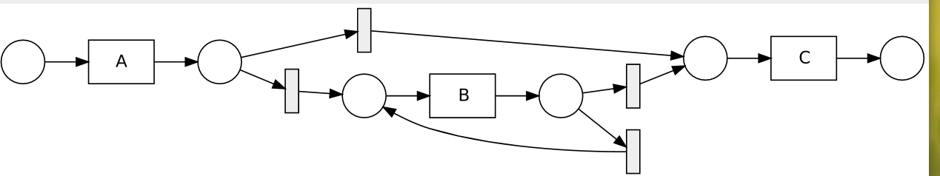
R 3.2
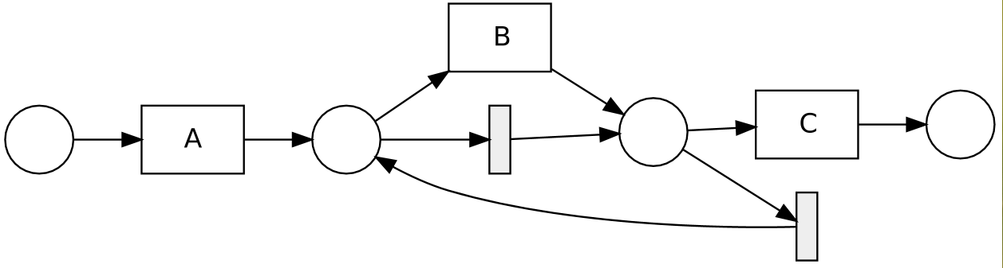
R3.3
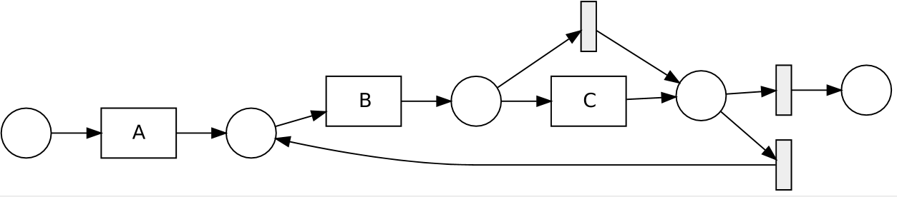
R3.4
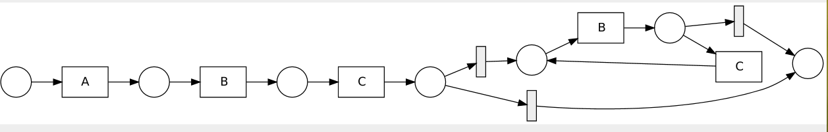
R3.9
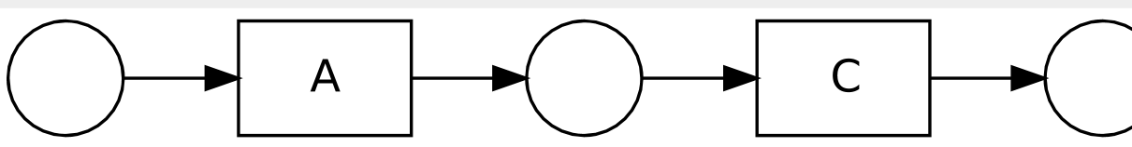
R 3.11
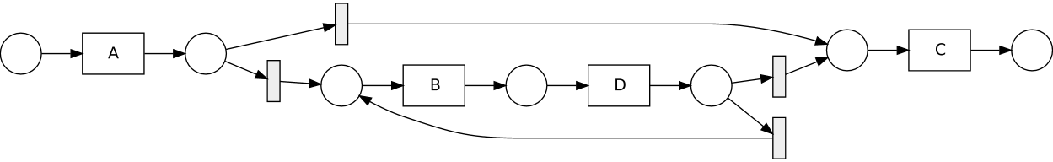
R3.12
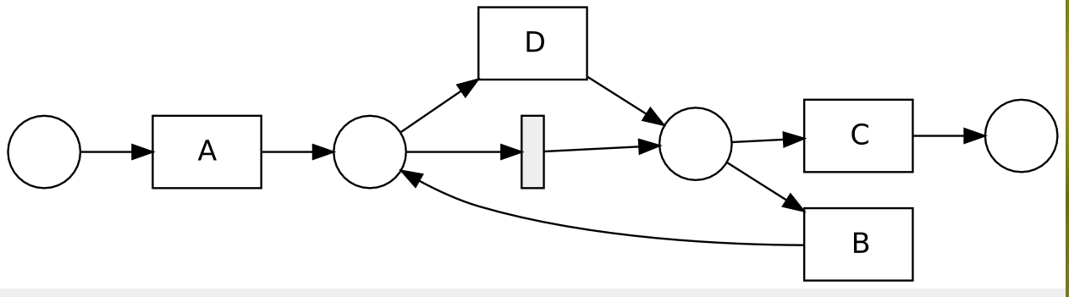

Crash!!! I need to know the confusion matrix of it, but we could get it by manual, so no worry..
R3 .13
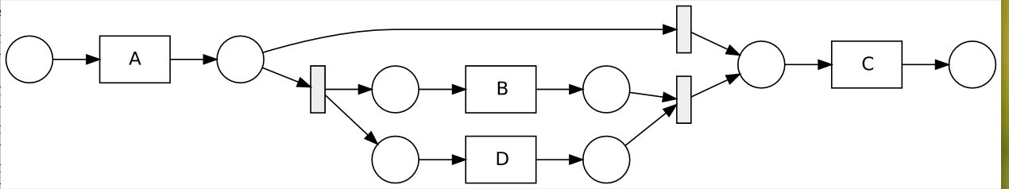
R3.15
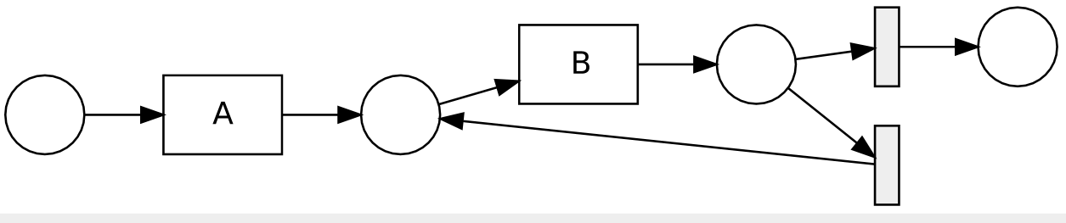
R3.16
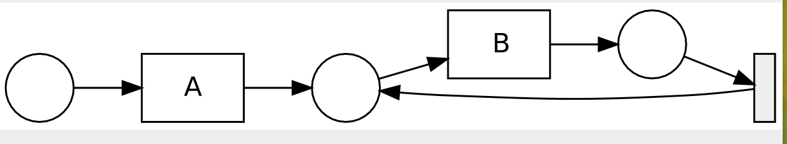
R 3.16
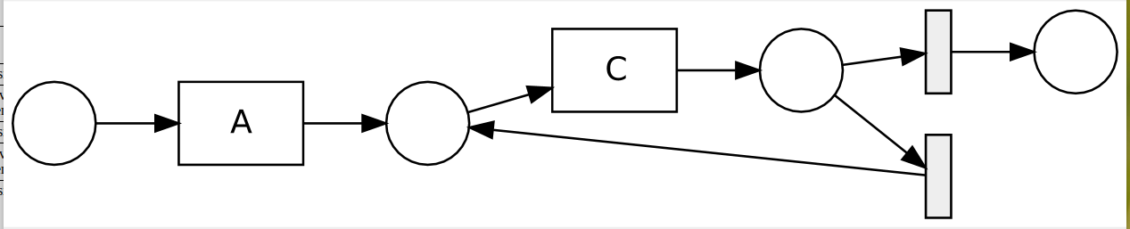
R3.17
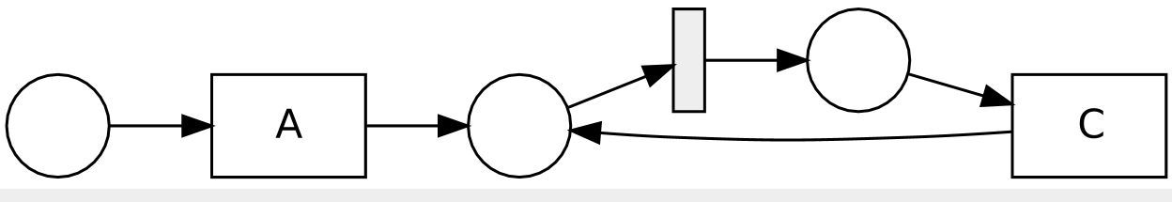
R3.19
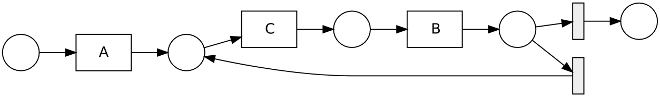
R3.20
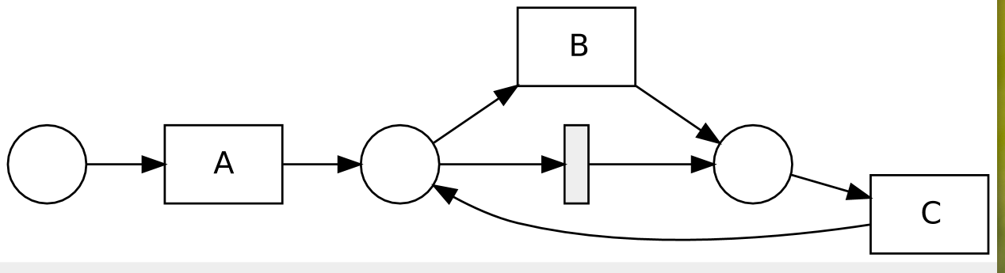

4. Global dependency
M4.1
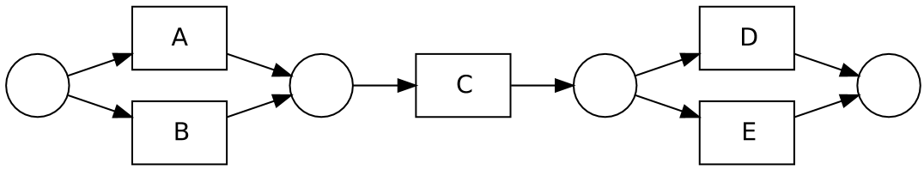
M4.2
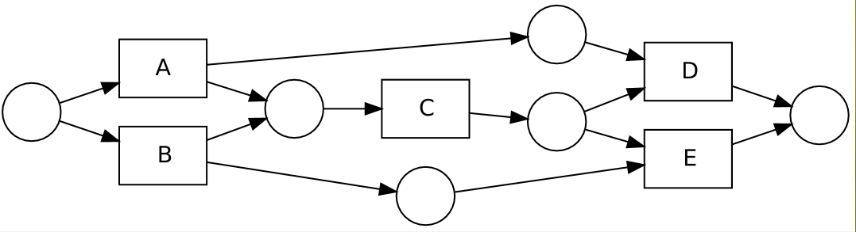

Log data:
Data ID | File Name | Data Description
D4.1 | 04_log_gdep_01.xes | // here to add global dependency to existing model  Pos: 50<A,C,D> 50 <B,C,E>,  Neg: 50<A,C,E> 50<B,C,D>
D4.2 | 04_log_gdep_02.xes | // here to delete existing global dependency  Pos: 50<A,C,D> 50 <B,C,E>, 50<A,C,E> 50<B,C,D>
D4.3 | 04_log_gdep_03.xes | // here to change the structure of global dependcy  Pos: 50<A,C,E> 50 <B,C,D>,  Neg: 50<A,C,D> 50<B,C,E>

Simple Experiment:

ID | Model ID | Data ID | Method | Result | Conclusion
4.1 | M4.1 | D4.1 | Inductive Miner with positive labels | M4.1 | couldn’t see global dependency
4.2 | M4.1 | D4.1 | Repair model with positive labels;; same as with pos complement | M4.1 | couldn’t see global dependency
4.3 | M4.1 | D4.3 | Inductive Miner with positive labels | M4.1 | couldn’t see global dependency
4.4 | M4.1 | D4.3 | Repair model with positive labels;; same as with pos complement | M4.1 | couldn’t see global dependency
4.5 | M4.2 | D4.2 | Inductive Miner with positive labels | M4.1
4.6 | M4.2 | D4.2 | Repair model with positive labels;; same as with pos complement | R4.1 | couldn’t see the duplicate events, only consider it as a loop!!!

R4.1
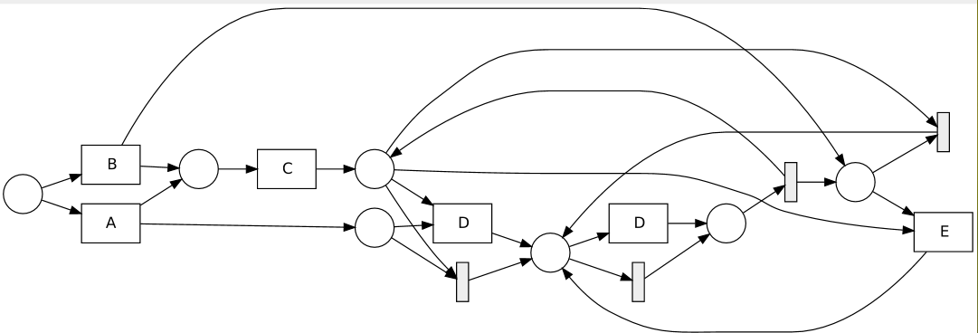
5. Exclusive Relationship
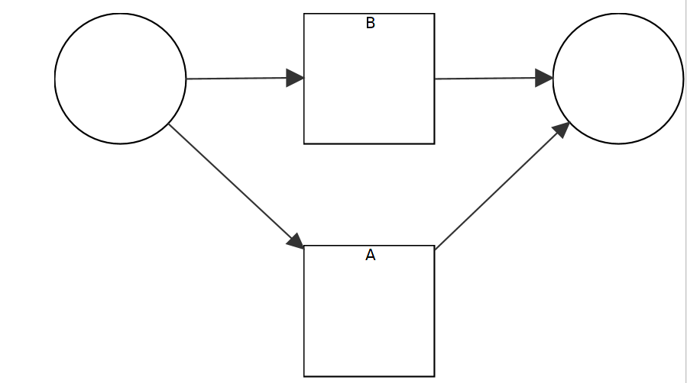
Existing Model : M5.1

M5.2
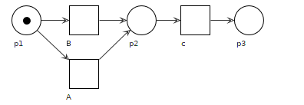
Log data:
Data ID | File Name | Data Description
D5.1 | 05_log_xor_01.xes | // add events to xor relation  pos: 50<A> 50<B>, 50<C> neg: there is no negative examples
D5.1.2 | 05_log_xor_01_02.xes | // add events to xor relation  pos: 50<A,C> 50<B,C>, 50<D,C> neg: there is no negative examples
D5.2 | 05_log_xor_02.xes | // here to add events on one branch  pos: 50<A,C> 50<B> neg: 50<A>
D5.2.2 | 05_log_xor_02_02.xes | // here to add events on one branch  pos: 50<A,D,C> 50<B,C> neg: 50<A,C>
D5.3 | 05_log_xor_03.xes | // here to delete xor relation  pos: 50<A,C> neg: 50<B,C>
D5.4 | 05_log_xor_04.xes | // here to add and delete from xor, to avoid B, if not show B, we only add more events to xor, and not delete??  pos: 50<A,C>, 50<D,C>, neg: 50<B,C>
D5.5 | 05_log_xor_05.xes | // here to change xor to sequence  pos: 50<A,B,C> neg: 50<A,C>, 50<B,C>
D5.6 | 05_log_xor_06.xes | // here to change xor to parallel  pos: 50<A,B,C> 50<B,A,C> neg: 50<A,C>, 50<B,C>

Simple Experiment:

ID | Model ID | Data ID | Method | Result | Conclusion
5.1 | M5.1 | D5.1 | Inductive Miner with positive labels | R5.1
5.2 | M5.1 | D5.1 | Repair model with positive labels;; same as with pos complement | R5.2 | Silent transition happens, not useful, to explain, then conduct the next experiment
5.3 | M5.2 | D5.1.2 | Inductive Miner with positive labels | R5.3
5.4 | M5.2 | D5.1.2 | Repair model with positive labels;; same as with pos complement | R5.4 | Add silent to skip
5.5 | M5.1 | D5.2 | Inductive Miner with positive labels | R5.5
5.6 | M5.1 | D5.2 | Repair model with positive labels;; same as with pos complement | R5.6 | Not as expected
5.7 | M5.2 | D5.2.2 | Inductive Miner with positive labels | R5.7
5.8 | M5.2 | D5.2.2 | Repair model with positive labels;; same as with pos complement | R5.8 | Still skip silent, not really find the behind relation
5.9 | M5.2 | D5.3 | Inductive Miner with positive labels | R5.9
5.10 | M5.2 | D5.3 | Repair model with positive labels | R5.9 | The same like R5.9, quite amazing result, is what we want
5.11 | M5.2 | D5.4 | Inductive Miner with positive labels | R5.11
5.12 | M5.2 | D5.4 | Repair model with positive labels | R5.12 | Still use silent transition to get but not exclusive relation
5.13 | M5.2 | D5.5 | Inductive Miner with positive labels | R5.13
5.14 | M5.2 | D5.5 | Repair model with positive labels | R5.14 | Use loop to represent another choice
5.15 | M5.2 | D5.6 | Inductive Miner with positive labels | R5.15
5.16 | M5.2 | D5.6 | Repair model with positive labels | R5.14 | Use loop to represent another choice

R5.1
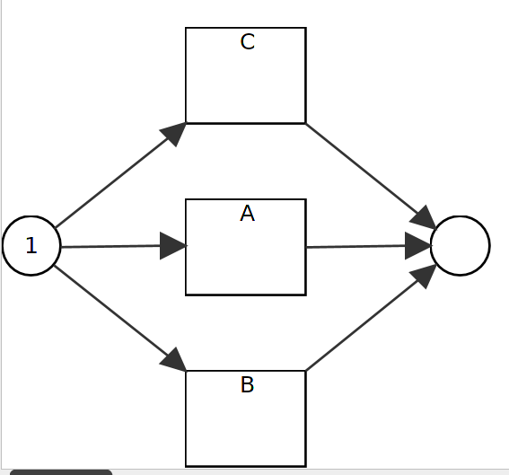
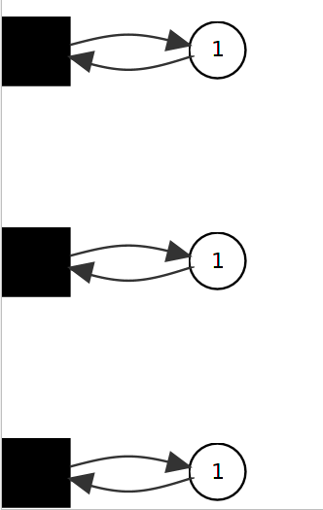
R5.2

I’m not sure the problem, so I need more tests, create normal xor relation.

R5.3
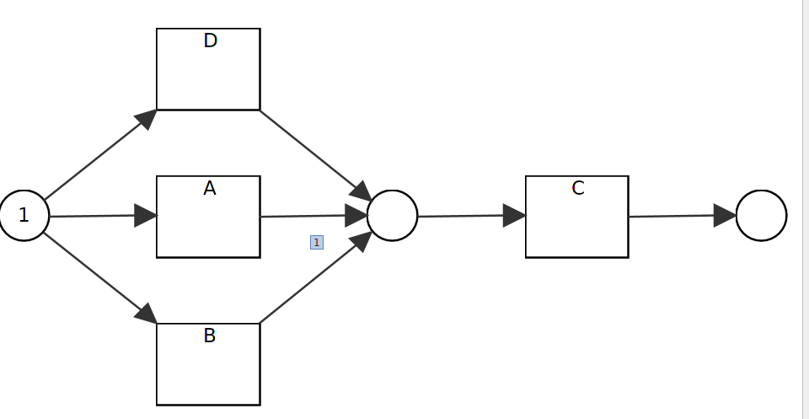
R.5.4
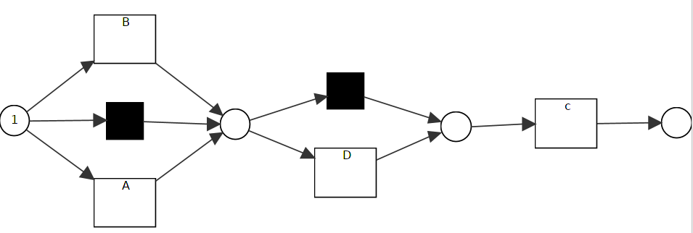
R5.5
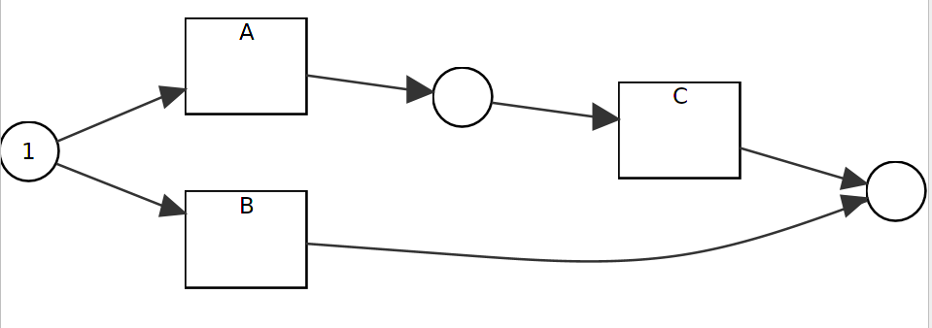
R5.6
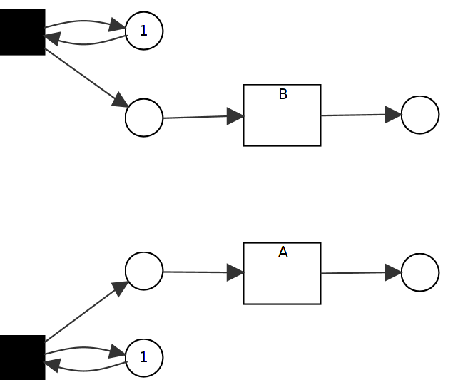
// goes wrong for this picture, need to fix it.. Later, we change all data with extensional events.
R5.7
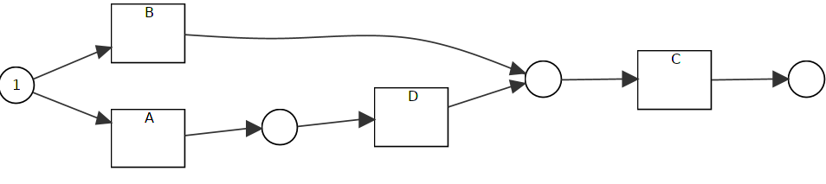
R5.8
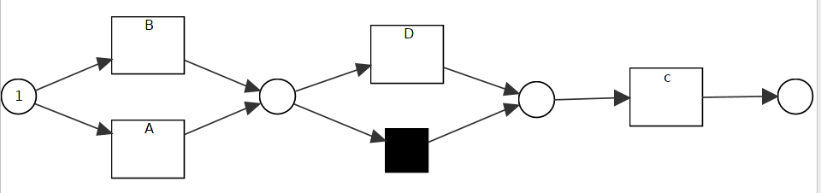
R5.9, R5.10
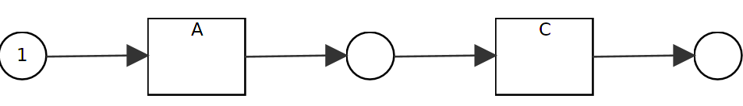
R5.11
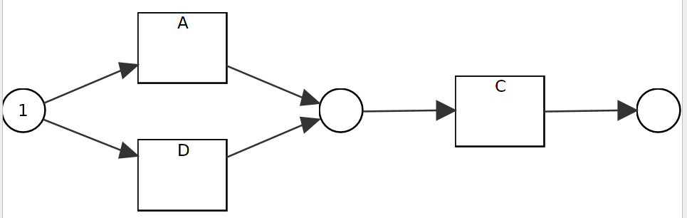
R5.12
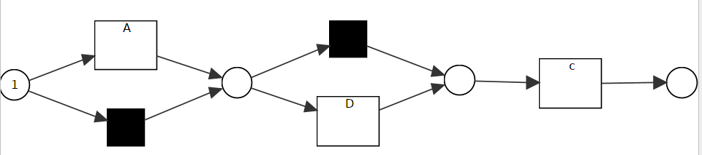
R5.13
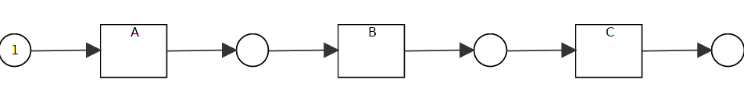
R5.14
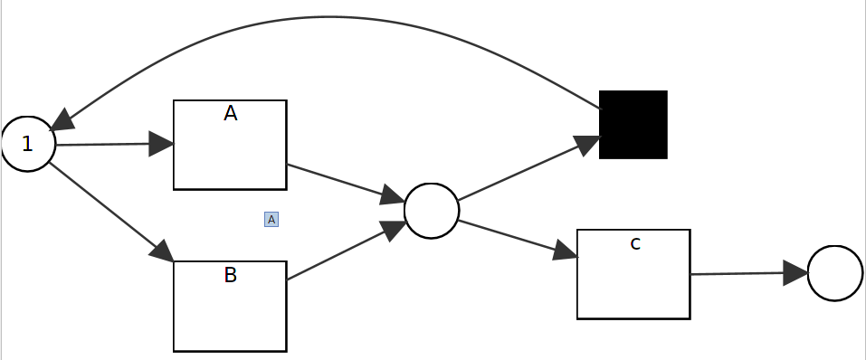
R5.15
